**DESCRIPTION OF A TABLE:**

* desc patient;

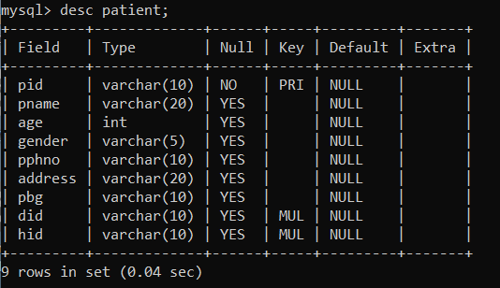

* desc donor;

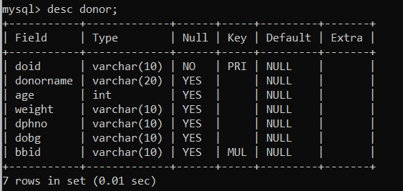

* desc bb_availablity;

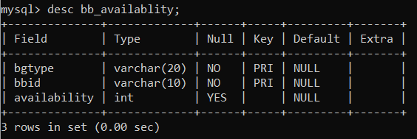

* desc blood;

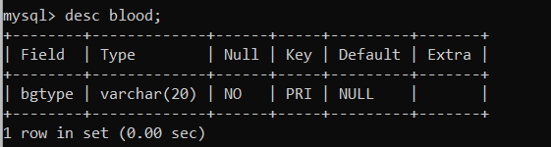

* desc bloodbank;

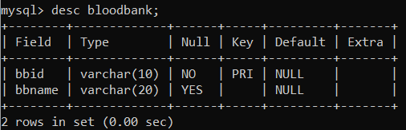

* desc doctor;

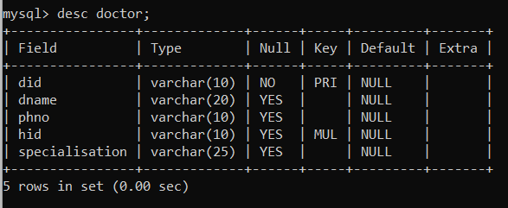

* desc hospital;

