**QUERIES:**

**1) Write a query to retrieve patient details whose blood is available in the blood bank.**

select *

from patient

where pbg in(select p.pbg

from bb_availablity b, bloodbank bb, patient p, hospital h

where p.hid = h.hid

and h.bbid = bb.bbid

and bb.bbid = b.bbid

and p.pbg = b.bgtype);

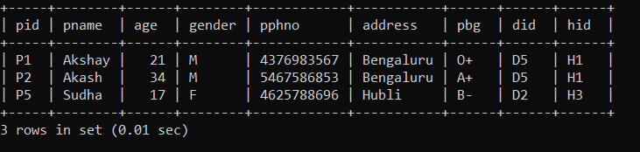

**2) Create an assertion to check if blood availability is less than 2000 units.**

create assertion bloodavailcnd

check(not exists (select *

from bb_availablity

where availability > 2000));

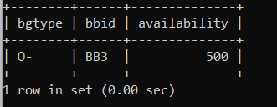

**3) Write a query to list the doctor details who treats more than one patient.**

select d.dname,count(distinct hid)

from doctor d

where 1<(select count(*)

from patient p

where p.did=d.did);

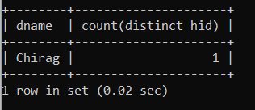

**4) Write a query to retrieve donor details whose age is above 20years.**

select doid, donorname, age

from donor

where age>20;

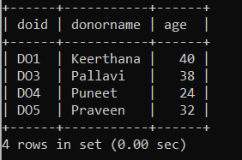

**5) Write a query to list the hospital where all blood types are available.**

select hid, hname

from hospital h

where h.bbid in (select ba.bbid

from bb_availablity ba, blood b, bloodbank bb

where bb.bbid = ba.bbid

and ba.bgtype = b.bgtype

and ba.bbid not in(select bbid

from bb_availablity

group by bbid

having count(bbid) < (select count(bgtype)

from blood)));

