**TABLES WITH TUPLE VALUES:**

* select * from patient;



* select * from doctor;



* select * from hospital;

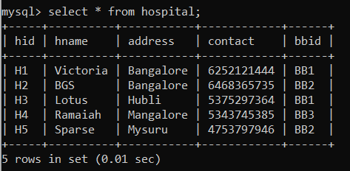

* select * from blood;

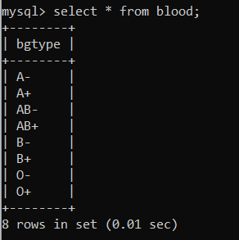

* select * from bloodbank;

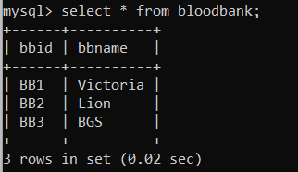

* select * from bb_availablity;

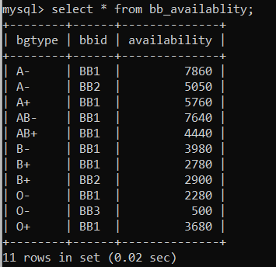

* select * from donor;

