# **Linux Environment Variable Assignment**

1. **Create a script named “myscript” in current directory to do the following.**
2. **create a dir named “subd1” in current directory**

mkdir subd1

1. **create a file named “dircontent” with contents of the current directory**

ls > dircontent

1. **display the contents of the file “dircontent”**

cat dircontent

1. **display the contents of a non existing file named “unknownfile”**

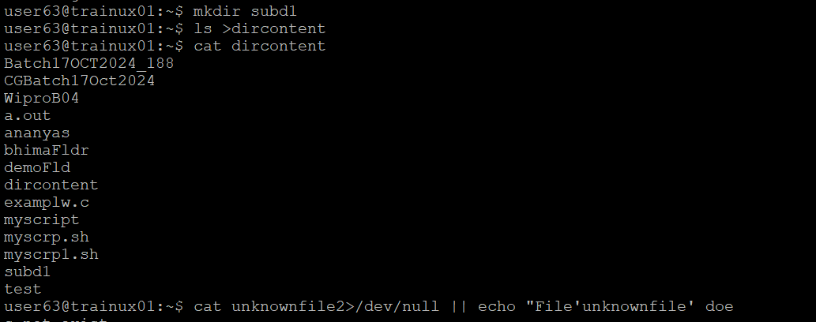cat unknownfile 2>/dev/null || echo "File 'unknownfile' does not exist."

1. **Run the script and validate the output in following cases**
2. **Redirect only the stdout to an o/p file named stdout.txt**

./myscript > stdout.txt

1. **Redirect only the stderr to an o/p file named stderr.txt**

**./**myscript 2> stderr.txt

1. **Redirect both stdout and stderr to an o/p file named stdall.txt**

./myscript > stdall.txt 2>&1

1. **Display all o/p and error and also redirect both stdout and stderr to an o/p file named stdall.txt**

./myscript | tee stdall.txt

1. **Redirect the output of command below using pipe (|) to wc and get the output .**

To redirect the output of the command ls -l, to wc using a pipe (|), you would use the following command:

ls -l | wc