# **Datatypes and Format Specifiers Assignment**

**1. WAP to read the following information at run time and to display. Choose appropriate data type and format specifier.**

1. **username [maximum of length 125]**
2. **age**
3. **Salary [float]**
4. **Designation code [as short type with values {1, 2, 3, 4, 5, 6}**
5. **Gender [a single char field]**

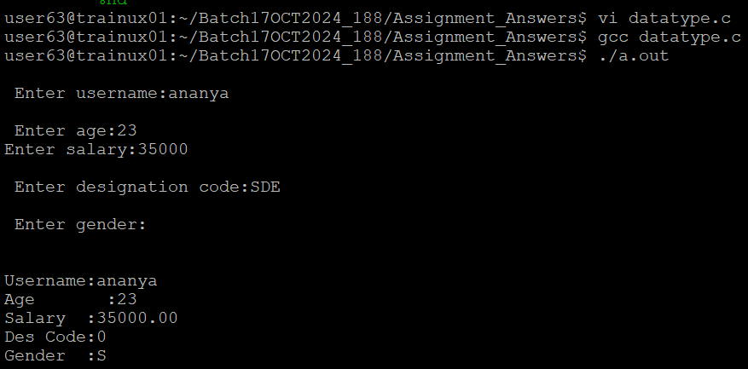

**2. WAP to read a user choice as ‘y’ or ‘Y’ or ‘n’ or ‘N’ and display read choice as “Yes” or “No” according to the input received.**

‘y’ or ‘Y’🡪 display “Yes”

‘n’ or ‘N’🡪 display “No”

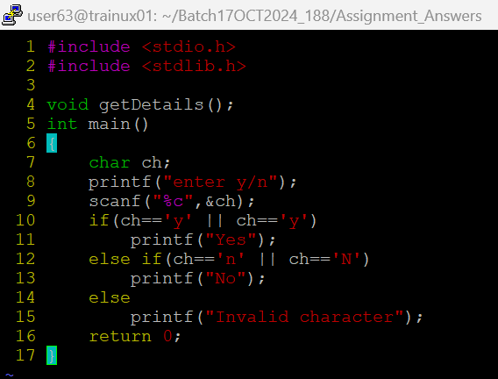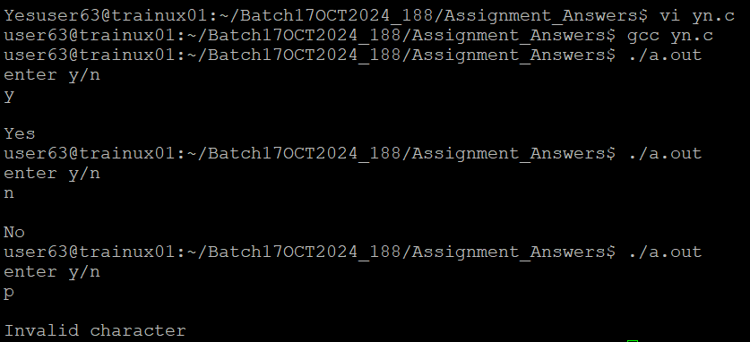 for any other character received 🡪 display “invalid character” and exit

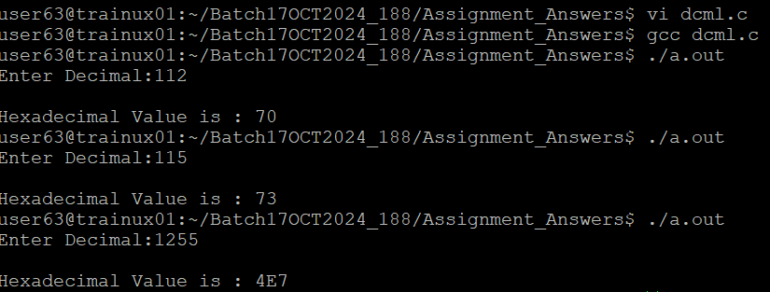**3. WAP to read a number in decimal (0-127) and display it in 2 digit hex character.**