# 1D, 2D, MultiDimensional Array Assignments

**Mandatory**

**1D Array**

1. **Refer the code snippet and answer the queries**

int main()

{

int array[100];

int *ptr;

// do something

}

**Q1. Can pointer be used in Array-style syntax? e.g. ptr[10], ptr[0]**

Ans: Yes, a pointer can be used in array-style syntax

**Q2. Can Array be used in Pointer-style syntax? e.g. *array, *(array + 0), *(array + 10)**

Ans: Yes, an array can be used in pointer-style syntax

**Q3.is ptr++ valid?**

Ans: Yes, ptr++ is valid.

**Q4: is array++ valid?**

Ans: No, array++ is not valid

**Q5. what is sizeof(array)?**

Ans: sizeof(array) will return the total size of the array, typically 400 bytes

**Q6. what is sizeof(ptr)?**

Ans: sizeof(ptr) will return the size of a pointer, typically 8 bytes on a 64-bit system.

1. **Refer the code snippet below. Comment on the other elements (other than those that are explicitly initialized) of all array variables in code snippet below.**

**#define MAX 100**

int main()

{

int arr[MAX] = {11,22,33};

int arr1[MAX]={0};

static int arr2[MAX];

}

1. **For arr[MAX] = {11, 22, 33};**

Elements arr[3] to arr[99] will be initialized to 0.

1. **For arr1[MAX] = {0};**:

All elements of arr1[0] to arr1[99] will be initialized to 0.

1. **For static int arr2[MAX];**:

All elements of arr2[0] to arr2[99] will be initialized to 0 due to the static storage class

**3.Refer the program “array_pointer.c”. Add a function getmax() to find the maximum in the array and call in main() and display the result.**

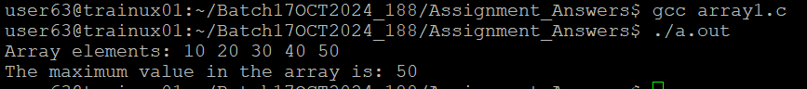

**4.Extend the code given below to read N and a start value from the user to**

**perform the given operations.**

#define MAX 100

int main()

{

int arr[MAX] = {11,22,33};

}

Add the following functions choosing proper input, output and return.

1. init() - Use the inputs to initialize the first N elements of the array with N consequetive values starting with given start value .
2. update() – increment value of every element in the array
3. display() – display the contents of array

**2D, MultiDimensional Arrays**

1. Implement sort() to sort a given array. Refer the code snippet below.

int main()

{

char arr[]= “xaybz”;

sort(arr, sizeof(arr)/sizeof(arr[0]);

return 0;

}

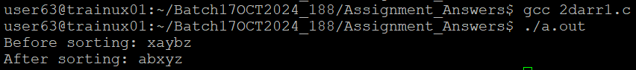

1. Refer the code snippet below.

int main()

{

char arr[][3] = {

sort(arr, sizeof(arr)/sizeof(arr[0]);

return 0;

}

Allow user to perform the following operations.

* 1. init() - initialize the array and return 0
  2. search_update() – search for a given element in array and if found update it to given value and return 0 else return 1
  3. display() – traverse and display array contents

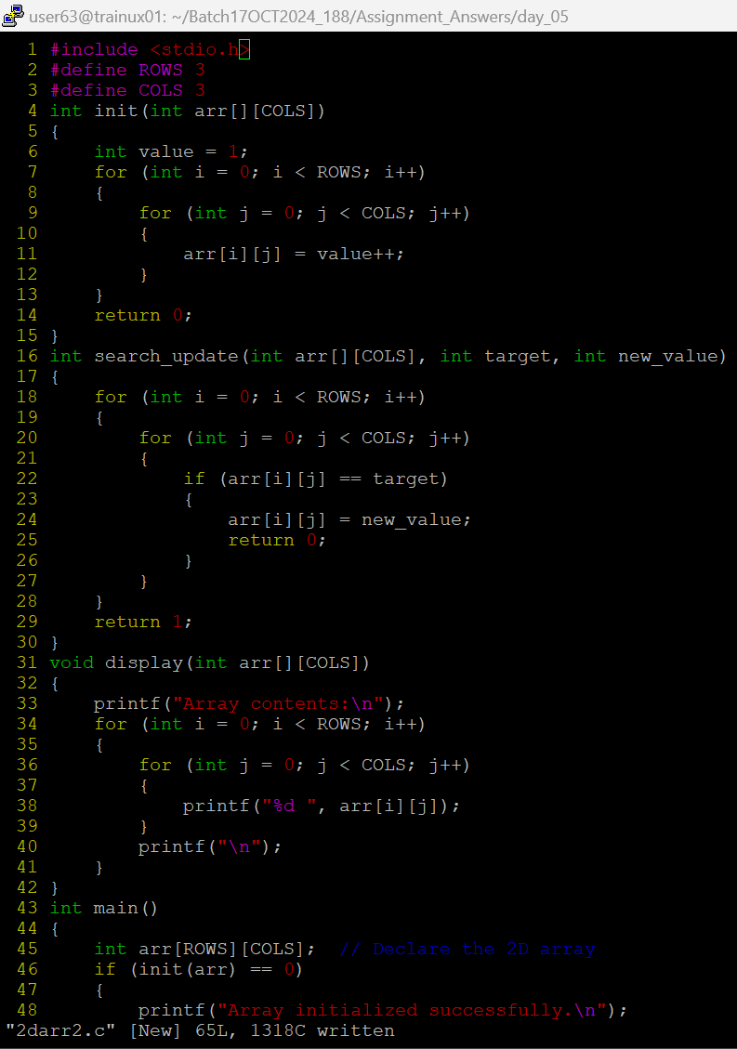For the functions, pass array and other required arguments to functions and return as per requirement

