Title: Ultra-Low Power IoT Sensor Node Using SDC Optimization and UPF-Based Power Intent

Author: Ananya Sai Prasad

Department: Electronics and Communication Engineering (VLSI Design and Technology)

Institution: VIT University, Vellore

Tools: Verilog HDL, Cadence Genus, UPF, SDC, TCL
Abstract:
With the rapid growth of the Internet of Things (IoT), numerous battery-operated embedded devices have been deployed for applications in environmental monitoring, healthcare, industrial processes, and smart city initiatives. Since these types of devices are expected to operate for a long time without the need of replacing their batteries or recharging them, minimizing power consumption is one of the key aspects of modern digital integrated circuit design. Ultra-low power operation leads not only to the improved battery life but to the improved reliability of the system and the possibility to use autonomous detection systems even in remote places.
The paper describes the design and implementation of an ultra-low power IoT sensor node using industrial-standard ASIC design methodology. The main goal was to achieve minimal dynamic and leakage power with preserved functional correctness and timing performance. The construction of the common architecture of the sensor node was the first step in order to create a basis for comparison. After that, certain upgrades were made using the improved SDC and UPF-based power intent. Low-power design techniques such as clock gating, power gating, multi-voltage power domains, isolation cells, state retention, and always-on logic were incorporated in this.
In the design process, RTL synthesis was done using Cadence Genus, timing was optimized with the help of SDC constraints, UPF power intent was implemented, timing, area, and power analysis was performed. As a result, multiple implementation scenarios were compared during the project, starting from the baseline design to SDC-optimized architectures and an architecture with UPF enabled, finishing on fully optimized low-power designs. A detailed comparison of the reports demonstrates that the technique applied for improving the timing works well when combined with systematic power management methods to decrease power consumption and maintain the design functionality.
This study serves an example of the use of ASIC low-power designing approaches in the IoT application area.

Introduction:
In recent years, the Internet of Things (IoT) has been one of the most important breakthroughs in technology, making it possible for billions of devices to connect with each other and share data in many different areas of application. These devices are employed in numerous smart homes, health care systems, industrial processes, agriculture, environmental monitoring, and intelligent transport systems. Most of them work on battery and continue to do so for months or years without any maintenance. Because of this, it is mandatory to increase the efficiency of energy consumption in the design of modern IoT hardware.
In general, digital integrated circuits consume power because of dynamic power, which is generated by switching, and leakage power, which comes from leakage currents in transistors in an idle circuit. With the miniaturization of semiconductor devices, the contribution of leakage power to overall energy use has become more important. Hence, it is necessary to apply effective power management techniques to increase battery life without losing the performance of the whole system.
Traditional digital designs often overlook the significance of advanced power optimization in their designs and focus mainly on functional correctness and timing validity. While such designs help attain performance benchmarks, they could waste power excessively due to continuous operation of the clock signal and continuously powered inactive blocks as well as inefficient voltage control. The restrictions associated with traditional structures render them inadequate for energy-limited applications in IoT environments where reliability is paramount in the design process.
Modern ASIC design practices proffer a good number of methods that contribute to lowering power consumption while not negatively affecting the functionality of the circuit. Clock gating ensures that switching activity is minimized via turning off the clock signals to inactive modules. Power gating means disconnecting idle parts of the circuit from the power supply to mitigate leakage effects. Multi-voltage design enables different parts of the circuit to work at various voltage levels depending on the requirements of the functioning of that part of the circuit. Additional methods include isolation cells, retention registers, and always-on power domains for ensuring proper operation during the changes between working and low-power operations.
The aim of this project is to study the Ultra-Low Power IoT Sensor Node using Cadence Genus. Before optimization, a traditional design implementation was generated and assessed, with further optimization of timing constraints as well as energy-efficient solution employing Unified Power Format (UPF). The optimized design has been evaluated based on its timing, power, area, and quality of synthesis report. The comparative research showcases and illustrates the benefit of low power design techniques.
Problem Statement:
IoT sensor nodes powered by batteries need to have extremely low power consumption so that they can operate for a long time and yet perform reliably and accurately. Traditional RTL designs do not usually use established techniques for power management which causes excessive activity during switching and large amount of leakage power. In addition, designs created without any timing constraints or considering power usage cannot take advantage of modern low-power optimization options offered by EDA technologies.
The goal of this work is to determine the extent to which using SDC and UPF allows minimizing the power consumption of an ASIC IoT sensor node through proper optimization of timing constraints in the design process. The implemented approach offers a possibility of comparing a standard design with other versions of the design optimized for power efficiency while conserving timing performance and functional correctness.
Objective:
The primary objectives of this project are:
- To design an IoT sensor node that is based on RTL which can be used for ASIC implementation.
- To perform logic synthesis using Cadence Genus.
- To use optimized Synopsys Design Constraints (SDC) for the timing optimization purposes.
- To utilize Unified Power Format (UPF) based power intent that can effectively manage power.
- To analyze the various reports of power, timing, area, and quality of results (QoR) generated during the synthesis.
- To check the baseline and optimized implementations to see improvements in power efficiency.
- To prove the usefulness of the modern low-power ASIC design techniques in IoT applications.
Literature Review:
The increasing proliferation of Internet of Things (IoT) devices has made power efficiency a key factor in design, since the majority of sensor nodes are relying on limited battery power supply. The basic digital designs have concentrated on functionality and timing itself, which leads to wasted power in leaks and dynamic usage. In order to meet these challenges, new ASIC development has already included techniques like clock gating, power gating, multi-voltage operation, and state retention techniques.
The Unified Power Format (UPF) is an example of standard approach to defining power purposes, including domains of power of isolation techniques and retention logic without need to change the RTL. Synopsys Design Constraints (SDC) help the synthesis to accomplish difficult timing. This work uses the same techniques for the ultra-low power IoT sensor node development.
System Architecture:
The Ultra-Low Power IoT Sensor Node suggested in this research work is developed on the basis of a modular architecture comprising a sensor interface, sensor controller, power management unit, and output. The power management unit regulates the operational state of the system and is responsible for making it possible to utilize low-power modes when the device does not operate, while still allowing the system to be able to wake up.
The design employs two separate power domains: Always-On (AON) and Core to achieve maximum leakage power reduction. Various techniques such as clock gating, power gating, isolation cells and state retention are used to lower power consumption without compromising functionality.
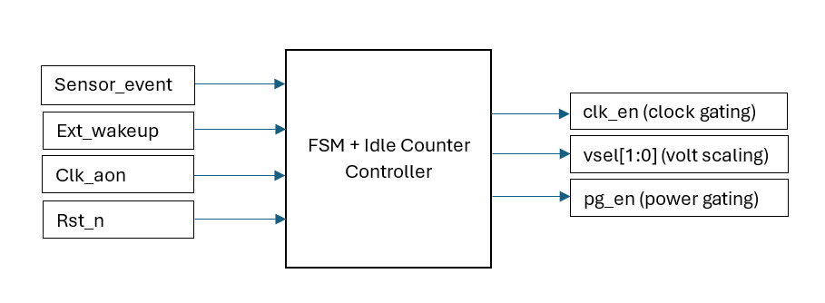
Figure 1: System Architecture of the Ultra-Low Power IoT Sensor Node
Design Methodology:
The project began with a typical ASIC design flow, first doing RTL development using Verilog HDL and then proceeding to logic synthesis using Cadence Genus. After analyzing the baseline design implementation for its timing, power, area, and quality of results (QoR), work on timing optimization started by refining the Synopsys Design Constraints (SDC), followed by using UPF to express the power intent of the design.
At the end, many implementations were compared, including the baseline design, the SDC-based design, Optimized SDC design, and UPF-based design.

Low-Power Design Techniques:
The inclusion of various low-power design techniques that are recognized by the industry was done to decrease the total power consumption of the IoT sensor node. In the first step, the initial design was verified so that important timing, power, and area characteristics could be set. Then in the subsequent implementations, more advanced methods were used to improve energy sustainability without compromising functionality.
The basic methods of optimization applied were clock gating that helps to avoid unnecessary switching processes, power gating that lowers leakage or losses in non-active mode, and UPF to provide various kinds of power domains. An Always-On (AON) domain was employed in the microcontroller to ensure the proper working of obligatory control logic while an inactive Core domain was put in operational status.
Experimental Setup:
In the course of this project, Cadence Genus was utilized for implementing the proposed designed, while Verilog HDL was used for the purpose of RTL design, and synthesis. Timing constraints were applied based on the Synopsys Design Constraints (SDC), and power intent was defined in accordance with the Unified Power Format (UPF). Several synthesis runs were done in order to determine effects of optimization techniques on the design in general.
In total, four implementation scenarios were analyzed during the review process including baseline design, SDC-optimized design, UPF-enabled design and modified SDC plus UPF design implementation. The output of each implementation was analyzed based on power, timing, area and Quality of Results (QoR).
Results and Discussion:
The outcomes of the synthesis have shown the advantages that low-power optimization techniques provide in the case of the IoT sensor node. The optimized designs were demonstrated to have improved power efficiency when compared to the baseline implementation, even though the timing performance was not affected. This benefit was attained due to the optimized timing constraints which made it possible to use the synthesis to a better effect than without it while making use of PP solutions for the first time.
The comparative analysis of the derived reports shows that the combination of the SDC optimization technique and UPF-based power intention brings even more power savings than each of the techniques applied independently. The requirements for timing and area have been met, showing that it is possible to achieve low power consumption with no power loss in terms of functionality.

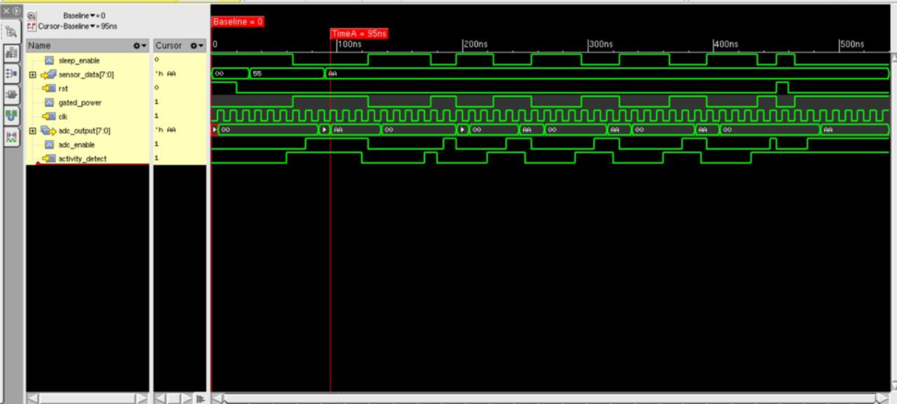
Figure 2: Simulation Results

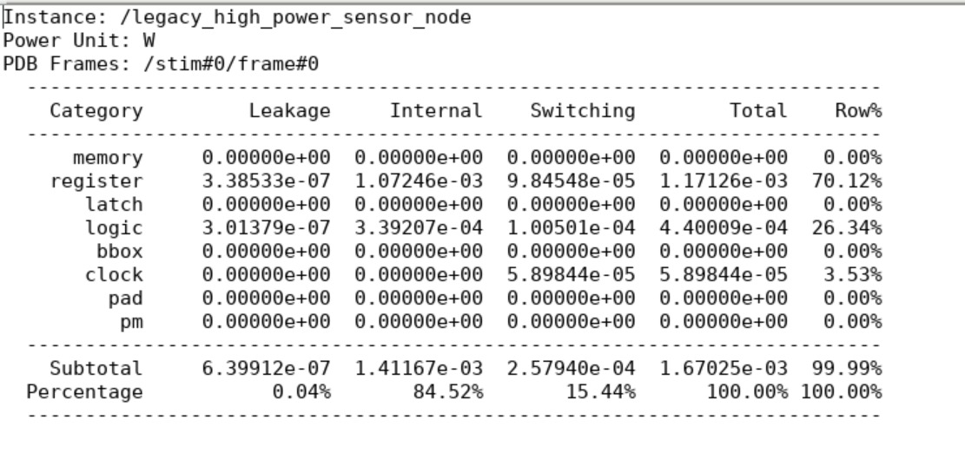
Figure 3: Baseline design Power Report
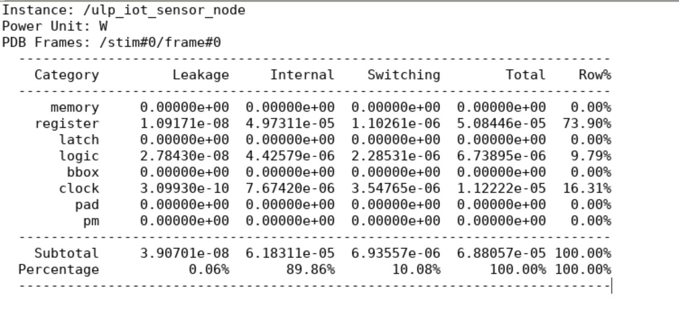
Figure 4: Modified SDC design Power Report

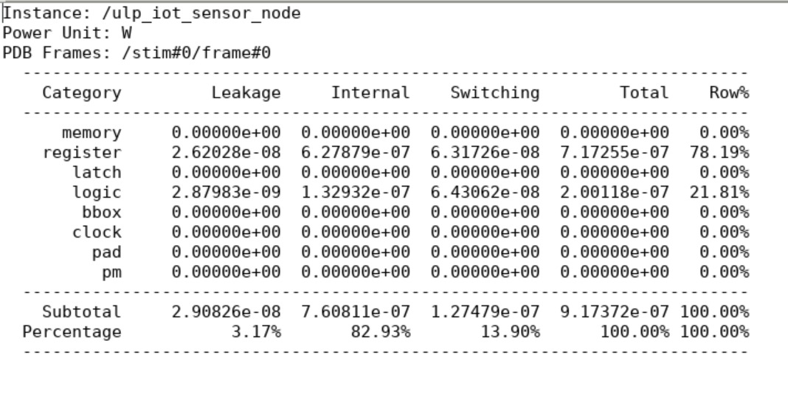
Figure 5: Modified SDC+UPF design Power Report

Comparative Analysis:
The project assessed four various execution scenarios to find out the role of different optimization methods. The original design acted like the reference implementation, while the improved designs included the optimized timing constraints, application of UPF-based power intent as well as the combination of several methods. This method allowed systematic comparison of power, timing, and area among different design options.
The optimized execution gave the excellent switches between power efficiency and efficiency. The method that uses SDC optimization and UPF cut down the excessive switching activity, dealt with power management, and kept timing closure. The findings show how important it is to combine timing optimization with power-aware techniques in contemporary ASIC design.
Conclusion:
This project describes the creation and optimization of an ultra-low power Internet of Things (IoT) sensor node using state-of-the-art ASIC design techniques. The design utilized a combination of RTL optimization, SDC timing optimization, and UPF-based power intent in order to achieve great power efficiency while also keeping the design functional and timing consistent. The comparative analysis showed that utilizing several lower power design techniques has more advantages than using one optimization method.
The project also gave practical experience with EDA tools and improved the notion of low power ASIC design concepts like power domains, clock gating, power gating, isolation, etc. These design concepts are essential to the implementation of power-efficient digital devices.

