Name: ANANYA SHETTY
Roll Number: 2
PRN:1032230416
Batch:D1

Critical Analysis of MyGov Podcast Interface

MyGov Podcast is a government-oriented digital audio platform that provides informative content related to government initiatives, public awareness, policies, and citizen-related topics. Although the platform focuses on delivering important information, its interface can be improved to make podcast discovery and listening more engaging and efficient.

1. Learnability

The basic purpose of the interface can be understood by users because podcast titles and audio content are displayed directly. However, first-time users may not immediately understand how to browse podcast series, identify categories, or find related episodes.
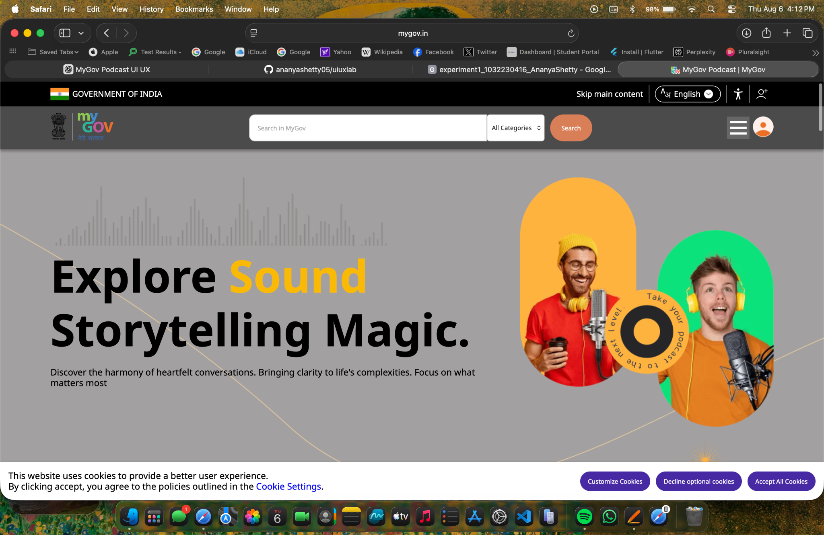

2. Usability

Users can access informational podcast content, but finding a specific episode or topic may require additional effort. The interface could provide better sorting and filtering options based on government schemes, departments, languages, and topics.
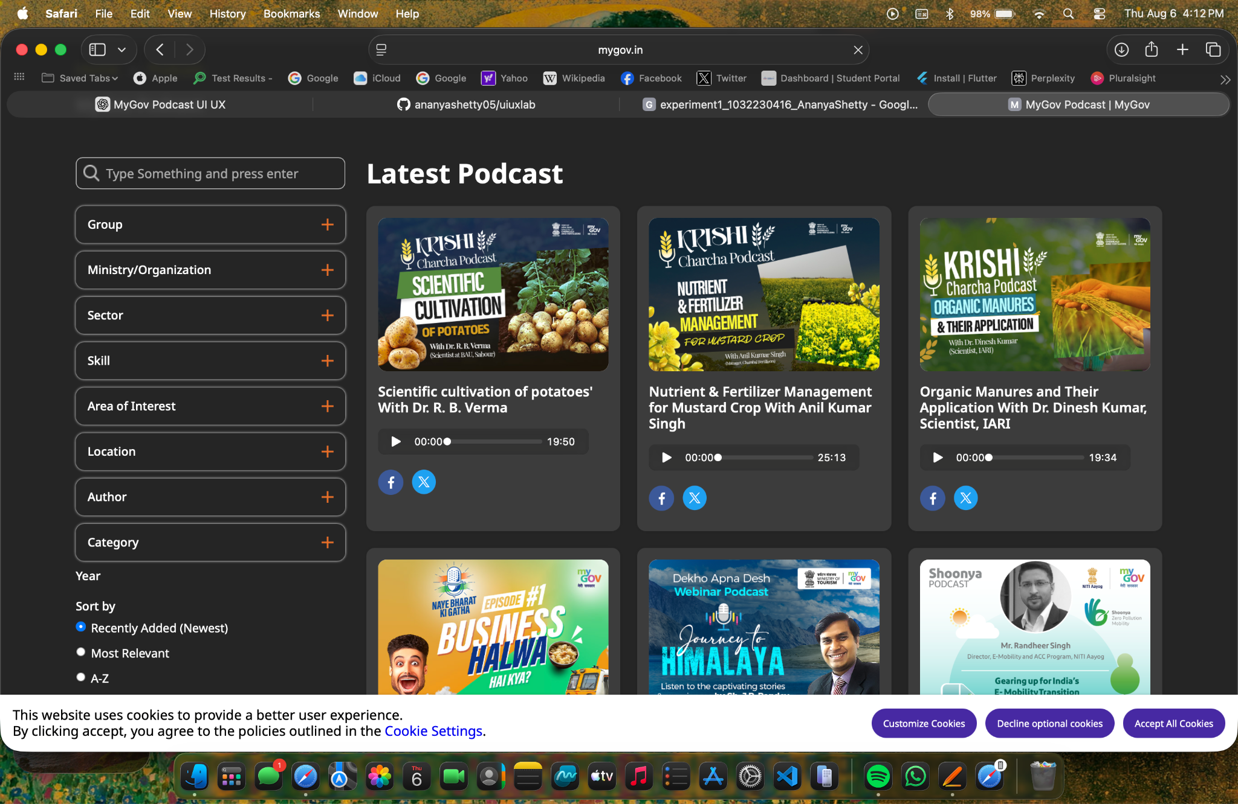

3. Consistency

The interface generally follows the visual identity of a government digital platform. However, the presentation of podcast cards, text, images, and interactive elements could be more consistent. A standard layout for all podcast episodes would improve usability.

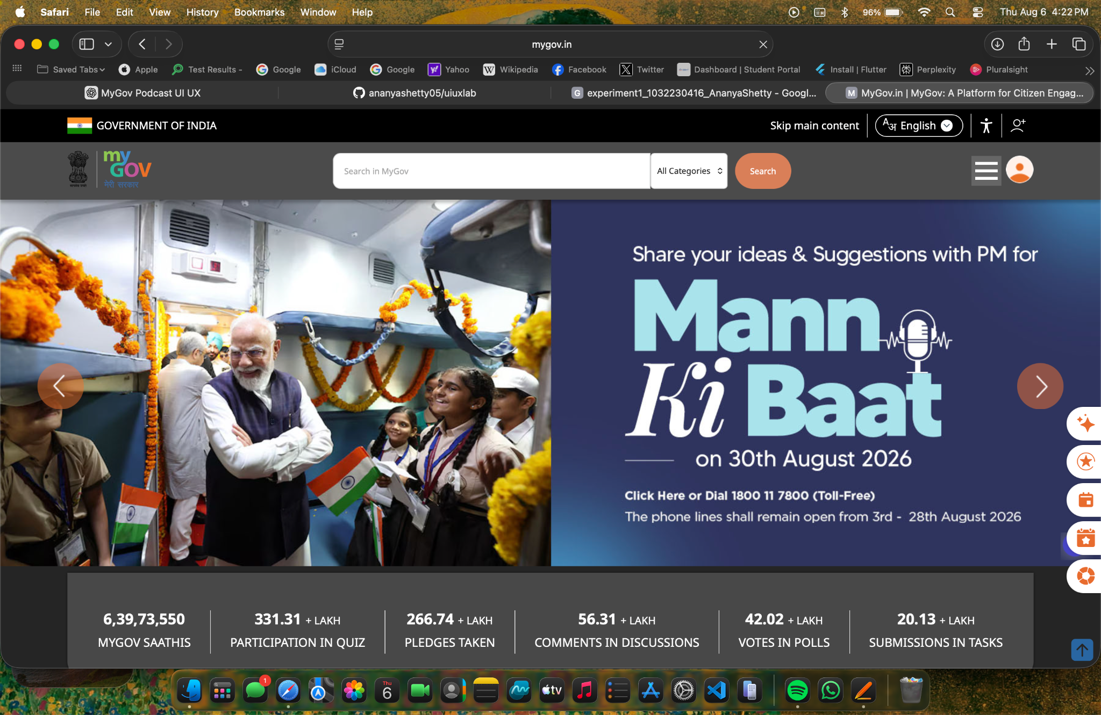
4. Use of Metaphors

Common audio metaphors such as play and pause controls are easy to understand. Familiar icons for search, sharing, and navigation can help users interact with the platform. However, stronger use of podcast-specific metaphors such as playlists, queues, and subscriptions could improve the experience.

5. Navigation Structure

Navigation is an important area for improvement. Podcasts should be clearly organised by topic, department, language, and series. Users should be able to move easily between an episode, its series, and related episodes.

6. Visual Hierarchy

Important podcast titles and episode information should receive greater visual emphasis. Currently, government branding and textual information may compete for user attention. Larger podcast artwork and clearly highlighted play controls could create a better hierarchy.
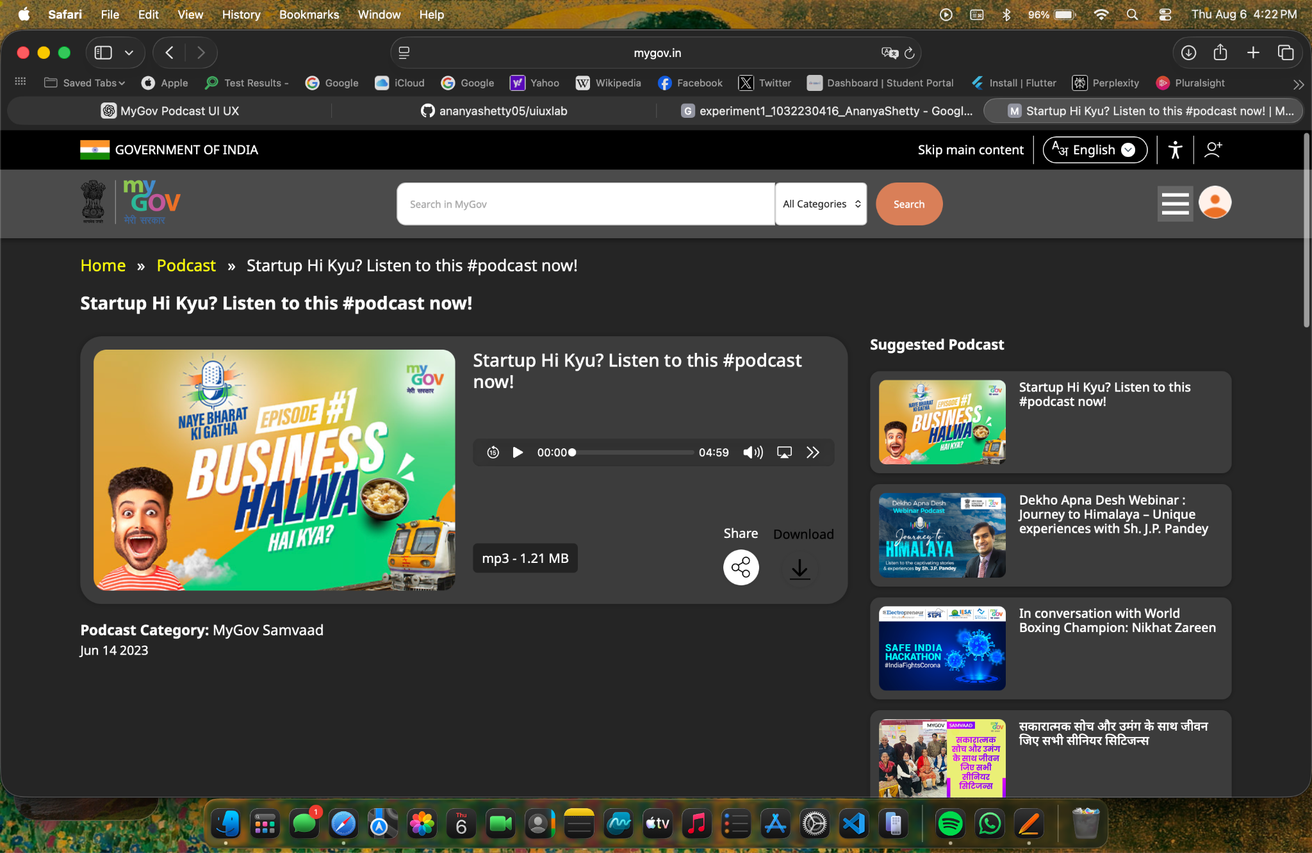

7. Accessibility

Accessibility is especially important for a public government platform. The interface should provide sufficient colour contrast, readable fonts, screen-reader compatibility, keyboard navigation, transcripts, and captions or text alternatives for audio content. Multilingual accessibility should also be prioritised.

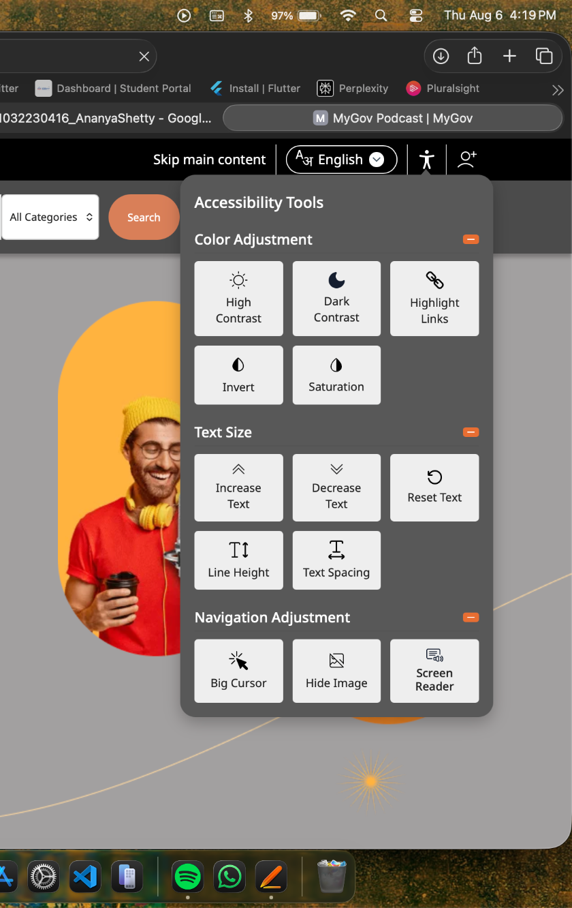
8. Responsiveness

The interface should work effectively across mobile phones, tablets, and desktop devices because citizens may access the platform using different devices. Audio controls and text should adapt properly to smaller screens.

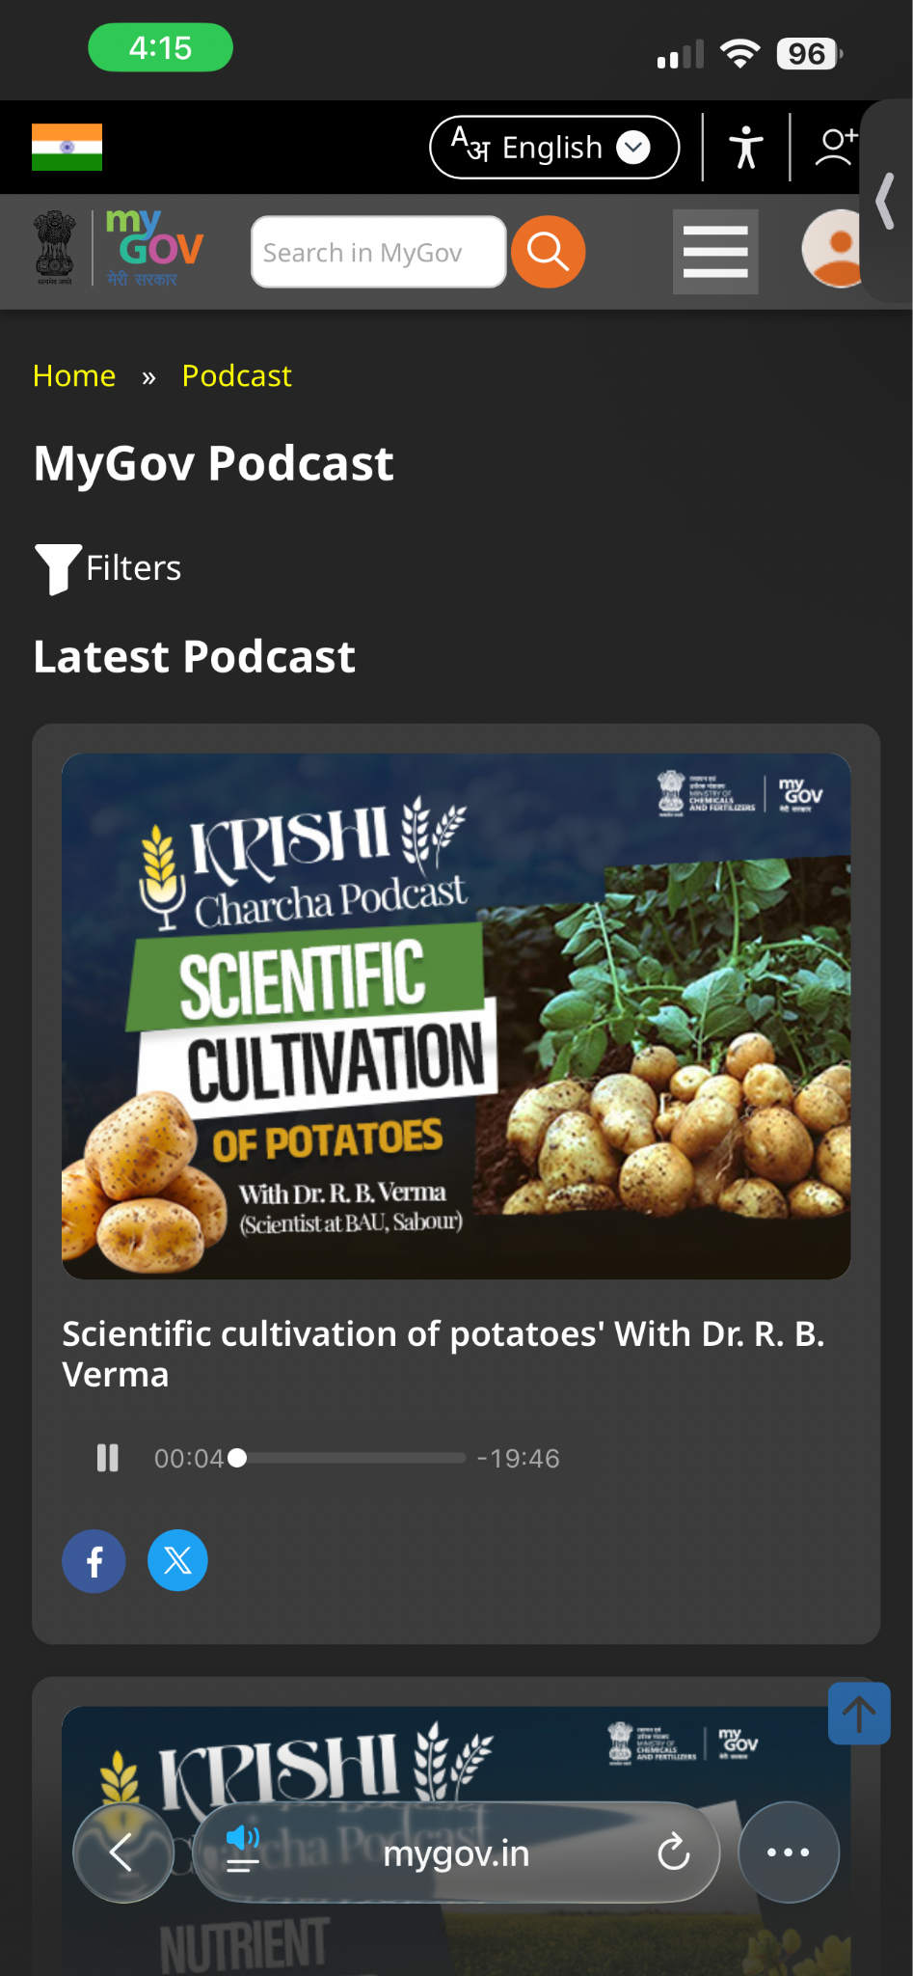
9. Efficiency of Interaction

A user should be able to discover and play a podcast with minimum steps. Features such as Continue Listening, Recently Played, Saved Episodes, and quick play controls could reduce interaction time.
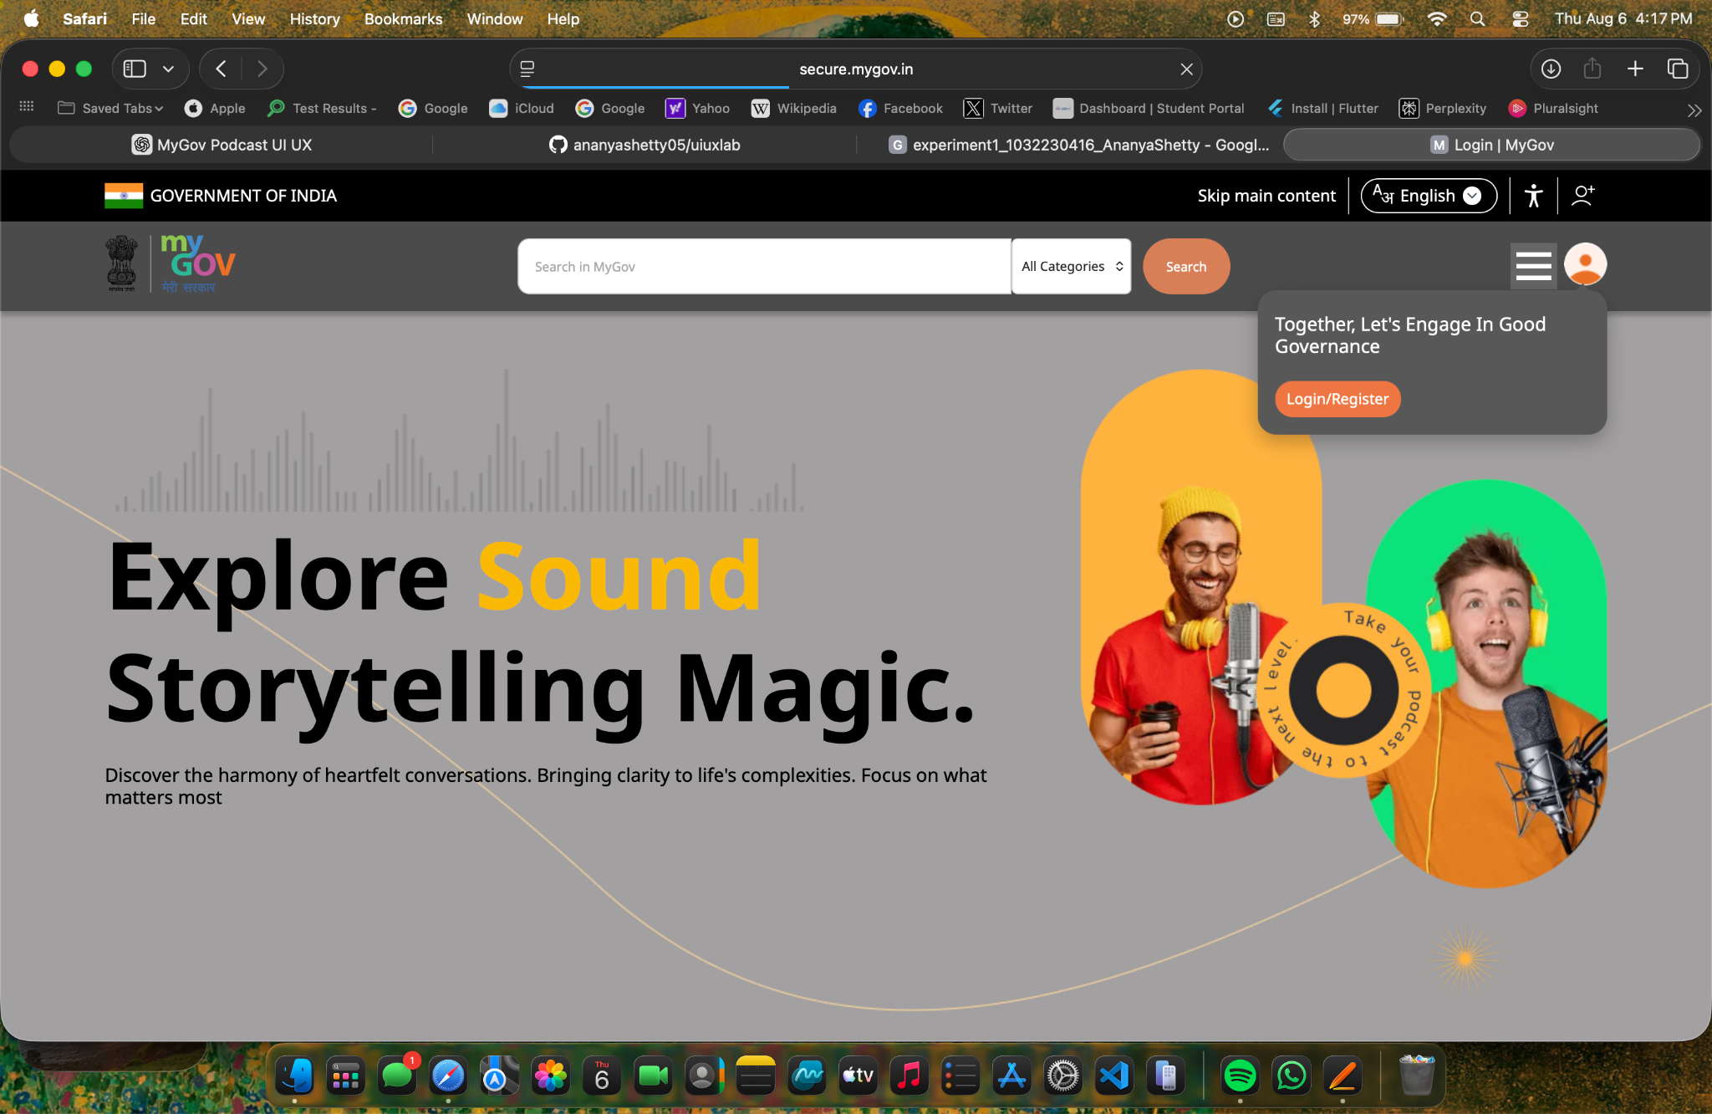
Login itself is buffering

10. Feedback and System Status

The audio player should clearly show loading status, current playback position, total duration, and buffering status. Download or save actions should provide confirmation messages to the user.
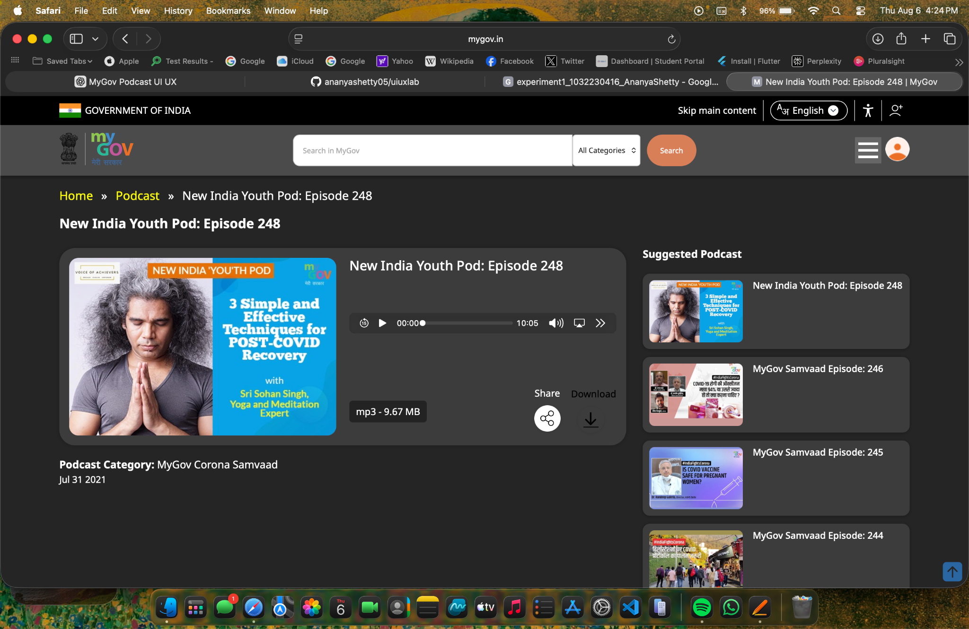

11. Error Prevention and Recovery

Clear error messages should be provided when audio cannot be played or when internet connectivity is poor. The platform should remember the user’s playback position so that an interrupted podcast can be continued later.
Not present

12. Aesthetic and Minimalist Design

The interface could adopt a cleaner and more modern podcast-oriented design. Unnecessary textual information should be reduced on the main browsing screen. Important information can be placed on the individual podcast detail page.
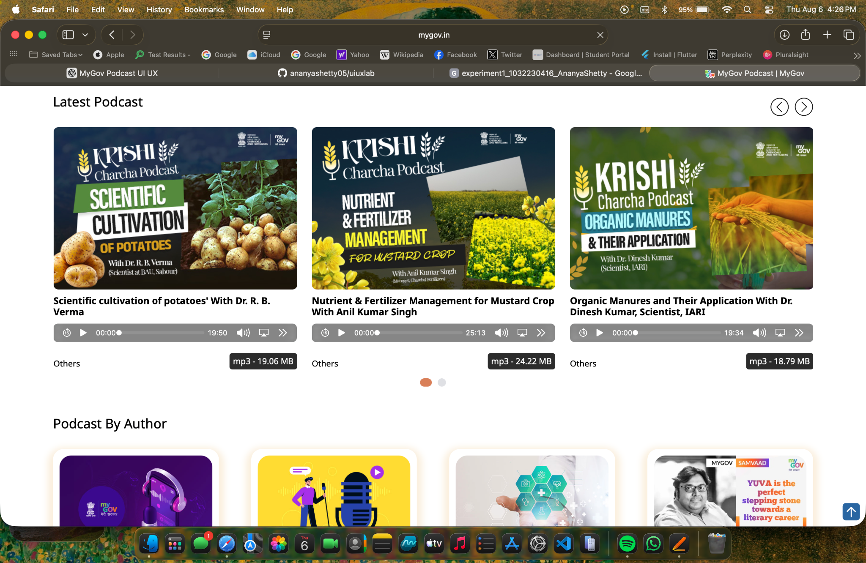

13. Content Readability

Government-related content can contain formal or complex terminology. Podcast descriptions should use readable typography, short paragraphs, and clear headings. Important topics and scheme names should be visually highlighted.
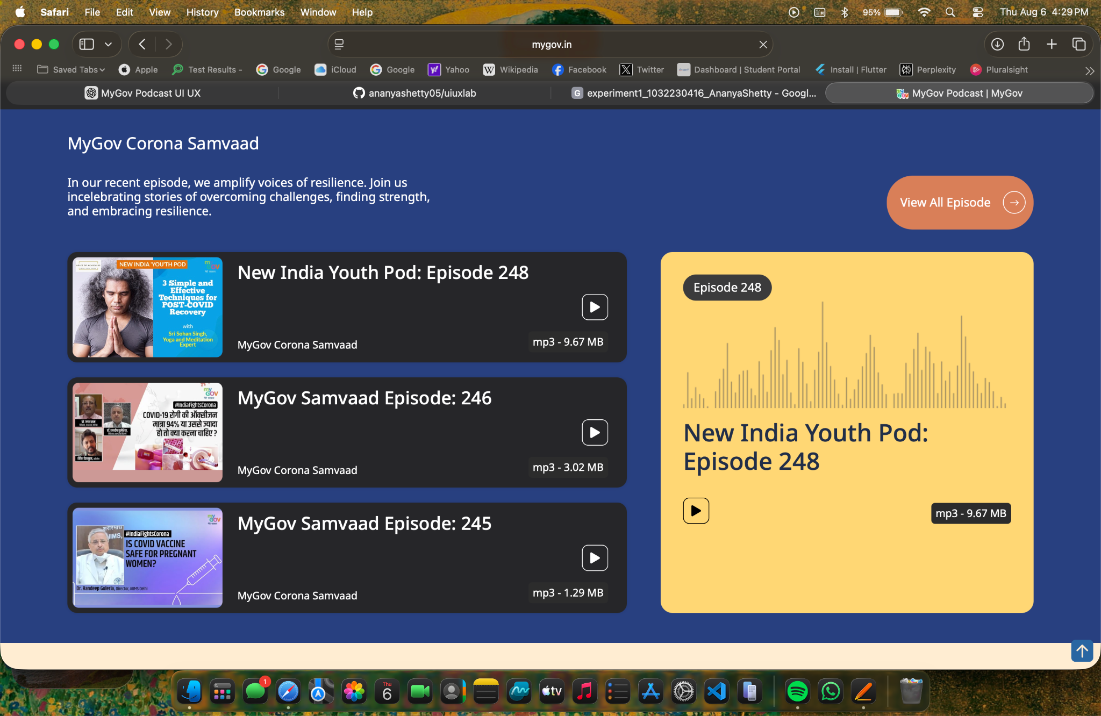

14. Search and Discoverability

Search and discoverability require improvement. Users should be able to search using topics, ministries, schemes, speakers, and languages. Filters and category-based browsing would make public information easier to find.
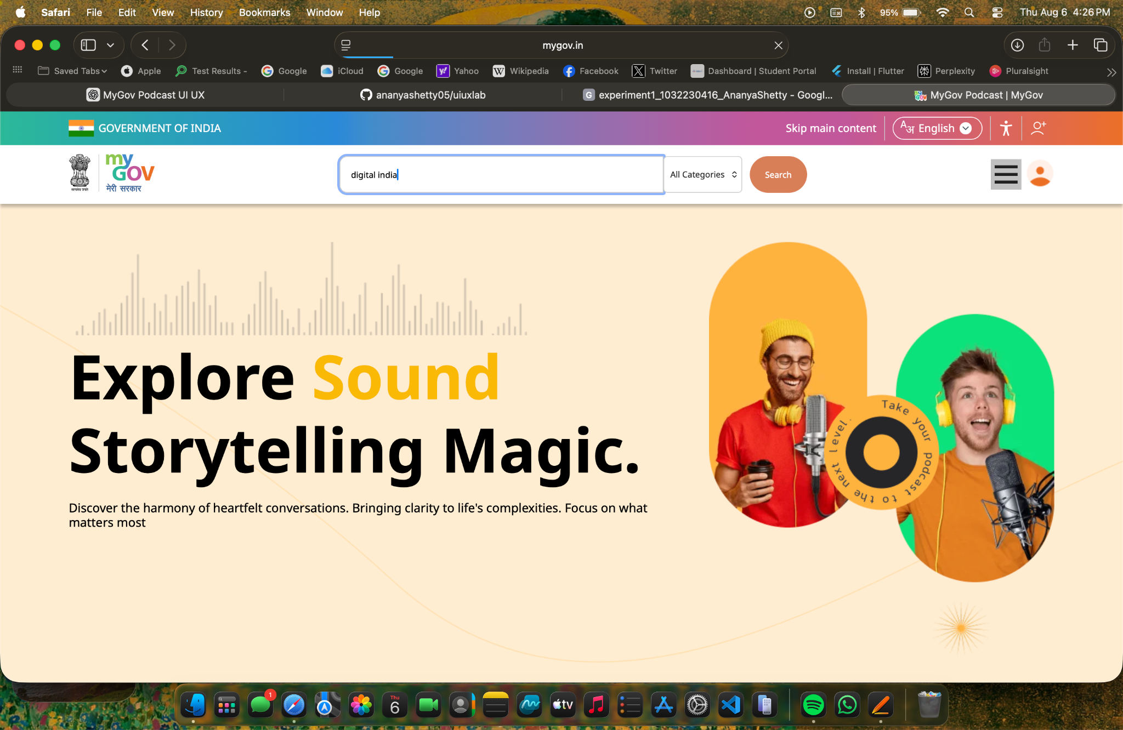

15. Performance Perception

Loading indicators and progressive loading should be used when podcast content takes time to load. A visible audio buffering indicator would reassure users that the system is responding.

16. Trust and Credibility

As a government-oriented platform, MyGov has strong credibility. Official branding and verified government information increase trust. However, clearly displaying the publishing department, date, speaker information, and source of each podcast could further strengthen credibility.

17. Personalization

Personalization appears limited compared to commercial podcast applications. The platform could recommend content based on selected interests, preferred languages, previously listened to topics, and followed government departments.

18. User Satisfaction

The platform provides useful and credible informational content. However, the user experience could be improved through better navigation, search, personalization, and a modern audio player interface.

Shneiderman’s Golden Rules Analysis

The MyGov Podcast interface can improve consistency by standardising podcast cards and interaction patterns. Informative feedback should be provided for playback and loading actions. Easy reversal can be supported through simple save and unsave options. The platform can reduce short-term memory load by providing listening history and Continue Listening features. Universal usability should be prioritised because the platform serves citizens with different languages, abilities, and levels of technical knowledge.

Conclusion

MyGov Podcast provides important and credible public information, but its interface can be improved from a user experience perspective. Better podcast categorisation, multilingual search, accessibility support, listening history, and personalised recommendations would make the platform easier and more engaging for citizens. A modern podcast-focused interface would improve the discoverability and accessibility of government information.

