With the help of Machine learning, we have created a model to obtain the dimensional values for design 1, corresponding to cut off frequency provided by the user.

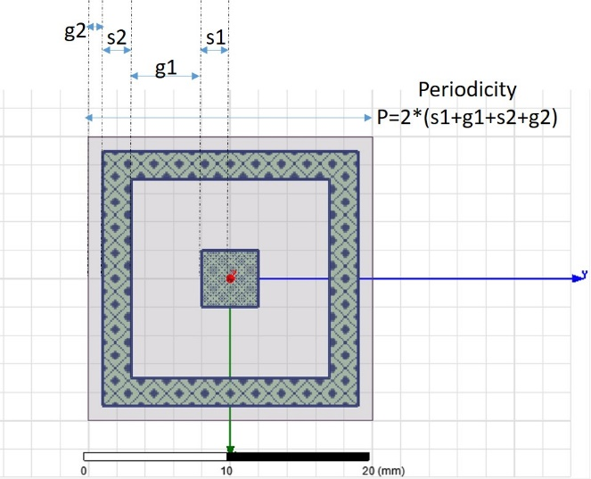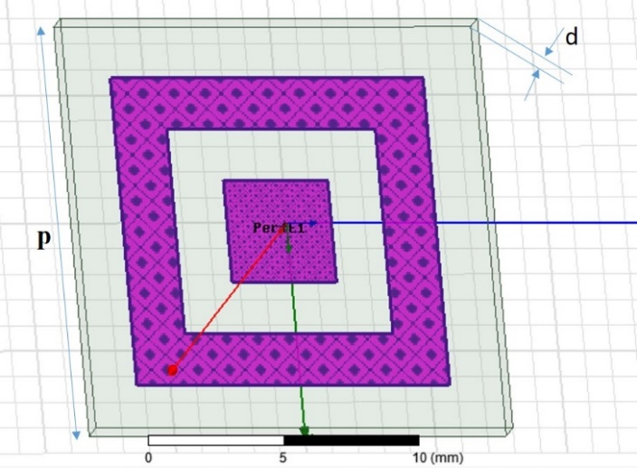

Following are few of obtained dimensional values:

|  |  |  |  |  |  |  |  |  |  |
| --- | --- | --- | --- | --- | --- | --- | --- | --- | --- |
| User defined cut-off frequencies (in GHz) | | Dimensions (in mm) obtained by using trained model | | | | Simulation result cut-off frequencies (in GHz) | | Absolute Error | |
| Lower cutoff frequency | Upper Cutoff frequency |
| G1 | G2 | S1 | S2 | Lower cutoff freq | Upper cutoff freq | Lower cutoff | Upper Cutoff |
| 2 | 4 | 2.2 | 0.2 | 7.0 | 0.0 |  |  |  |  |
| 3 | 5 | 11.6 | 2.5 | 6.4 | 1.5 |  |  |  |  |
| 6 | 8 | 10.0 | 0.5 | 3.0 | 2.0 |  |  |  |  |
| 8 | 10 | 0.4 | 2.0 | 3.8 | 0.2 |  |  |  |  |
| 10 | 12 | 2.0 | 1.5 | 3.0 | 1.5 |  |  |  |  |
| 12 | 14 | 2.4 | 2.8 | 2.3 | 2.9 |  |  |  |  |
| 14 | 16 | 1.8 | 1.0 | 1.8 | 1.5 |  |  |  |  |
| 16 | 18 | 0.8 | 3.0 | 1.5 | 1.0 |  |  |  |  |
| 8 | 12 | 4.0 | 0.5 | 3.0 | 0.5 |  |  |  |  |
| 6 | 14 | 11.8 | 0.0 | 0.1 | 0.0 |  |  |  |  |
| 8 | 18 | 10.2 | 0.0 | 0.0 | 0.0 |  |  |  |  |

Absolute Error will be calculated by taking simulation frequency as reference value, in both lower and upper cutoff frequency cases.