With the help of Machine learning, we have created a model to obtain the dimensional values for design 1, corresponding to cut off frequency provided by the user.

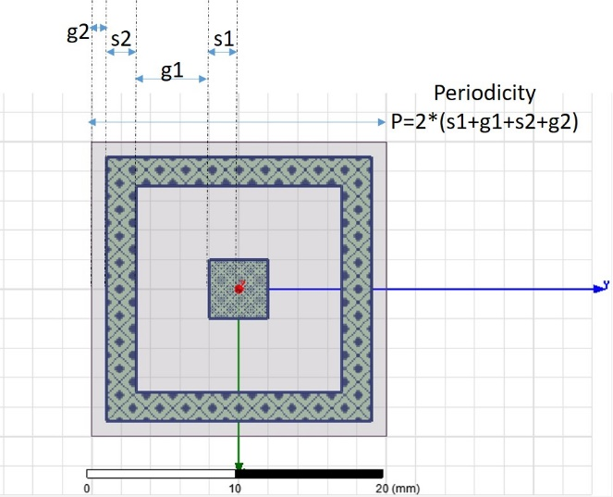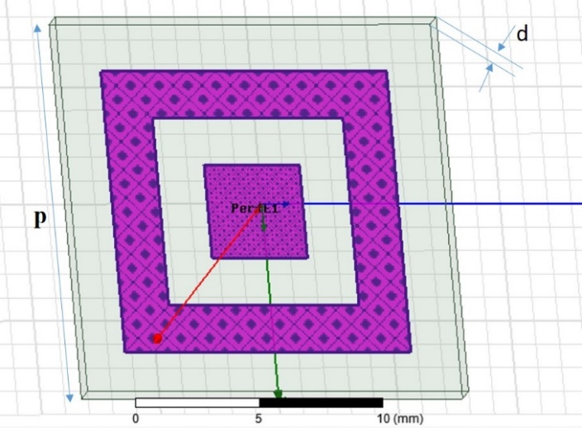

Following are few of obtained dimensional values:

|  |  |  |  |  |  |  |
| --- | --- | --- | --- | --- | --- | --- |
| User defined cut-off frequencies (in GHz) | | Center cutoff frequency (GHz) | Dimensions (in mm) | | | |
| Lower cutoff frequency | Upper Cutoff frequency |
| G1 | G2 | S1 | S2 |
| 2 | 4 |  | 13.4 | 0.6 | 6.3 | 1.4 |
| 3 | 6 |  | 11.7 | 1.0 | 5.8 | 0.7 |
| 8 | 10 |  | 5.1 | 1.5 | 2.4 | 2.0 |
| 2 | 18 |  | 15.5 | 0.1 | 0.0 | 0.0 |
| 10 | 15 |  | 4.7 | 0.0 | 2.0 | 1.3 |
| 15 | 19 |  | 3.5 | 0.1 | 1.1 | 1.4 |
| 18 | 19 |  | 0.5 | 0.9 | 4.3 | 1.6 |
| 7 | 18 |  | 12.3 | 0.9 | 0.0 | 0.0 |
| 9 | 16 |  | 7.0 | 0.0 | 1.2 | 0.5 |
| 11 | 12 |  | 0.9 | 1.0 | 3.5 | 1.9 |
| 17 | 18 |  | 0.2 | 1.4 | 4.4 | 1.6 |
|  |  |  |  |  |  |  |
|  |  |  |  |  |  |  |
|  |  |  |  |  |  |  |
|  |  |  |  |  |  |  |
|  |  |  |  |  |  |  |