With the help of Machine learning, we have created a model to obtain the dimensional values for design 1, corresponding to cut off frequency provided by the user.

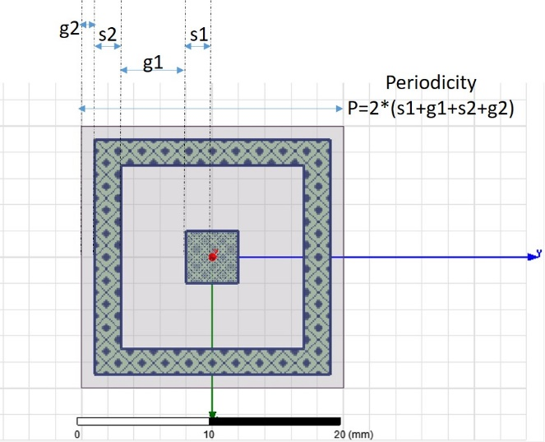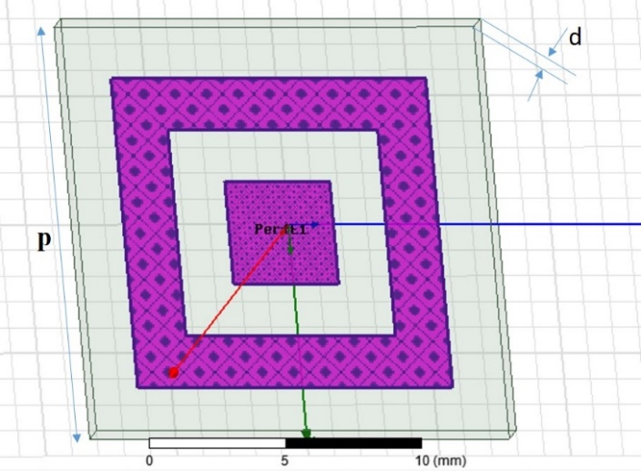

Following are few of obtained dimensional values:

|  |  |  |  |  |  |  |
| --- | --- | --- | --- | --- | --- | --- |
| User defined cut-off frequencies (in GHz) | | Center cutoff frequency (GHz) | Dimensions (in mm) | | | |
| Lower cutoff frequency | Upper Cutoff frequency |
| G1 | G2 | S1 | S2 |
| 2 | 4 |  | 10.0 | 2.0 | 5.0 | 0.5 |
| 3 | 6 |  | 10.0 | 2.0 | 5.0 | 0.5 |
| 8 | 10 |  | 2.5 | 2.0 | 3.5 | 1.75 |
| 2 | 18 |  | 7.0 | 0.0 | 1.0 | 0.5 |
| 10 | 15 |  | 6.25 | 0.5 | 1.0 | 0.5 |
| 15 | 19 |  | 2.25 | 0.25 | 1.0 | 0.5 |
| 18 | 19 |  | 0.0 | 1.25 | 3.0 | 1.25 |
| 7 | 18 |  | 7.0 | 0.0 | 1.0 | 0.5 |
| 9 | 16 |  | 6.75 | 0.0 | 1.25 | 0.5 |
| 11 | 12 |  | 1.5 | 2.0 | 3.75 | 1.5 |
| 17 | 18 |  | 0.0 | 1.75 | 2.5 | 1.75 |
|  |  |  |  |  |  |  |
|  |  |  |  |  |  |  |
|  |  |  |  |  |  |  |
|  |  |  |  |  |  |  |
|  |  |  |  |  |  |  |