With the help of Machine learning, we have created a model to obtain the dimensional values for design 1, corresponding to cut off frequency provided by the user.

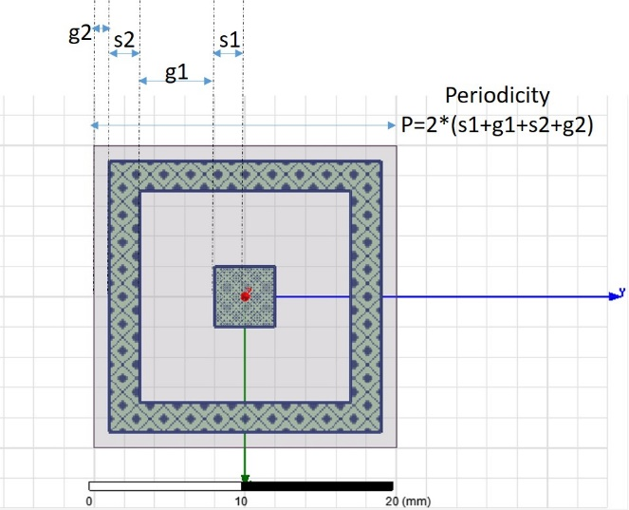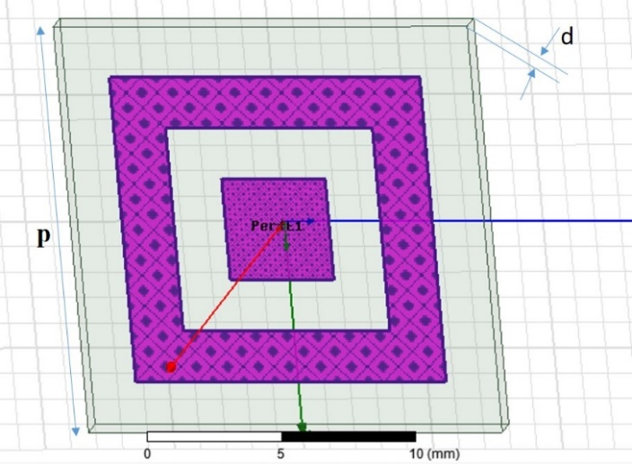

Following are few of obtained dimensional values:

|  |  |  |  |  |  |  |  |  |  |
| --- | --- | --- | --- | --- | --- | --- | --- | --- | --- |
| User defined cut-off frequencies (in GHz) | | Dimensions (in mm) obtained by using trained model | | | | Simulation result cut-off frequencies (in GHz) | | Absolute Error | |
| Lower cutoff frequency | Upper Cutoff frequency |
| G1 | G2 | S1 | S2 | Lower cutoff freq | Upper cutoff freq | Lower cutoff | Upper Cutoff |
| 2 | 4 | 02.00 | 00.20 | 07.05 | 00.10 |  |  |  |  |
| 3 | 5 | 10.75 | 01.60 | 07.05 | 02.05 |  |  |  |  |
| 6 | 8 | 10.00 | 00.50 | 03.00 | 02.00 |  |  |  |  |
| 8 | 10 | 03.75 | 00.70 | 03.45 | 02.65 |  |  |  |  |
| 10 | 12 | 02.00 | 01.50 | 03.00 | 01.50 |  |  |  |  |
| 12 | 14 | 03.25 | 01.60 | 01.85 | 02.65 |  |  |  |  |
| 14 | 16 | 02.75 | 02.90 | 01.45 | 02.95 |  |  |  |  |
| 16 | 18 | 00.75 | 03.00 | 01.85 | 01.00 |  |  |  |  |
| 8 | 12 | 04.00 | 00.50 | 03.00 | 00.50 |  |  |  |  |
| 6 | 14 | 11.25 | 00.00 | 00.25 | 00.10 |  |  |  |  |
| 8 | 18 | 06.00 | 00.00 | 01.00 | 00.50 |  |  |  |  |

Absolute Error will be calculated by taking simulation frequency as reference value, in both lower and upper cutoff frequency cases.