With the help of Machine learning, we have created a model to obtain the dimensional values for design 1, corresponding to cut off frequency provided by the user.

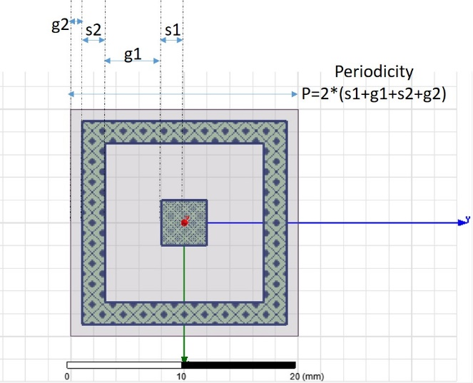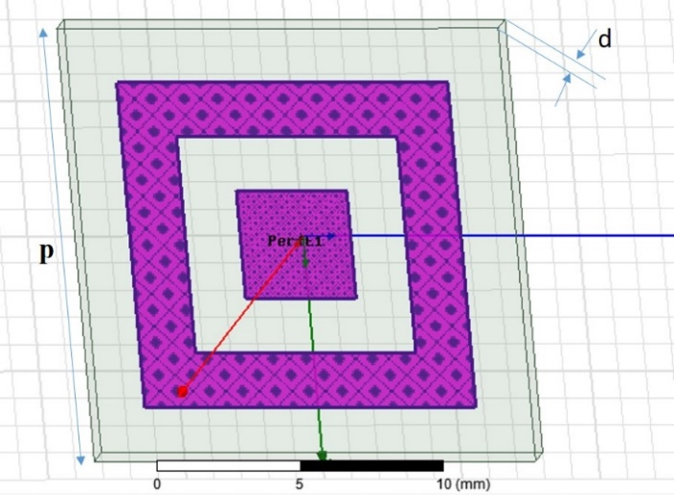

Following are few of obtained dimensional values:

|  |  |  |  |  |  |  |  |  |  |  |
| --- | --- | --- | --- | --- | --- | --- | --- | --- | --- | --- |
| User defined cut-off frequencies (in GHz) | | Dimensions (in mm) obtained by using trained model | | | |  | Simulation result cut-off frequencies (in GHz) | | Absolute Error | |
| Lower cutoff frequency | Upper Cutoff frequency |
| G1 | G2 | S1 | S2 | W1 | Lower cutoff freq | Upper cutoff freq | Lower cutoff | Upper Cutoff |
| 2 | 4 |  |  |  |  |  |  |  |  |  |
| 3 | 5 |  |  |  |  |  |  |  |  |  |
| 6 | 8 | 10.00 | 00.10 | 02.50 | 01.00 | 00.50 |  |  |  |  |
| 8 | 10 | 09.50 | 00.06 | 00.25 | 02.50 | 01.45 |  |  |  |  |
| 10 | 12 |  |  |  |  |  |  |  |  |  |
| 12 | 14 |  |  |  |  |  |  |  |  |  |
| 14 | 16 |  |  |  |  |  |  |  |  |  |
| 16 | 18 |  |  |  |  |  |  |  |  |  |
| 8 | 12 | 09.50 | 00.00 | 00.25 | 02.50 | 02.35 |  |  |  |  |
| 6 | 14 |  |  |  |  |  |  |  |  |  |
| 8 | 18 |  |  |  |  |  |  |  |  |  |

Absolute Error will be calculated by taking simulation frequency as reference value, in both lower and upper cutoff frequency cases.