# Price vs PropertySqFt

Residuals:

Min: -877383

1Q: -279877

Median: -50843

3Q: 218123

Max: 1433042

Coefficients:

|  |  |  |  |  |
| --- | --- | --- | --- | --- |
|  | Estimate Std. | Error | t value | Pr(>|t|) |
| (Intercept) | 3.686e+05 | 1.551e+04 | 23.77 | <2e-16 *** |
| PROPERTYSQFT | 2.341e+02 | 7.995e+00 | 29.28 | <2e-16 *** |

---

Signif. codes: 0 ‘***’ 0.001 ‘**’ 0.01 ‘*’ 0.05 ‘.’ 0.1 ‘ ’ 1

Residual standard error: 405700 on 3940 degrees of freedom

Multiple R-squared: 0.1787, Adjusted R-squared: 0.1785

F-statistic: 857.3 on 1 and 3940 DF, p-value: < 2.2e-16

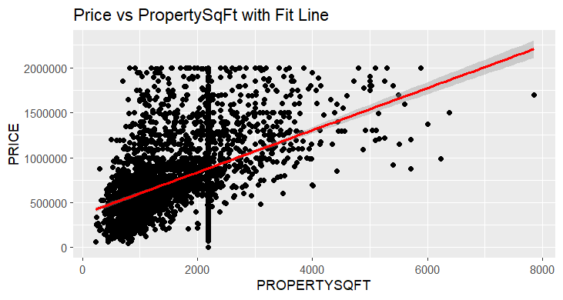

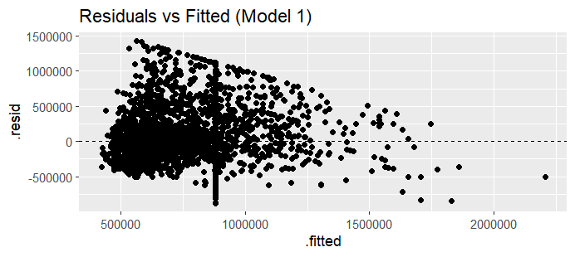

# Price vs Beds

Residuals:

Min: -1225713

1Q: -282105

Median: -81757

3Q: 201658

Max: 1430859

Coefficients:

|  |  |  |  |  |
| --- | --- | --- | --- | --- |
|  | Estimate Std. | Error | t value | Pr(>|t|) |
| (Intercept) | 456444 | 11702 | 39.01 | <2e-16 *** |
| BEDS | 107696 | 3269 | 32.94 | <2e-16 *** |

---

Signif. codes: 0 ‘***’ 0.001 ‘**’ 0.01 ‘*’ 0.05 ‘.’ 0.1 ‘ ’ 1

Residual standard error: 396100 on 3939 degrees of freedom

Multiple R-squared: 0.216, Adjusted R-squared: 0.2158

F-statistic: 1085 on 1 and 3939 DF, p-value: < 2.2e-16

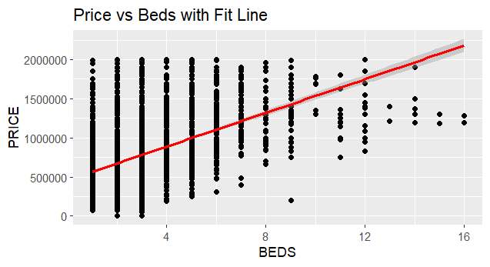

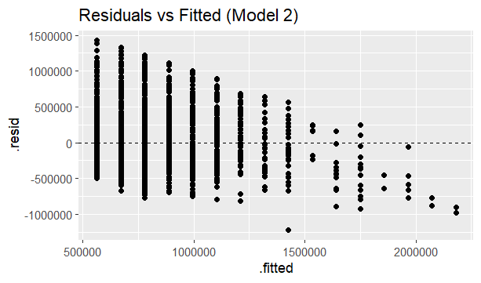

# Price vs Baths

Residuals:

Min: -1352255

1Q: -260008

Median: -83789

3Q: 188992

Max: 1434992

Coefficients:

|  |  |  |  |  |
| --- | --- | --- | --- | --- |
|  | Estimate Std. | Error | t value | Pr(>|t|) |
| (Intercept) | 337227 | 11682 | 28.87 | <2e-16 *** |
| BATH | 222781 | 5074 | 43.91 | <2e-16 *** |

---

Signif. codes: 0 ‘***’ 0.001 ‘**’ 0.01 ‘*’ 0.05 ‘.’ 0.1 ‘ ’ 1

Residual standard error: 366800 on 3940 degrees of freedom

Multiple R-squared: 0.3286, Adjusted R-squared: 0.3284

F-statistic: 1928 on 1 and 3940 DF, p-value: < 2.2e-16

