Correlation between media and its features
Ananya Subramaniam
Data Analytics 4000
12/12/25

Abstract
Ever since I was young, I had always been very interested in movies and TV shows. The creation of such media is so vital to our society. They act as a mirror into real-world problems and bring people together. From this community, more creativity is able to flourish. Thus, I wanted to explore this creativity in relation to features associated with the industry. By looking at the correlation between different factors, I want to see if I can predict future plans.
In this report, I will answer the question Is there is a correlation between the popularity of a show/movie and different factors (genres, runtime, seasons, release year)? My hypothesis is that there will not be a correlation. I think without a relationship, there will be less bounds on the creativity involved. People should not feel restricted on statistics, but rather write the story that needs to be written.

Data Description and Preliminary Analysis
For this project, I sourced the data from Kaggle, a Data Science and Machine learning company. The data comes from Netflix and contains information about movies and TV shows. There are 5977 Lines of Data with content from different countries. It uses IMDB and tMDB information to measure popularity against the other information provided. The data is structured in a CSV file with these fields: id,title,type,description,release_year,age_certification,runtime,genres,production_countries,seasons,imdb_id,imdb_score,imdb_vote, tmdb_popularity,tmdb_score. (Kaggle-Netflix-Tv-Shows-and-Movies/Titles.Csv at Main · Amirtds/Kaggle-Netflix-Tv-Shows-and-Movies, n.d.)
From my initial perspective of this source, I understood that there was not an easy way to analyze the data because of the multiple popularity fields. The imdb_score,imdb_vote, tmdb_popularity, and tmdb_score fields were all involved in the overall popularity of the movie or TV show. TMDB score (also called the average rating) represents user opinion (average user rating out of 10), while TMDB popularity is a calculated metric that measures a title's activity and reach based on engagement factors like daily views, watchlist additions, and total votes. In short, score is about quality and popularity is about how much a title is being talked about and viewed. The IMDb vote is the raw, individual rating (1-10) submitted by each user, while the IMDb score is the final, calculated rating that IMDb displays on a movie's page, which is a weighted average to prevent manipulation. These values had to be combined to make sure I am getting a clear measurement from them. At first, I wanted to take the average of all four values. However, I realized that doing Principal Component Analysis on the four would reduce the correlated features into fewer, uncorrelated components, making my models less prone to overfitting

Exploratory Analysis
Before I wanted to analyze the values, the data had to be cleaned up. Due to the four popularity measurements, it was going to be difficult to test the different factors (genres, runtime, release year, seasons) against them. Thus, I did Principal Component Analysis (PCA) to find their correlation. For each row, I added the first principal component as a new column named PC1. This column is referred to as the popularity of either the movie or TV show. However, some of them didn’t have values for every field, so I had to sort out and clean the NA and null values.
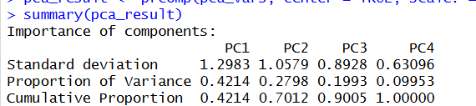
Figure 1: PC1 had the largest importance
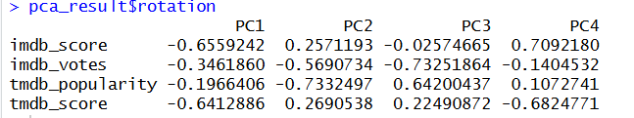
Figure 1.1: The PC1 breakdown for each field
After creating this new column, I divided the data based on low, medium, and high popularity. The lowest 33% was put in the “Low” category. The middle 33% was put in the “Medium” category. The top 33% was put in the “High” category. Making this distinction would help in clustering and it helped me understand the benefit of finding the correlation instead of having the individual values.
Another way I organized the data was by splitting the file into two subsets – one for movies and the other for TV shows. This made it easier to analyze them because of their different components. For example, runtime for movies was much larger while TV shows was per episode. These factors would have skewed my charts.
Lastly, as I was doing the genre summary, I noticed that the genres were stored as a list in the data set. To remedy this, I mutated the dataset by expanding the genre list. In this new dataset, each row has one genre per row. For example the Movie “Taxi Driver” had genres stored as [“crime”, “drama”] – 1 line. By altering it, two lines were made. Line 1 - Taxi Driver with genre “crime”, and line 2 – Taxi Driver with genre “drama.” This made it much easier to analyze every time the genre was used.

Model Development and Application

Descriptive Stats
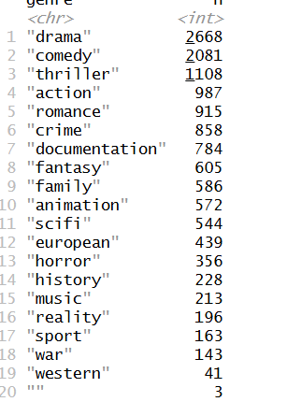
Figure 2: Genre count in entire dataset
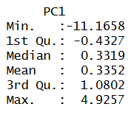
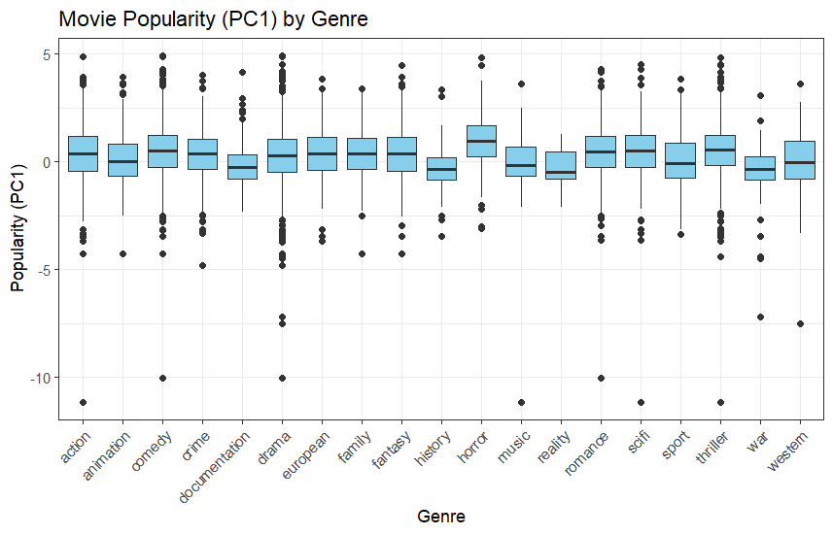
The initial analysis I wanted to test is the population summary within the most varied group – genres. There are 19 genres across this dataset with “Drama” having the largest amount of data at 2668 and “Western” at the lowest with 41 rows of data. The speculative reasoning for this difference is the specificity and demand of each drama. After finding how many data points I am working with, it was important to measure the popularity between the genres. First, I plotted the box plot representations of the popularity in regards to each genre for both Movies and TV shows.
Figure 3 & 4: Box plot representing movie popularity by Genre and the descriptive stats associated with the popularity (PC1) as a whole.
We can see from Figure 4 that the popularity has a wide distribution with the maximum value at ~4.93 and the minimum value at -11.2. This tells us that some movies were very unpopular and below average (0.335) while a small subset is extremely popular as they are far above average. There is a slight positive skew which means there are more movies with moderate popularity. In regards to Figure 3, five genres are prominently associated with popular movies: Drama, Action, Thriller, Sci-fi, and Family. In the medium range, Comedy, Music and Romance genres tend to be close to 0 which means that these categories consistently produce somewhat popular movies. Crime, Horror, History, War, and Western consistently have lower popularity or are highly variable. However, no genre has an extremely high median popularity which means genre alone does not separate popularity. With the presence of outliers with every genre, we can infer that popularity cannot be predicted solely with genre.
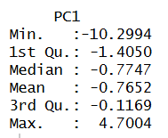
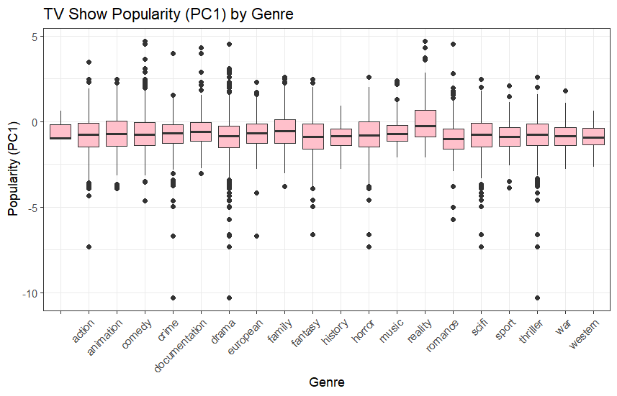
Figure 5 & 6: Box plot representing TV show popularity by Genre and the descriptive stats associated with the popularity (PC1) as a whole.
Similar to movies, the TV show popularity range is also large with the maximum popularity score being ~4.7 while the minimum score is ~-10.3 (Figure 6). The distribution is strongly left-skewed as many shows have a negative PC1 hence a low popularity score. Many genres show heavy lower-tail outliers. Almost every genre has TV shows with PC1 < −5 or −7 which means many extremely unpopular shows are produced in every genre. In comparison to movies, there were fewer high-popularity outliers.
In both media models, Drama remained popular which can be attributed to its higher number of data points associated with it (Figure 2). Similarly, Western, War, and History have lower medians indicating lower popularity as they often appeal to niche audiences. Drama as a genre can be paired with many other genre types as media have to dramatize events to compel audiences to stay engaged. This test was useful to find the general spread of the genres, but to further analyze the research question, other factors much also be considered. 2

Linear Models
For the linear models, I first looked at the popularity of movies in relationship to genres, release year, and runtime (in minutes). They key goal was to fit linear regression models of the form Popularity (PC1) ~ Genre, Release, Runtime. First, quantifying the relationship with genres was difficult because it is categorical. The model treated it as a factor and created binary indicators for each genre. Since the Action genre was first alphabetically, it was chosen as the baseline. This meant that the coefficient of each genre tells us how much or less popular another genre is compared to the baseline – Action.
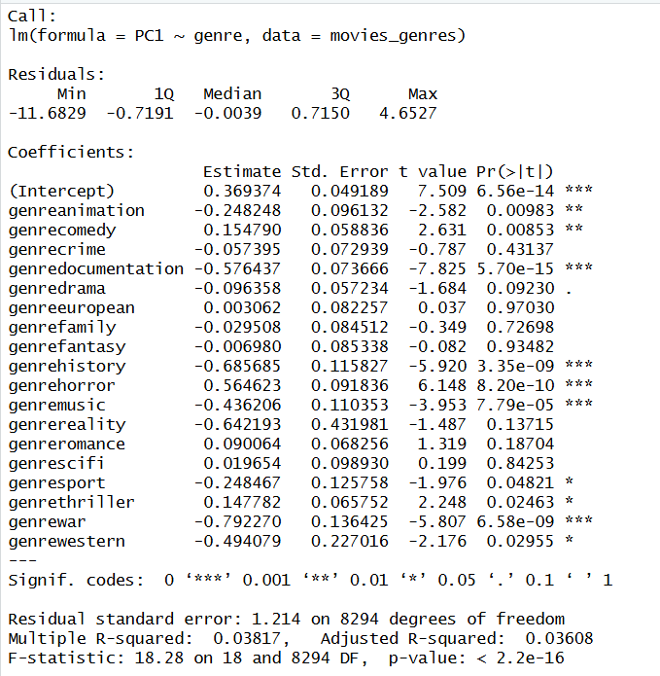
Figure 7: Linear Model between Popularity and Genre for movies
From Figure 7, we can see that the p-values for Comedy, Fantasy, Thriller, and Musical have a higher popularity than Action movies. This model is useful in directly comparing the genres and can be expanded upon by having a different baseline. However, the R² values displays that genre explains only ~3.6% of the variation in movie popularity. So while some genres have statistically different popularity levels, genre does not strongly predict popularity. This matches our earlier visual analysis that genres overlap heavily and popularity is influenced by many other factors. Though the model is statistically significant as a whole (F-statistic p-value < 2.2e-16), the practical predictive power is still low (R² ≈ 0.036).
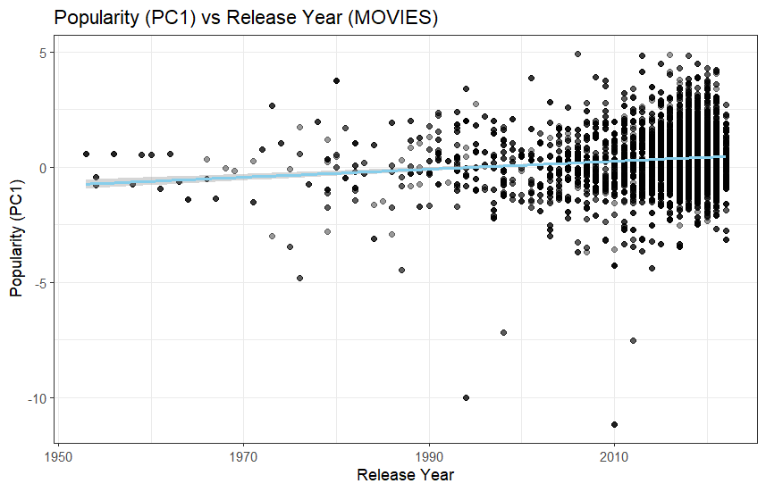
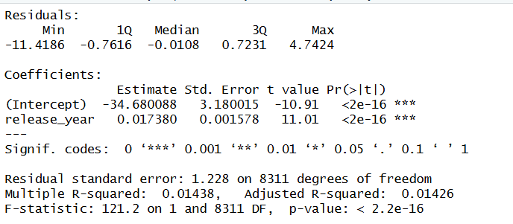
Figure 8 & 9: Linear Model between Popularity and Release Year for movies
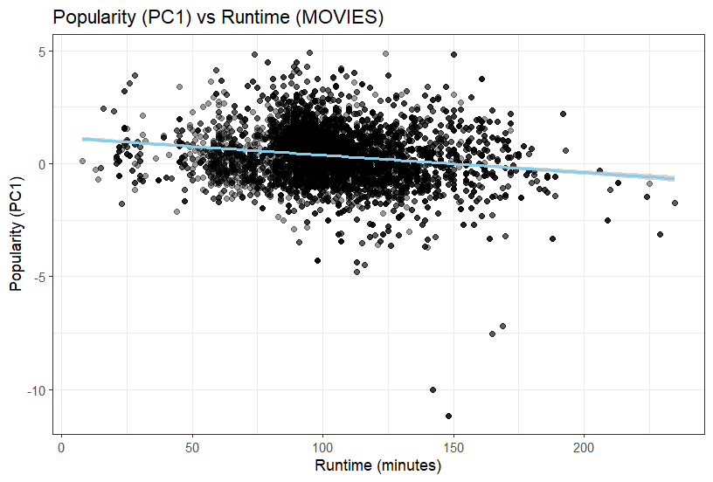
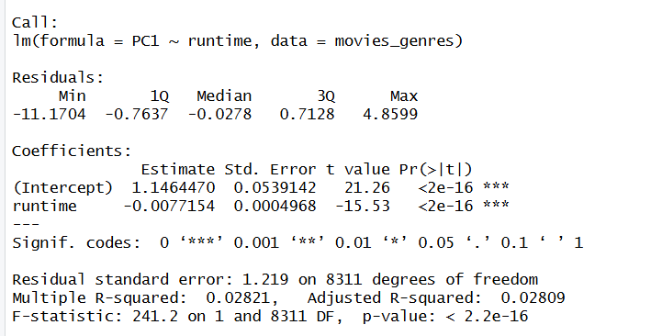
Figure 8 shows a slight popularity increase over time as the blue regression line has an upward slope. Thus, newer movies tend to be slightly more popular than older movies, but this relationship is very small. Between year 2000-2020, popularity has a much wider spread as it ranges from +10 to -5. These outliers are largely post 2000 which can be due to more people interacting with content related to the movie. The regression output displayed by Figure 9 concurs with the positive slope at 0.01738, and it is also significant with p < 2e-16. However, release year only predicts 1.4% of the population variety. Even though the model is statistically significant, it falls into the same pitfalls as the genre model.
Figure 10 & 11: Linear Model between Popularity and Runtime for movies
Figure 10 demonstrates a slight popularity decrease over time as the blue regression line has a downward slope. Therefore, longer movies are commonly unpopular. The majority of the data lies close to the 80–120-minute area shown by the large cluster of points. Yet, similar to release year, the effect is very minimal. This model would be useful; however, there are a large number of outliers. The model has a runtime coefficient of –0.0077 which means for every 1-minute increase in runtime, popularity (PC1) decreases by 0.0077. Despite the effect being small, it is noticeable across large time differences. For example, if we were to increase the movie by 90 minutes, the PC1 would decrease by 0.69. The small p-value emphasizes the negative relationship between runtime and popularity being statistically significant, but the R² value remains low at only encompassing 2.8% of the variation. The scatterplot shows substantial variability at all runtime values, indicating that runtime alone is not a strong driver of audience popularity.
Overall, the results indicate that movie popularity is influenced by genre, release year, and runtime, but none of these factors alone serves as a strong predictor. Together, these findings highlight that while all three each contribute meaningfully to understanding popularity patterns, movie popularity is ultimately shaped by a complex combination of factors.
After analyzing movie relationships, the same tests were done to TV shows by testing the relationship between popularity and genres, release year, seasons, and runtime. The same issues were prevalent with shows in regards to genre being categorical. Action was once again set as a baseline to analyze the other genres.
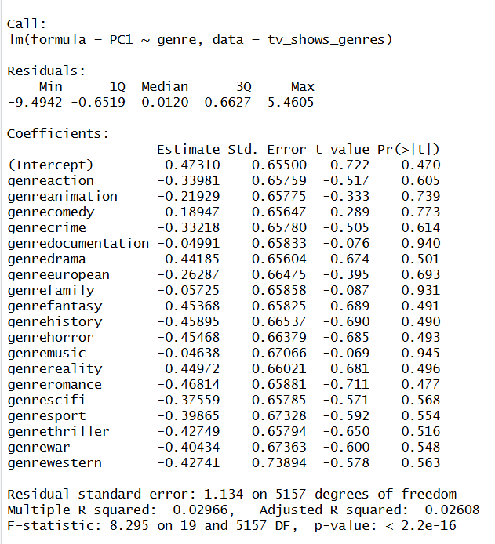
Figure 12: Linear Model between Popularity and Genre for TV shows
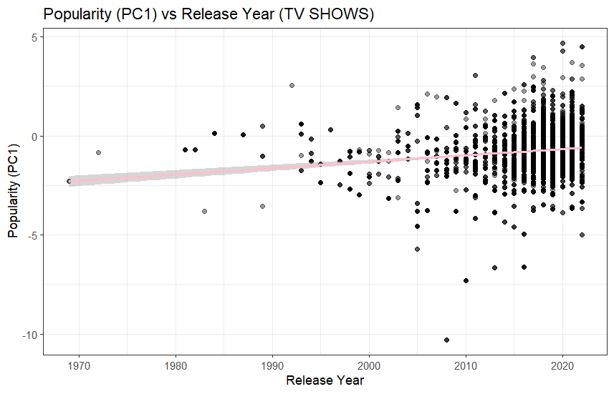
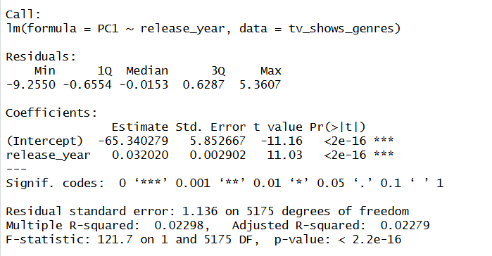
Figure 12 shows us different result compared to the movie analysis. Although the overall model is statistically significant due to the large sample size, none of the individual genre coefficients are statistically significant (p > 0.05), meaning that no genre differs meaningfully from the reference genre (Action) in terms of popularity. Since all of the genre coefficients are negative, they suggest slightly lower popularity compared to Action. In contrast, the R² value of ~3% confirms that genre explains almost none of the variation in TV show popularity. This aligns with earlier boxplot analysis showing substantial overlap across all genres.
Figure 13 & 14: Linear Model between Popularity and Release Year for TV Shows
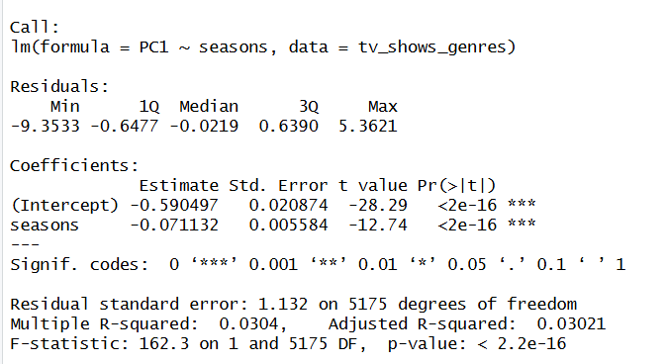
Showing a slight popularity increase over time as the pink regression line has an upward slope, we can understand newer shows tend to be slightly more popular than older shows, but this relationship is very small. The analysis is similar to the movie model analysis. Between year 2000-2020, popularity has a much wider spread as it ranges from +10 to -5. These outliers are largely post 2000 which can be due to more people interacting with content related to the show. The regression output displayed by Figure 14 concurs with the positive slope at 0.03202, only slightly higher than the slope of the movie model. It is also significant with p < 2e-16. However, release year only predicts 2.2% of the population variety. Even though the model is statistically significant, the same problems occur.
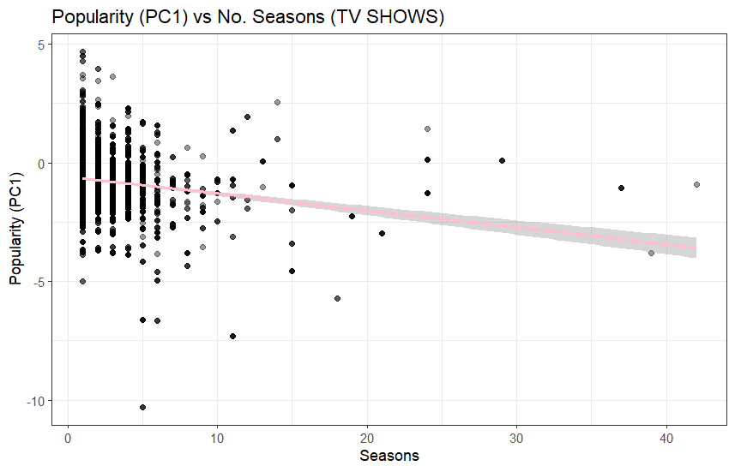
Figure 14 & 15: Linear Model between Popularity and Number of Seasons for TV shows
The analysis reveals a statistically significant negative relationship between the number of seasons a TV show produces and its overall popularity. Shows with more seasons tend to have lower popularity scores, although the explanatory power of this relationship is weak (R² ≈ 0.03). Most highly popular shows cluster in the 1–3 season range, while long-running series tend to exhibit lower popularity despite their longevity. These shows include news networks, reality programs, children’s shows, soap operas, talk shows, etc. This suggests that popularity, as measured by IMDb and TMDB metrics, is not what sustains many multi-season TV shows; instead, long-running series may rely on stable niche audiences or low production costs. Therefore, while a negative trend exists, the number of seasons alone is not a strong predictor of a show's popularity.
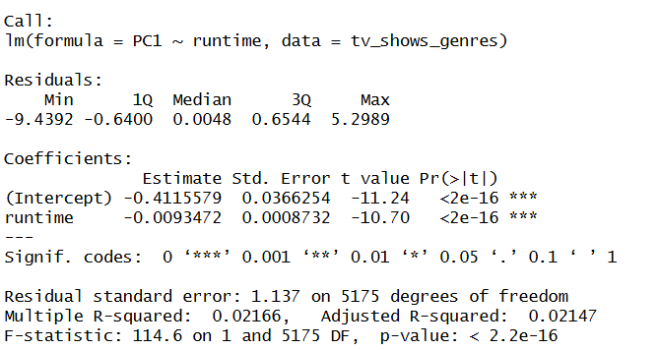
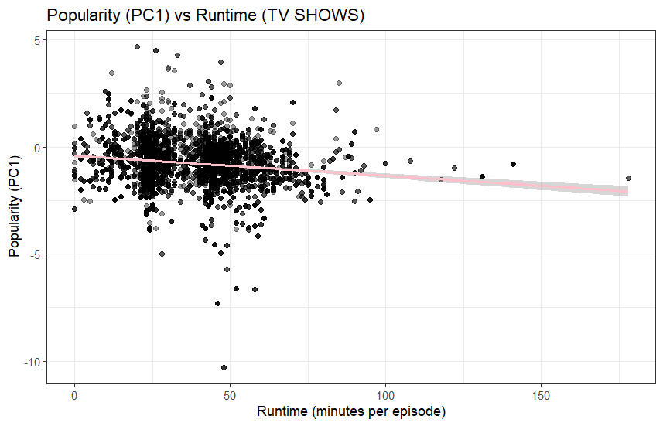
Figure 16 & 17: Linear Model between Popularity and Runtime (minutes per episode) for TV shows
Figures 16 and 17 shows a statistically significant negative relationship between episode runtime and TV show popularity (β = −0.0093, p < 2e−16). This indicates that shows with longer episodes tend to be slightly less popular. However, the effect is weak, with runtime explaining only about 2% of the variation in popularity with the R² ≈ 0.022. Thus, while a mild downward trend exists, runtime alone is not meaningfully predictive of a TV show's popularity.
Similar to the linear models with movies, TV shows exhibit the same issue of not having a single way to determine popularity. This supports the overall message of this analysis that there should not be a quantifiable way to determine popularity. Rather, it should be dependent on the work put in by creators and audiences alike.

K Means Clustering
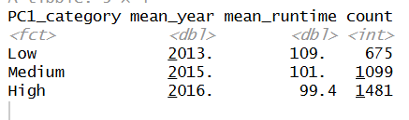
Using the column made from the PCA analysis to declare the categories, I wanted to further analyze the data by clustering it based on their popularity. First, I clustered movies based on their release year and runtime.
Figure 18: Table for PC1 popularity categories for movies
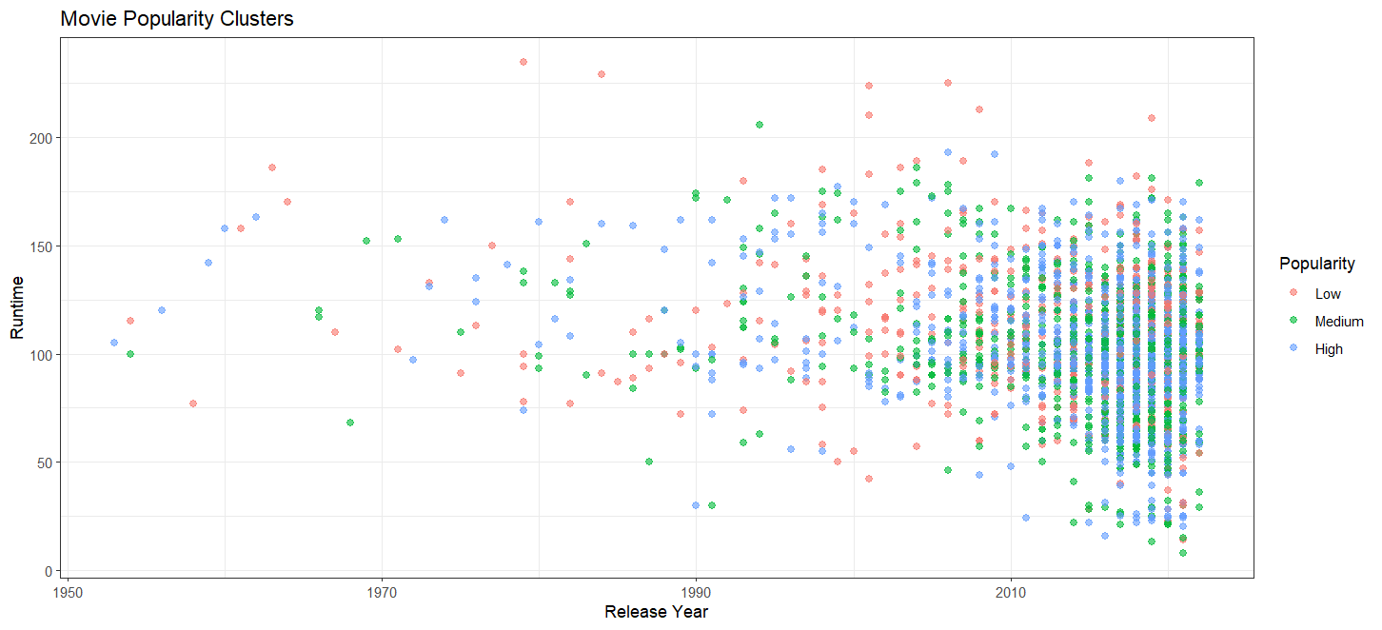
Figure 19: Plot Runtime vs Release Year Colored by Popularity Cluster
With this table (Figure 18) for movies, we can see that high-popularity movies tend to be newer. The average release year for low-popularity movies was 2013. For medium-popularity movies the average release year was 2015 while it was 2016 for high-popularity movies. Newer movies tend to have higher popularity. This matches the earlier regression plot with popularity increasing overtime. Additionally, higher-popularity movies tend to have shorter runtimes with low popularity movies having a 109 min. runtime, medium popularity movies with a 101 runtime, and high popularity movies having a 99.4 runtime. Movies become slightly shorter as popularity increases. This also matches the regression plot. This table supports the conclusion that movie popularity is associated with being more recent and slightly shorter in duration.

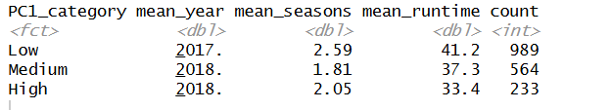
Figure 20: Table for PC1 popularity categories for TV shows
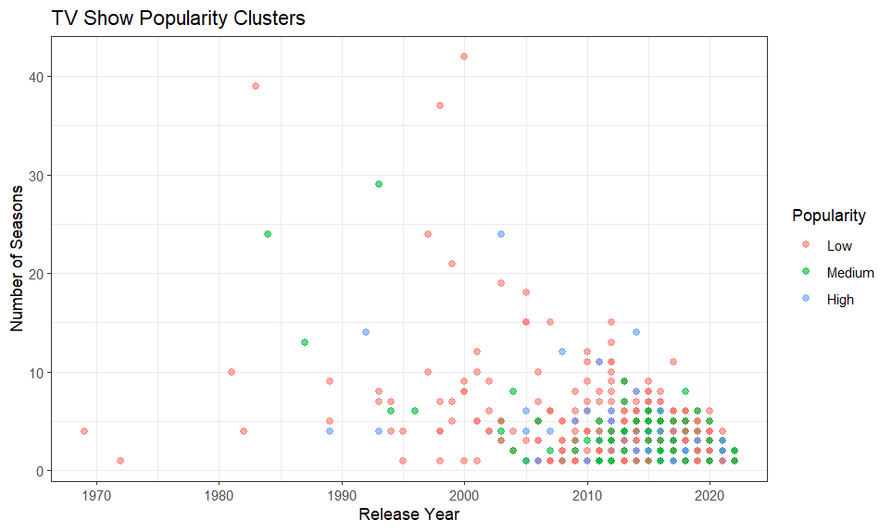
Figure 21: Seasons vs Release Year Colored by Popularity
Figure 20 displays the relationship of newer TV shows being somewhat more popular with the most popular shows having the average release year of 2018. Though the shows with medium-popularity also have a mean release year of 2018, the least popular shows were released 2017. This difference is very minimal which supports the idea that year is not a greatly contributing factor. Furthermore, the number of seasons also fluctuates with the least and most popular shows both having an average of ~2 seasons. Compared to the movies model, a similar trend is seen where lower runtimes have higher popularity. These match with the TV show regression plot and supports the conclusion that runtime can affect popularity.

Limitations
This study had limitations that restricted it from fully analyzing the topic. One limitation I encountered was the empty fields I had mentioned earlier. Because of that, many of the rows’ PCA could not be calculated which omitted rows. This changed the amount of information that was fed in the models. Additionally, I think that comparing the features with the revenue would be a better way to accurately predict the next wave of content. Many times, these factors can’t be controlled. For instance, seasons can be restricted based on the network/streaming service. Release year is also impacted based on global trends such as Covid-19 delaying filming and other processes. Lastly, this dataset is contained with data from Netflix. This is inherently biased because other platforms do not contribute in the makeup of the statistics.

Conclusion
In conclusion, the question I wanted to answer was Is there is a correlation between the popularity of a show and different factors (genres, runtime, seasons, release year)? After conducting linear models of relationships between popularity and these features for movies and TV shows, I can make the general statement that there is not a correlation. Though there were general trends, by analyzing the models closely, we can see that these factors did not make up most of the popularity measurements. Many of the features are dependent on the introduction of trends and the internet. For example, release year was perceived to be a significant factor especially in the 2000s-2020 era. However, that was also the time that the internet was becoming more common. Thus, people were expressing more of their emotions towards films coming out around that time because it was more recent. Another example is with number of seasons in regards to TV shows. Shows with a larger number of seasons generally had lower popularity, but these shows were typically long-standing ones with a large audience. When there is a large audience, ratings will fluctuate. In fact, many low-popularity shows stay long-running because they are cheap, formulaic, or have stable niche audiences. Timing, and audience trends are more appropriate lens to look through these factors. With this study, it is important to emphasize the importance of creating to say something rather than prove statistics. The no correlation output is significant because it means that people are spreading their voice without being constrained with the pressure of guaranteed successes.

Works Cited

Kaggle-netflix-tv-shows-and-movies/titles.csv at main · amirtds/kaggle-netflix-tv-shows-and-movies. (n.d.). GitHub. Retrieved December 12, 2025, from https://github.com/amirtds/kaggle-netflix-tv-shows-and-movies/blob/main/titles.csv

