MINILAB 0 REPORT
Name: Harshul Jalan
Email: hjalan2@wisc.edu

Overview
In this minilab, we were required to write a FIFO and MAC along with its test benches and then use the IPs instead.

Screenshots
- Without IP FIFO Waveform and Log
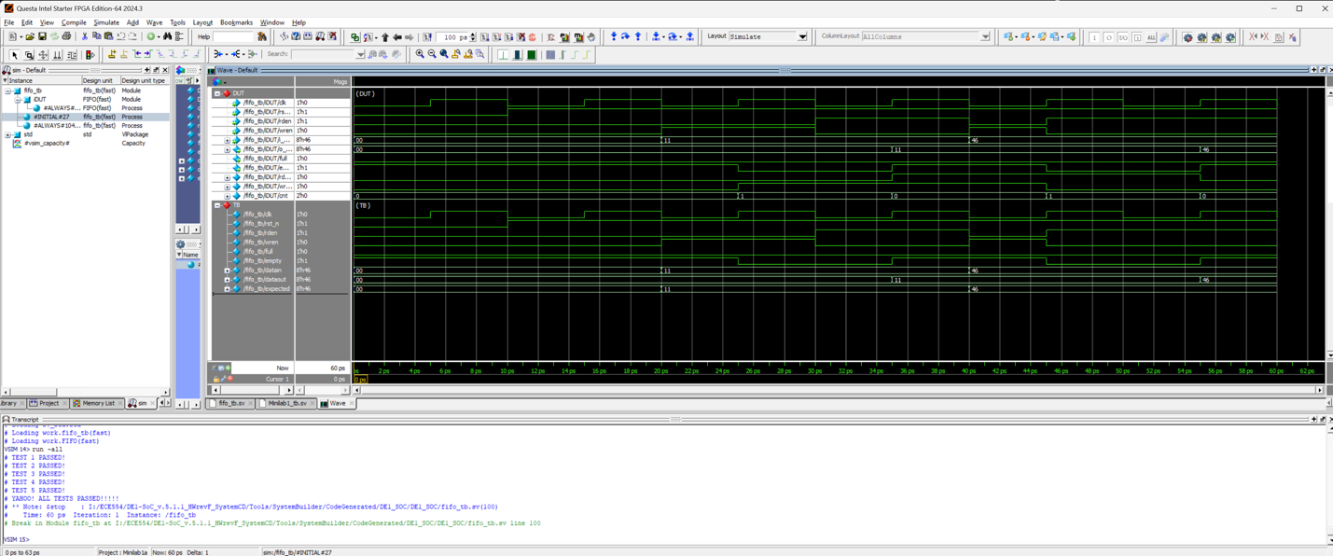
- With IP FIFO Waveform and Log
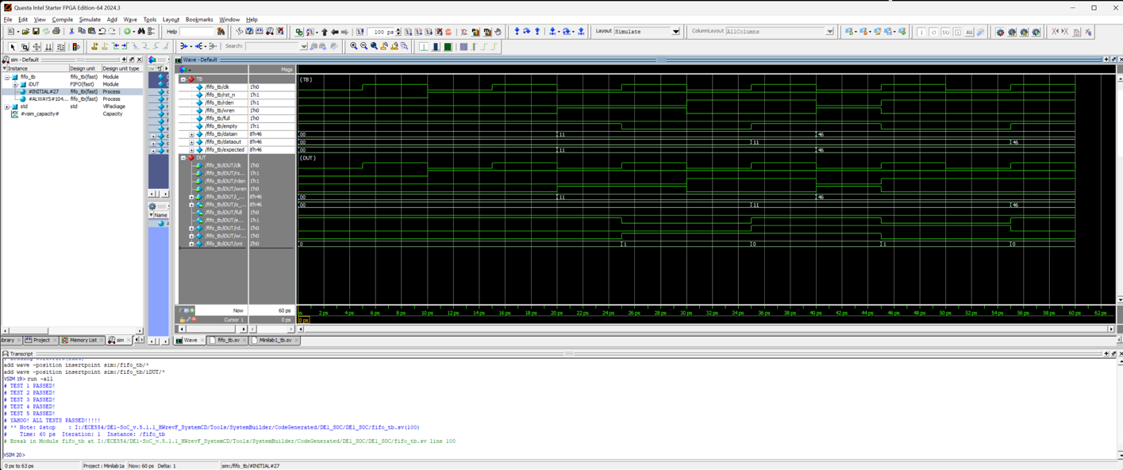
- Without IP MAC Waveform and Log
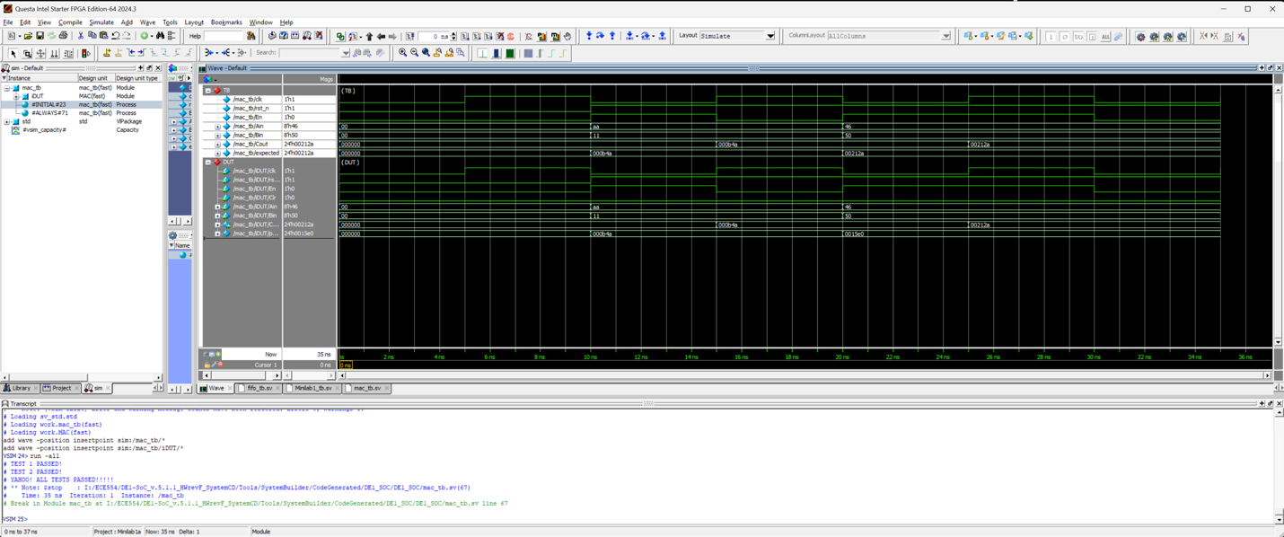
- With IP MAC Waveform and Log
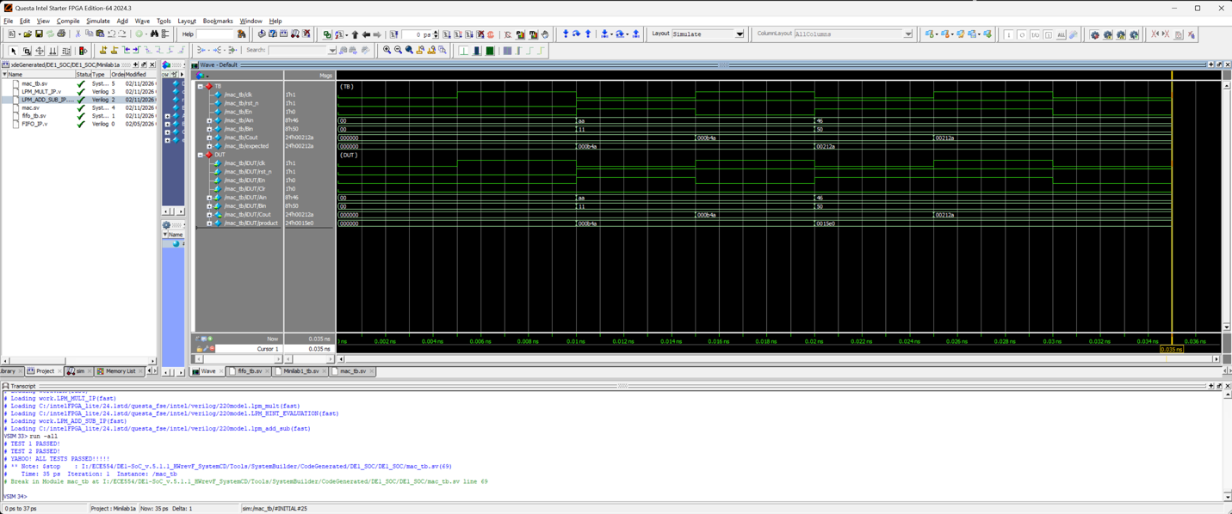
- Working Board
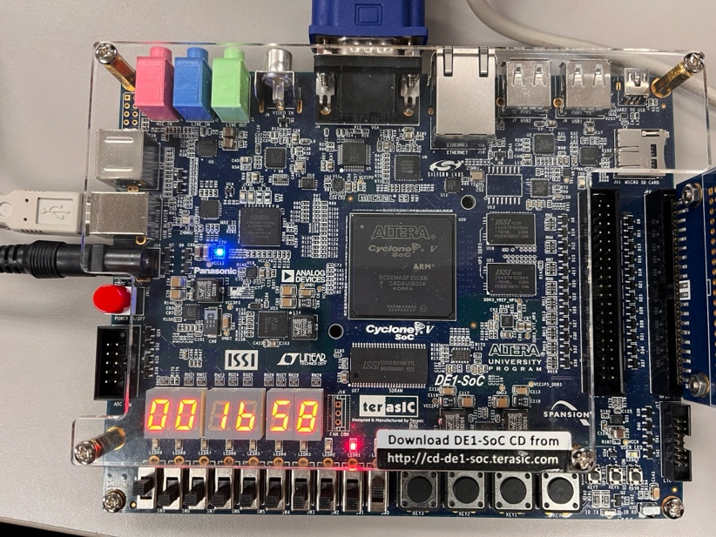
Usage Reports
- Both usage reports are included in the Minilab0 folder.
- In Summary1, the design uses a larger number of 6- and 7-input logic functions.
- In Summary2, the design reduces the use of higher-input logic functions and instead relies more on smaller-input logic elements. However, this version uses more block memory bits.
- Additionally, Summary2 shows lower fanout compared to Summary1, indicating slightly improved signal distribution in that implementation.

