1. What are three conclusions we can make about Kickstarter campaigns given the provided data?
   1. The most successful campaigns categories are Music, Theater, Film & Video and the least successful are Journalism and Food.
   2. The most successful years are 2011,2010,2012.
   3. The top 3 countries with more success rate are US, GB and CA.
   4. Higher the initial goal, less successful the campaign has been as illustrated in the below graph

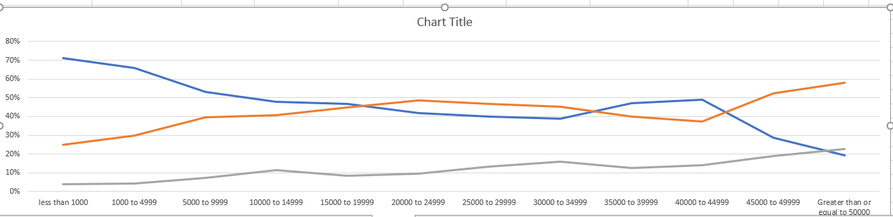

1. What are some of the limitations of this dataset?
   1. Currency is not uniform, so for analysis conversion rates need to be applied.
   2. Month by Month campaign progress would have provided more insight
   3. 2009 and 2017 years have only partial data so cannot be considered for a year by year analysis
2. What are some other possible tables/graphs that we would create
   1. We can create another table for country vs campaign state to analyze which countries have more success rate. We can build something similar for category vs country.

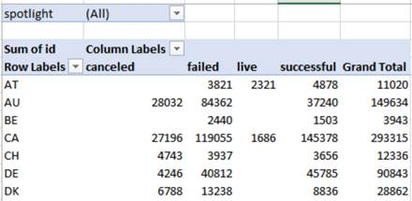

* 1. Group analysis based on average donation for different campaign states
  2. A prediction for Live state campaigns to indicate if they are on track
  3. We can also create metrics based on the duration of the campaign in months or days. It can be calculated based on Date Created Conversion and Date Ended Conversion

