FOCP C Programming Assignment
Module 2: Conditional Statements and Operators
Question 4: Roy and Profile Picture
Platform: HackerEarth
Programming Language: C
Problem Link: https://www.hackerearth.com/practice/basic-programming/implementation/basics-of-implementation/practice-problems/algorithm/roy-and-profile-picture/
Problem Statement
Roy wants to change his Facebook profile picture. Facebook has a restriction on the minimum dimensions of a picture.
The minimum dimension is L × L, where L is the length of the side of a square.
For each photo of width W and height H, the following conditions apply:
- If either width or height is less than L, print UPLOAD ANOTHER.
- If both dimensions are greater than or equal to L:
  - If width and height are equal, print ACCEPTED.
  - Otherwise, print CROP IT.
Input Format
- The first line contains an integer L.
- The second line contains an integer N, the number of photos.
- The next N lines contain two integers W and H, representing the width and height of each photo.
Constraints
- 1 <= L, W, H <= 10000
- 1 <= N <= 1000
Sample Input
180
3
640 480
120 300
180 180
Sample Output
CROP IT
UPLOAD ANOTHER
ACCEPTED
Source Code
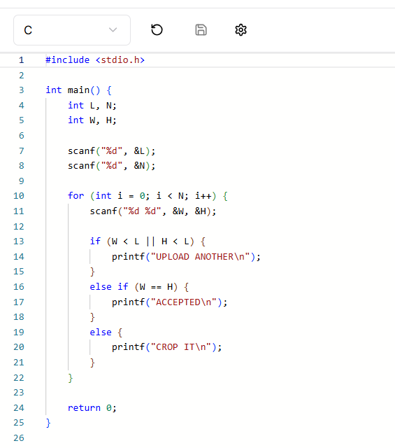
Output
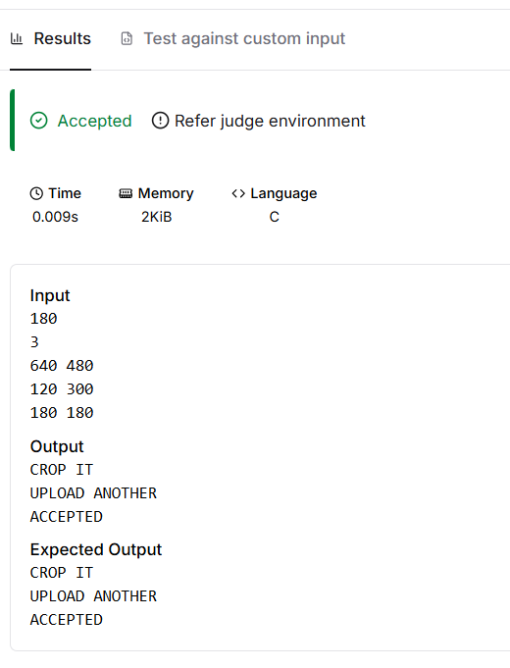
Result
The program was executed successfully, and the sample test cases were passed on HackerEarth.

