FOCP C Programming Assignment
Module 4
Question 1: Sum of First and Last Digits
Platform: HackerEarth
Programming Language: C
Problem Link: https://www.hackerearth.com/practice/basic-programming/input-output/basics-of-input-output/practice-problems/algorithm/first-and-last-digit/
Problem Statement
Danial likes to separate the digits of a number and play with them.
Given an integer N, find the sum of the first and last digits of N.
Input Format
- The first line contains a single integer T, denoting the number of test cases.
- Each of the next T lines contains a single integer N.
Output Format
For each test case, print the sum of the first and last digits of N on a new line.
Constraints
- 0 < N <= 10^6
- 0 < T <= 100
Sample Input
3
1234
124894
242323
Sample Output
5
5
5
Explanation
- For 1234: First digit = 1, Last digit = 4. Sum = 5.
- For 124894: First digit = 1, Last digit = 4. Sum = 5.
- For 242323: First digit = 2, Last digit = 3. Sum = 5.
Source Code
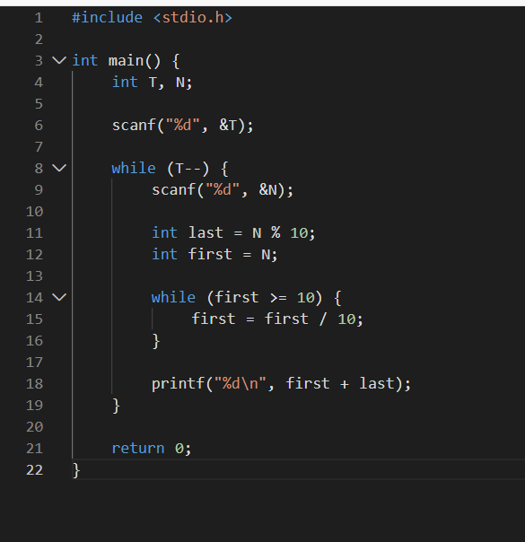
Output
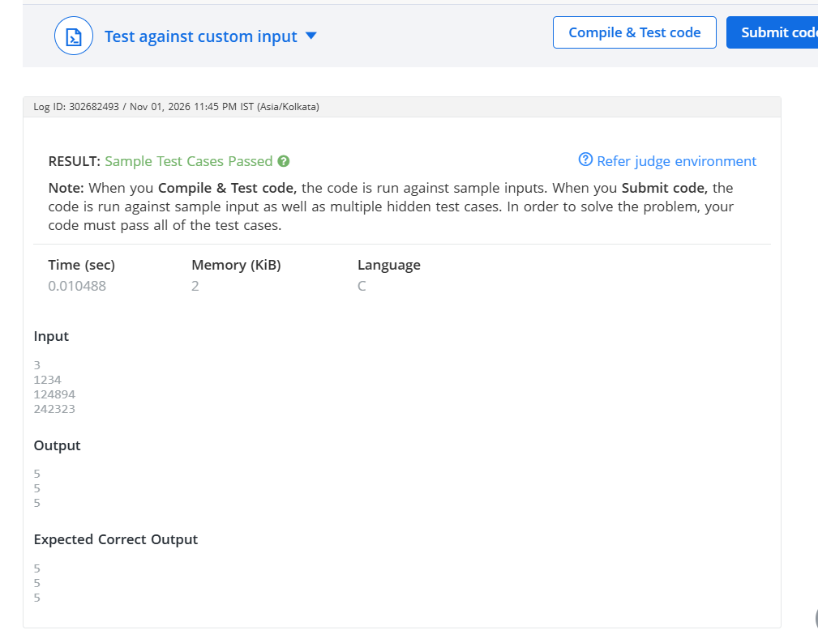
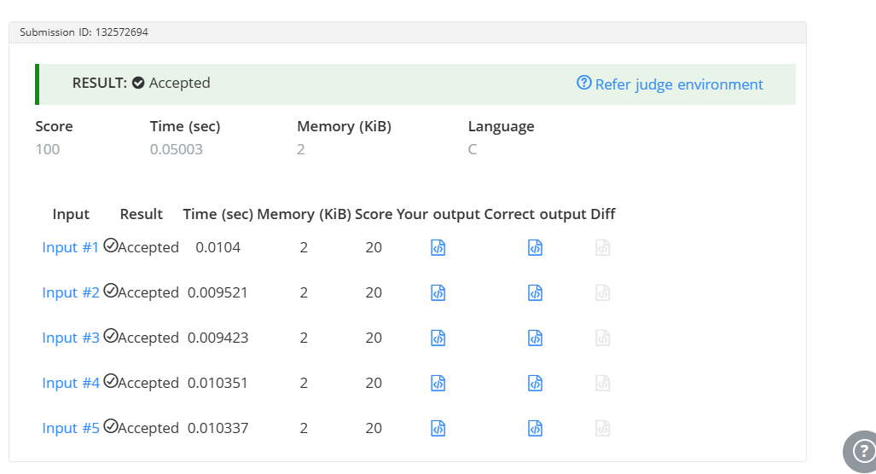Result
The program was executed successfully, and the sample test cases were passed on HackerEarth.

