Module 5: Factors, Divisibility and Mathematical Loops
Question 4: Count Divisors
Platform: HackerEarth
Difficulty: Easy
Problem Link: https://www.hackerearth.com/practice/basic-programming/input-output/basics-of-input-output/practice-problems/algorithm/count-divisors/
Problem Statement
You have been given 3 integers - l, r and k. Find how many numbers between l and r (both inclusive) are divisible by k. You do not need to print these numbers, you just have to find their count.
Input Format
The first and only line of input contains 3 space-separated integers l, r and k.
Output Format
Print the required answer on a single line.
Example
Input:
1 10 1
Output:
10
Code Screenshot
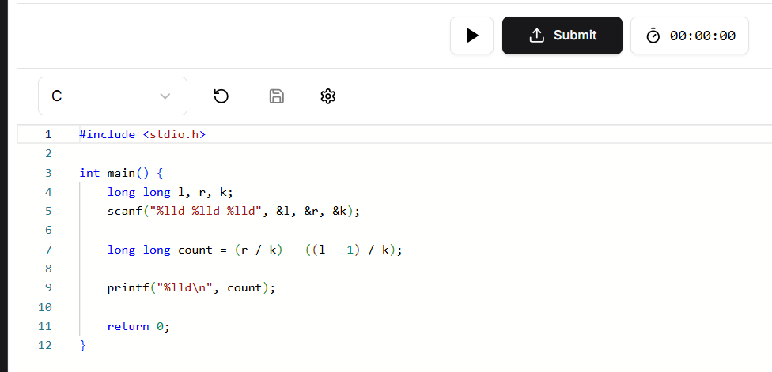Output Screenshot
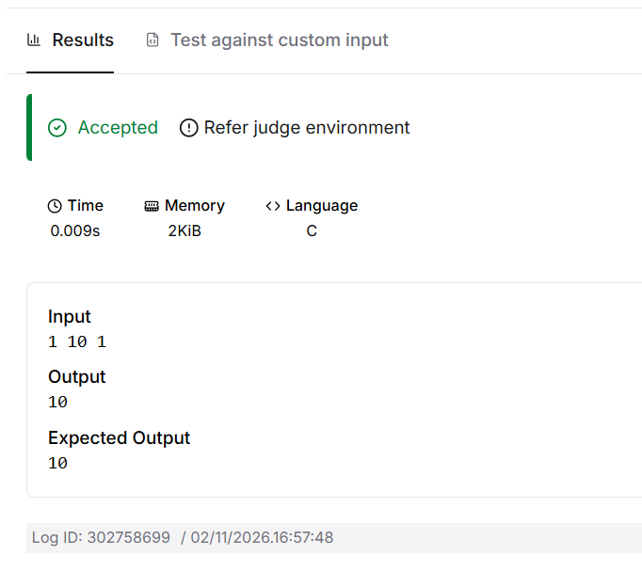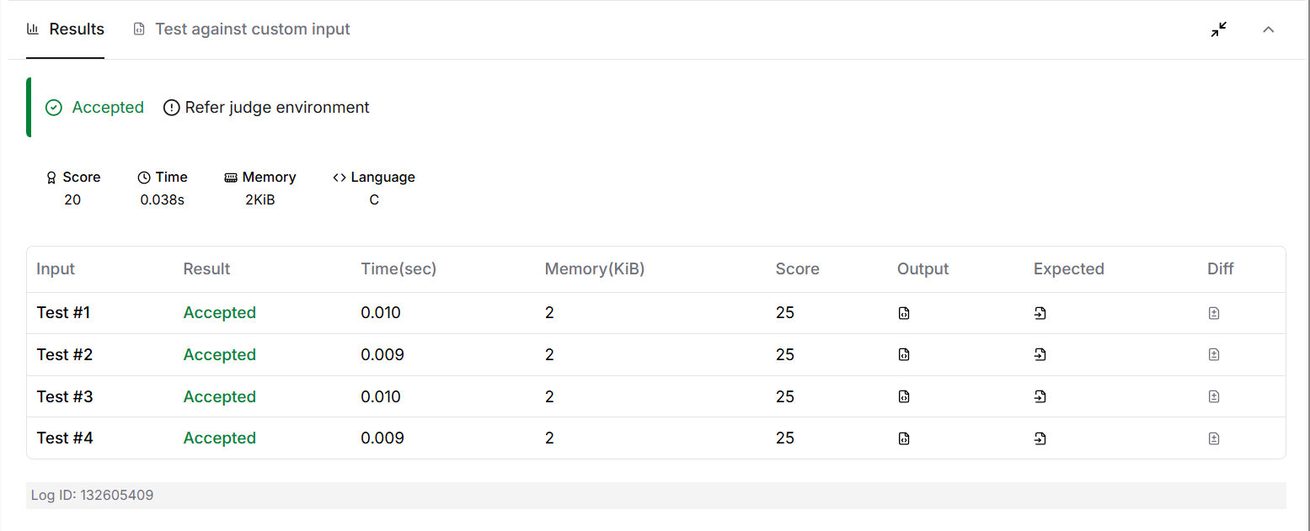Result
The program counts the numbers divisible by k between l and r. Platform: HackerEarth.

