Module 5: Factors, Divisibility and Mathematical Loops
Question 5: Prime Numbers
Platform: HackerEarth
Problem Statement
Given a number n, tell if it is a prime number. Print 1 if it is a prime number and print 0 if the given number is not prime.
Input Format
A single integer n.
Output Format
- Print 1 if the number is prime.
- Print 0 if the number is not prime.
- Print a newline after the answer.
Constraints
2 <= n <= 100
Sample Input
5
Sample Output
1
Explanation
Since 5 is a prime number, the output is 1.
Code Screenshot
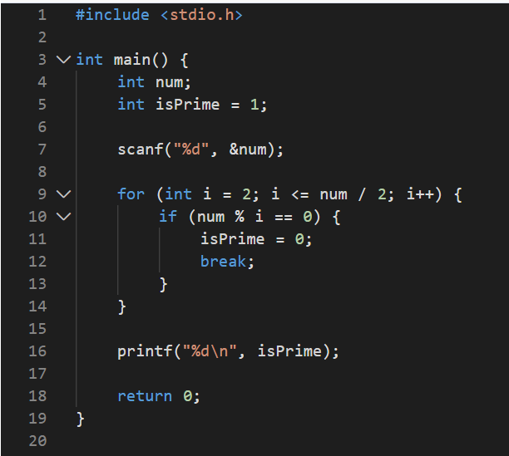

Output Screenshot
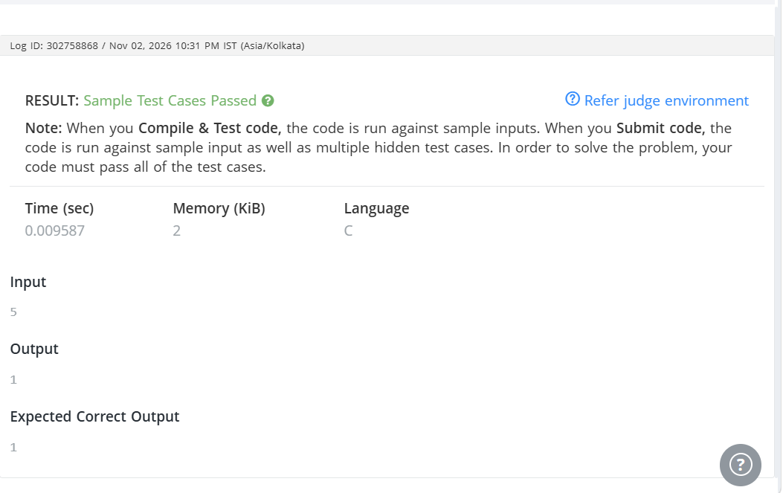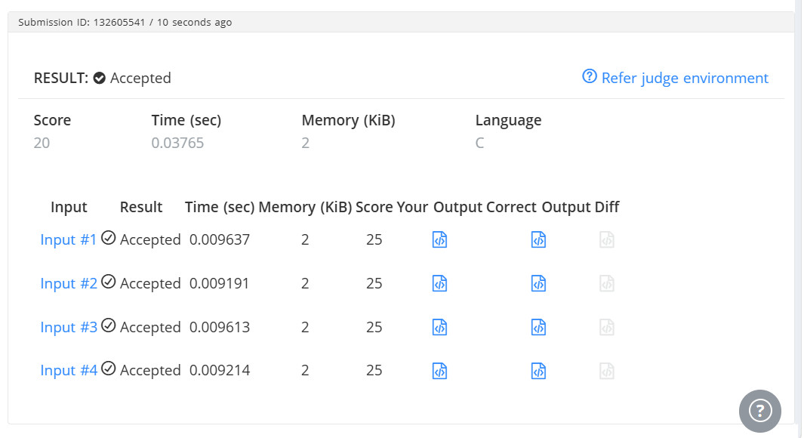Result
The program checks whether the given number is prime. Platform: HackerEarth.

