Module 6: Nested Loops – Online Judge Problems
Question 1: Staircase
Platform: HackerRank
Problem Link: https://www.hackerrank.com/challenges/staircase/problem
Problem Statement
You are given an integer n. Print a staircase of size n using # symbols and spaces.
The staircase has both its base and height equal to n. It is right-aligned, and the last line is not preceded by any spaces.
Function Description
Complete the staircase function with the following parameter:
- n: an integer representing the size of the staircase.
Print
Print the staircase. No value should be returned.
Input Format
A single integer n denoting the size of the staircase.
Sample Input
6
Sample Output
#
##
###
####
#####
######
Explanation
The staircase is right-aligned, composed of # symbols and spaces, and has a height and width of n.
Code Screenshot
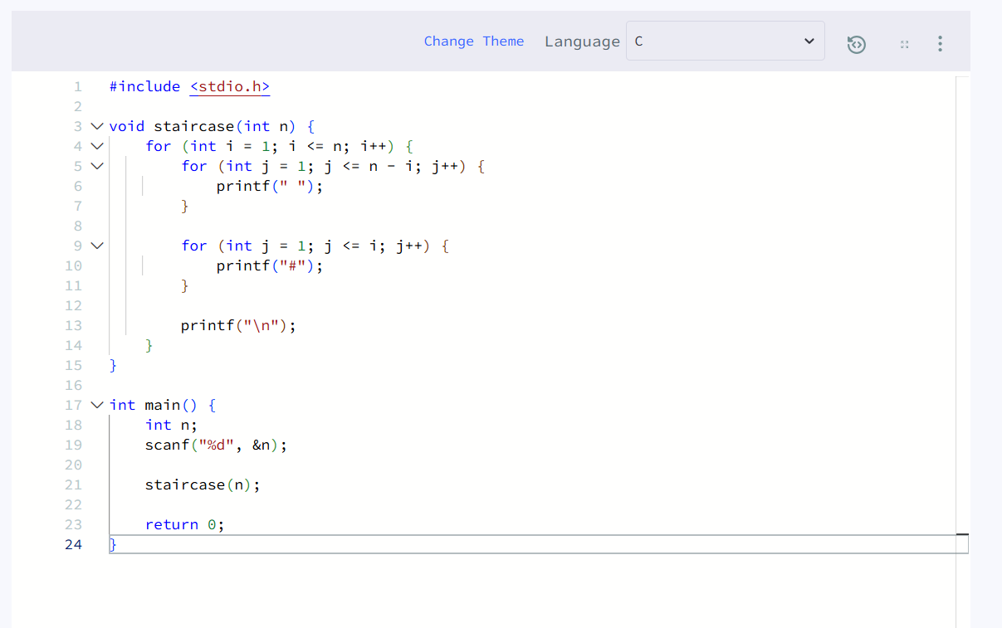Output Screenshot
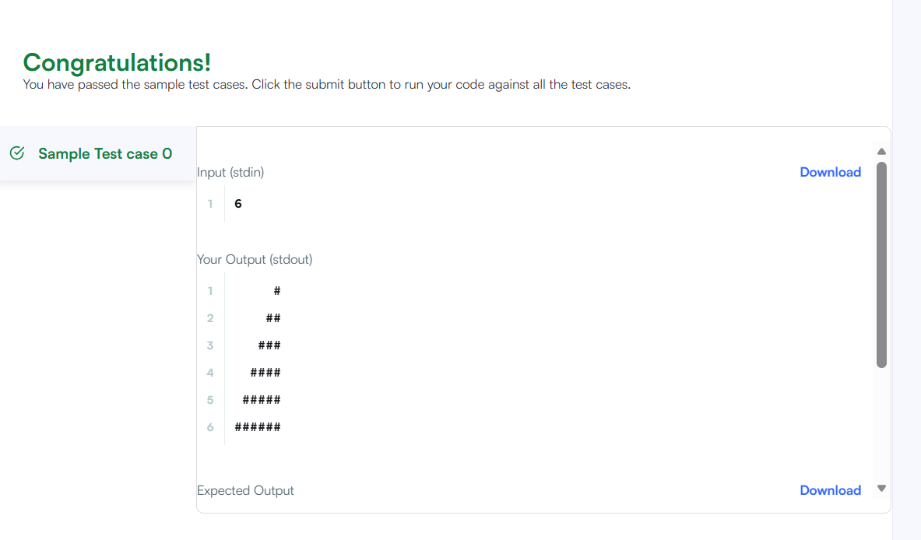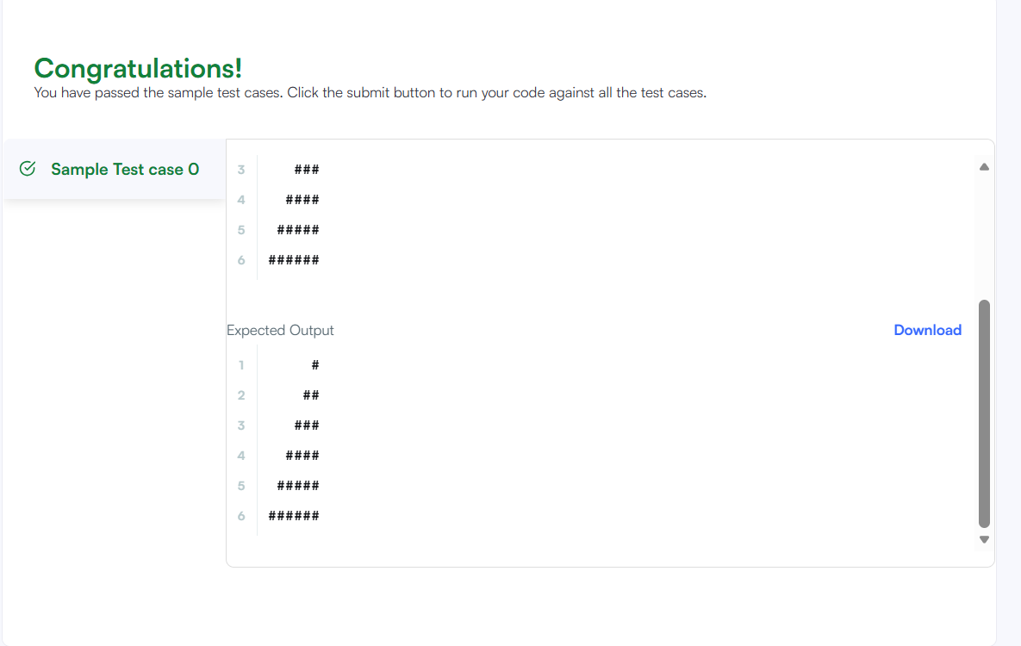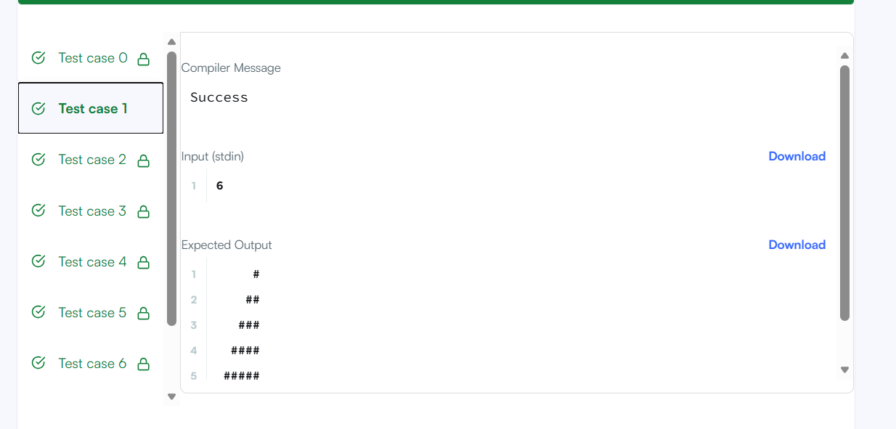Result
The program prints a right-aligned staircase of the given size. Platform: HackerRank.

