Module 6: Nested Loops – Online Judge Problems
Question 2: Printing Pattern Using Loops
Platform: HackerRank
Problem Link: https://www.hackerrank.com/challenges/printing-pattern-2/problem
Problem Statement
Print a pattern of numbers from n to 1 as shown in the given examples. Each number is separated by a single space.
The pattern is arranged in a square, with the outermost layer containing n and each inner layer decreasing by 1 until the centre contains 1.
Input Format
The input contains a single integer n.
Sample Input 0
2
Sample Output 0
2 2 2
2 1 2
2 2 2
Sample Input 1
5
Sample Output 1
5 5 5 5 5 5 5 5 5
5 4 4 4 4 4 4 4 5
5 4 3 3 3 3 3 4 5
5 4 3 2 2 2 3 4 5
5 4 3 2 1 2 3 4 5
5 4 3 2 2 2 3 4 5
5 4 3 3 3 3 3 4 5
5 4 4 4 4 4 4 4 5
5 5 5 5 5 5 5 5 5
Explanation
The pattern is printed in a square of size (2n - 1) × (2n - 1). The outer layers contain larger numbers, and the numbers decrease towards the centre.
Code Screenshot
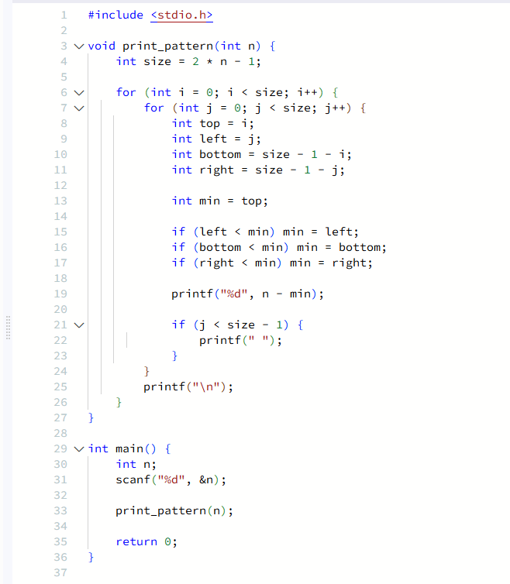Output Screenshot
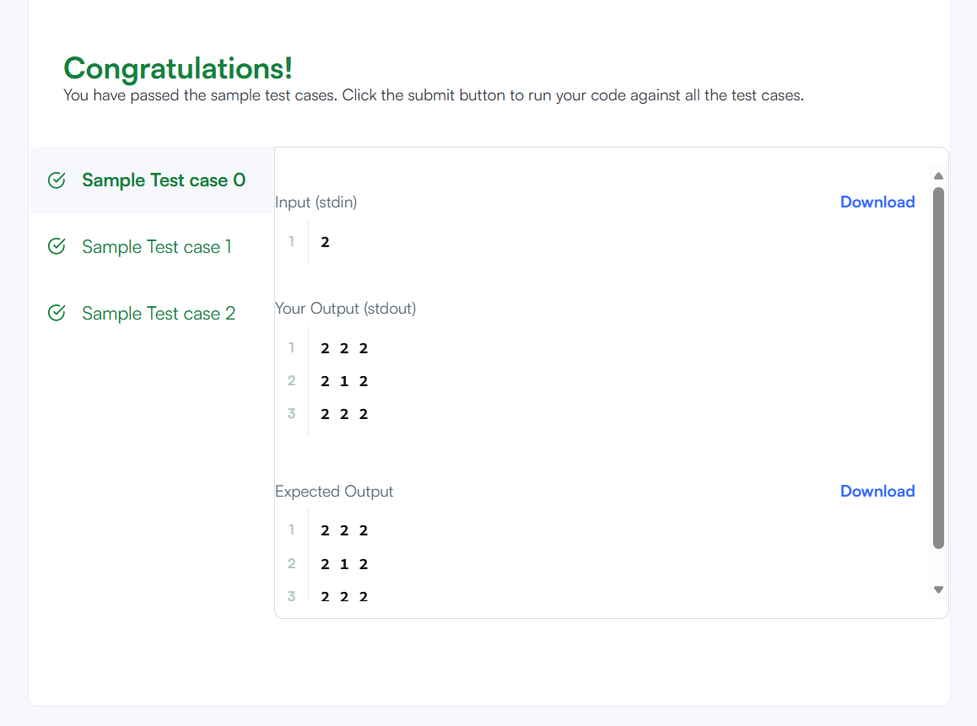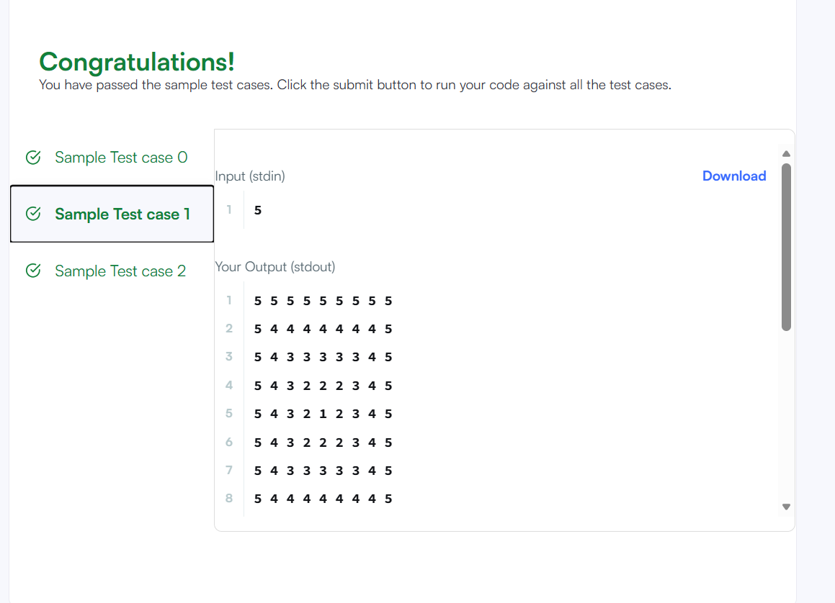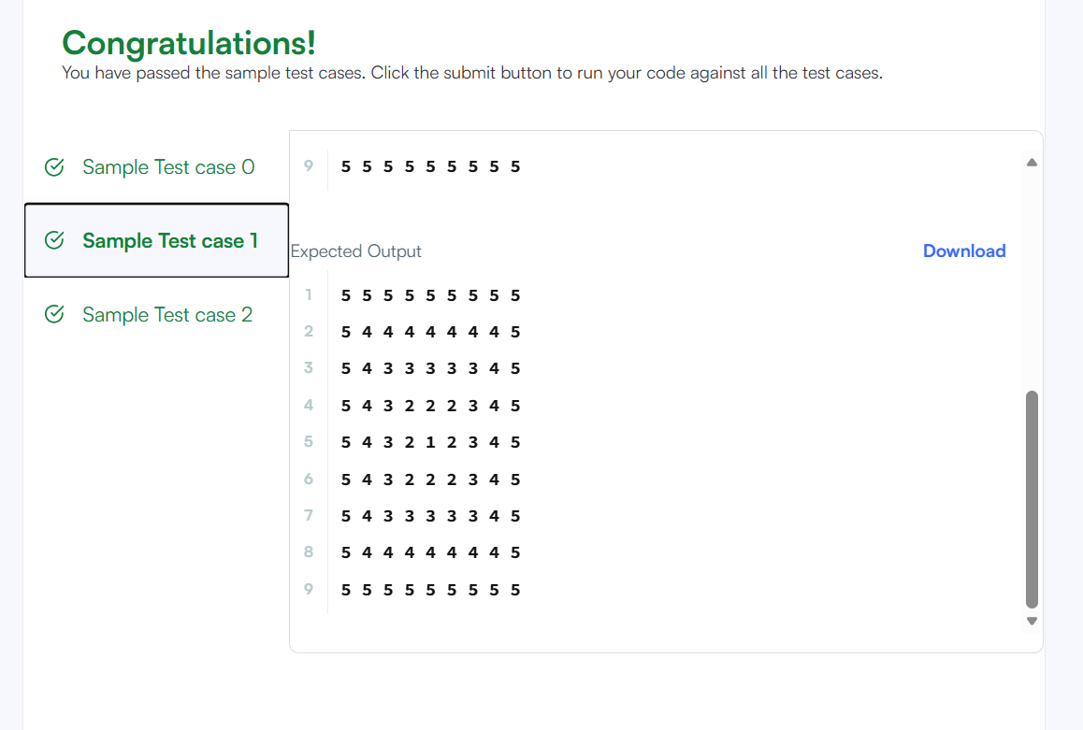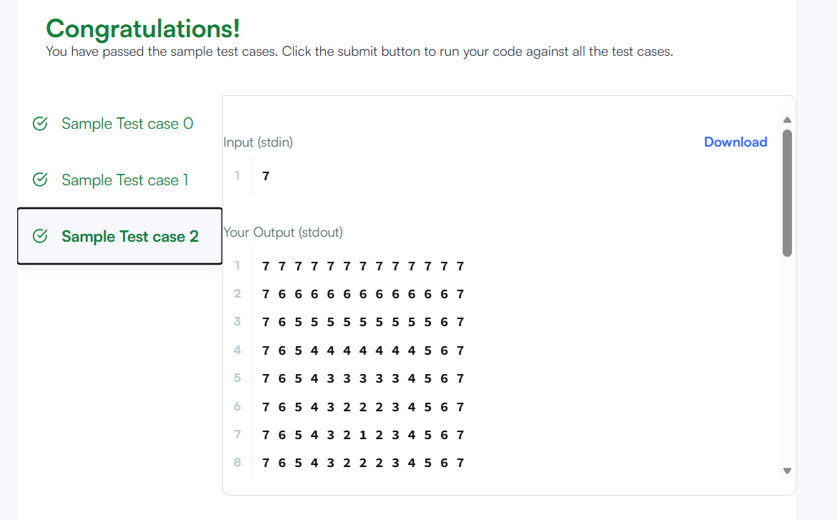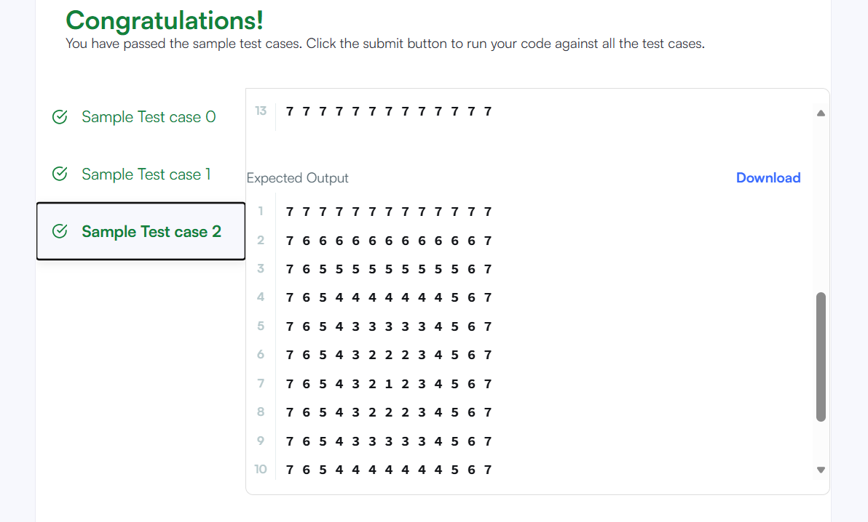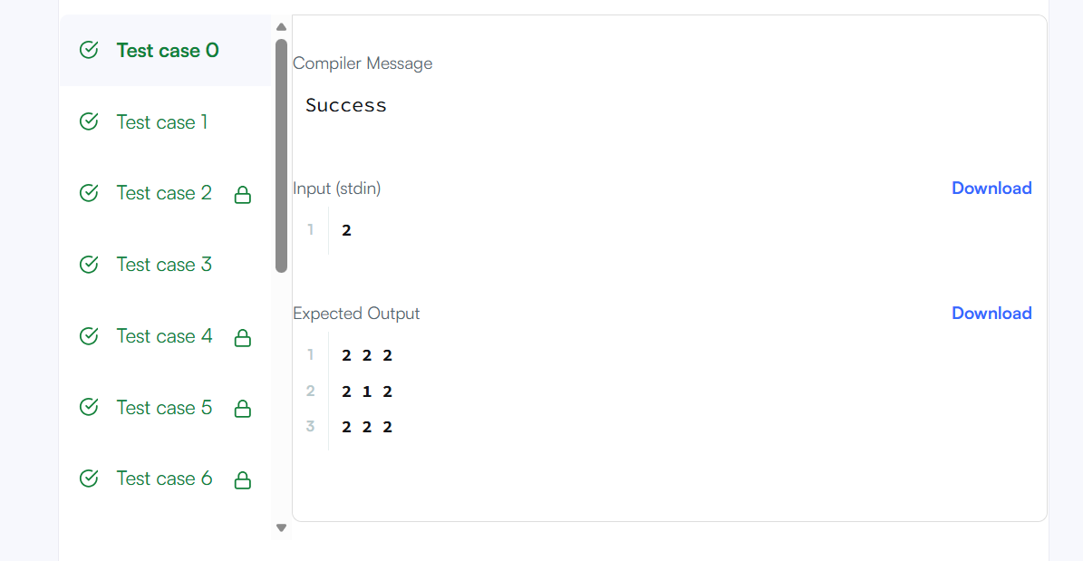Result
The program prints the required number pattern using nested loops. Platform: HackerRank.

