FOCP C Programming Assignment
Question 4: 2651. Calculate Delayed Arrival Time
Platform: LeetCode
Programming Language: C
Problem Statement URL:
https://leetcode.com/problems/calculate-delayed-arrival-time/
Problem Statement
You are given a positive integer arrivalTime denoting the arrival time of a train in hours, and another positive integer delayedTime denoting the amount of delay in hours.
Return the time when the train will arrive at the station.
Note that the time in this problem is in 24-hours format.
Example 1:
Input: arrivalTime = 15, delayedTime = 5
Output: 20
Explanation: Arrival time was 15:00 hours. It is delayed by 5 hours. Now it will reach at 15 + 5 = 20 (20:00 hours).
Example 2:
Input: arrivalTime = 13, delayedTime = 11
Output: 0
Explanation: Arrival time was 13:00 hours. It is delayed by 11 hours. Now it will reach at 13 + 11 = 24 (which is denoted by 00:00 in 24-hour format).
Constraints:
- 1 <= arrivalTime < 24
- 1 <= delayedTime <= 24
Source Code
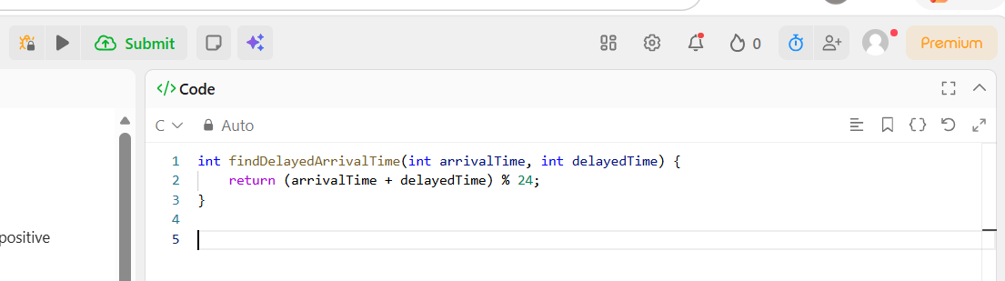Output
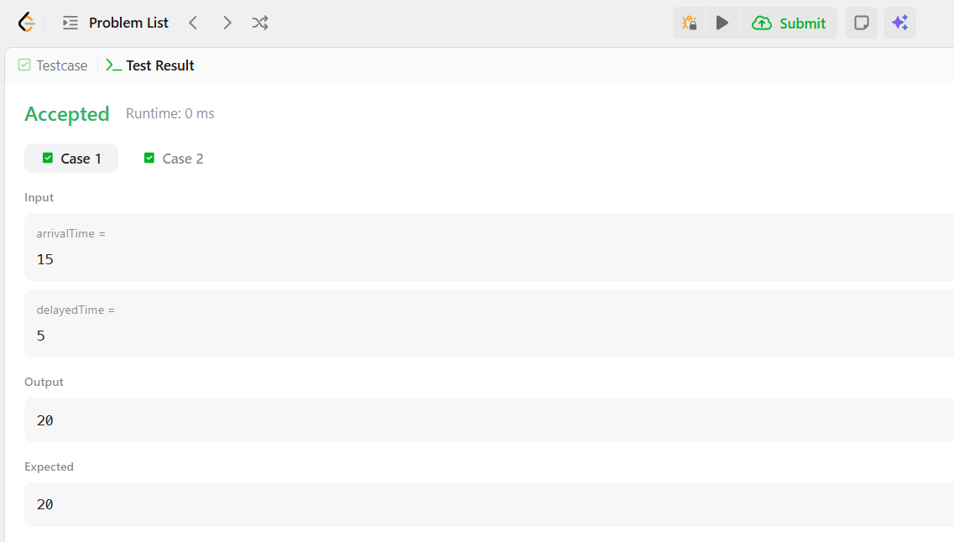
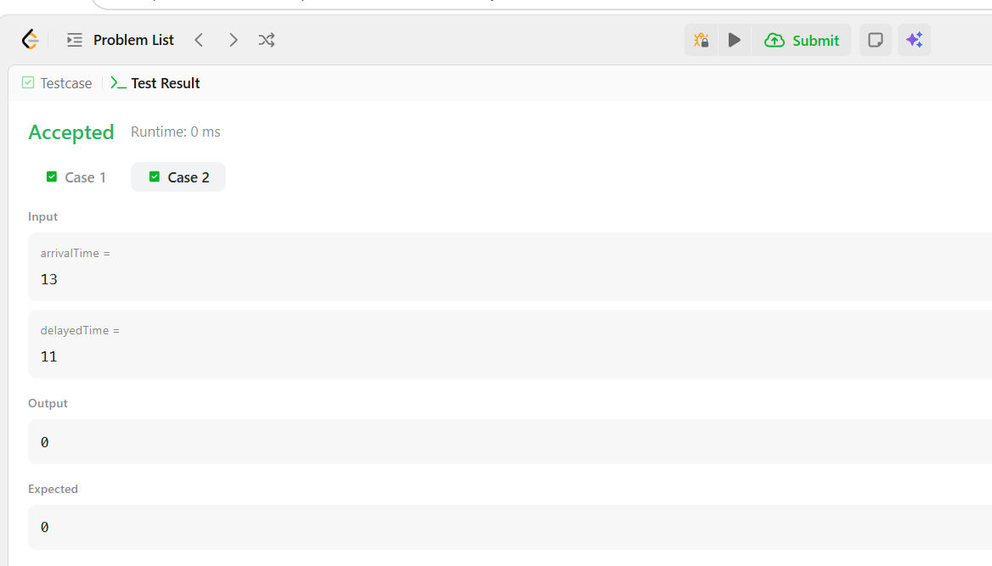
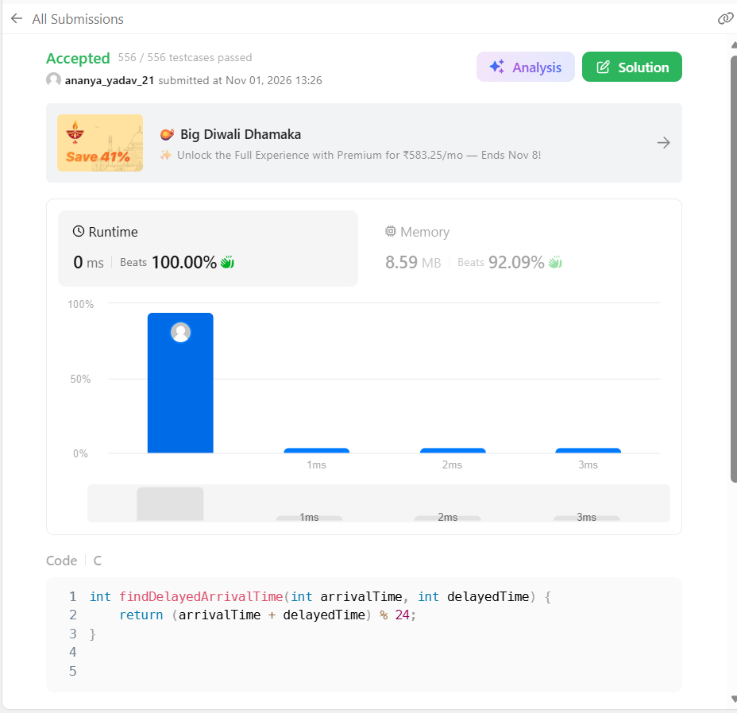Result
The program was executed successfully, and the solution was accepted on LeetCode.

