FOCP C Programming Assignment
Question 5: 2739. Total Distance Traveled
Platform: LeetCode
Programming Language: C
Problem Statement URL:
https://leetcode.com/problems/total-distance-traveled/
Problem Statement
A truck has two fuel tanks. You are given two integers, mainTank representing the fuel present in the main tank in liters and additionalTank representing the fuel present in the additional tank in liters.
The truck has a mileage of 10 km per liter. Whenever 5 liters of fuel get used up in the main tank, if the additional tank has at least 1 liter of fuel, 1 liter of fuel will be transferred from the additional tank to the main tank.
Return the maximum distance which can be traveled.
Note: Injection from the additional tank is not continuous. It happens suddenly and immediately for every 5 liters consumed.
Example 1:
Input: mainTank = 5, additionalTank = 10
Output: 60
Explanation: After spending 5 litres of fuel, 1 litre is transferred from the additional tank. The truck travels 50 km using the first 5 litres and another 10 km using the transferred litre. Total distance = 60 km.
Example 2:
Input: mainTank = 1, additionalTank = 2
Output: 10
Explanation: After spending 1 litre of fuel, the main tank becomes empty. Total distance = 10 km.
Constraints:
- 1 <= mainTank, additionalTank <= 100
Source Code
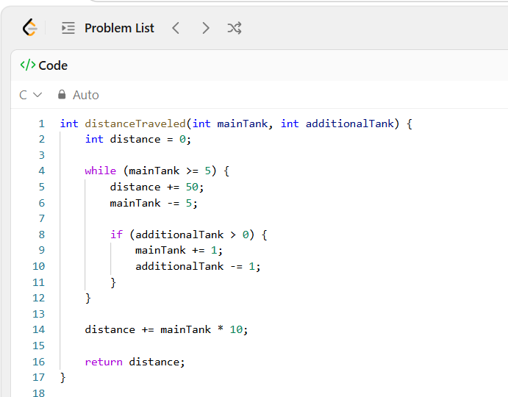
Output
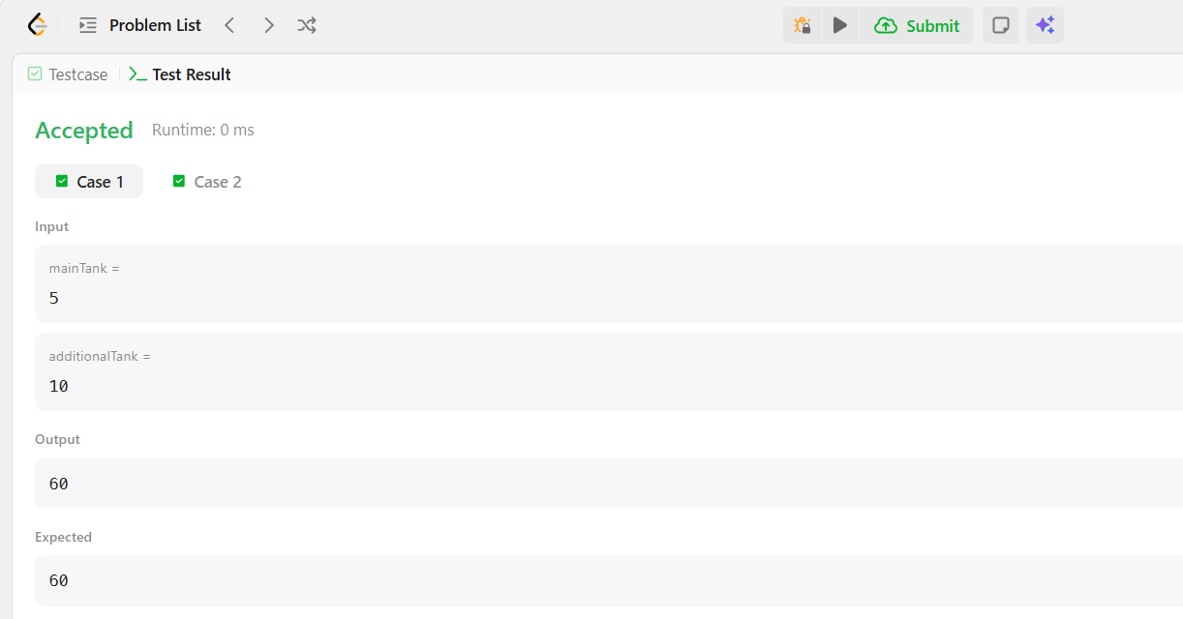
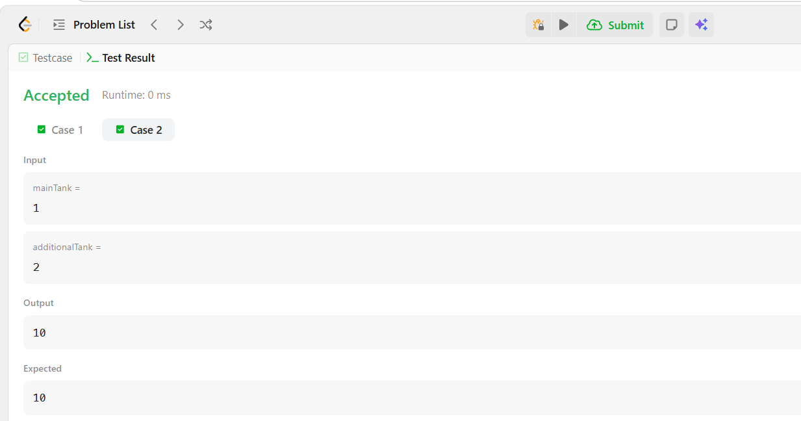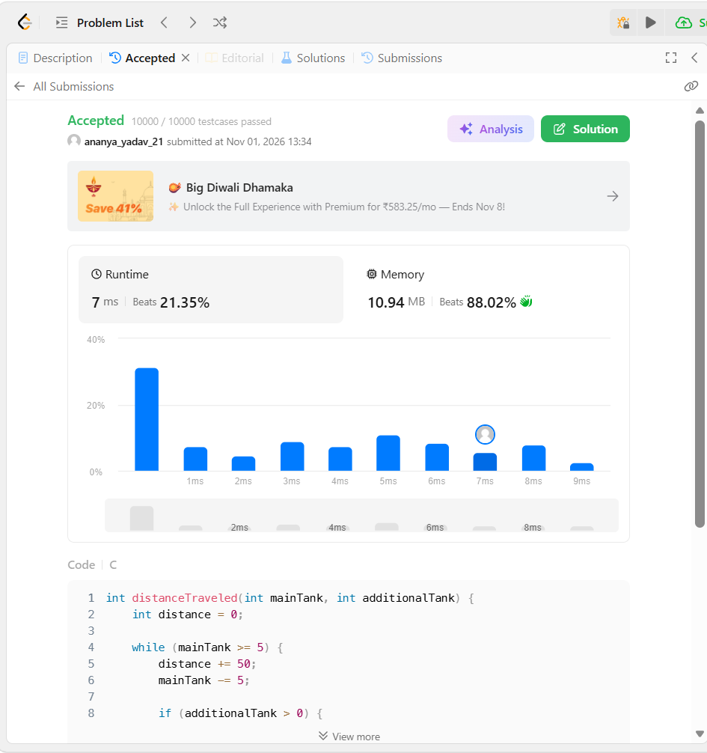Result
The program was executed successfully, and the solution was accepted on LeetCode.

