FOCP C Programming Assignment
Module 3: Loops
Question 3: Number of Operations to Make Zero
Platform: LeetCode
Programming Language: C
Problem Link: https://leetcode.com/problems/count-operations-to-obtain-zero/
Problem Statement
You are given two non-negative integers num1 and num2.
In one operation:
- If num1 >= num2, subtract num2 from num1.
- Otherwise, subtract num1 from num2.
Repeat these operations until either num1 or num2 becomes zero.
Return the total number of operations performed.
Examples
Example 1:
Input: num1 = 2, num2 = 3
Output: 3
Explanation: The operations are:
- (2, 3) → (2, 1)
- (2, 1) → (1, 1)
- (1, 1) → (0, 1)
Example 2:
Input: num1 = 10, num2 = 10
Output: 1
Explanation: (10, 10) → (0, 10)
Constraints
- 0 <= num1, num2 <= 10^5
Source Code
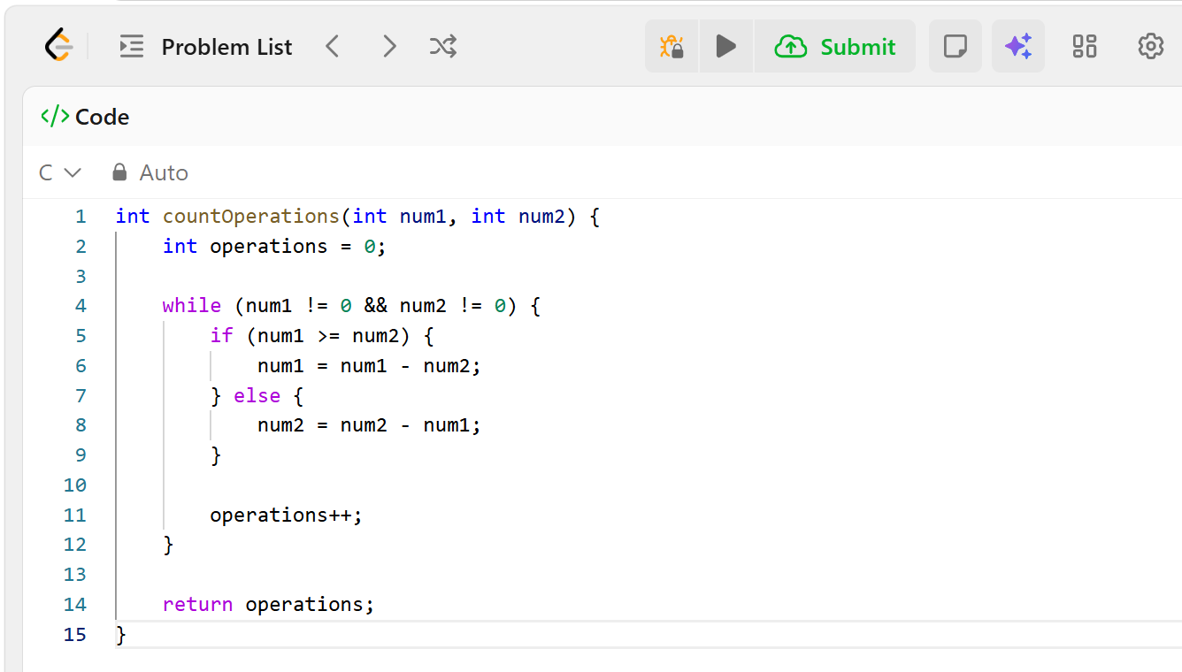Output
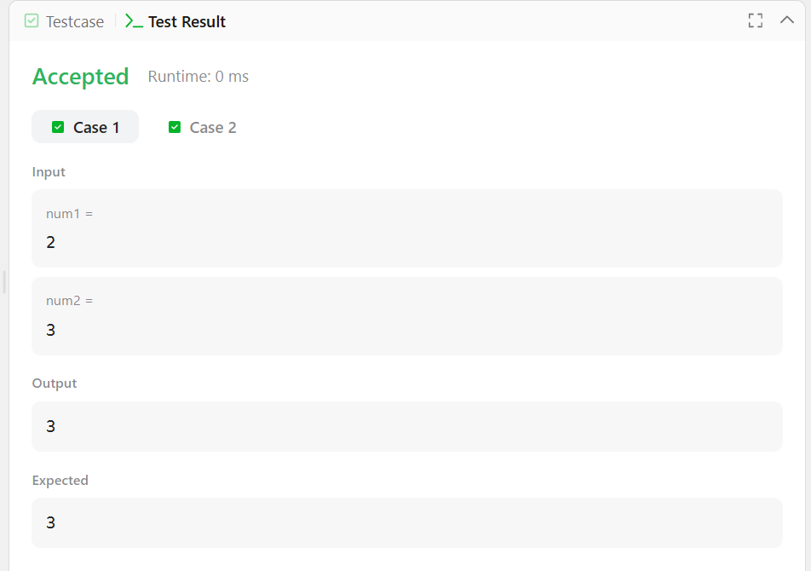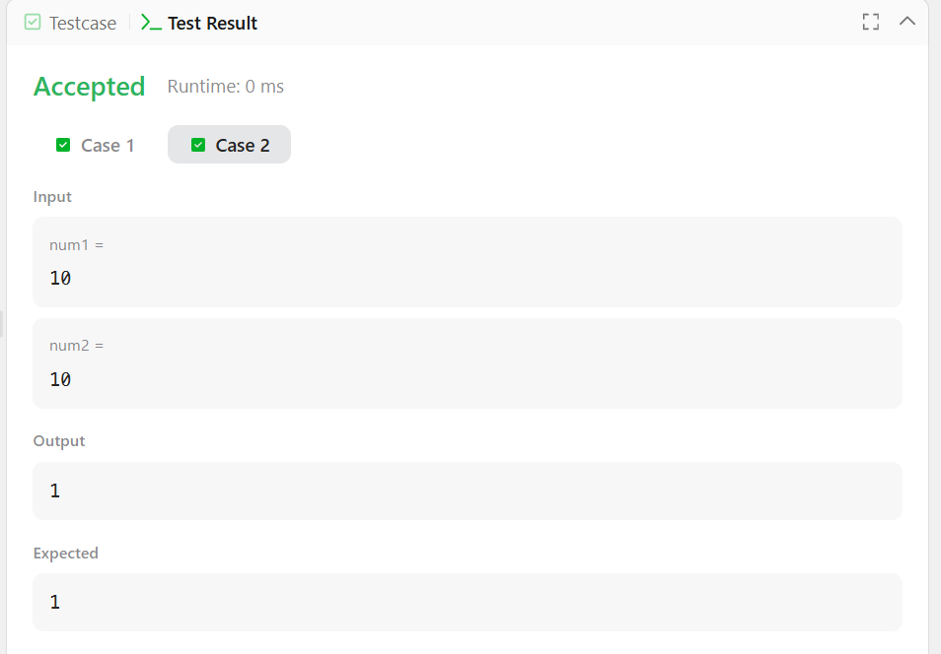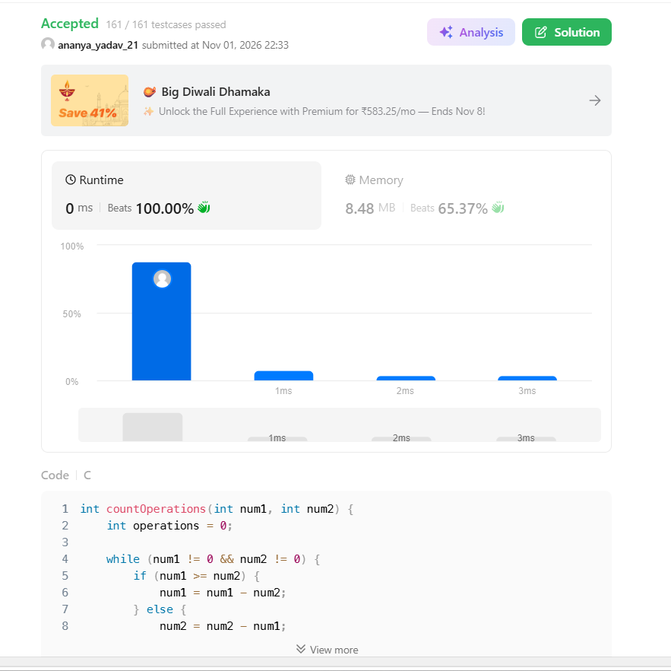Result
The program was executed successfully, and all test cases were passed on LeetCode.

