FOCP C Programming Assignment
Module 3: Loops
Question 4: Count Odd Numbers in an Interval
Platform: LeetCode
Programming Language: C
Problem Link: https://leetcode.com/problems/count-odd-numbers-in-an-interval-range/
Problem Statement
Given two non-negative integers low and high, return the count of odd numbers between low and high (inclusive).
Examples
Example 1:
Input: low = 3, high = 7
Output: 3
Explanation: The odd numbers between 3 and 7 are [3, 5, 7].
Example 2:
Input: low = 8, high = 10
Output: 1
Explanation: The odd number between 8 and 10 is [9].
Constraints
- 0 <= low <= high <= 10^9
Source Code
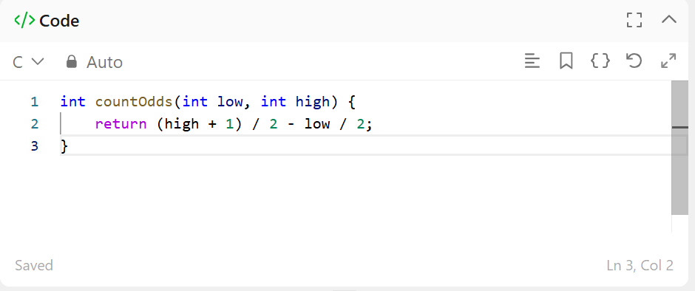Output
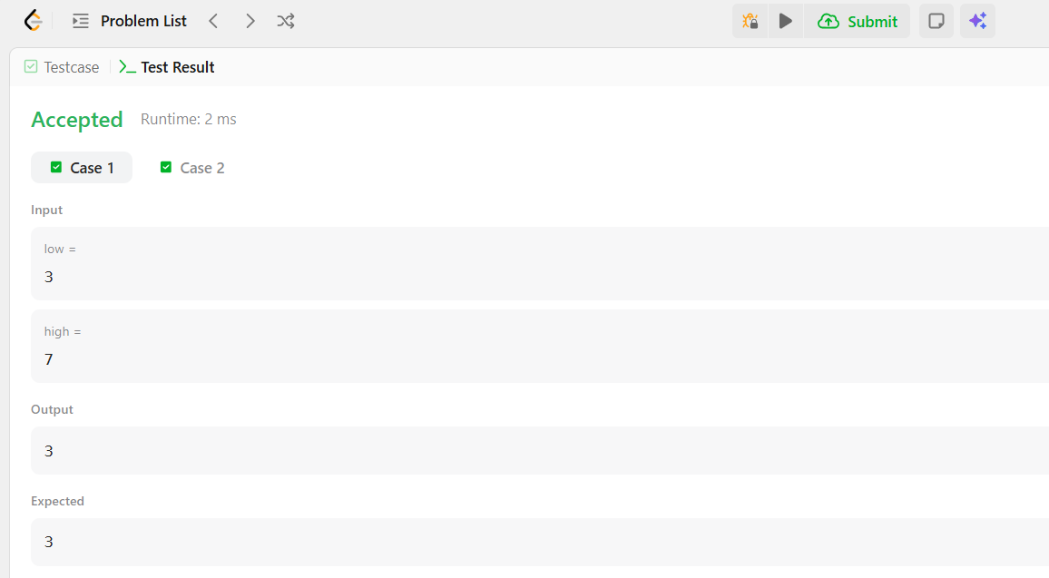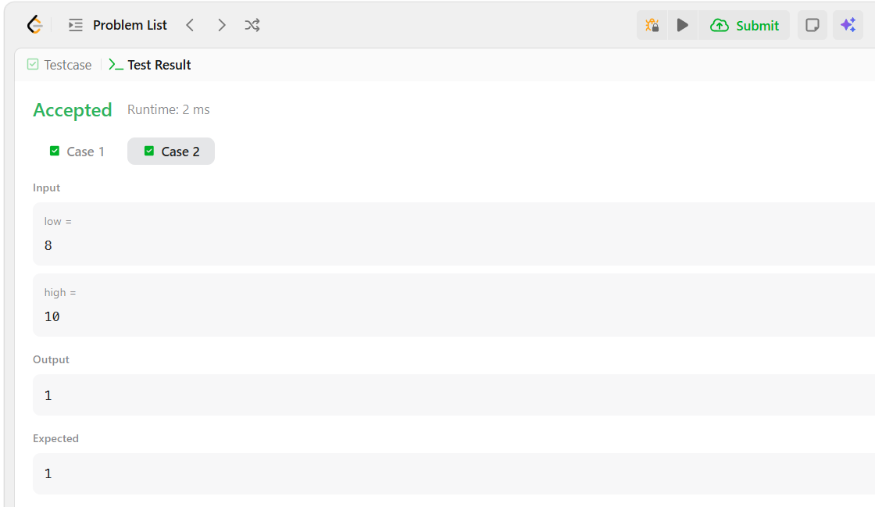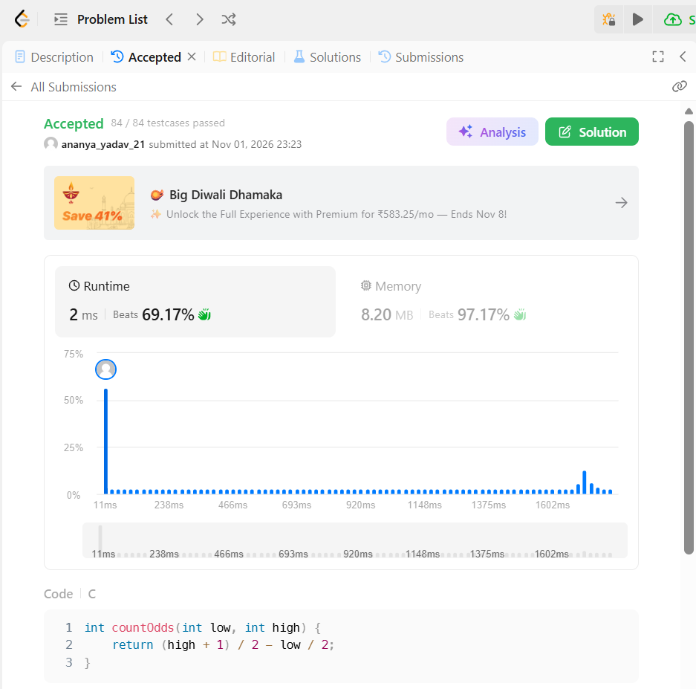Result
The program was executed successfully, and all test cases were passed on LeetCode.

