Module 4 – Question 5
Question Name: Palindrome Number
Platform: LeetCode
Programming Language: C
Problem URL: https://leetcode.com/problems/palindrome-number/
Problem Statement
Given an integer x, return true if x is a palindrome, and false otherwise.
A palindrome number reads the same from left to right and from right to left.
Input Format
A single integer x.
Output Format
Return true if the integer is a palindrome; otherwise, return false.
Constraints
- -2^31 <= x <= 2^31 - 1
Sample Input 1
121
Sample Output 1
true
Explanation
121 reads as 121 from left to right and from right to left. Therefore, it is a palindrome.
Sample Input 2
-121
Sample Output 2
false
Explanation
From left to right, it reads -121. From right to left, it becomes 121-. Therefore, it is not a palindrome.
Sample Input 3
10
Sample Output 3
false
Explanation
It reads 01 from right to left. Therefore, it is not a palindrome.
Code Screenshot
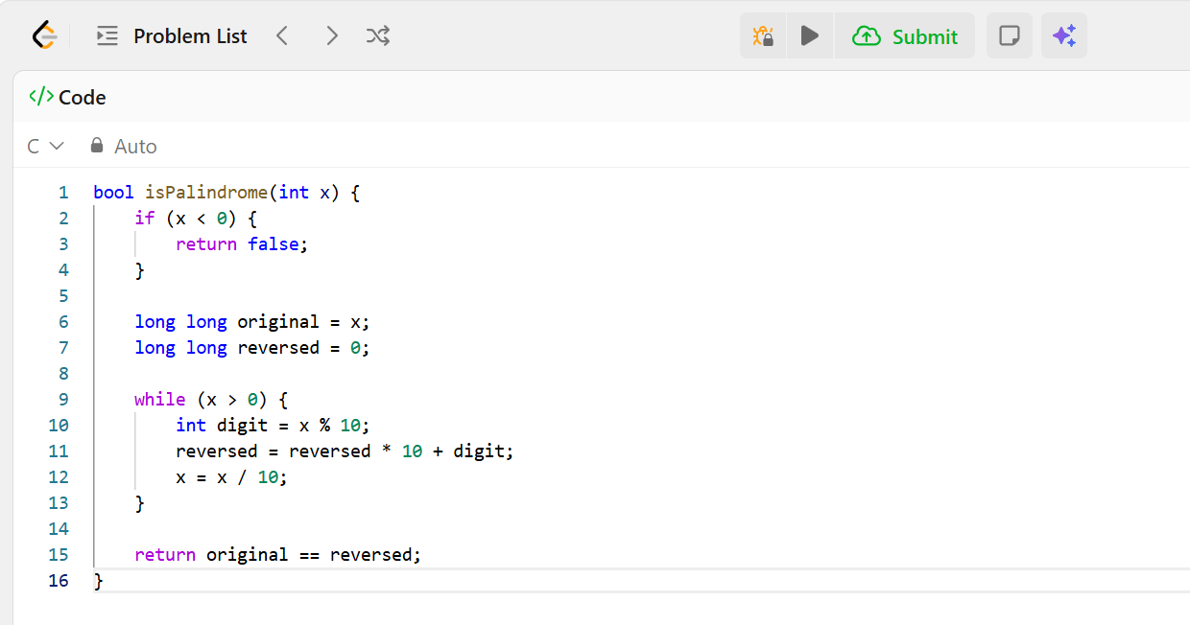Output Screenshot
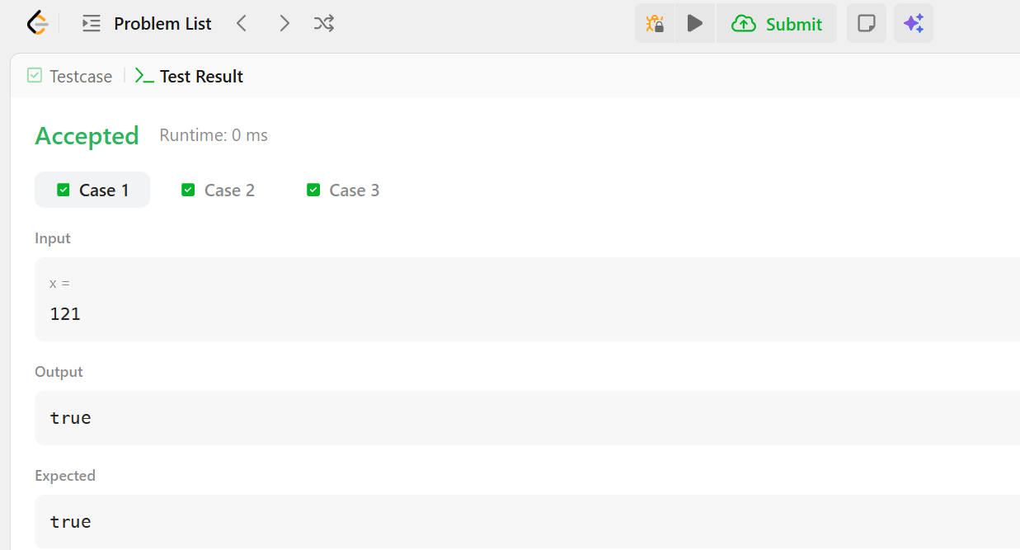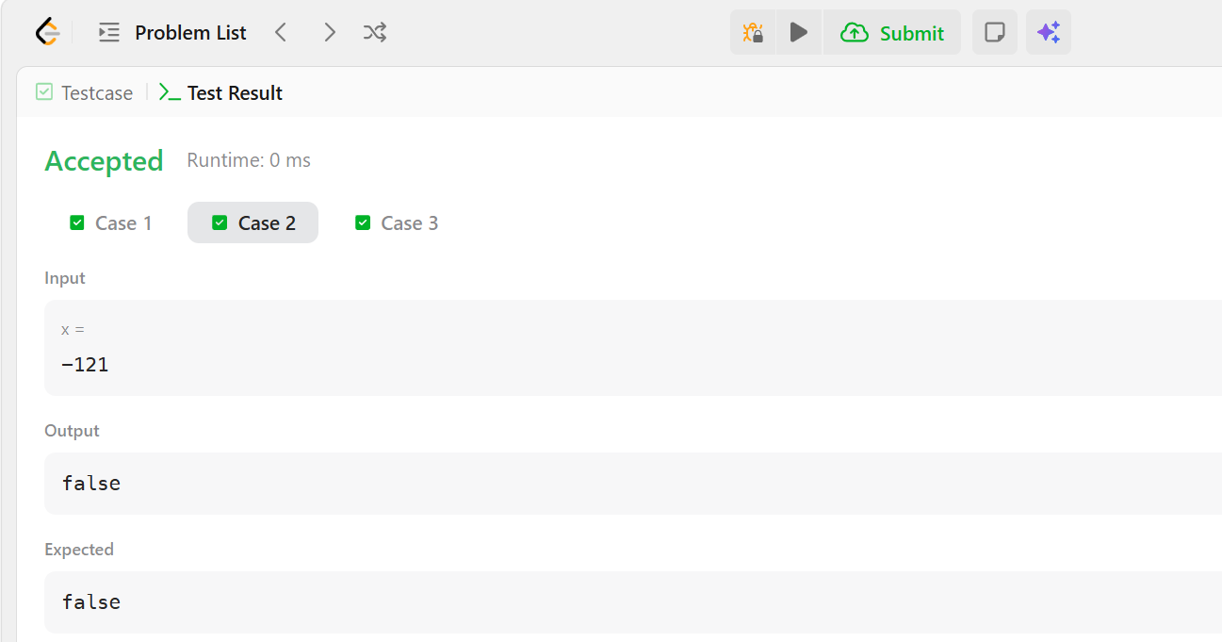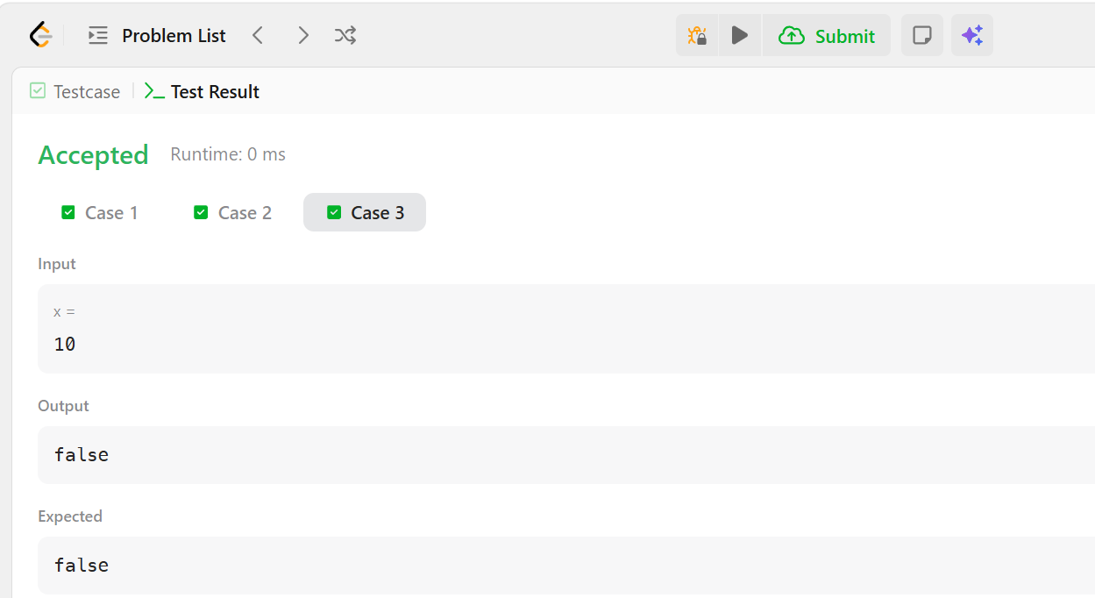
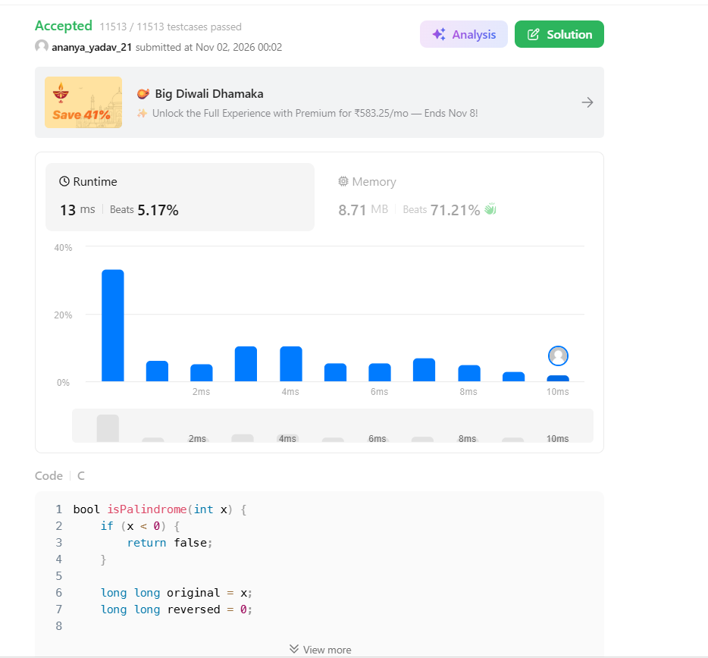
Result
The solution checks whether an integer reads the same forward and backward. Negative numbers are treated as non-palindromes. The expected results for the three examples are true, false, and false respectively.

