Module 4 – Question 6
Question Name: Reverse Integer
Platform: LeetCode
Programming Language: C
Problem URL: https://leetcode.com/problems/reverse-integer/
Problem Statements
Given a signed 32-bit integer x, return x with its digits reversed.
If reversing x causes the value to go outside the signed 32-bit integer range [-2^31, 2^31 - 1], return 0.
Assume the environment does not allow you to store 64-bit integers (signed or unsigned).
Input Format
A single signed 32-bit integer x.
Output Format
Return the integer with its digits reversed. If the reversed integer overflows the signed 32-bit range, return 0.
Constraints
- -2^31 <= x <= 2^31 - 1
Sample Input 1
123
Sample Output 1
321
Explanation
The digits of 123 reversed become 321.
Sample Input 2
-123
Sample Output 2
-321
Explanation
The digits of -123 reversed become -321.
Sample Input 3
120
Sample Output 3
21
Explanation
The digits of 120 reversed become 021, which is treated as 21.
Code Screenshot
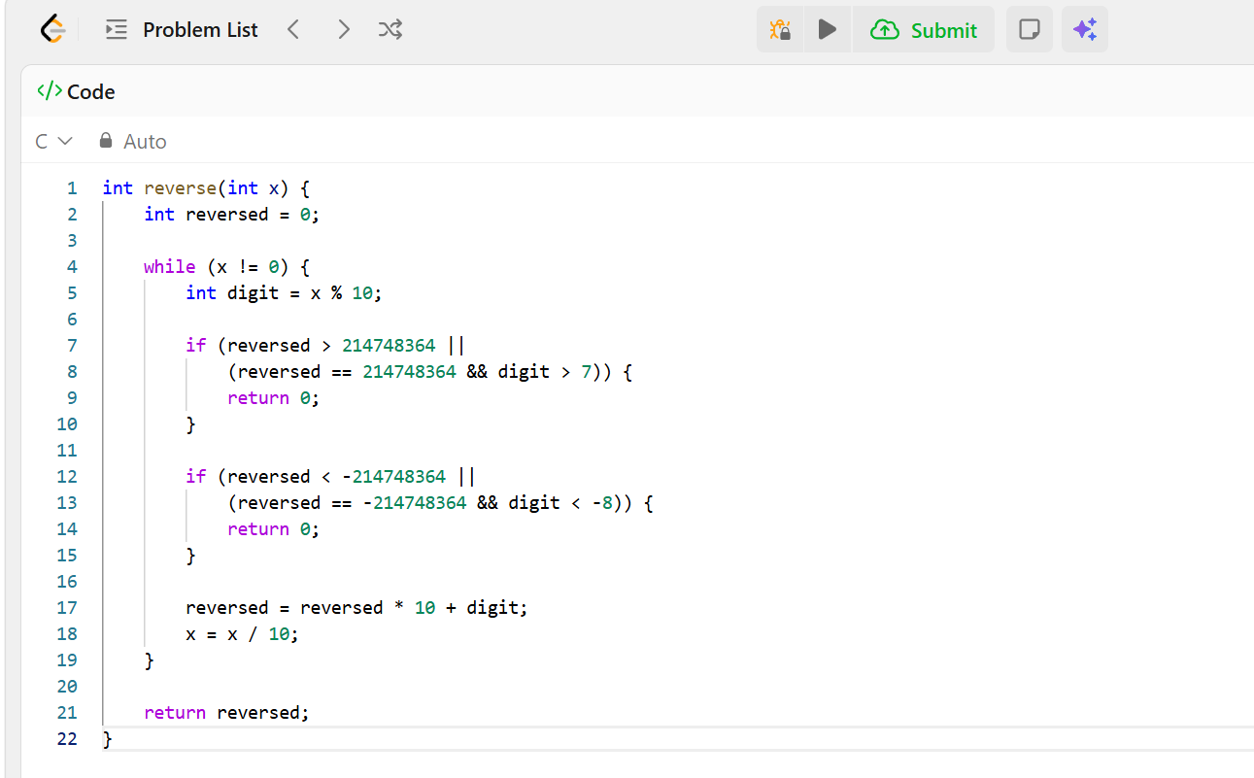Output Screenshot
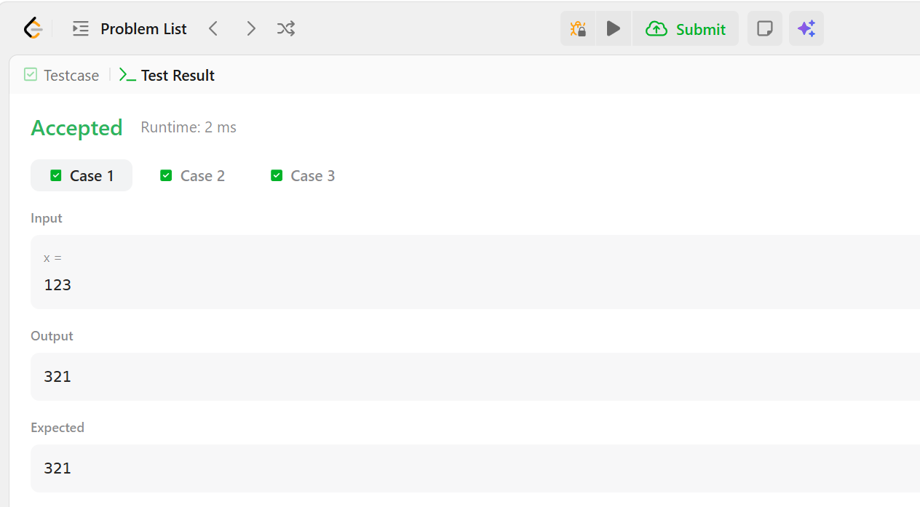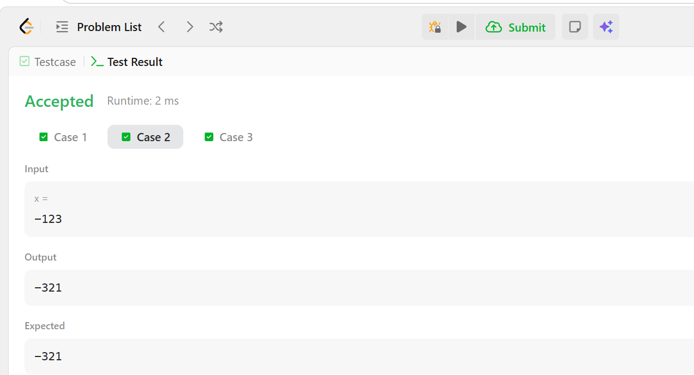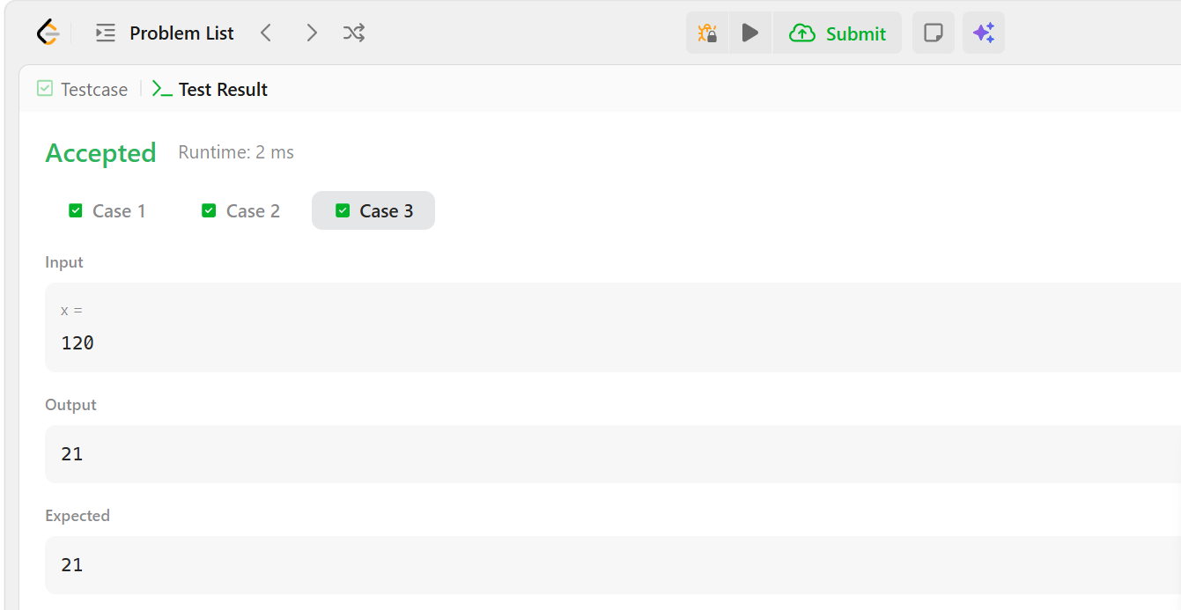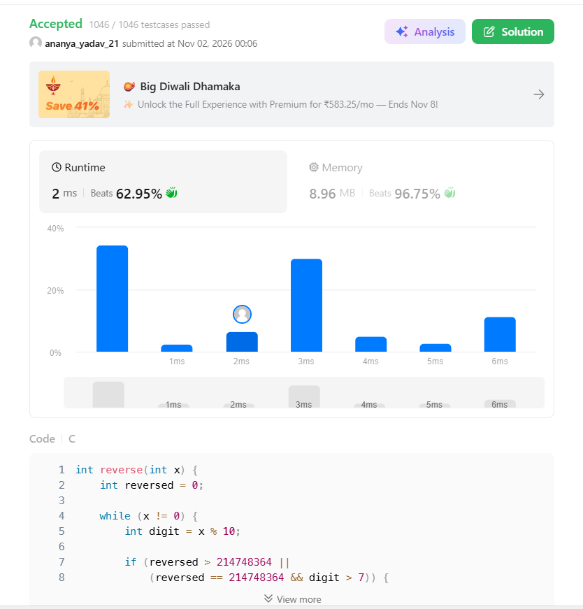Result
The program was successfully submitted on LeetCode. It reverses the integer and handles 32-bit overflow correctly.

