TripMate: Phase 2 Progress Notes
Progress update, screenshots and repository link
Group No.: ______ · Course: Generative AI (PSIS activity) · Activity 2: Tool-Augmented / Agentic LLM Application
Submission date: 23 September 2026
Repository: https://github.com/ananydoneria/tripmate · Notebook: TripMate_Agent.ipynb

1. What works now
Part | Status | Evidence
6 tools (geocoding, weather, currency, holidays, Wikivoyage guide, budget) | Working | Tested against the live APIs; 23 offline unit tests with mocked HTTP
Agent: create_agent + Gemini tool calling | Working | Multi-tool plans (Jaipur: 8 tool calls in one turn)
System PromptTemplate with grounding and failure rules | Working | Rendered per call with today's date; relative dates resolved correctly
Memory (LangGraph checkpointer) | Working | Follow-up turns reuse city and dates
PydanticOutputParser itinerary chain with repair fallback | Working | Valid JSON for 3-day plans; repair path unit-tested with a fake LLM
Failure handling: outages, 429, HTTP 204, unknown places | Working | Outage simulation switch; structured {ok: false, hint} results
Streamlit UI and CLI | Working, polishing | Tool-trace panel, outage switches
Live evaluation (10 scenarios), report, video | In progress | Due in Phase 3

2. Output of the partially working system
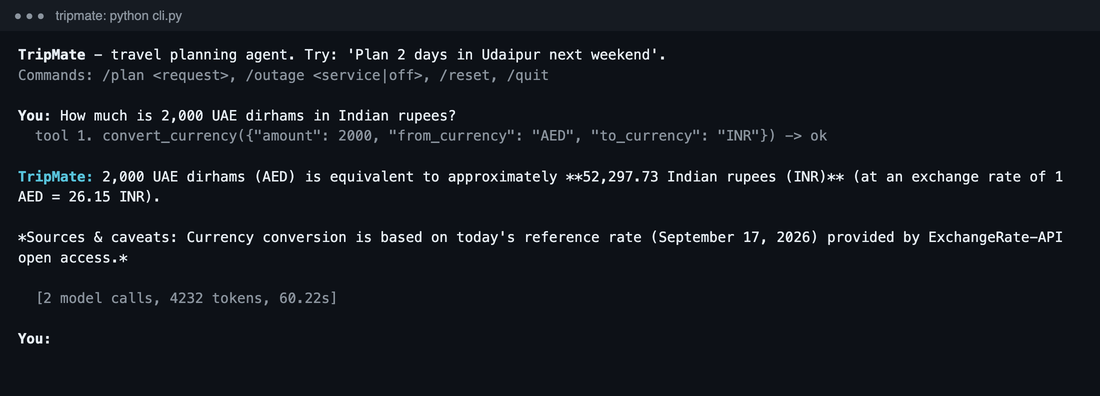
Figure 1. Real CLI session: the agent calls convert_currency; ECB rates lack AED, so the tool switches to the fallback provider and the answer reports the exact converted amount.

3. Problems found so far and how we handled them
- Wrong place, no error. The geocoder ranks "Manali" in Tamil Nadu (population 35k) above the Himalayan hill station (8k). Tools now return the resolved place and the other matches, accept qualified names ("Manali, Himachal Pradesh"), and the prompt tells the LLM to check the place and retry.
- Qualifier bug. "Jaipur, Rajasthan, India" failed because only the first qualifier was compared. Found in a live run where the agent recovered by retrying with "Jaipur, India"; fixed so every qualifier must match.
- Gemini free-tier quota. HTTP 429 after 5 requests/minute on gemini-2.5-flash and after 20 requests/day on gemini-3.5-flash. Added LangChain's InMemoryRateLimiter (4/min per model) and a fallback middleware that switches to gemini-3.5-flash-lite and skips the exhausted model for 10 minutes.
- Unexpected API responses. Wikivoyage rate-limits with a non-JSON 429 (Retry-After: 21): honoured and cached. Nager.Date answers HTTP 204 for India: reported as no_data, never as "no holidays". Forecasts stop at 16 days: last year's observations are used, labelled historical_proxy.

4. Next steps (until 30 September)
- Run and analyse the 10 live test scenarios; add grounding checks to the report.
- Finish the architecture and LLM-tool sequence diagrams, README and technical report.
- Record the 5-7 minute demo video; incorporate the Phase 2 feedback.

