Driver Distraction Detection using MobileNet.

G. Ananye Shobhith  
*Student  
Department of ECE*  
*Vardhaman College of Engineering*Hyderabad, India  
ananyeshobith.gajula@gmail.com

P. S. S. Chaitanya  
*Student   
Department of ECE*  
*Vardhaman College of Engineering*Hyderabad, India  
chaitanyaparimi14@gmail.com

V. Harini  
*Assistant Professor  
Department of ECE*  
*Vardhaman College of Engineering*Hyderabad, India  
v.harini@vardhaman.org

M. Srikar Goud  
*Student   
Department of ECE*  
*Vardhaman College of Engineering*Hyderabad, India  
mokuralasrikar2002@gmail.com

***Abstract— Several people lose their lives in traffic accidents. Road accidents can occur for a variety of causes, but in the majority of cases, driver inattention or exhaustion provides the greatest risk. Road accidents, many of which are fatal, are mostly caused by driver distraction and inattention. It is crucial to building information systems that can identify driver distraction and inattention to prevent traffic accidents. At the moment, distraction detection systems for road vehicles are either not yet widely accessible or are restricted to certain factors like driver fatigue. The human driver will continue to play a lengthier role as a supervisor of vehicle automation despite the rising automation of driving brought on by the availability of increasingly sophisticated assistance technologies. So, we came up with a solution named "Driver Distraction Detection using MobileNet." The primary goal of this model is to decrease traffic accidents and increase public safety by utilizing MobileNet to identify driver distractions.***

Keywords—Driver distraction, MobileNet, Road accidents, Public safety.

# Introduction

Around the world, driver attention is a major factor in traffic accidents. Driver distraction is one of the five biggest causes of road accidents. It describes any activity, such as using a phone, eating, drinking, adjusting the radio or GPS, or conversing with other passengers, that takes the driver's focus away from the primary duty of driving. Driver attention has a big impact on traffic accidents and fatalities.

Distractions can be cognitive, like thinking about a personal issue or problem, or visual, like staring at a phone. They can also be auditory, like loud music listening, or manual, like grasping for something. Driving while distracted can have detrimental effects, such as slower reaction times, poorer judgment, and diminished situational awareness. As a result, there may be a greater chance of collisions, injuries, and fatalities on the road. Road traffic is extremely difficult because of both driver distraction and driver inattention, frequently resulting in collisions and fatalities. When distracted, drivers are less able to detect and address possible traffic threats. Accidents might happen as a result of sluggish reflexes, bad decisions, and decreased situational awareness. Over the world, traffic fatalities and accidents are frequently caused by driver distraction. Accidents involving driver attention can happen for a variety of causes.

One of the most prevalent types of driver distraction is using a phone while driving. Texting, calling, checking social media, and internet browsing fall under this category. These tasks demand visual, cognitive, and manual focus, diverting the driver's attention off the road and away from the steering wheel, which may slow down their reaction times and affect their judgment. According to an article of The Times of India, 1040 lives were lost in India due to usage of mobile phones while driving. The usage of mobile phones by drivers while driving is said to have caused to 1,997 road accidents in 2021, according to a report in the news agency PTI.

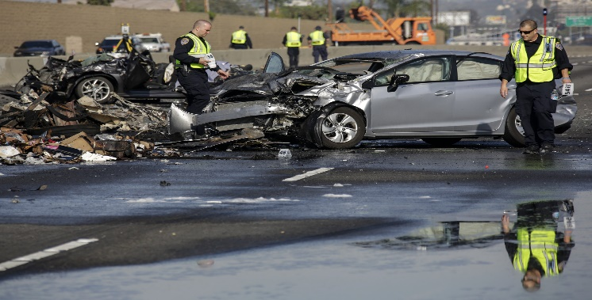

Fig. 1 Accident caused due to driver distraction.

Having food or drinks while driving is one of the main reasons for accidents on roads. Drinking or eating while operating a motor vehicle demands physical focus and can be a serious distraction for drivers. Spills drops, or choking could arise from this, which could make the driver lose control of the car and lead to accidents. Drivers may also become distracted when making changes to the radio, GPS, or air conditioning in their vehicles. The driver must pay physical and visual attention to this, which takes their hands off the wheel and their eyes off the road.

Drivers may become distracted when conversing with passengers, especially if the topic is emotionally charged or needs a lot of cognitive focus. This may result in the motorist becoming distracted from the road and having less situational awareness and conviction. More than 500 road accidents were caused due to drivers having a conversation with passengers while driving.

Driving while tired or sleepy can be very disorienting, slowing response time and affecting cognition. Accidents may result from this, especially on tedious or protracted journeys. Many existing solutions are present in the market which will reduce this problem. Driver drowsiness is causing more than 100000 accidents and approximately 50000 injuries every year.

Motorists can be distracted by outside distractions like billboards, commercials, or other cars. These distractions have the potential to take the driver's focus off the road and limit their capacity to react to shifting traffic situations. Other important distractions for drivers might come from internal reasons like stress, worry, or emotional anguish. Due to cognitive impairment and decreased situational awareness caused by these variables, it may be more difficult for drivers to react to shifting traffic circumstances.

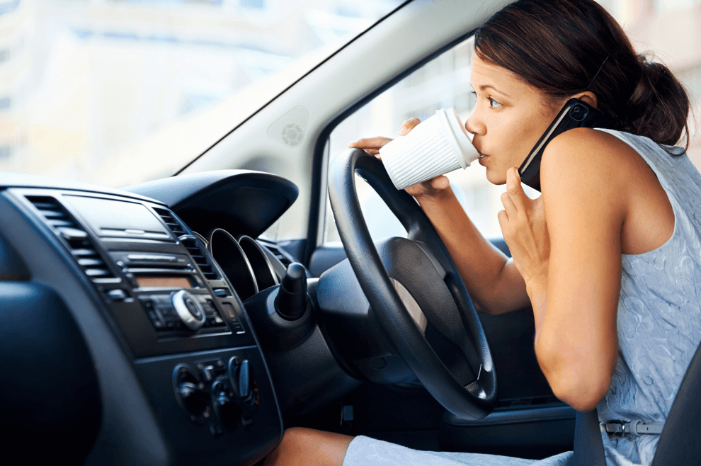

Fig. 2 Driver distracted by soft drink and mobile phone.

Conventional approaches to detecting driver attention rely on sensors and simple algorithms to observe the driver's actions and spot symptoms of distraction. Eye tracking, motions of the steering wheel, head movements, physiological signs, as well as changes in speed and acceleration of the vehicle, are some of the classic techniques that are frequently used to identify driver distraction.

When a driver is gazing away from the road, eye-tracking sensors can follow their eye movements and alert the driver. When the driver might be interacting with passengers, the radio, or a mobile phone, this could be a sign of distraction. The driver's steering pattern can be changed, and steering wheel sensors can spot any irregular or sudden motions. When the driver may be reaching for something, eating or drinking, or conversing with passengers, this could be a sign of distraction. Head movement sensors can identify when a driver is dozing off from exhaustion or looking away from the road.

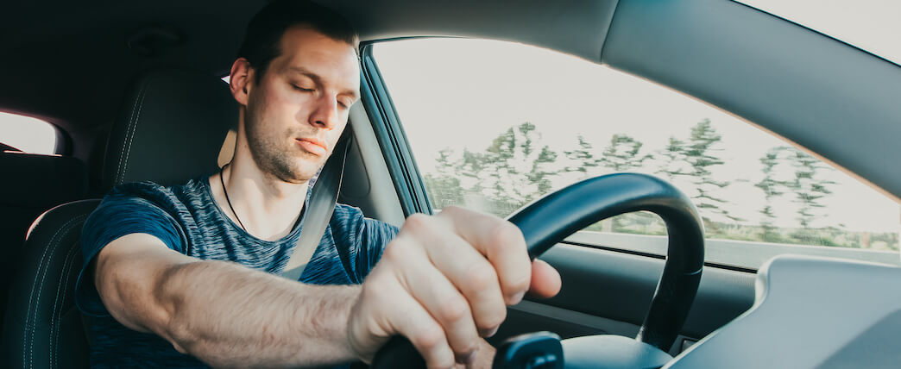

Fig. 3 Driver dozing while driving.

The driver's vital signs, like heart rate and breathing rate, can be tracked by physiological sensors to look for signs of stress or exhaustion. While the driver may be under emotional or cognitive stress as a result of outside circumstances like traffic congestion or personal concerns, these signals may be an indication of distraction. Automobile sensors can track the speed and acceleration patterns of the vehicle and identify any abrupt or unpredictable changes. While the driver may be responding to outside stimuli or engaging in activities that demand manual concentration, this may be a sign of distraction.

|  |  |  |  |
| --- | --- | --- | --- |
| Year | Total Driver Distraction Fatalities | Percentage of Fatalities due to Distracted Driving to total deaths. | Distracted driving accidents |
| 2017 | 3003 | 9.8% | 912000 |
| 2018 | 2645 | 9.1% | 938000 |
| 2019 | 2895 | 7.8% | 986000 |
| 2020 | 3142 | 9.3% | 680000 |
| 2021 | 3713 | 8.5% | 905000 |

Table 1. Driver accident data due to driver distraction in recent years.

These techniques may be useful for identifying distractions, but they may not be able to do so for all types of distractions, and they may also have limitations in terms of precision and dependability. Therefore, it is essential to analyze the driver's behavior during the driving time to detect the distraction and analyze the number of road accident.

# Literature Survey

## [Omar Wathiq](https://ieeexplore.ieee.org/author/37086337850);[Bhavna D. Ambudkar](https://ieeexplore.ieee.org/author/37304155700) proposed an “Optimized driver safety through driver fatigue detection.”This detects distraction of driver based on eye detection methods, face component detection methods and drowsiness detection methods. It uses SVM classifier to detect the distraction. It provides a moderate accuracy of 86%.

## [S. Pradeep Kumar](https://ieeexplore.ieee.org/author/37087062286), [Jerritta Selvaraj](https://ieeexplore.ieee.org/author/37087057907), [R. Krishnakumar](https://ieeexplore.ieee.org/author/37088384209), [Arun Sahayadhas](https://ieeexplore.ieee.org/author/37086198907) worked on a project named, “Detecting distraction in drivers using Electrophalogram(EEG) Signals.” This model analyzes electrophalogram(EEG) signals to detect the distraction of driver. Its accuracy is low that is 55%. It uses SVM and KNN algorithms for classification.

## M. Vinodhini, B Keerthana, S Lakshna, K. R Meenatchi came up with a model named,”Driver Drowsiness Detection based on Monitoring of Eye Blink Rate.” It is based on eye blink rate of the driver. Its accuracy is 77%. It detects the eye blink rate of the driver which can be varied in different accuracy. This may lead to false results.

## Dreisig, M., Baccour, M. H., Schack, T., & Kasneci, E. proposed,” Driver Drowsiness Classification Based on Eye Blink and Head Movement Features Using the k-NN Algorithm.” It uses K Nearesr Neighbour algorithm for detection of head movement and also detects the blinking rate of driver’s eye. Accuracy is 81.2%. Model working is slow. 35 features related to eye blinking behaviour are extracted in driving simulator experiments.

# Proposed Methodology

The proposed Driver Distraction Detection using MobileNet for the safety of drivers, pedestrians and other travelers who travel in vehicles is based on MobileNet algorithm which provides faster and accurate results. This system will monitor the driver at regular intervals and based on the input, it gives output whether the driver is distracted or not. If the driver is distracted, it tells which type of distraction is seen with the driver.

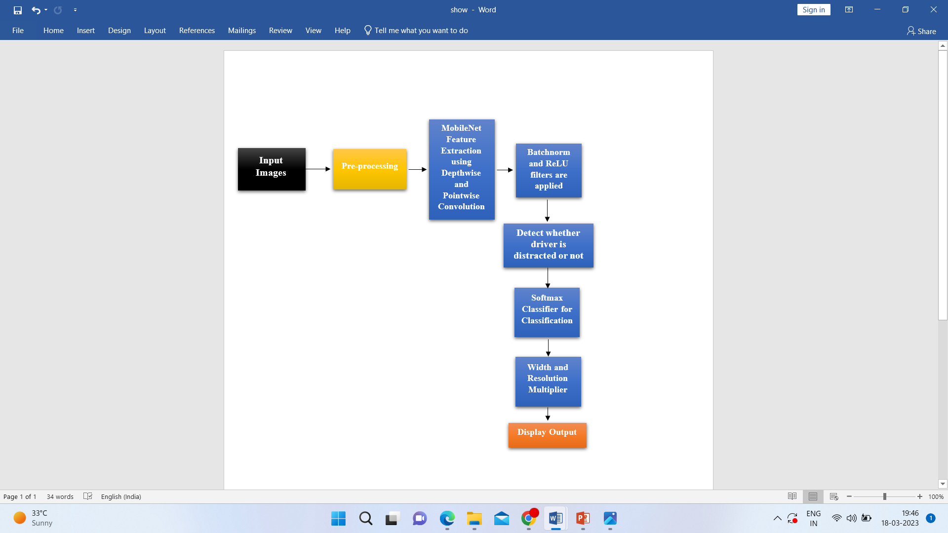

Fig4. Block Diagram

## Software Requirements

Software requirements are:

• Operating System: Windows 7, Windows 8 or any other higher version. Windows version lower than Windows 7 might not run this code because due to less version of operating system it cannot handle a large data and new commands of updated versions might not be executed in lower versions.

• Language: Python 3 (Developer: Anaconda – Jupyter notebook or Google Colab.)

## Hardware Requirements

Hardware requirements are:

• RAM: 16GB RAM or higher. Lower RAM versions produce errors like stack overflow and memory insufficient errors. Due to high amount of data for the data sets which are very large, more RAM desktop or laptop are advisable.

• Storage: 64GB or higher. Due to large data sets, a minimum of 64GB space is required and if the space in the laptop or desktop is more, then smooth execution of the code is possible. Hard disk of 40GB or higher can also be used to store the data and csv files of the code.

## MobileNet

Convolutional neural networks have been used to create the MobileNet architecture, which was created for embedded and mobile vision applications.

Due to its few parameters and low computational cost, MobileNet is intended to be both lightweight and effective. In order to do this, it splits the standard convolution operation into a depthwise convolution and a pointwise convolution. This is accomplished by employing depthwise separable convolutions. Although the depthwise convolution applies a single filter to each input channel, the pointwise convolution applies a 1x1 filter to combine the result. This maintains accuracy while reducing the convolutional algorithm’s computational cost.

Moreover, bottlenecking is a method used by MobileNet to minimize the quantity of network parameters. A 1x1 convolution, a 3x3 depthwise convolution, and a final 1x1 convolution make up the bottleneck layer. This decreases the depthwise convolution’s input channel count, improving computing efficiency.

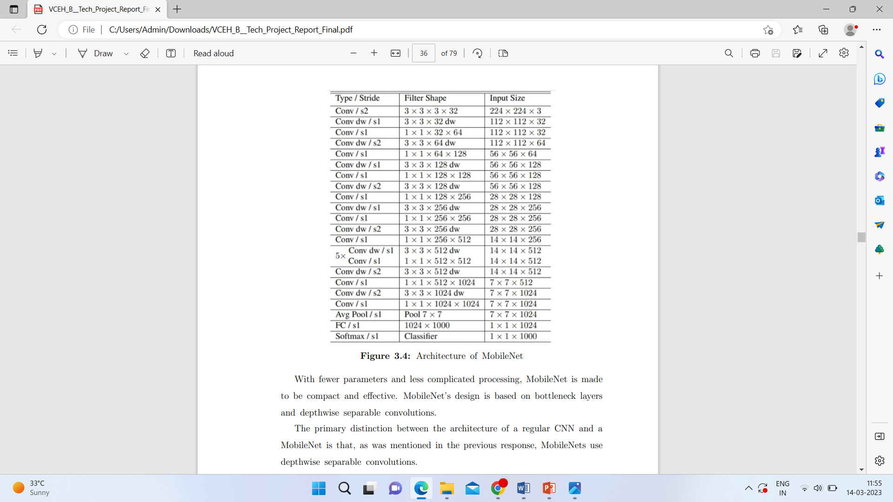

Fig5: MobileNet Architecture

With fewer parameters and less complicated processing, MobileNet is made to be compact and effective. MobileNet’s design is based on bottleneck layers and depthwise separable convolutions. The primary distinction between the architecture of a regular CNN and a MobileNet is that, as was mentioned in the previous response, MobileNets use depthwise separable convolutions.

## Depthwise Separable Convolutions

A depthwise separable convolution is generated by combining a pointwise convolution with a depthwise convolution. MobileNet can be used as a feature extractor to evaluate input images while detecting driver’s inattention. A classifier can then be used to detect whether or not the driver is distracted using the output from MobileNet. MobileNet's use of depthwise separable convolutions can aid in lowering the computing demands of this procedure, making it more appropriate for implementation on mobile devices or other platforms with limited resources.

1. *Depthwise Convolution*

In a depthwise convolution, a set of output channels are created by applying the filter separately to each channel of the input volume of driver distraction images. This process operates similarly to convolving each filter with a single input volume channel.

When compared to standard convolutions, the usage of depthwise separable convolutions in driver distraction detection with MobileNet requires fewer parameters and computations while still retaining a comparable degree of accuracy. Depthwise convolution is computationally efficient compared to traditional convolution, as it requires fewer parameters and operations to process the same amount of data. This makes it a popular choice for mobile and embedded devices, where computational resources are limited.

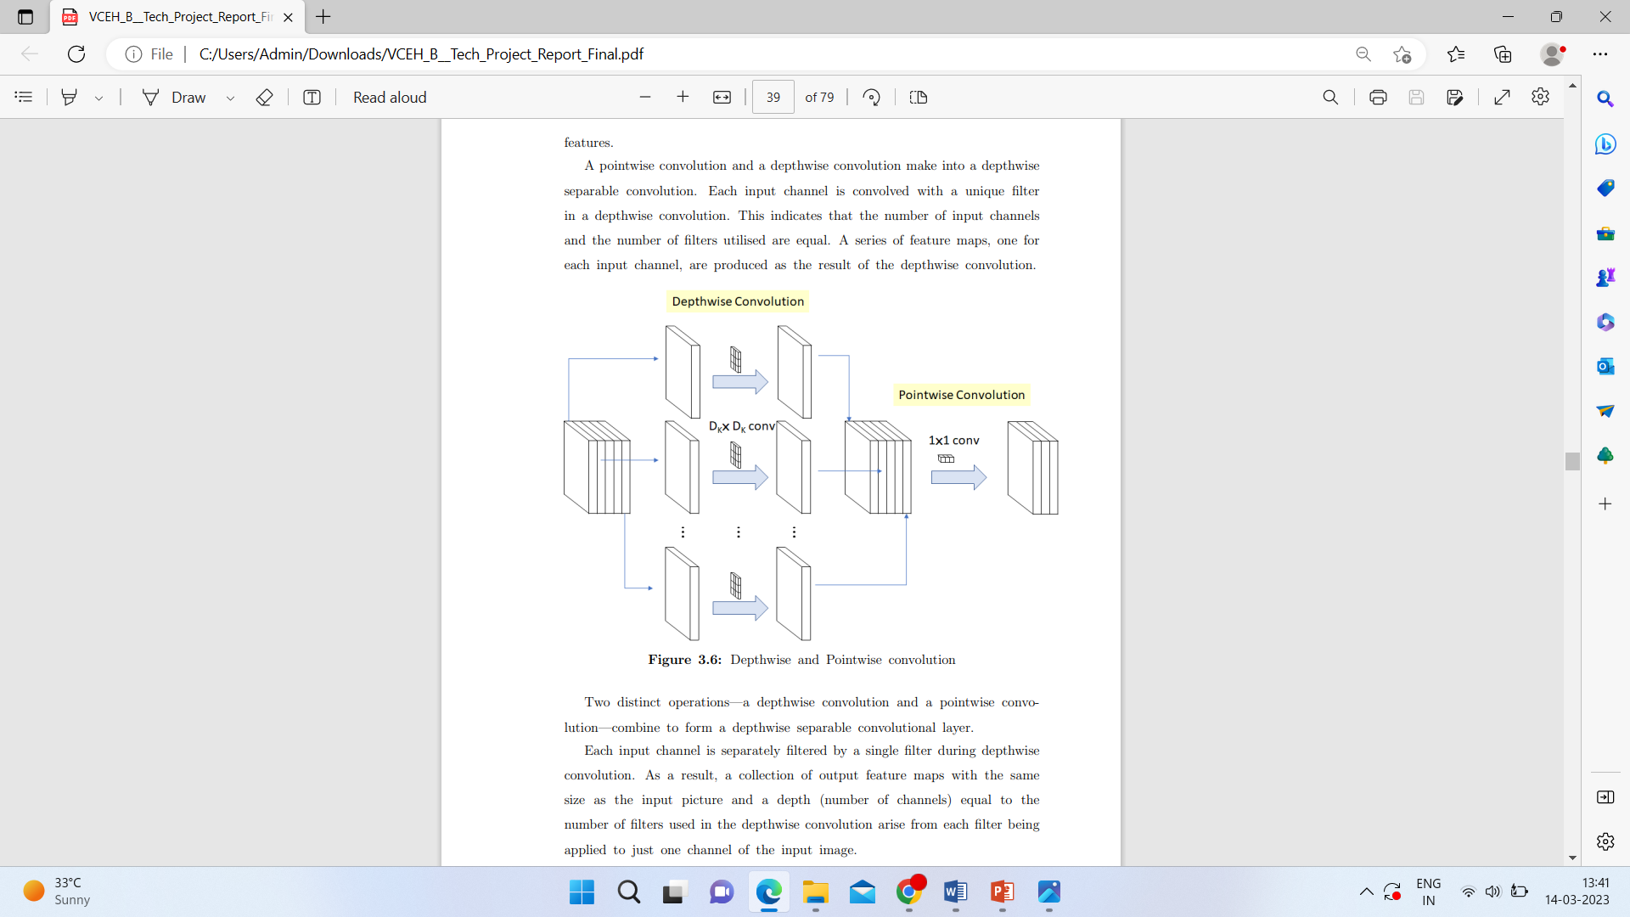

Fig6: Pointwise and Depthwise Convolution.

1. *Pointwise Convolution*

Pointwise convolution, sometimes referred to as 1x1 convolution, uses filters with a width and height of 1. It is often used to modify the depth of the feature maps created by earlier convolutional layers. To detect driver distraction, we can use pointwise convolution in MobileNet, which lowers the number of parameters and computations needed for inference. The result of the pointwise convolution can also serve as a feature vector for a classifier. The use of pointwise convolution in MobileNet for driver distraction detection can help to achieve high accuracy on mobile devices.

## Bottleneck Layers

A bottleneck layer is created by combining a depthwise separable convolutional layer and a 1x1 pointwise convolutional layer.

One of the significant innovations that enable MobileNets in driver distraction detection to be highly efficient while maintaining high accuracy is the introduction of bottleneck layers. By utilizing depthwise separable convolutions and bottleneck layers, MobileNet can deliver high-level, accurate, and speed performance on several categories of driver inattention photos.

## System Implementation

The suggested model is first provided the photos from the driver distraction data set that were downloaded from Kaggle. More than one lakh images make up the data set, which has a size of more than 4 gigabytes. The suggested model first trains the pictures that are present in all ten of the stated categories after receiving the images.

After training of the model is completed then the model is tested. The model undergoes 21 epochs. The model trained images are ready to be tested then. The testing data set images are taken to be tested. Based on the trained model, tested images output is displayed. If the driver does not get distracted, then the model does not give any output because the driver is driving and need not be alerted. If the driver is getting distracted that is if the driver is driving using mobile phone on left hand, driver is using mobile phone on right hand, driver is drinking or eating with left hand, driver is drinking or eating with right hand, driver is using radio, driver is talking to other passenger, driver is talking to someone on phone with left hand, driver is talking in phone with right hand, driver is reaching out back seat and driver is adjusting

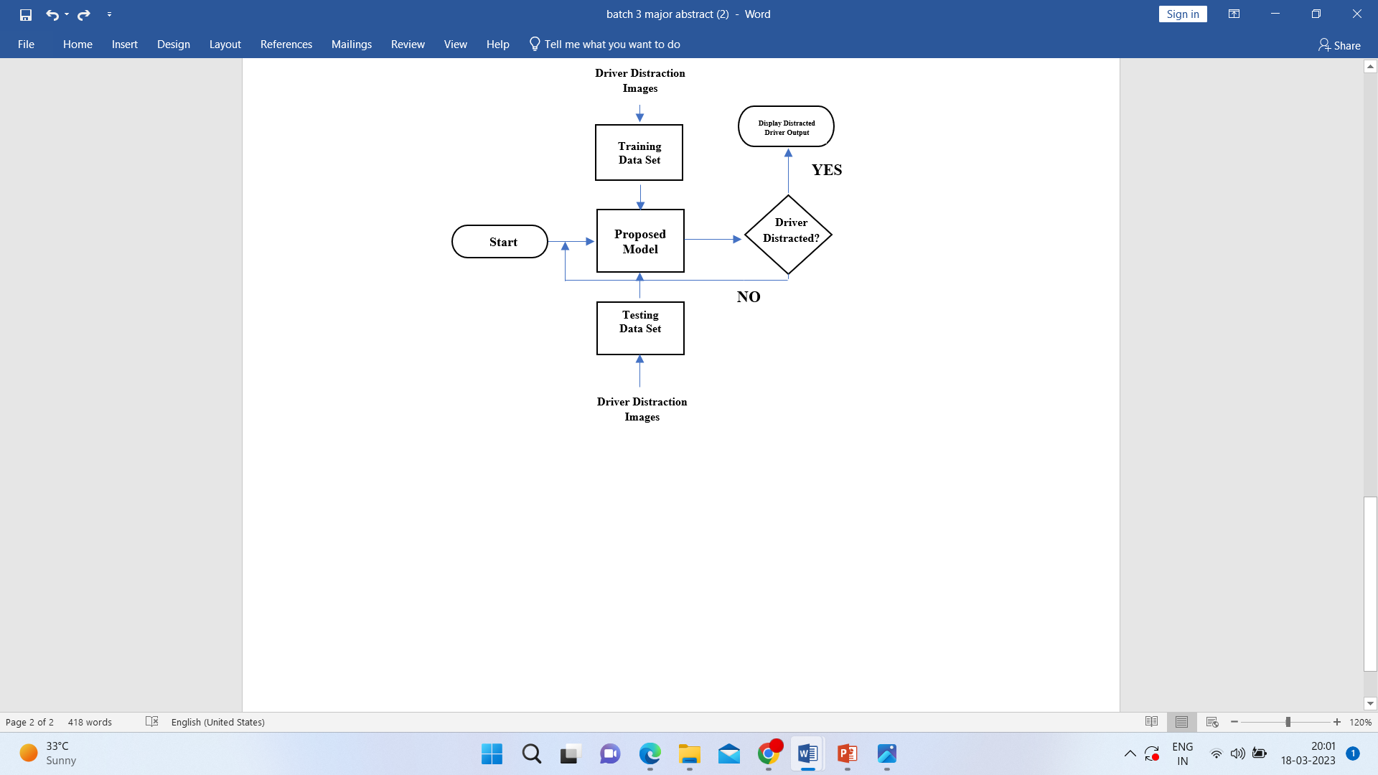

Fig7: Flow Chart of System Implementation

hair or his or her hands on face, then the model detects that the driver is distracted. The model displays in whichever way the driver is distracted and mentions it above the displayed image. In this way the output is displayed by detecting if the driver is distracted or no.

## Data set transmission

The dataset can be used to train the network to detect driver distraction after it has been delivered to the MobileNet model, or it can be used to categorize input. In the proposed model, the data set of 102150 dataset images, in which 22424 are training images and 79726 are for testing are sent to the model for training and testing. We require at least 16 GB RAM and more than 64 GB space for running and executing the code with the provided data set.

## Image Processing

In order to extract features from a driver’s input image, MobileNet utilizes a number of convolutional layers in the context of image processing. The final output is created after the features have been processed through a number of completely connected layers.

For image processing, the images go through the following filters and undergo the following process.

1. *ZeroPadding2D*

A layer in convolutional neural networks (CNNs) called ZeroPadding2D is used to pad the input with zeros along its spatial dimensions. To detect driver distraction, MobileNet has a layer called ZeroPadding2D. The ZeroPadding2D layer’s goal is to add zero values to the input image’s border in order to maintain its spatial dimensions.

The input image used in driver distraction detection is often a frame of video from a camera installed inside the vehicle. Even if the camera is not always in the ideal position or if the driver is moving around in the picture, the ZeroPadding2D layer can be used to guarantee that the input image is of a constant size. As an illustration, the ZeroPadding2D layer can add a 1-pixel border of zeros around an image with an input size of 224x224 pixels, resulting in a picture with 226x226 pixels. Due to the spatial information being kept during processing, the

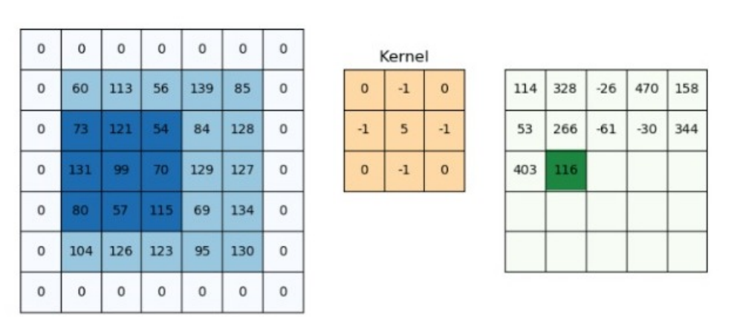

Fig8: ZerPadding2D

image will have the same dimensions as the other photos in the dataset.

1. *Batch Normalization*

During training, the activations of the previous layer in each mini batch are normalized using the batch normalization technique, which is utilized in deep neural networks. MobileNet has a layer called Batch Normalization that can be utilized to enhance the model’s generalization and training abilities. By dividing by the standard deviation of the activations in each mini-batch and removing the mean, the layer normalizes the output of the preceding layer. Next, learnable parameters are used to scale and shift the normalized output. The issue of internal covariate shift, which happens when the distribution of the activations of one-layer changes as the parameters of the preceding layer are modified during training, can be reduced with the aid of batch normalization. This may result in training taking longer and the model performing worse. Batch Normalization enhances the generalization performance of the model by normalizing the activations of each layer during the training process.

1. *ReLU*

Compared to other activation mechanisms, ReLU provides a number of benefits. Since it is just a thresholding operation, it is computationally efficient and simple to implement in hardware. Since it helps to reduce the vanishing gradient problem and enables the network to learn complicated representations, it has been demonstrated to operate effectively in deep networks. ReLU may result in” dead” neurons, which have a constant zero output. This is a potential drawback. This may occur if the network’s weights are set up so that the neuron only ever receives negative input. This has led to the development of ReLU variations as LeakyReLU and ELU, which feature a tiny slope for negative input values to prevent dead neurons, to alleviate the issue.

1. *DepthwiseConv2D*

In order to create the building blocks that are stacked to create the overall network, depthwiseConv2D layers are often utilized in conjunction with pointwise convolutions. The models produced by these building blocks are compact and precise for tasks like object detection and picture classification because they strike a compromise between computational efficiency and expressive power.

1. *Conv2D*

In a Conv2D layer, a series of filters are used to execute the convolution operation on the entire input tensor, producing a set of feature maps. A tiny weights matrix is learned for each filter during training. The filter is moved over the input tensor throughout the convolution operation, and the dot product between the input values and filter weights at each position is calculated. The output feature map’s output value is created by adding the obtained values together.

1. *GlobalAveragePooling*

For image classification and other computer vision tasks, MobileNet and other convolutional neural networks use global average pooling (GAP), a form of pooling layer. A fixed-size window is applied to each feature map in a typical pooling layer, and the maximum, average, or other function is applied to the values inside the window to create a single output value. As opposed to this, global average pooling produces a single output value for each channel by applying the average function to the whole feature map.

1. *Dense Layer*

After feature extraction layers like Conv2D, DepthwiseConv2D, and Global Average Pooling in MobileNet, dense layers are often employed as the network’s last layer(s). One or more Dense layers carry out the classification or regression task after flattening the output of the feature extraction layers.

## Building a CNN transfer using MobileNet

Getting the data ready for CNN training is the first step. In order to do this, the data is often divided into training, validation, and testing sets. Moreover, the images are preprocessed by being scaled to a given size and having their pixel values normalised. The last layers that are particular to the ImageNet dataset, which MobileNet was initially trained on, must be taken out before loading the MobileNet model. These layers consist of the final Dense layer and the Global Average Pooling layer (s). After loading the MobileNet model, further custom layers can be added to complete the required classification task. One or more Dense layers with the right number of neurons for the classification task are often added along with a new Global Average Pooling layer in this manner. The MobileNet layers are frozen using the trainable feature to stop the weights from changing during training. The correct loss function, optimizer, and evaluation metrics are then included in the model’s compilation for the classification task. The last stage is to train the model using the training data, employing methods like early stopping and data augmentation to avoid overfitting. After the model has been trained, its performance may be evaluated using the validation and test sets. In order to do the specific classification task, the model can also be utilised to create predictions about fresh photos.

## Object Recognition

The process of finding a specific target object in a collection of photos or a video is known as object recognition in image processing. Any object has a variety of features that can be taken from an image to create an object’s feature detail. These features stand for the object’s best qualities. Then, one can use the information derived from a training target image to detect the object while attempting to locate it inside the entire test image, which also includes other objects. In systems that monitor a driver’s behaviour and warn them if they are distracted or not paying attention to the road, MobileNet can be utilised for object recognition. The network can be trained on a dataset of photos including various distractions, such as using a phone, eating, or adjusting the radio, in order to employ MobileNet for driver distraction detection. Images showing the driver in a focused, undistracted condition should also be included in the training data. The network gains the ability to distinguish between distracted states and various sorts of distractions during training.

## Softmax Classifier

To detect driver distraction, the softmax classifier must first categorize the driver's current condition using the input data. A typical neural network layer used for classification problems is the softmax classifier. It uses the supplied data to generate a probability distribution over the various distraction classes, including chatting on a cell phone, eating, napping, and not paying attention while driving. Periodically, distracted driving warnings are generated using the softmax classifier's output.

## Width and Resolution Multiplier

We employ MobileNet's width multiplier to create a new, more compact model with a suitable trade-off between accuracy, latency, and size. The constant of the width multiplier is always smaller than 1. Costs and parameters are reduced by the resolution multiplier. Reduced representation results. The multiplier constant for resolution is never more than 1.

# Simulating Results

A dataset is a group of linked data that has been arranged and formatted in a certain way for a given function. It may be kept in a variety of formats, including spreadsheets, databases, or text files, and may contain a variety of data types, including numerical, category, textual, or multimedia data. A dataset, as used in computer science and machine learning, is a group of data that has been categorised and arranged for a particular use.

In driver distraction detection using MobileNet algorithm, various driver distraction images are used as data sets for both training and testing data set images. A total of about 102150 dataset images have been collected, in which 22424 are training images and 79726 are for testing. Images are of different categories like driver using mobile phone on different hands, driver drinking, driving turning around and other driver distractions. There are a total of 10 categories in training data set. Ten categories include driving using mobile phone on left hand, driver using mobile phone on right hand, driver drinking or eating with left hand, driver drinking or eating with right hand, driver using radio, driver talking to other passenger, driver talking to someone on phone with left hand, driver talking in phone with right hand, driver reaching out back seat and driver adjusting hair or his or her hands on face. Every image is taken from jpg form. Based on type or stride of convolution input size of dataset image is changed by model. Total data set is around 5.2 GB. This takes a lot of space in laptop or desktop. More number of data sets allows us to get more accuracy with greater range of results.

Based on the input image, the outcome of the driver distraction detection using MobileNet is a forecast of whether the driver is distracted or not. A sizable collection of pictures of distracted and not-distracted drivers is used to train the MobileNet model.

In the present model, when the model was trained with ten different categories which include driving using mobile phone on left hand, driver using mobile phone on right hand, driver drinking or eating with left hand, driver drinking or eating with right hand, driver using radio, driver talking to other passenger, driver talking to someone on phone with left hand, driver talking in phone with right hand, driver reaching out back seat and driver adjusting hair or his or her hands on face, then the testing images were sent for testing.

Some of the outputs of tested images are displayed below which include driver operating radio, driver texting on mobile phone in left hand, driver reaching behind, driver talking to passenger, driver drinking, driver talking on the phone with right hand. These are some of the results which we observed while testing the images.

Fig9: Output of driver operating the radio.

Fig10: Output of driver talking to a passenger.

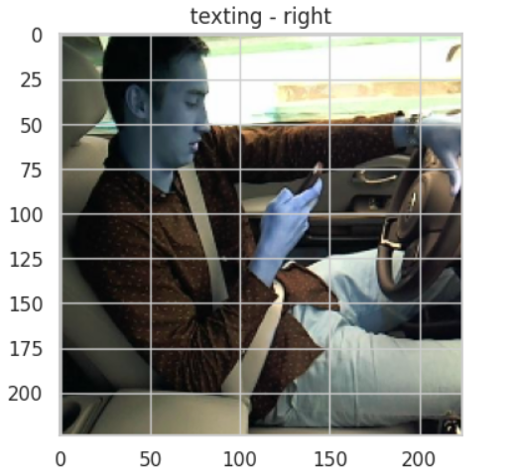

Fig11: Output of driver texting with right hand.

Fig12: Output of driver talking on phone.

Fig13: Output of driver texting with left hand

Then the CNN dropout accuracy of both training and testing images was observed. In the below figure, training accuracy is represented in black colour and testing accuracy is represented in red colour. The line style is solid and each value is marked with a square in the graph below. The training accuracy was observed to be 91.51 after 21 epochs. It remained high that is more than 80 from 10 epochs. Highest accuracy of 91.51 was recorded at 21st epoch. Highest validation accuracy was observed to be 84.89. Testing accuracy remained above 80 from initial epochs as observed in the graph below.

Fig14: Model Performance.

The CNN dropout loss of training and testing is observed as per the figure below. Training loss is represented in black colour and testing loss is shown in red colour in the below figure. Points where the losses are recorded are shown by square symbols. The line style remains solid. The dropout loss of both training and testing kept decreasing as the epochs increased. Minimum training loss was observed at 21st epoch which is 0.2619. Minimum validation loss was observed to be 0.39.

Overall, the accuracy of the model remains high with less loss. The model gives faster output when compared to other CNN models. It is easy to use and saves time with less effort. It is smaller and compatible when compared to other models which gives user a benefit of use. Using MobileNet in this model have given many benefits like speed, more accuracy, compatibility and saves time as well.

Accuracy can be used to gauge a classification model's performance. Commonly, it is expressed as a percentage. Accuracy is the percentage of forecasts when the anticipated value and actual value agree. As the figure below, shows the CNN dropout accuracy which is compared among the training and validation accuracies which is approximately around 84.1% after 5 epochs in the validation and in contrast the training accuracy is gradually improved as the number of epochs increases. After, 20 epochs both the accuracies are high above 75%. Training accuracy reaches 85.89% of accuracy.

Fig15: CNN Dropout Accuracy Training vs Testing.

Overall, the accuracy of the model remains high with less loss. The model gives faster output when compared to other CNN models. It is easy to use and saves time with less effort. It is smaller and compatible when compared to other models which gives user a benefit of use. Using MobileNet in this model have given many benefits like speed, more accuracy, compatibility and saves time as well.

Fig16: CNN Dropout Loss Training vs Testing.

# Conclusion

Driver Distraction detection would be a useful tool for drivers, passengers as well as pedestrians walking or crossing on road. As a result, driver distraction utilizing MobileNet is a promising strategy for enhancing traffic safety. With a trade-off between accuracy and computing economy, MobileNet is a cutting-edge deep learning architecture that is designed for mobile. The goal of lowering traffic accidents and enhancing road safety can be achieved in part through the promising research and development field of driver distraction detection using MobileNet. This method can be widely used and implemented in a variety of applications and settings, from private vehicles to business fleets, from urban to rural locations, and from developed to developing countries, thanks to the growing availability and affordability of mobile and embedded devices. Deep learning and mobile computing have the potential to improve everyone’s quality of life by enhancing the efficiency and safety of our roads.

To give a more thorough and precise evaluation of driver distraction, MobileNet can be combined with a variety of sensors and modalities, including cameras, microphones, accelerometers, and GPS. Transfer learning is a method that lets a pre-trained model, like MobileNet, be tailored for a particular job or domain, like detecting driver distraction. Testing in the real world is an essential stage in assessing the performance and efficacy of driver distraction detection systems in terms of their precision, dependability, and user acceptance. In order to better understand and fix the systems’ shortcomings and difficulties, we can test them in a variety of driving scenarios and surroundings, such as highways, cities, or varied weather conditions.

Notwithstanding these difficulties, driver distraction detection utilizing MobileNet remains a potential strategy for enhancing traffic safety and lowering accidents brought on by distracted drivers. It can notify the driver and other road users, stop accidents, and save lives by instantly identifying distracted drivers. This is preferred for better accuracy, smaller compatible models and faster models.

Future possibilities for driver distraction detection using MobileNet can improve its effectiveness, usefulness, and impact. We can create more precise, reliable, and user-friendly solutions that can help achieve the objective of lowering traffic accidents and enhancing road safety by utilising the most recent advancements in deep learning, mobile computing, and human-machine interaction.

##### References

1. P Baby Shamini; M. Vinodhini; B Keerthana; S Lakshna; K R Meenatchi. Driver Drowsiness Detection based on Monitoring of Eye Blink Rate. 4th International Conference on Smart Systems and Inventive Technology (ICSSIT), 2022.
2. Ioana-Raluca Adochiei; Oana-Isabela S,tirbu; Narcis Iulian Adochiei; Matei Pericle-Gabriel; Ciprian-Marius Larco; Stefan-Mircea Mustata; Diana Costin. Drivers’ Drowsiness Detection and Warning Systems for Critical Infrastructures. International Conference on e-Health and Bioengineering (EHB), 2020.
3. Nawazish Ali; Imran Hasan; Tansel Ozyer; Reda Alhajj. Driver Drowsiness Detection by Employing CNN and Dlib. 22nd International Arab Conference on Information Technology (ACIT), 2021..
4. Riadh Ayachi; Mouna Afif; Yahia Said; Abdessalem Ben Abdelali. Drivers Fatigue Detection Using EfficientDet In Advanced Driver Assistance Systems. 18th International Multi-Conference on Systems, Signals Devices (SSD), 2021.
5. Le-Anh Tran; Truong-Dong Do; Dong-Chul Park; My-Ha Le. Enhancement of Robustness in Object Detection Module for Advanced Driver Assistance Systems. International Conference on System Science and Engineering (ICSSE), 2021.
6. Cheng-Hsiung Hsieh; Dung-Ching Lin; Cheng-Jia Wang; Zong-Ting Chen; Jiun-Jian Liaw. Real-Time Car Detection and Driving Safety Alarm System With Google Tensorflow Object Detection API. International Conference on Machine Learning and Cybernetics (ICMLC), 2019.
7. Jie Xie; Allaa R. Hilal; Dana Kulic. Driver Distraction Recognition Based on Smartphone Sensor Data. IEEE International Conference on Systems, Man, and Cybernetics (SMC), 2018.
8. Jang Woon Baek; Byung-Gil Han; Kwang-Ju Kim; Yun-Su Chung; Soo-In Lee. Real-Time Drowsiness Detection Algorithm for Driver State Monitoring Systems. Tenth International Conference on Ubiquitous and Future Networks (ICUFN), 2018.
9. C. V Anilkumar; Mansoor Ahmed; R Sahana; R Thejashwini; P. S Anisha. Design of drowsiness, heart beat detection system and alertness indicator for driver safety. IEEE International Conference on Recent Trends in Electronics, Information Communication Technology (RTEICT), 2016.
10. Omar Wathiq; Bhavna D Ambudkar. Optimized driver safety through driver fatigue detection methods. International Conference on Trends in Electronics and Informatics (ICEI), 2017.
11. Matti Kutila; Maria Jokela; Gustav Markkula; Maria Romera Rue. Driver Distraction Detection with a Camera Vision System. IEEE International Conference on Image Processing, 2007.
12. Whui Kim; Hyun-Kyun Choi; Byung-Tae Jang; Jinsu Lim. Driver distraction detection using single convolutional neural network. International Conference on Information and Communication Technology Convergence (ICTC), 2017.
13. Walid Hussein; M. Samir Abou El-Seoud. Improved Driver Drowsiness Detection Model Using Relevant Eye Image’s Features. European Conference on Electrical Engineering and Computer Science (EECS), 2017.
14. Peter Hermannst adter; Bin Yang. Driver Distraction Assessment Using Driver Modeling. IEEE International Conference on Systems, Man, and Cybernetics, 2013.
15. Jie Xie; Allaa R. Hilal; Dana Kulic. Driver Distraction Recognition Based on Smartphone Sensor Data. IEEE International Conference on Systems, Man, and Cybernetics (SMC), 2018.