**DOCUMENTATION OF TYKE PROJECT FOLLOW**

* LANDING SCREEN TOUCH **GET STARTED** BUTTON FOR REGISTRATION - **SIGN UP PAGE** ( FIRST NAME, LAST NAME , EMAIL, SIGN UP BUTTON ) VALADITION ERROR MESSAGE ( FOR ALL FIELS – ‘**’PLEASE FILL THIS FIELD’’)**  OR **SIGN UP WITH GOOGLE**
* 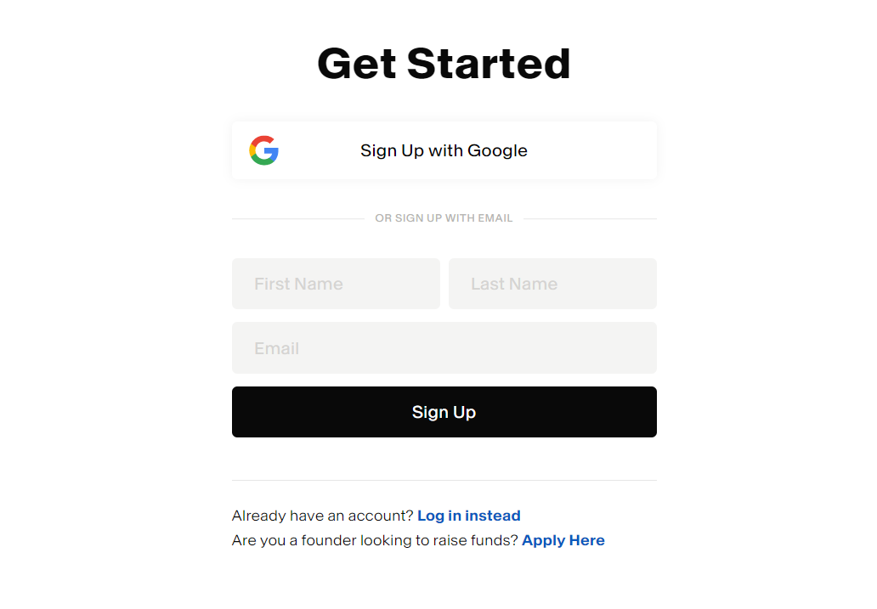
* ONCE WE SIGN UP ITS MOVED TO **OTP PAGE** OTP WILL GET IN YOUR **EMAIL –** ( 6 DIGITS NUMBER FILED BOX , NEXT BUTTON ) VALADITION ERROR MESSAGE ( ‘**’PLEASE FILL 6 DIGITS CODE** ’’)PRESS  **NEXT BUTTON**
* 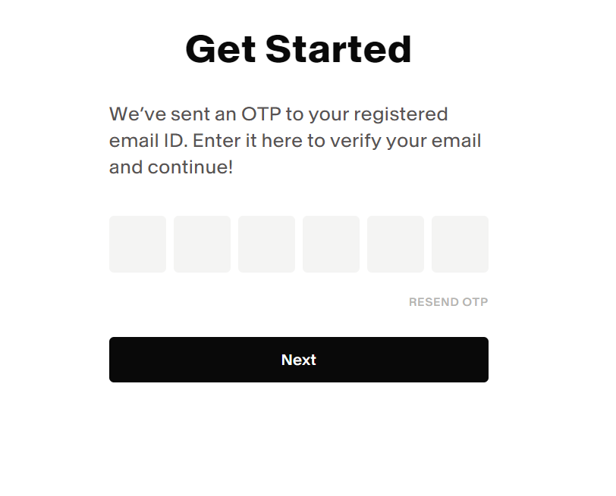
* THEN ITS MOVED TO **TELL ME ABOUT YOUR SELF PAGE** DROPDOWN OF COUNTROIES ( NATIONALITY ,COUNTRY OF RESIDENCY, NEXT BUTTON ) VALADITION ERROR MESSAGE(FOR ALL FIELS – ‘**’PLEASE FILL THIS FIELD’’)**
* THEN ITS MOVED TO **BECOME AN INVESTORES PAGE** ( 1. **RISK** (SWITCH BUTTON ) ,2.**LIMITED** **TRANSFER** (SWITCH BUTTON ), **Diversification**(SWITCH BUTTON ), **CANCELLATION** (SWITCH BUTTON ), **RESERCH** (SWITCH BUTTON ), FINISHED BUTTON * WANT TO SELECT ALL SWITCH BUTTON THEN ONLY ITS MOVED TO INVESTOR INTERSETED PAGE
* 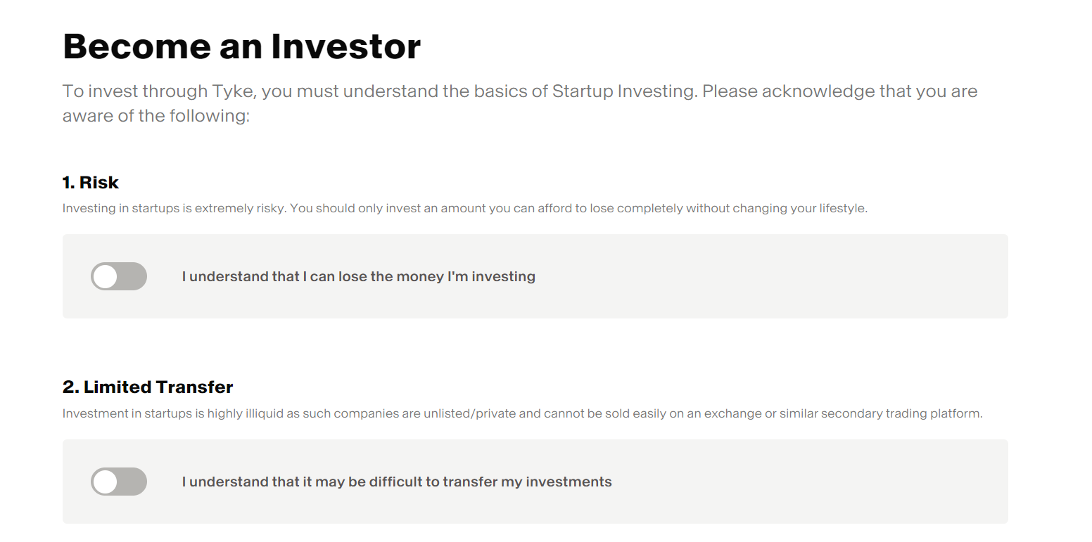
* IN INVESTOR INTERSETED IN PAGE * **INVESTOR WANT TO SELECT IN WHICH PRODUCT & IN WHICH BASE HE GOING TO INVES**
* **THEN ITS MOVED TO DASHBOARD**

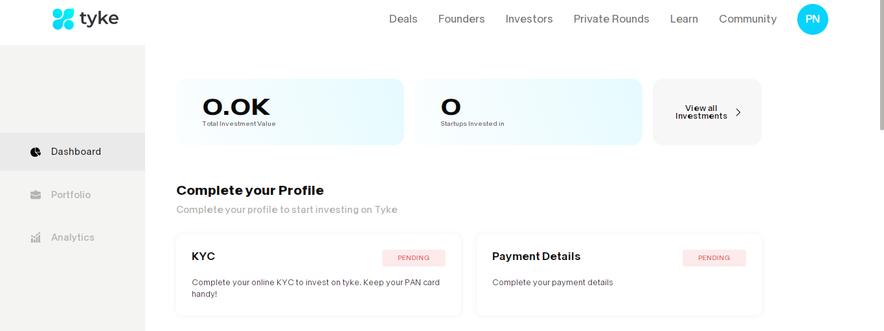

* IN THAT DASHBOARD NAVLINK HAS (DEALS,FOUNDER,INVESTORS,PRAVITE ROUNDS, LEARN, COMMUNITY)



* **DELAS PAGE**

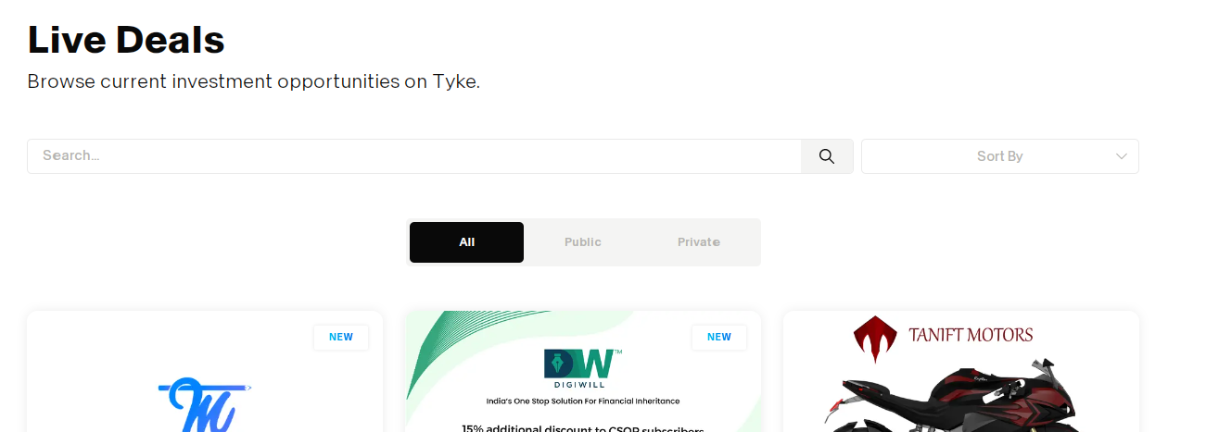

* DELAS PAGE HAVING SEARCH LINK TO FIND THE PRODUCT TO INVES & SORT BY LIST

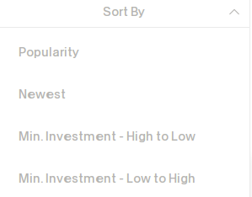

**FOUNDERS PAGE**

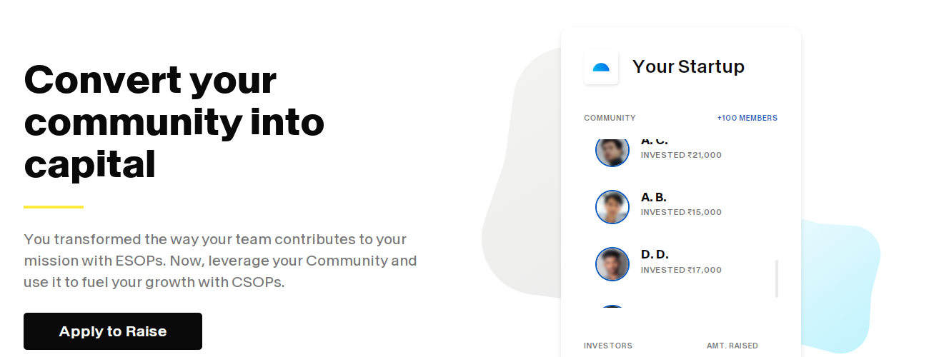

* **CLICK** APPLY TO RAISE BUTTON ITS MOVED TO

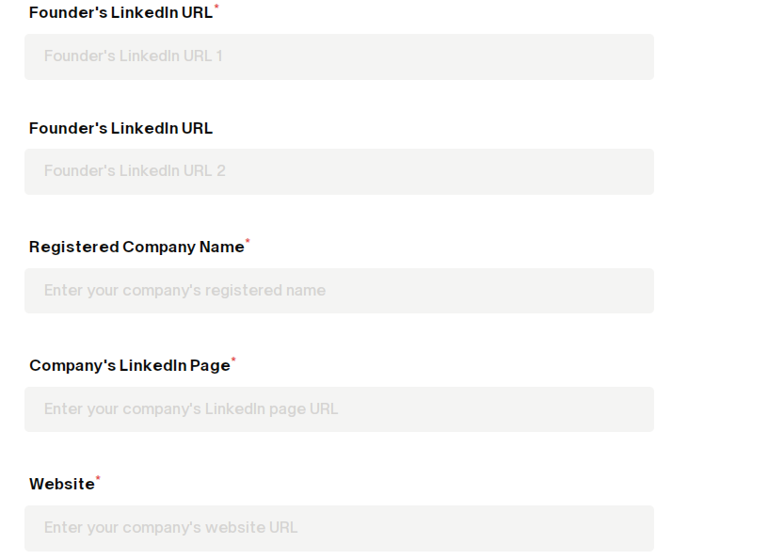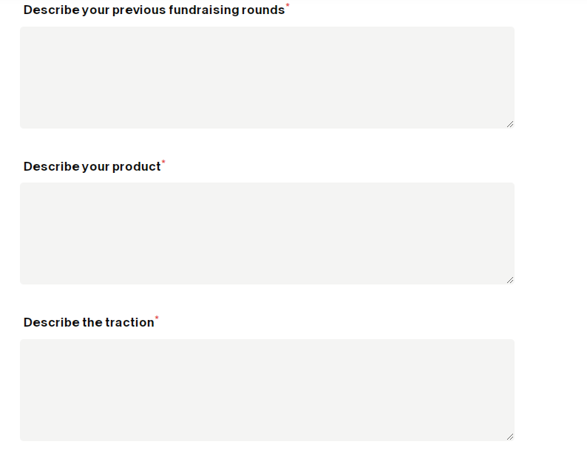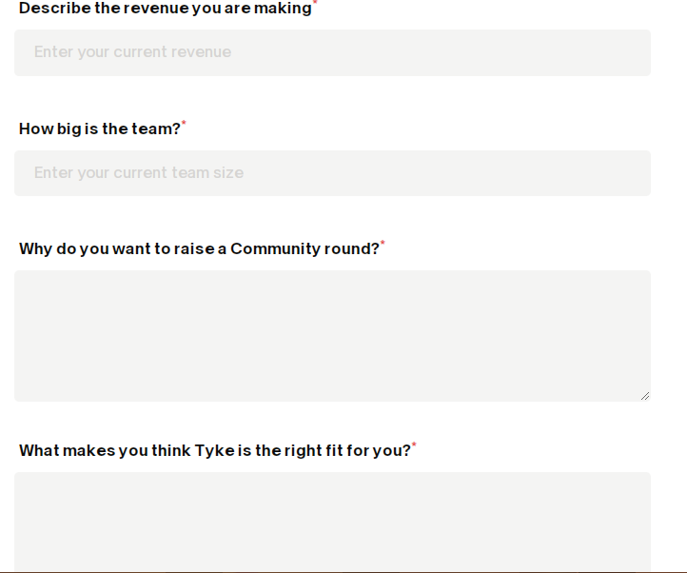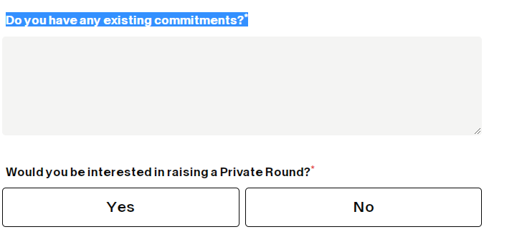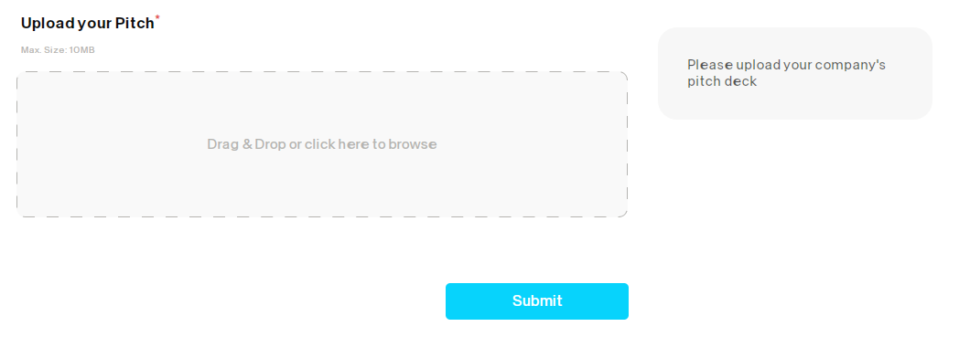

* **CLICK SUBMIT BUTTON ITS MOVED INVESTORS PAGE**

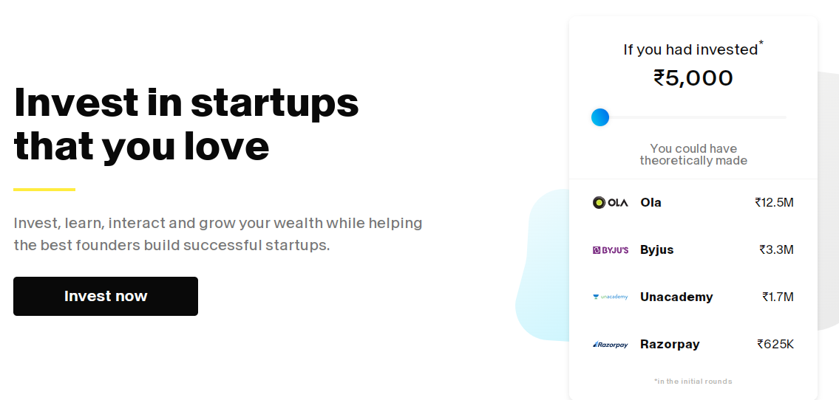

* **CLICK INVEST NOW BUTTON**

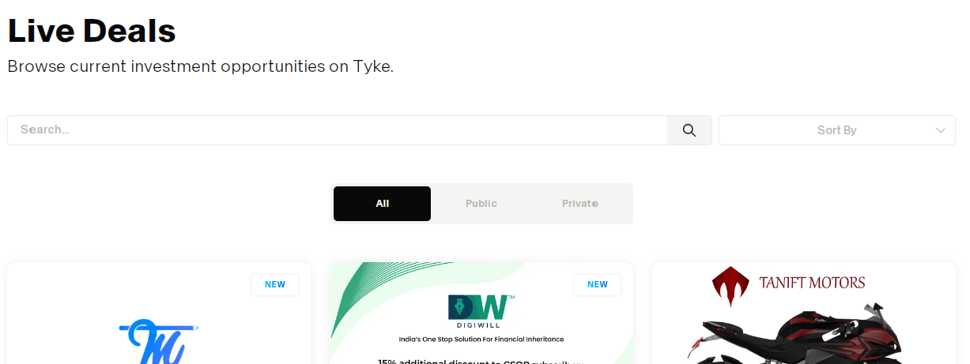

* **THERE ARE THREE BUTTON ALL,PUBLIC,PRIVATE**
* **THEN PRIVATE ROUNDS PAGE**



* **IN THAT PAGE THERE ARE THREE BUTTON FOUNDER ANGEL INVESTOR SYNDICATE**
* **LEARN PAGE ( BLOG PAGE )**

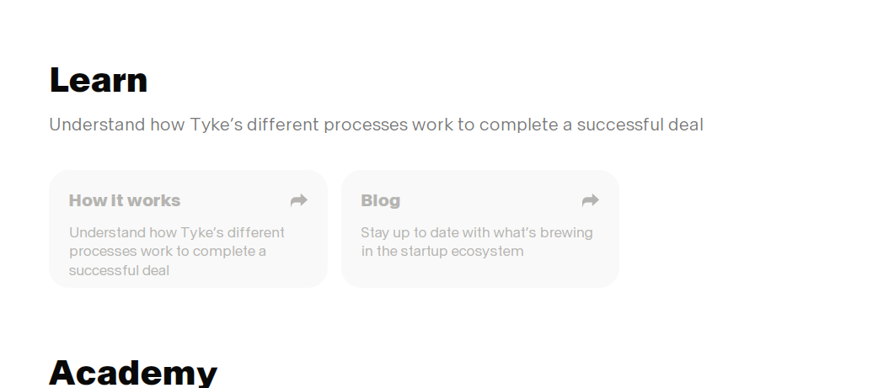

* IN PRIVATE ROUNDS THERE ARE THREE BUTTON **FOUNDR , ANGLE INVESTOR , SYNDICATE** ( **SCHEDULE A CALL** ) OPTION HAVING IF WE CLICK CALL BUTTON CLANDER OPTION IS SHOWING TO FIX DATE TO CALL

