# ­­

# Course: CSIS 3540 – Client Server Systems

# Due Date: 3/04/2019

# Educational Institution: Douglas College

# Instructor: Rahim Virani

# Ana Paulia Ruiz Pontes: 300300914

# Cesar Oliveira Reboucas: 300296145

# Lindsey Gunderson: 300125131

# Project Description

For our project we have decided to create a Cruise Web App and provide an easy layout for the user to filter through the different options for vacation destinations. The user will be able to see how many tours are available and search by different criteria, such as destination locations or the year the ship was built. We have three entities required for this project but we also are including three supporting tables for our main entities. The supporting tables will hold only information to connect the two tables while the main entities will perform the main actions for our program. In addition, our main entities will also contain CRUD operations for additional information to be added to the database.

* Facilities:
  + Includes the attractions that will be found on the ships
* Facilities_ship:
  + Defines a relationship between the facilities
  + Supporting table for the ship
* Cities:
  + Departure cities
  + One way cruise/returns to starting departure city
* Ship:
  + Includes all the specifications for the ship
  + Such as name, id and year it was built.
* Tours:
  + Describes the different tour options
  + Various locations, dates and duration
* Attractions:
  + Defines the different activities available for each cruise

Below we have included a list of the assigned entities for our project.

## General Tasks

|  |  |
| --- | --- |
| Task | Assigned To |
| Attractions and components | Ana |
| Ship Class and components | Ana |
| Cities Class and components | Cesar |
| Tours Class and components | Cesar |
| Facilities and components | Lindsey |
| Facilities_Ship and components | Lindsey |

# Class Diagram

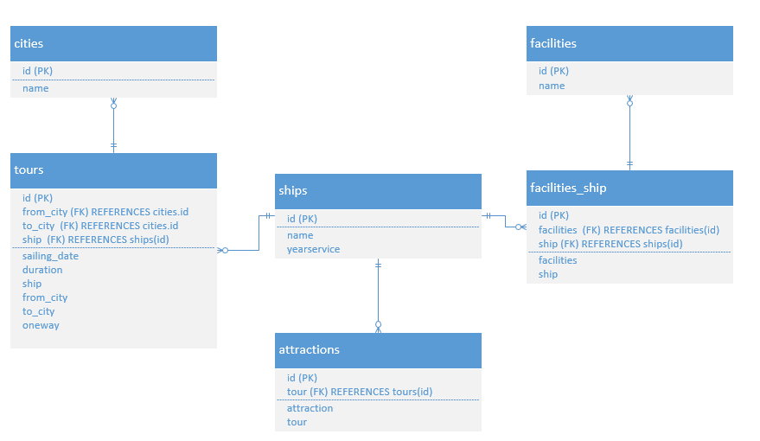

## Minute Meetings

|  |  |
| --- | --- |
| Attendance (who is present for your meeting) |  |
| What was done since the last time the group met (per person)? |  |
| What is working well? |  |
| What is not working well? |  |
| What will be done before the next time the team meets? |  |

|  |  |
| --- | --- |
| Attendance (who is present for your meeting) |  |
| What was done since the last time the group met (per person)? |  |
| What is working well? |  |
| What is not working well? |  |
| What will be done before the next time the team meets? |  |

|  |  |
| --- | --- |
| Attendance (who is present for your meeting) |  |
| What was done since the last time the group met (per person)? |  |
| What is working well? |  |
| What is not working well? |  |
| What will be done before the next time the team meets? |  |

# User Manual

### Navigation

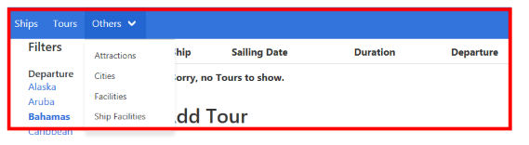

* Use the navigation bar at the top of the page to go to different areas on the webpage.

## Modifying a Tour

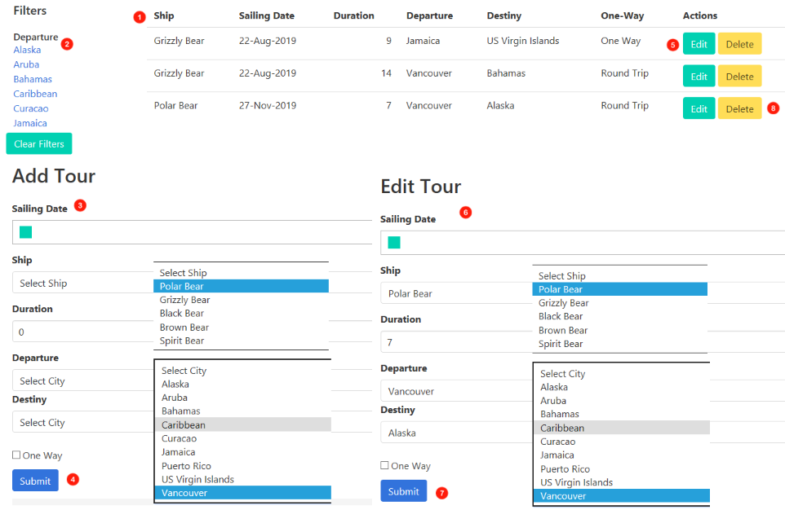

1. Displays a list of available Tours.
2. Tours can be filters and displayed in the list by filters on the side bar.
3. Add a new Tour by filling out the appropriate form data.
4. Press submit button to add the Tour to the list.
5. Edit a Tour by pressing the edit button next to the Tour to be edited.
6. Current Tour data will be filled out and fill in form with new desired output.
7. Press submit button to update the edited information to the list.
8. To delete a Tour, press the delete button located next to the Edit Button.

## Modifying a City

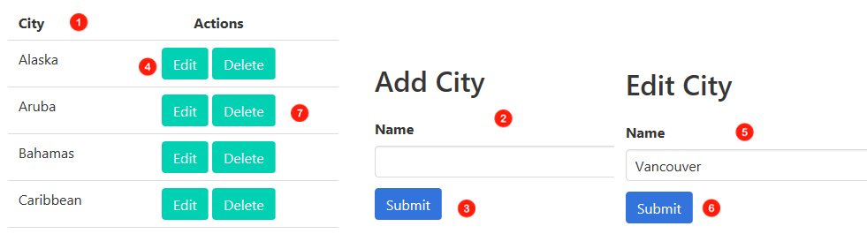

1. Page will display list with current Cities.
2. Add form will be displayed below list to add a new City.
3. Fill in form data and press submit button to add new City to the list.
4. Cities can also be edited, by clicking the edit button.
5. Edit Cities Form will replace the Add form below the list. Form will be populated with selected city data, replace textboxes with new data.
6. Press submit button to update changes to the City and add it to the list.
7. City can be deleted from the list by pressing the delete button.

## Modifying a Ship

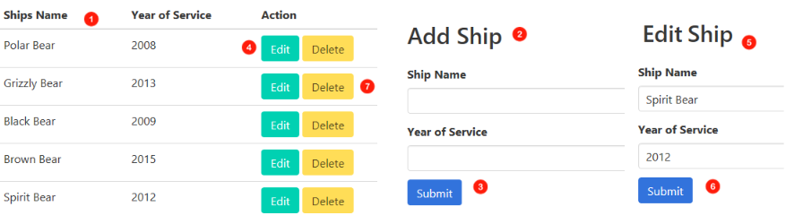­

1. Page will display list with current ships.
2. Add form will be displayed below list to add a new Ship.
3. Fill in form data and press submit button to add new Ship to the list.
4. Ships can also be edited, by clicking the edit button.
5. Edit Ship Form will replace the Add form below the list. Form will be populated with selected ship data, replace textboxes with new data.
6. Press submit button to update changes to the Ship and add it to the list.
7. Ships can be deleted from the list by pressing the delete button.

## Modifying an Attraction

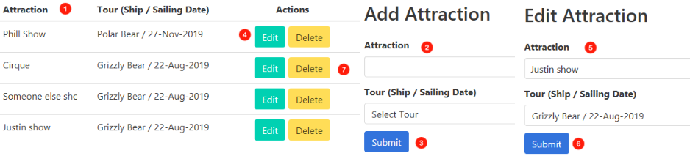

1. Page will display list with current Attractions.
2. Add form will be displayed below list to add a new Attraction.
3. Fill in form data and press submit button to add new Attraction to the list.
4. Attractions can also be edited, by clicking the edit button.
5. Edit Attractions Form will replace the Add form below the list. Form will be populated with selected attraction data, replace textbox and dropdown menu for dates with new data.
6. Press submit button to update changes to the Attractions and add it to the list.
7. Attractions­ can be deleted from the list by pressing the delete button.

### Modifying a Facility

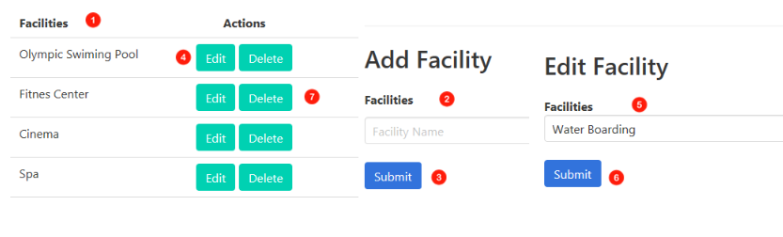

1. Displays a list of current active facilities.
2. To add a new facility, simply type the name of the facility in the textbox.
3. Press the submit button to add it to the list.
4. You can edit a Facility from the list by pressing the edit button.
5. An edit form will replace the add form on the page and the name of the facility being updated will appear in the textbox. Modify the Name in the textbox to desired name.
6. Update the name of Facility by pressing the submit button and it will be updated to the list.
7. To delete a Facility, press the Delete button located next to the Edit button.

### Searching for Ship Facility

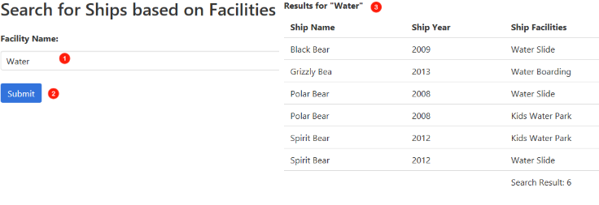

1. Type desired Ship Facility to search for.
2. Press submit button.
3. Search results will appear by ship in a list. If not results are found, results will be 0.

## Modifying a Ship Facility

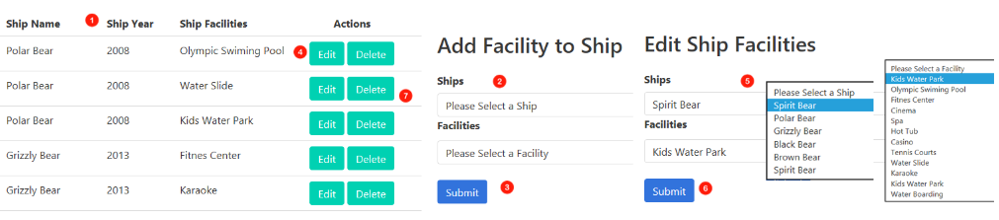

1. Displays a list of current active Ship Facilities.
2. To add a new facility, choose Ship and Facility to add to that ship from dropdown boxes.
3. Press the submit button to add it to the list.
4. You can edit a Ship Facility from the list by pressing the edit button.
5. An edit form will replace the add form on the page. The ship name and Ship Facility will appear in dropdown boxes. Modify the dropdown boxes to desired changes.
6. Press the submit button and edit will be updated to the list.
7. To delete a Ship Facility, press the Delete button located next to the Edit button.