|  |  |
| --- | --- |
| **APP SW Detailed Design** | |
| **Summary** | Software Detailed Design Document of the APP Component |

|  |  |  |
| --- | --- | --- |
| **Author** | **Review** | **Approval** |
| Title: Andreea Suiu | See Project Master Document for the roles and Project Members List for the name of people | See Project Master Document for the roles and Project Members List for the name of people |
|  |  |  |
| **Distribution** | | |
| See Project Master Document for the roles and Project Members List for the name of people | See Project Master Document for the roles and Project Members List for the name of people | See Project Master Document for the roles and Project Members List for the name of people |

# Table of content

1. General Information 3

1.1. Revision history * 3

1.2. Purpose and Scope 3

1.3. Referenced documents 3

1.3.1. External documents 3

1.3.2. Internal Documents 3

1.4. Terminology and definitions 3

2. SW atomic architectural unit design 4

2.1. Overview 4

2.2. Traceability 4

3. FEATURES 4

3.1. Services 4

3.1.1. Service Name 4

3.2. Types 5

3.2.1. Name Structure definition 5

3.3. Variables 5

3.4. Constants 5

4. EEPROM 5

5. Configuration 5

6. Compilation Options 5

# General Information

## Revision history *

|  |  |  |  |
| --- | --- | --- | --- |
| **Revision** | **Date** | **Author(s)** | **Description/comment** |
| 1.0. | 12.08.2022 | Andreea Suiu | First revision. |
| 1.1 | 21.12.2022 | Andreea Suiu | Second revision. |
|  |  |  |  |

*\* Template history is found in the CM tool used for templates*

## Purpose and Scope

The purpose of this document is to provide an overview of the APP SW Component operation principle, and to present the implementation choices in terms of module and function splitting.

## Referenced documents

### External documents

|  |  |  |
| --- | --- | --- |
| **Id** | **Title** | **Reference** |
|  |  |  |
|  |  |  |
|  |  |  |

### Internal Documents

|  |  |  |
| --- | --- | --- |
| **Id** | **Title** | **Reference** |
|  |  |  |
|  |  |  |
|  |  |  |
|  |  |  |

## Terminology and definitions

The generic acronyms are available in the [AEM process and method wiki](https://alvteams.alv.autoliv.int/sites/aeuaeequalityassurance/AEM%20Process%20wiki/acronyms.aspx)

|  |  |
| --- | --- |
| **Terminology** | **Meaning** |
| AAU | Atomic architectural unit |
| SW | software |
|  |  |

# SW Module Detailed Design

## Overview

The aim of the APP component is to make all preparations to guarantee trouble-free programming operation. In this process, it should initialize all layers of the complete stack, to enable and disable interrupts, to implement the unlock flash routine, to indicate the diagnostic session status.

## Traceability

# Features

## Services

### APP_Init

|  |  |  |  |
| --- | --- | --- | --- |
| Object | | | |
| Init function of APP SW Component. Here can be found all init API's of entire bootloader. This function initializes all layers of the complete STACK. EB_Init is called in this API. It shall be called only once at ECU startup. | | | |
| **Prototype** | | | |
| void APP_Init (void) | | | |
| **Detailed Design Requirement** | | | |
| DSG_APP_APP_Init | | | |
| **Architecture Requirement** | | | |
| ARCH_SW_APP_APP_Init | | | |
| **Input parameters** | | | |
| Name | Type | Description | Range |
| NA | NA | NA | NA |
| **Output parameters** | | | |
| Name | Type | Description | Range |
| NA | NA | NA | NA |
| **Return value** | | | |
| Type | Description | | |
| NA | NA | | |
| **Dynamic aspect** | | | |
| Who(callers) | Description | | |
| BM_Prg module. | Called in BM_BootStartUp function. | | |
| **Static aspect** | | | |
| * | | | |
| **Constrains** | | | |
|  | | | |

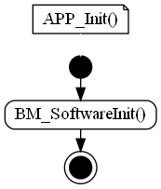

### APP_InterruptDisable

|  |  |  |  |
| --- | --- | --- | --- |
| Object | | | |
| Interrupt disable function of APP SW Component. Interrupts must be suspended. | | | |
| **Prototype** | | | |
| uint8 APP_InterruptDisable (void) | | | |
| **Detailed Design Requirement** | | | |
| DSG_APP_APP_InterruptDisable | | | |
| **Architecture Requirement** | | | |
| ARCH_SW_APP_APP_InterruptDisable | | | |
| **Input parameters** | | | |
| Name | Type | Description | Range |
| NA | NA | NA | NA |
| **Output parameters** | | | |
| Name | Type | Description | Range |
| NA | NA | NA | NA |
| **Return value** | | | |
| Type | Description | | |
| uint8 | KU8_ZERO = always return 0 (Tresos generated function). | | |
| **Dynamic aspect** | | | |
| Who(callers) | Description | | |
| Supplier Flash_TS_T40D2M7I0R0 module. | Called in FLASH_LLD_EraseSector function. | | |
| **Static aspect** | | | |
| * | | | |
| **Constrains** | | | |
| None. | | | |

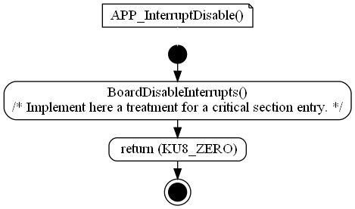

### APP_InterruptEnable

|  |  |  |  |
| --- | --- | --- | --- |
| Object | | | |
| Interrupt enable function of APP SW Component. Interrupts must be resumed. | | | |
| **Prototype** | | | |
| void APP_InterruptEnable (uint8 ebStatus) | | | |
| **Detailed Design Requirement** | | | |
| DSG_APP_APP_InterruptEnable | | | |
| **Architecture Requirement** | | | |
| ARCH_SW_APP_APP_InterruptEnable | | | |
| **Input parameters** | | | |
| Name | Type | Description | Range |
| ebStatus | uint8 | parameter unused from Tresos-generated function |  |
| **Output parameters** | | | |
| Name | Type | Description | Range |
| NA | NA | NA | NA |
| **Return value** | | | |
| Type | Description | | |
| NA | None. | | |
| **Dynamic aspect** | | | |
| Who(callers) | Description | | |
| Supplier Flash_TS_T40D2M7I0R0 module. | Called in FLASH_LLD_EraseSector function. | | |
| **Static aspect** | | | |
| * | | | |
| **Constrains** | | | |
| None. | | | |

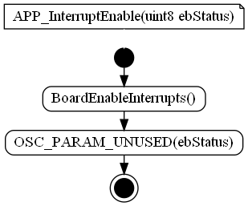

### APP_TpRxInd

|  |  |  |  |
| --- | --- | --- | --- |
| Object | | | |
| Receiver function of APP SW Component (Tresos generated function definition). | | | |
| **Prototype** | | | |
| void APP_TpRxInd (tTpMsgIdx uMsgIdx, u8 ebStatus) | | | |
| **Detailed Design Requirement** | | | |
| DSG_APP_APP_TpRxInd | | | |
| **Architecture Requirement** | | | |
| ARCH_SW_APP_APP_TpRxInd | | | |
| **Input parameters** | | | |
| Name | Type | Description | Range |
| uMsgIdx | tTpMsgIdx | message ID |  |
| ebStatus | unit8 | status |  |
| **Output parameters** | | | |
| Name | Type | Description | Range |
| NA | NA | NA | NA |
| **Return value** | | | |
| Type | Description | | |
| NA | None. | | |
| **Dynamic aspect** | | | |
| Who(callers) | Description | | |
| BlPduR module. | Called in BlPduR_RxInd function. Callback is called: when a message reception is completed, successfully or not. | | |
| **Static aspect** | | | |
| * | | | |
| **Constrains** | | | |
| None. | | | |

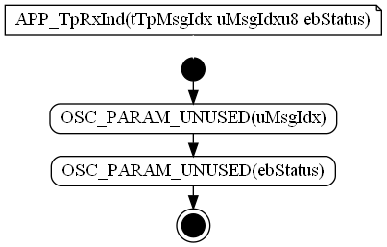

### APP_TpTxConf

|  |  |  |  |
| --- | --- | --- | --- |
| Object | | | |
| Transmitter function of APP SW Component (Tresos generated function definition). | | | |
| **Prototype** | | | |
| void APP_TpTxConf (tTpMsgIdx uMsgIdx, u8 ebStatus) | | | |
| **Detailed Design Requirement** | | | |
| DSG_APP_APP_TpTxConf | | | |
| **Architecture Requirement** | | | |
| ARCH_SW_APP_APP_TpTxConf | | | |
| **Input parameters** | | | |
| Name | Type | Description | Range |
| uMsgIdx | tTpMsgIdx | message ID |  |
| ebStatus | unit8 | status |  |
| **Output parameters** | | | |
| Name | Type | Description | Range |
| NA | NA | NA | NA |
| **Return value** | | | |
| Type | Description | | |
| NA | None. | | |
| **Dynamic aspect** | | | |
| Who(callers) | Description | | |
| BlPduR module. | Called in BlPduR_TxConf function. Callback is called: when a message reception is completed, successfully or not. | | |
| **Static aspect** | | | |
| * | | | |
| **Constrains** | | | |
| None. | | | |

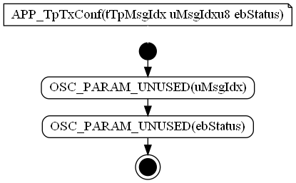

### APP_UdsSessionStatusInd

|  |  |  |  |
| --- | --- | --- | --- |
| Object | | | |
| UDS Session status function of APP SW Component (Tresos generated function definition). | | | |
| **Prototype** | | | |
| void APP_UdsSessionStatusInd (tUdsSessionType eUdsNewSessType, tUdsSessionType eUdsOldSessType, tUdsChangeReason eUdsChangingCause) | | | |
| **Detailed Design Requirement** | | | |
| DSG_APP_APP_UdsSessionStatusInd | | | |
| **Architecture Requirement** | | | |
| ARCH_SW_APP_APP_UdsSessionStatusInd | | | |
| **Input parameters** | | | |
| Name | Type | Description | Range |
| eUdsNewSessType | tUdsSessionType | new session | NA |
| eUdsOldSessType | tUdsSessionType | old session | NA |
| aubUdsData | uint8 | pointer on received data | NA |
| eUdsChangingCause | tUdsChangeReason | the reason of the changing session | NA |
| **Output parameters** | | | |
| Name | Type | Description | Range |
| NA | NA | NA | NA |
| **Return value** | | | |
| Type | Description | | |
| NA | None. | | |
| **Dynamic aspect** | | | |
| Who(callers) | Description | | |
| BlPduR module. | Called in UDS_SessionStatusInd function. | | |
| **Static aspect** | | | |
| * | | | |
| **Constrains** | | | |
| None. | | | |

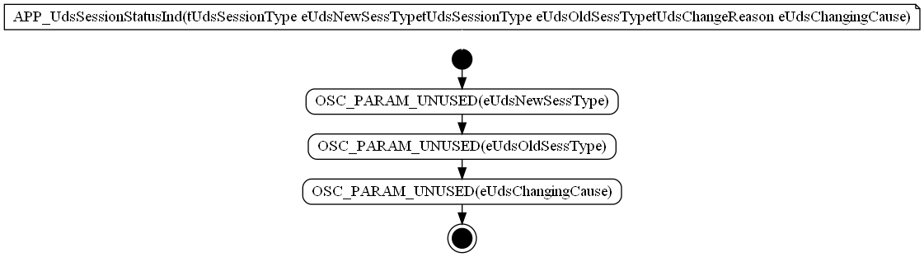

### APP_UnlockFlash

|  |  |  |  |
| --- | --- | --- | --- |
| Object | | | |
| Unlock Flash function of APP SW Component. | | | |
| **Prototype** | | | |
| tUdsStatus APP_UnlockFlash (PduLengthType * pulLen, uint8 * aubUdsData) | | | |
| **Detailed Design Requirement** | | | |
| DSG_APP_APP_UnlockFlash | | | |
| **Architecture Requirement** | | | |
| ARCH_SW_APP_APP_UnlockFlash | | | |
| **Input parameters** | | | |
| Name | Type | Description | Range |
| aubUdsData | uint8 | pointer on request data | NA |
| pulLen | PduLengthType | pointer on data length | NA |
| **Output parameters** | | | |
| Name | Type | Description | Range |
| pulLen | PduLengthType | pointer on data length | NA |
| aubUdsData | uint8 | pointer on received data | NA |
| **Return value** | | | |
| Type | Description | | |
| tUdsStatus | u8ret = Respond with acknowledge code or NRC code. | | |
| **Dynamic aspect** | | | |
| Who(callers) | Description | | |
| Tresos_BSW_generated module. | Tresos_BSW_generated - UDS_Cfg. | | |
| **Static aspect** | | | |
| * | | | |
| **Constrains** | | | |
| None. | | | |



### NCS_SdfVariableRangeError

|  |  |  |  |
| --- | --- | --- | --- |
| Object | | | |
| Variable range error check function of APP SW Component (Tresos generated function definition). | | | |
| **Prototype** | | | |
| void NCS_SdfVariableRangeError (u16 uwParam) | | | |
| **Detailed Design Requirement** | | | |
| DSG_APP_NCS_SdfVariableRangeError | | | |
| **Architecture Requirement** | | | |
| ARCH_SW_APPNCS_SdfVariableRangeError | | | |
| **Input parameters** | | | |
| Name | Type | Description | Range |
| uwParam | uint16 | parameter unused from Tresos-generated function | NA |
| **Output parameters** | | | |
| Name | Type | Description | Range |
| NA | NA | NA | NA |
| **Return value** | | | |
| Type | Description | | |
| NA | None. | | |
| **Dynamic aspect** | | | |
| Who(callers) | Description | | |
| Uds_TS_TxDxM3I17R0 module. | Called in UDS_Prg. | | |
| **Static aspect** | | | |
| * | | | |
| **Constrains** | | | |
| None. | | | |

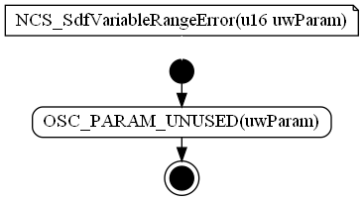

## Variabiles

### stNoIntShareVar

|  |  |  |
| --- | --- | --- |
| Type | Value |  |
| tNoInitShareVar stNoIntShareVar | NA | |
| **Description** | | |
| Shared variable between bootloader and application. Shall be stored in a NoInit area known by both software. | | |
| **Definition** | | |
| tNoInitShareVar stNoIntShareVar [extern] | | |

### stNVMBootloaderData

|  |  |  |
| --- | --- | --- |
| Type | Value |  |
| tNVMBootloaderData stNVMBootloaderData | NA | |
| **Description** | | |
| NVM Bootloader Data (RAM structure of NVM mirror). | | |
| **Definition** | | |
| tNVMBootloaderData stNVMBootloaderData [extern] | | |

## Macros

### NVM_PRESENT

|  |  |
| --- | --- |
| Name | Value |
| NVM_PRESENT | STD_OFF |
| **Definition** | |
| #define NVM_PRESENT STD_OFF | |
| **Description** | |
| Values used to set if NvM is present. | |

### KU8_DATA_ARRAY_LENGTH

|  |  |
| --- | --- |
| Name | Value |
| KU8_DATA_ARRAY_LENGTH | (12U) |
| **Definition** | |
| #define KU8_DATA_ARRAY_LENGTH (12U) | |
| **Description** | |
| KU8_DATA_ARRAY_LENGTH Value definition. | |

### KU8_DATA_ARRAY_START_INDEX

|  |  |
| --- | --- |
| Name | Value |
| KU8_DATA_ARRAY_START_INDEX | (4U) |
| **Definition** | |
| #define KU8_DATA_ARRAY_START_INDEX (4U) | |
| **Description** | |
| KU8_DATA_ARRAY_START_INDEX Value definition. | |

### KU8_DATA_STATUS_POSITION

|  |  |
| --- | --- |
| Name | Value |
| KU8_DATA_STATUS_POSITION | (5U) |
| **Definition** | |
| #define KU8_DATA_STATUS_POSITION (5U) | |
| **Description** | |
| KU8_DATA_STATUS_POSITION Value definition. | |

### KU8_FLASH_ADRESS_POSITION

|  |  |
| --- | --- |
| Name | Value |
| KU8_FLASH_ADRESS_POSITION | (3U) |
| **Definition** | |
| #define KU8_FLASH_ADRESS_POSITION (3U) | |
| **Description** | |
| KU8_FLASH_ADRESS_POSITION Value definition. | |

### KU8_FLASH_ADRESS_VALUE

|  |  |
| --- | --- |
| Name | Value |
| KU8_FLASH_ADRESS_VALUE | (0x45u) |
| **Definition** | |
| #define KU8_FLASH_ADRESS_VALUE (0x45u) | |
| **Description** | |
| KU8_FLASH_ADRESS_VALUE Value definition. | |

### KU8_RECEIVED_DATA_LENGTH

|  |  |
| --- | --- |
| Name | Value |
| KU8_RECEIVED_DATA_LENGTH | (12u) |
| **Definition** | |
| #define KU8_RECEIVED_DATA_LENGTH (12u) | |
| **Description** | |
| KU8_RECEIVED_DATA_LENGTH Value definition. | |

### PROG_BLOCK_INVALID

|  |  |
| --- | --- |
| Name | Value |
| PROG_BLOCK_INVALID | (0x00U) |
| **Definition** | |
| #define PROG_BLOCK_INVALID (0x00U) | |
| **Description** | |
| PROG_BLOCK_INVALID Value definition. | |

### PROG_BLOCK_NBR

|  |  |
| --- | --- |
| Name | Value |
| PROG_BLOCK_NBR | (4U) |
| **Definition** | |
| #define PROG_BLOCK_NBR (4U) | |
| **Description** | |
| PROG_BLOCK_NBR Value definition. | |

### PROG_BLOCK_VALID

|  |  |
| --- | --- |
| Name | Value |
| PROG_BLOCK_VALID | (0x01U) |
| **Definition** | |
| #define PROG_BLOCK_VALID (0x01U) | |
| **Description** | |
| PROG_BLOCK_VALID Value definition. | |

### PROG_COHERENCY_ERR_INVALID_BLOCK

|  |  |
| --- | --- |
| Name | Value |
| PROG_COHERENCY_ERR_INVALID_BLOCK | (4U) |
| **Definition** | |
| #define PROG_COHERENCY_ERR_INVALID_BLOCK (4U) | |
| **Description** | |
| PROG_COHERENCY_ERR_INVALID_BLOCK Value definition. | |

### PROG_COHERENCY_OK

|  |  |
| --- | --- |
| Name | Value |
| PROG_COHERENCY_OK | (0U) |
| **Definition** | |
| #define PROG_COHERENCY_OK (0U) | |
| **Description** | |
| PROG_COHERENCY_OK Value definition. | |

### PROG_ECUPROGINFO_CONSISTENT

|  |  |
| --- | --- |
| Name | Value |
| PROG_ECUPROGINFO_CONSISTENT | (0x40U) |
| **Definition** | |
| #define PROG_ECUPROGINFO_CONSISTENT (0x40U) | |
| **Description** | |
| PROG_ECUPROGINFO_CONSISTENT Value definition. | |

### PROG_ECUPROGINFO_INCONSISTENT

|  |  |
| --- | --- |
| Name | Value |
| PROG_ECUPROGINFO_INCONSISTENT | (0x44U) |
| **Definition** | |
| #define PROG_ECUPROGINFO_INCONSISTENT (0x44U) | |
| **Description** | |
| PROG_ECUPROGINFO_INCONSISTENT Value definition. | |

### PROG_FINGERPRINT_LENGTH

|  |  |
| --- | --- |
| Name | Value |
| PROG_FINGERPRINT_LENGTH | (9U) |
| **Definition** | |
| #define PROG_FINGERPRINT_LENGTH (9U) | |
| **Description** | |
| PROG_FINGERPRINT_LENGTH Value definition. | |

### PROG_INFO_MEMORY_STATUS

|  |  |
| --- | --- |
| Name | Value |
| PROG_INFO_MEMORY_STATUS | (0x08U) |
| **Definition** | |
| #define PROG_INFO_MEMORY_STATUS (0x08U) | |
| **Description** | |
| PROG_INFO_MEMORY_STATUS Value definition. | |

### PROG_INFO_REPROG_STATE_ERASED_END

|  |  |
| --- | --- |
| Name | Value |
| PROG_INFO_REPROG_STATE_ERASED_END | (0x20U) |
| **Definition** | |
| #define PROG_INFO_REPROG_STATE_ERASED_END (0x20U) | |
| **Description** | |
| PROG_INFO_REPROG_STATE_ERASED_END Value definition. | |

### PROG_INFO_REPROG_STATE_ERASED_START

|  |  |
| --- | --- |
| Name | Value |
| PROG_INFO_REPROG_STATE_ERASED_START | (0x10U) |
| **Definition** | |
| #define PROG_INFO_REPROG_STATE_ERASED_START (0x10U) | |
| **Description** | |
| PROG_INFO_REPROG_STATE_ERASED_START Value definition. | |

### PROG_INFO_REPROG_STATE_MASK

|  |  |
| --- | --- |
| Name | Value |
| PROG_INFO_REPROG_STATE_MASK | (0x70U) |
| **Definition** | |
| #define PROG_INFO_REPROG_STATE_MASK (0x70U) | |
| **Description** | |
| PROG_INFO_REPROG_STATE_MASK Value definition. | |

### PROG_INFO_REPROG_STATE_REPROG_START

|  |  |
| --- | --- |
| Name | Value |
| PROG_INFO_REPROG_STATE_REPROG_START | (0x30U) |
| **Definition** | |
| #define PROG_INFO_REPROG_STATE_REPROG_START (0x30U) | |
| **Description** | |
| PROG_INFO_REPROG_STATE_REPROG_START Value definition. | |

### PROG_MAX_NBR_SEG

|  |  |
| --- | --- |
| Name | Value |
| PROG_MAX_NBR_SEG | (5U) |
| **Definition** | |
| #define PROG_MAX_NBR_SEG (5U) | |
| **Description** | |
| PROG_MAX_NBR_SEG Value definition. | |

### PROG_REPROG_FLAG_START_SEC_VAR_NO_INIT_8

|  |  |
| --- | --- |
| Name | Value |
| PROG_REPROG_FLAG_START_SEC_VAR_NO_INIT_8 | NA |
| **Definition** | |
| #define PROG_REPROG_FLAG_START_SEC_VAR_NO_INIT_8 | |
| **Description** | |
| Constant with external linkage. | |

### PROG_REPROG_FLAG_STOP_SEC_VAR_NO_INIT_8

|  |  |
| --- | --- |
| Name | Value |
| PROG_REPROG_FLAG_STOP_SEC_VAR_NO_INIT_8 | NA |
| **Definition** | |
| #define PROG_REPROG_FLAG_STOP_SEC_VAR_NO_INIT_8 | |
| **Description** | |
| Constant with external linkage. | |

# EEPROM

# Configuration

# Compilation Options