|  |  |
| --- | --- |
| **SchM SW Detailed Design** | |
| **Summary** | Software Detailed Design Document of the SchM Component |

|  |  |  |
| --- | --- | --- |
| **Author** | **Review** | **Approval** |
| Title: Andreea Suiu | See Project Master Document for the roles and Project Members List for the name of people | See Project Master Document for the roles and Project Members List for the name of people |
|  |  |  |
| **Distribution** | | |
| See Project Master Document for the roles and Project Members List for the name of people | See Project Master Document for the roles and Project Members List for the name of people | See Project Master Document for the roles and Project Members List for the name of people |

# Table of content

1. General Information 3

1.1. Revision history * 3

1.2. Purpose and Scope 3

1.3. Referenced documents 3

1.3.1. External documents 3

1.3.2. Internal Documents 3

1.4. Terminology and definitions 3

2. SW atomic architectural unit design 4

2.1. Overview 4

2.2. Traceability 4

3. FEATURES 4

3.1. Services 4

3.1.1. Service Name 4

3.2. Types 5

3.2.1. Name Structure definition 5

3.3. Variables 5

3.4. Constants 5

4. EEPROM 5

5. Configuration 5

6. Compilation Options 5

# General Information

## Revision history *

|  |  |  |  |
| --- | --- | --- | --- |
| **Revision** | **Date** | **Author(s)** | **Description/comment** |
| 1.0. | 09.12.2022 | Andreea Suiu | First revision. |
|  |  |  |  |
|  |  |  |  |

*\* Template history is found in the CM tool used for templates*

## Purpose and Scope

The purpose of this document is to provide an overview of the SchM SW Component operation principle, and to present the implementation choices in terms of module and function splitting.

## Referenced documents

### External documents

|  |  |  |
| --- | --- | --- |
| **Id** | **Title** | **Reference** |
|  |  |  |
|  |  |  |
|  |  |  |

### Internal Documents

|  |  |  |
| --- | --- | --- |
| **Id** | **Title** | **Reference** |
|  |  |  |
|  |  |  |
|  |  |  |
|  |  |  |

## Terminology and definitions

The generic acronyms are available in the [AEM process and method wiki](https://alvteams.alv.autoliv.int/sites/aeuaeequalityassurance/AEM%20Process%20wiki/acronyms.aspx)

|  |  |
| --- | --- |
| **Terminology** | **Meaning** |
| AAU | Atomic architectural unit |
| SW | software |
|  |  |

# SW Module Detailed Design

## Overview

The aim of the SchM component is to manage (enable/disable) the interrupts when an event occurs in different exclusive areas.

## Traceability

# Features

## Services

### SchM_Enter_Can_CAN_EXCLUSIVE_AREA_02

|  |  |  |  |
| --- | --- | --- | --- |
| Object | | | |
| This function is used to disable interrupts when an event occurs (Can module). | | | |
| **Prototype** | | | |
| EXPORTED void SchM_Enter_Can_CAN_EXCLUSIVE_AREA_02 (void) | | | |
| **Precondition** | | | |
| None. | | | |
| **Detailed Design Requirement** | | | |
| DSG_SchM_SchM_Enter_Can_CAN_EXCLUSIVE_AREA_02 | | | |
| **Architecture Requirement** | | | |
| ARCH_SW_SchM_Enter_Can_CAN_EXCLUSIVE_AREA_02 | | | |
| **Input parameters** | | | |
| Name | Type | Description | Range |
| NA | NA | NA | NA |
| **Output parameters** | | | |
| Name | Type | Description | Range |
| NA | NA | NA | NA |
| **Return value** | | | |
| Type | Description | | |
| NA | None. | | |
| **Dynamic aspect** | | | |
| Who(callers) | Description | | |
| Can_TS_T40D2M10I2R0 module. | Called in Can_FlexCan_Write function. | | |
| **Static aspect** | | | |
| * | | | |
| **Constrains** | | | |
| None. | | | |

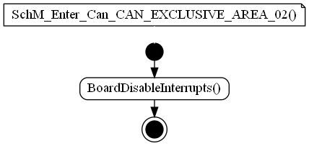

### SchM_Enter_Can_CAN_EXCLUSIVE_AREA_03

|  |  |  |  |
| --- | --- | --- | --- |
| Object | | | |
| This function is used to disable interrupts when an event occurs (Can module). | | | |
| **Prototype** | | | |
| EXPORTED void SchM_Enter_Can_CAN_EXCLUSIVE_AREA_03 (void) | | | |
| **Precondition** | | | |
| None. | | | |
| **Detailed Design Requirement** | | | |
| DSG_SchM_SchM_Enter_Can_CAN_EXCLUSIVE_AREA_03 | | | |
| **Architecture Requirement** | | | |
| ARCH_SW_SchM_Enter_Can_CAN_EXCLUSIVE_AREA_03 | | | |
| **Input parameters** | | | |
| Name | Type | Description | Range |
| NA | NA | NA | NA |
| **Output parameters** | | | |
| Name | Type | Description | Range |
| NA | NA | NA | NA |
| **Return value** | | | |
| Type | Description | | |
| NA | None. | | |
| **Dynamic aspect** | | | |
| Who(callers) | Description | | |
| Can_TS_T40D2M10I2R0 module. | Called in Can_FlexCan_GotoFreezeMode function. | | |
| **Static aspect** | | | |
| * | | | |
| **Constrains** | | | |
| None. | | | |

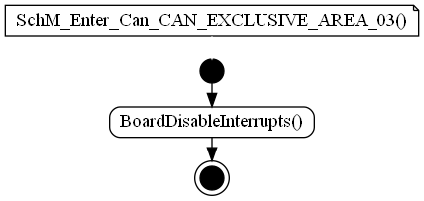

### SchM_Enter_Can_CAN_EXCLUSIVE_AREA_04

|  |  |  |  |
| --- | --- | --- | --- |
| Object | | | |
| This function is used to disable interrupts when an event occurs (Can module). | | | |
| **Prototype** | | | |
| EXPORTED void SchM_Enter_Can_CAN_EXCLUSIVE_AREA_04 (void) | | | |
| **Precondition** | | | |
| None. | | | |
| **Detailed Design Requirement** | | | |
| DSG_SchM_SchM_Enter_Can_CAN_EXCLUSIVE_AREA_04 | | | |
| **Architecture Requirement** | | | |
| ARCH_SW_SchM_Enter_Can_CAN_EXCLUSIVE_AREA_04 | | | |
| **Input parameters** | | | |
| Name | Type | Description | Range |
| NA | NA | NA | NA |
| **Output parameters** | | | |
| Name | Type | Description | Range |
| NA | NA | NA | NA |
| **Return value** | | | |
| Type | Description | | |
| NA | None. | | |
| **Dynamic aspect** | | | |
| Who(callers) | Description | | |
| Can_TS_T40D2M10I2R0 module. | Called in Can_FlexCan_ResetController function. | | |
| **Static aspect** | | | |
| * | | | |
| **Constrains** | | | |
| None. | | | |

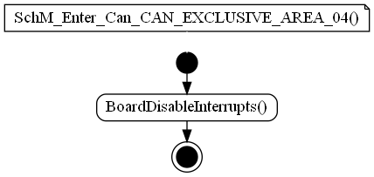

### SchM_Enter_Can_CAN_EXCLUSIVE_AREA_05

|  |  |  |  |
| --- | --- | --- | --- |
| Object | | | |
| This function is used to disable interrupts when an event occurs (Can module). | | | |
| **Prototype** | | | |
| EXPORTED void SchM_Enter_Can_CAN_EXCLUSIVE_AREA_05 (void) | | | |
| **Precondition** | | | |
| None. | | | |
| **Detailed Design Requirement** | | | |
| DSG_SchM_SchM_Enter_Can_CAN_EXCLUSIVE_AREA_05 | | | |
| **Architecture Requirement** | | | |
| ARCH_SW_SchM_Enter_Can_CAN_EXCLUSIVE_AREA_05 | | | |
| **Input parameters** | | | |
| Name | Type | Description | Range |
| NA | NA | NA | NA |
| **Output parameters** | | | |
| Name | Type | Description | Range |
| NA | NA | NA | NA |
| **Return value** | | | |
| Type | Description | | |
| NA | None. | | |
| **Dynamic aspect** | | | |
| Who(callers) | Description | | |
| Can_TS_T40D2M10I2R0 module. | Called in Can_FlexCan_ResetController function. | | |
| **Static aspect** | | | |
| * | | | |
| **Constrains** | | | |
| None. | | | |

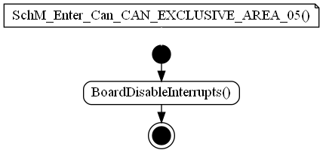

### SchM_Enter_Can_CAN_EXCLUSIVE_AREA_06

|  |  |  |  |
| --- | --- | --- | --- |
| Object | | | |
| This function is used to disable interrupts when an event occurs (Can module). | | | |
| **Prototype** | | | |
| EXPORTED void SchM_Enter_Can_CAN_EXCLUSIVE_AREA_06 (void) | | | |
| **Precondition** | | | |
| None. | | | |
| **Detailed Design Requirement** | | | |
| DSG_SchM_SchM_Enter_Can_CAN_EXCLUSIVE_AREA_06 | | | |
| **Architecture Requirement** | | | |
| ARCH_SW_SchM_Enter_Can_CAN_EXCLUSIVE_AREA_06 | | | |
| **Input parameters** | | | |
| Name | Type | Description | Range |
| NA | NA | NA | NA |
| **Output parameters** | | | |
| Name | Type | Description | Range |
| NA | NA | NA | NA |
| **Return value** | | | |
| Type | Description | | |
| NA | None. | | |
| **Dynamic aspect** | | | |
| Who(callers) | Description | | |
| Can_TS_T40D2M10I2R0 module. | Called in Can_FlexCan_SetControllerToStopMode function. | | |
| **Static aspect** | | | |
| * | | | |
| **Constrains** | | | |
| None. | | | |

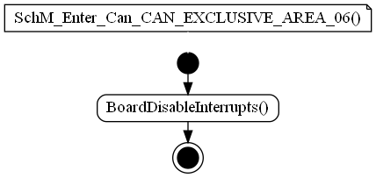

### SchM_Enter_Can_CAN_EXCLUSIVE_AREA_07

|  |  |  |  |
| --- | --- | --- | --- |
| Object | | | |
| This function is used to disable interrupts when an event occurs (Can module). | | | |
| **Prototype** | | | |
| EXPORTED void SchM_Enter_Can_CAN_EXCLUSIVE_AREA_07 (void) | | | |
| **Precondition** | | | |
| None. | | | |
| **Detailed Design Requirement** | | | |
| DSG_SchM_SchM_Enter_Can_CAN_EXCLUSIVE_AREA_07 | | | |
| **Architecture Requirement** | | | |
| ARCH_SW_SchM_Enter_Can_CAN_EXCLUSIVE_AREA_07 | | | |
| **Input parameters** | | | |
| Name | Type | Description | Range |
| NA | NA | NA | NA |
| **Output parameters** | | | |
| Name | Type | Description | Range |
| NA | NA | NA | NA |
| **Return value** | | | |
| Type | Description | | |
| NA | None. | | |
| **Dynamic aspect** | | | |
| Who(callers) | Description | | |
| Can_TS_T40D2M10I2R0 module. | Called in Can_FlexCan_DisableInterrupts function. | | |
| **Static aspect** | | | |
| * | | | |
| **Constrains** | | | |
| None. | | | |

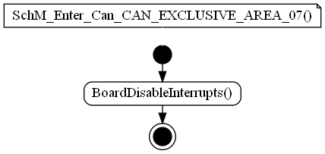

### SchM_Enter_Can_CAN_EXCLUSIVE_AREA_08

|  |  |  |  |
| --- | --- | --- | --- |
| Object | | | |
| This function is used to disable interrupts when an event occurs (Can module). | | | |
| **Prototype** | | | |
| EXPORTED void SchM_Enter_Can_CAN_EXCLUSIVE_AREA_08 (void) | | | |
| **Precondition** | | | |
| None. | | | |
| **Detailed Design Requirement** | | | |
| DSG_SchM_SchM_Enter_Can_CAN_EXCLUSIVE_AREA_08 | | | |
| **Architecture Requirement** | | | |
| ARCH_SW_SchM_Enter_Can_CAN_EXCLUSIVE_AREA_08 | | | |
| **Input parameters** | | | |
| Name | Type | Description | Range |
| NA | NA | NA | NA |
| **Output parameters** | | | |
| Name | Type | Description | Range |
| NA | NA | NA | NA |
| **Return value** | | | |
| Type | Description | | |
| NA | None. | | |
| **Dynamic aspect** | | | |
| Who(callers) | Description | | |
| Can_TS_T40D2M10I2R0 module. | Called in Can_FlexCan_EnableInterrupts function. | | |
| **Static aspect** | | | |
| * | | | |
| **Constrains** | | | |
| None. | | | |

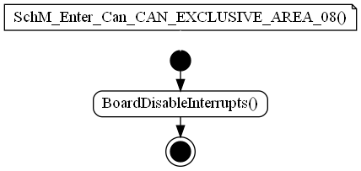

### SchM_Enter_Can_CAN_EXCLUSIVE_AREA_09

|  |  |  |  |
| --- | --- | --- | --- |
| Object | | | |
| This function is used to disable interrupts when an event occurs (Can module). | | | |
| **Prototype** | | | |
| EXPORTED void SchM_Enter_Can_CAN_EXCLUSIVE_AREA_09 (void) | | | |
| **Precondition** | | | |
| None. | | | |
| **Detailed Design Requirement** | | | |
| DSG_SchM_SchM_Enter_Can_CAN_EXCLUSIVE_AREA_09 | | | |
| **Architecture Requirement** | | | |
| ARCH_SW_SchM_Enter_Can_CAN_EXCLUSIVE_AREA_09 | | | |
| **Input parameters** | | | |
| Name | Type | Description | Range |
| NA | NA | NA | NA |
| **Output parameters** | | | |
| Name | Type | Description | Range |
| NA | NA | NA | NA |
| **Return value** | | | |
| Type | Description | | |
| NA | None. | | |
| **Dynamic aspect** | | | |
| Who(callers) | Description | | |
| Can_TS_T40D2M10I2R0 module. | Called in Can_FlexCan_SellectClockSource function. | | |
| **Static aspect** | | | |
| * | | | |
| **Constrains** | | | |
| None. | | | |

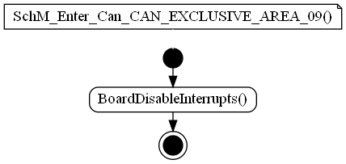

### SchM_Enter_Can_CAN_EXCLUSIVE_AREA_13

|  |  |  |  |
| --- | --- | --- | --- |
| Object | | | |
| This function is used to disable interrupts when an event occurs (Can module). | | | |
| **Prototype** | | | |
| EXPORTED void SchM_Enter_Can_CAN_EXCLUSIVE_AREA_13 (void) | | | |
| **Precondition** | | | |
| None. | | | |
| **Detailed Design Requirement** | | | |
| DSG_SchM_SchM_Enter_Can_CAN_EXCLUSIVE_AREA_13 | | | |
| **Architecture Requirement** | | | |
| ARCH_SW_SchM_Enter_Can_CAN_EXCLUSIVE_AREA_13 | | | |
| **Input parameters** | | | |
| Name | Type | Description | Range |
| NA | NA | NA | NA |
| **Output parameters** | | | |
| Name | Type | Description | Range |
| NA | NA | NA | NA |
| **Return value** | | | |
| Type | Description | | |
| NA | None. | | |
| **Dynamic aspect** | | | |
| Who(callers) | Description | | |
| Can_TS_T40D2M10I2R0 module. | Called in Can_FlexCan_SetControllerToStartMode function. | | |
| **Static aspect** | | | |
| * | | | |
| **Constrains** | | | |
| None. | | | |

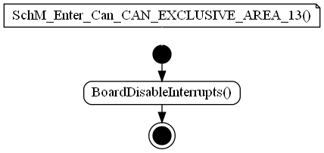

### SchM_Enter_Fee_FEE_EXCLUSIVE_AREA_00

|  |  |  |  |
| --- | --- | --- | --- |
| Object | | | |
| This function is used to disable interrupts when an event occurs (Fee module). | | | |
| **Prototype** | | | |
| EXPORTED void SchM_Enter_Fee_FEE_EXCLUSIVE_AREA_00 (void) | | | |
| **Precondition** | | | |
| None. | | | |
| **Detailed Design Requirement** | | | |
| DSG_SchM_SchM_Enter_Fee_FEE_EXCLUSIVE_AREA_00 | | | |
| **Architecture Requirement** | | | |
| ARCH_SW_SchM_Enter_Fee_FEE_EXCLUSIVE_AREA_00 | | | |
| **Input parameters** | | | |
| Name | Type | Description | Range |
| NA | NA | NA | NA |
| **Output parameters** | | | |
| Name | Type | Description | Range |
| NA | NA | NA | NA |
| **Return value** | | | |
| Type | Description | | |
| NA | None. | | |
| **Dynamic aspect** | | | |
| Who(callers) | Description | | |
| Fee_TS_T40D2M10I2R0 module. | Called in Fee_Read function. | | |
| **Static aspect** | | | |
| * | | | |
| **Constrains** | | | |
| None. | | | |

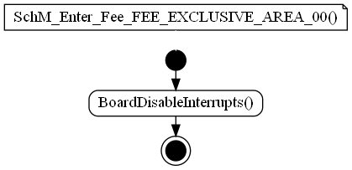

### SchM_Enter_Fee_FEE_EXCLUSIVE_AREA_01

|  |  |  |  |
| --- | --- | --- | --- |
| Object | | | |
| This function is used to disable interrupts when an event occurs (Fee module). | | | |
| **Prototype** | | | |
| EXPORTED void SchM_Enter_Fee_FEE_EXCLUSIVE_AREA_01 (void) | | | |
| **Precondition** | | | |
| None. | | | |
| **Detailed Design Requirement** | | | |
| DSG_SchM_SchM_Enter_Fee_FEE_EXCLUSIVE_AREA_01 | | | |
| **Architecture Requirement** | | | |
| ARCH_SW_SchM_Enter_Fee_FEE_EXCLUSIVE_AREA_01 | | | |
| **Input parameters** | | | |
| Name | Type | Description | Range |
| NA | NA | NA | NA |
| **Output parameters** | | | |
| Name | Type | Description | Range |
| NA | NA | NA | NA |
| **Return value** | | | |
| Type | Description | | |
| NA | None. | | |
| **Dynamic aspect** | | | |
| Who(callers) | Description | | |
| Fee_TS_T40D2M10I2R0 module. | Called in Fee_Write function. | | |
| **Static aspect** | | | |
| * | | | |
| **Constrains** | | | |
| None. | | | |

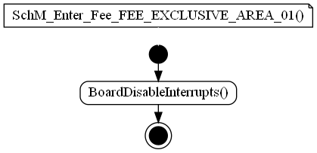

### SchM_Enter_Fls_FLS_EXCLUSIVE_AREA_00

|  |  |  |  |
| --- | --- | --- | --- |
| Object | | | |
| This function is used to disable interrupts when an event occurs (Fls module). | | | |
| **Prototype** | | | |
| EXPORTED void SchM_Enter_Fls_FLS_EXCLUSIVE_AREA_00 (void) | | | |
| **Precondition** | | | |
| None. | | | |
| **Detailed Design Requirement** | | | |
| DSG_SchM_SchM_Enter_Fls_FLS_EXCLUSIVE_AREA_00 | | | |
| **Architecture Requirement** | | | |
| ARCH_SW_SchM_Enter_Fls_FLS_EXCLUSIVE_AREA_00 | | | |
| **Input parameters** | | | |
| Name | Type | Description | Range |
| NA | NA | NA | NA |
| **Output parameters** | | | |
| Name | Type | Description | Range |
| NA | NA | NA | NA |
| **Return value** | | | |
| Type | Description | | |
| NA | None. | | |
| **Dynamic aspect** | | | |
| Who(callers) | Description | | |
| Fls_TS_T40D2M10I2R0 module. | Called in Fls_Flash_SectorErase function. | | |
| **Static aspect** | | | |
| * | | | |
| **Constrains** | | | |
| None. | | | |

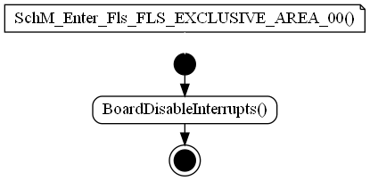

### SchM_Enter_Fls_FLS_EXCLUSIVE_AREA_10

|  |  |  |  |
| --- | --- | --- | --- |
| Object | | | |
| This function is used to disable interrupts when an event occurs (Fls module). | | | |
| **Prototype** | | | |
| EXPORTED void SchM_Enter_Fls_FLS_EXCLUSIVE_AREA_10 (void) | | | |
| **Precondition** | | | |
| None. | | | |
| **Detailed Design Requirement** | | | |
| DSG_SchM_SchM_Enter_Fls_FLS_EXCLUSIVE_AREA_10 | | | |
| **Architecture Requirement** | | | |
| ARCH_SW_SchM_Enter_Fls_FLS_EXCLUSIVE_AREA_10 | | | |
| **Input parameters** | | | |
| Name | Type | Description | Range |
| NA | NA | NA | NA |
| **Output parameters** | | | |
| Name | Type | Description | Range |
| NA | NA | NA | NA |
| **Return value** | | | |
| Type | Description | | |
| NA | None. | | |
| **Dynamic aspect** | | | |
| Who(callers) | Description | | |
| Fls_TS_T40D2M10I2R0 module. | Called in Fls_Erase function. | | |
| **Static aspect** | | | |
| * | | | |
| **Constrains** | | | |
| None. | | | |

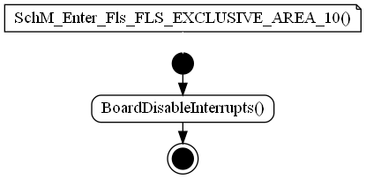

### SchM_Enter_Fls_FLS_EXCLUSIVE_AREA_11

|  |  |  |  |
| --- | --- | --- | --- |
| Object | | | |
| This function is used to disable interrupts when an event occurs (Fls module). | | | |
| **Prototype** | | | |
| EXPORTED void SchM_Enter_Fls_FLS_EXCLUSIVE_AREA_11 (void) | | | |
| **Precondition** | | | |
| None. | | | |
| **Detailed Design Requirement** | | | |
| DSG_SchM_SchM_Enter_Fls_FLS_EXCLUSIVE_AREA_11 | | | |
| **Architecture Requirement** | | | |
| ARCH_SW_SchM_Enter_Fls_FLS_EXCLUSIVE_AREA_11 | | | |
| **Input parameters** | | | |
| Name | Type | Description | Range |
| NA | NA | NA | NA |
| **Output parameters** | | | |
| Name | Type | Description | Range |
| NA | NA | NA | NA |
| **Return value** | | | |
| Type | Description | | |
| NA | None. | | |
| **Dynamic aspect** | | | |
| Who(callers) | Description | | |
| Fls_TS_T40D2M10I2R0 module. | Called in Fls_Write function. | | |
| **Static aspect** | | | |
| * | | | |
| **Constrains** | | | |
| None. | | | |

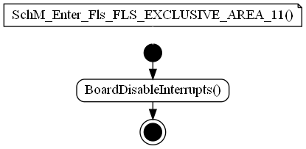

### SchM_Enter_Fls_FLS_EXCLUSIVE_AREA_12

|  |  |  |  |
| --- | --- | --- | --- |
| Object | | | |
| This function is used to disable interrupts when an event occurs (Fls module). | | | |
| **Prototype** | | | |
| EXPORTED void SchM_Enter_Fls_FLS_EXCLUSIVE_AREA_12 (void) | | | |
| **Precondition** | | | |
| None. | | | |
| **Detailed Design Requirement** | | | |
| DSG_SchM_SchM_Enter_Fls_FLS_EXCLUSIVE_AREA_12 | | | |
| **Architecture Requirement** | | | |
| ARCH_SW_SchM_Enter_Fls_FLS_EXCLUSIVE_AREA_12 | | | |
| **Input parameters** | | | |
| Name | Type | Description | Range |
| NA | NA | NA | NA |
| **Output parameters** | | | |
| Name | Type | Description | Range |
| NA | NA | NA | NA |
| **Return value** | | | |
| Type | Description | | |
| NA | None. | | |
| **Dynamic aspect** | | | |
| Who(callers) | Description | | |
| Fls_TS_T40D2M10I2R0 module. | Called in Fls_Read function. | | |
| **Static aspect** | | | |
| * | | | |
| **Constrains** | | | |
| None. | | | |

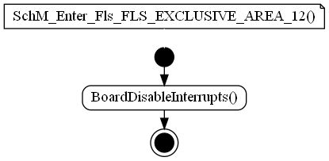

### SchM_Enter_Fls_FLS_EXCLUSIVE_AREA_13

|  |  |  |  |
| --- | --- | --- | --- |
| Object | | | |
| This function is used to disable interrupts when an event occurs (Fls module). | | | |
| **Prototype** | | | |
| EXPORTED void SchM_Enter_Fls_FLS_EXCLUSIVE_AREA_13 (void) | | | |
| **Precondition** | | | |
| None. | | | |
| **Detailed Design Requirement** | | | |
| DSG_SchM_SchM_Enter_Fls_FLS_EXCLUSIVE_AREA_13 | | | |
| **Architecture Requirement** | | | |
| ARCH_SW_SchM_Enter_Fls_FLS_EXCLUSIVE_AREA_13 | | | |
| **Input parameters** | | | |
| Name | Type | Description | Range |
| NA | NA | NA | NA |
| **Output parameters** | | | |
| Name | Type | Description | Range |
| NA | NA | NA | NA |
| **Return value** | | | |
| Type | Description | | |
| NA | None. | | |
| **Dynamic aspect** | | | |
| Who(callers) | Description | | |
| Fls_TS_T40D2M10I2R0 module. | Called in Fls_Write function. | | |
| **Static aspect** | | | |
| * | | | |
| **Constrains** | | | |
| None. | | | |

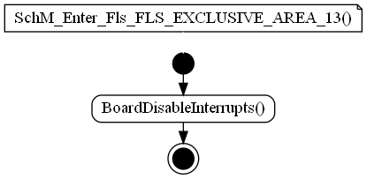

### SchM_Enter_NvM_SCHM_NVM_EXCLUSIVE_AREA_0

|  |  |  |  |
| --- | --- | --- | --- |
| Object | | | |
| This function is used to disable interrupts when an event occurs (NvM module). | | | |
| **Prototype** | | | |
| EXPORTED void SchM_Enter_NvM_SCHM_NVM_EXCLUSIVE_AREA_0 (void) | | | |
| **Precondition** | | | |
| None. | | | |
| **Detailed Design Requirement** | | | |
| DSG_SchM_SchM_Enter_NvM_SCHM_NVM_EXCLUSIVE_AREA_0 | | | |
| **Architecture Requirement** | | | |
| ARCH_SW_SchM_Enter_NvM_SCHM_NVM_EXCLUSIVE_AREA_0 | | | |
| **Input parameters** | | | |
| Name | Type | Description | Range |
| NA | NA | NA | NA |
| **Output parameters** | | | |
| Name | Type | Description | Range |
| NA | NA | NA | NA |
| **Return value** | | | |
| Type | Description | | |
| NA | None. | | |
| **Dynamic aspect** | | | |
| Who(callers) | Description | | |
| NvM_TS_TxDxM6I17R0 module. | Called in many functions. | | |
| **Static aspect** | | | |
| * | | | |
| **Constrains** | | | |
| None. | | | |

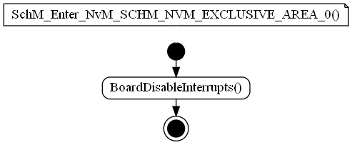

### SchM_Exit_Can_CAN_EXCLUSIVE_AREA_02

|  |  |  |  |
| --- | --- | --- | --- |
| Object | | | |
| This function is used to enable interrupts when an event ends (Can module). | | | |
| **Prototype** | | | |
| EXPORTED void SchM_Exit_Can_CAN_EXCLUSIVE_AREA_02 (void) | | | |
| **Precondition** | | | |
| None. | | | |
| **Detailed Design Requirement** | | | |
| DSG_SchM_SchM_Exit_Can_CAN_EXCLUSIVE_AREA_02 | | | |
| **Architecture Requirement** | | | |
| ARCH_SW_SchM_Exit_Can_CAN_EXCLUSIVE_AREA_02 | | | |
| **Input parameters** | | | |
| Name | Type | Description | Range |
| NA | NA | NA | NA |
| **Output parameters** | | | |
| Name | Type | Description | Range |
| NA | NA | NA | NA |
| **Return value** | | | |
| Type | Description | | |
| NA | None. | | |
| **Dynamic aspect** | | | |
| Who(callers) | Description | | |
| Can_TS_T40D2M10I2R0 module. | Called in Can_FlexCan_Write function. | | |
| **Static aspect** | | | |
| * | | | |
| **Constrains** | | | |
| None. | | | |

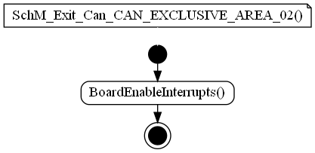

### SchM_Exit_Can_CAN_EXCLUSIVE_AREA_03

|  |  |  |  |
| --- | --- | --- | --- |
| Object | | | |
| This function is used to enable interrupts when an event ends (Can module). | | | |
| **Prototype** | | | |
| EXPORTED void SchM_Exit_Can_CAN_EXCLUSIVE_AREA_03 (void) | | | |
| **Precondition** | | | |
| None. | | | |
| **Detailed Design Requirement** | | | |
| DSG_SchM_SchM_Exit_Can_CAN_EXCLUSIVE_AREA_03 | | | |
| **Architecture Requirement** | | | |
| ARCH_SW_SchM_Exit_Can_CAN_EXCLUSIVE_AREA_03 | | | |
| **Input parameters** | | | |
| Name | Type | Description | Range |
| NA | NA | NA | NA |
| **Output parameters** | | | |
| Name | Type | Description | Range |
| NA | NA | NA | NA |
| **Return value** | | | |
| Type | Description | | |
| NA | None. | | |
| **Dynamic aspect** | | | |
| Who(callers) | Description | | |
| Can_TS_T40D2M10I2R0 module. | Called in Can_FlexCan_GotoFreezeMode function. | | |
| **Static aspect** | | | |
| * | | | |
| **Constrains** | | | |
| None. | | | |

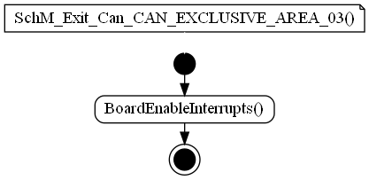

### SchM_Exit_Can_CAN_EXCLUSIVE_AREA_04

|  |  |  |  |
| --- | --- | --- | --- |
| Object | | | |
| This function is used to enable interrupts when an event ends (Can module). | | | |
| **Prototype** | | | |
| EXPORTED void SchM_Exit_Can_CAN_EXCLUSIVE_AREA_04 (void) | | | |
| **Precondition** | | | |
| None. | | | |
| **Detailed Design Requirement** | | | |
| DSG_SchM_SchM_Exit_Can_CAN_EXCLUSIVE_AREA_04 | | | |
| **Architecture Requirement** | | | |
| ARCH_SW_SchM_Exit_Can_CAN_EXCLUSIVE_AREA_04 | | | |
| **Input parameters** | | | |
| Name | Type | Description | Range |
| NA | NA | NA | NA |
| **Output parameters** | | | |
| Name | Type | Description | Range |
| NA | NA | NA | NA |
| **Return value** | | | |
| Type | Description | | |
| NA | None. | | |
| **Dynamic aspect** | | | |
| Who(callers) | Description | | |
| Can_TS_T40D2M10I2R0 module. | Called in Can_FlexCan_ResetController function. | | |
| **Static aspect** | | | |
| * | | | |
| **Constrains** | | | |
| None. | | | |

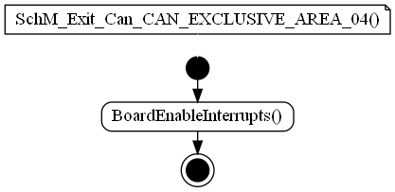

### SchM_Exit_Can_CAN_EXCLUSIVE_AREA_05

|  |  |  |  |
| --- | --- | --- | --- |
| Object | | | |
| This function is used to enable interrupts when an event ends (Can module). | | | |
| **Prototype** | | | |
| EXPORTED void SchM_Exit_Can_CAN_EXCLUSIVE_AREA_05 (void) | | | |
| **Precondition** | | | |
| None. | | | |
| **Detailed Design Requirement** | | | |
| DSG_SchM_SchM_Exit_Can_CAN_EXCLUSIVE_AREA_05 | | | |
| **Architecture Requirement** | | | |
| ARCH_SW_SchM_Exit_Can_CAN_EXCLUSIVE_AREA_05 | | | |
| **Input parameters** | | | |
| Name | Type | Description | Range |
| NA | NA | NA | NA |
| **Output parameters** | | | |
| Name | Type | Description | Range |
| NA | NA | NA | NA |
| **Return value** | | | |
| Type | Description | | |
| NA | None. | | |
| **Dynamic aspect** | | | |
| Who(callers) | Description | | |
| Can_TS_T40D2M10I2R0 module. | Called in Can_FlexCan_ResetController function. | | |
| **Static aspect** | | | |
| * | | | |
| **Constrains** | | | |
| None. | | | |

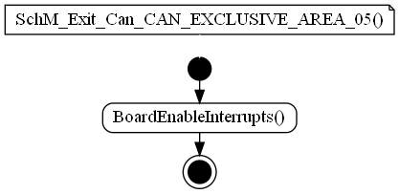

### SchM_Exit_Can_CAN_EXCLUSIVE_AREA_06

|  |  |  |  |
| --- | --- | --- | --- |
| Object | | | |
| This function is used to enable interrupts when an event ends (Can module). | | | |
| **Prototype** | | | |
| EXPORTED void SchM_Exit_Can_CAN_EXCLUSIVE_AREA_06 (void) | | | |
| **Precondition** | | | |
| None. | | | |
| **Detailed Design Requirement** | | | |
| DSG_SchM_SchM_Exit_Can_CAN_EXCLUSIVE_AREA_06 | | | |
| **Architecture Requirement** | | | |
| ARCH_SW_SchM_Exit_Can_CAN_EXCLUSIVE_AREA_06 | | | |
| **Input parameters** | | | |
| Name | Type | Description | Range |
| NA | NA | NA | NA |
| **Output parameters** | | | |
| Name | Type | Description | Range |
| NA | NA | NA | NA |
| **Return value** | | | |
| Type | Description | | |
| NA | None. | | |
| **Dynamic aspect** | | | |
| Who(callers) | Description | | |
| Can_TS_T40D2M10I2R0 module. | Called in Can_FlexCan_SetControllerToStopMode function. | | |
| **Static aspect** | | | |
| * | | | |
| **Constrains** | | | |
| None. | | | |

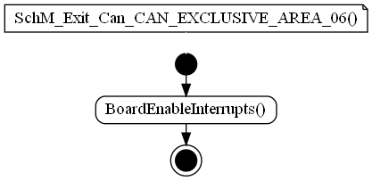

### SchM_Exit_Can_CAN_EXCLUSIVE_AREA_07

|  |  |  |  |
| --- | --- | --- | --- |
| Object | | | |
| This function is used to enable interrupts when an event ends (Can module). | | | |
| **Prototype** | | | |
| EXPORTED void SchM_Exit_Can_CAN_EXCLUSIVE_AREA_07 (void) | | | |
| **Precondition** | | | |
| None. | | | |
| **Detailed Design Requirement** | | | |
| DSG_SchM_SchM_Exit_Can_CAN_EXCLUSIVE_AREA_07 | | | |
| **Architecture Requirement** | | | |
| ARCH_SW_SchM_Exit_Can_CAN_EXCLUSIVE_AREA_07 | | | |
| **Input parameters** | | | |
| Name | Type | Description | Range |
| NA | NA | NA | NA |
| **Output parameters** | | | |
| Name | Type | Description | Range |
| NA | NA | NA | NA |
| **Return value** | | | |
| Type | Description | | |
| NA | None. | | |
| **Dynamic aspect** | | | |
| Who(callers) | Description | | |
| Can_TS_T40D2M10I2R0 module. | Called in Can_FlexCan_DisableInterrupts function. | | |
| **Static aspect** | | | |
| * | | | |
| **Constrains** | | | |
| None. | | | |

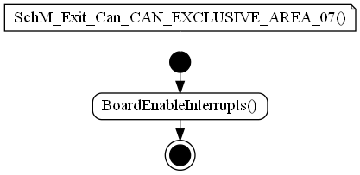

### SchM_Exit_Can_CAN_EXCLUSIVE_AREA_08

|  |  |  |  |
| --- | --- | --- | --- |
| Object | | | |
| This function is used to enable interrupts when an event ends (Can module). | | | |
| **Prototype** | | | |
| EXPORTED void SchM_Exit_Can_CAN_EXCLUSIVE_AREA_08 (void) | | | |
| **Precondition** | | | |
| None. | | | |
| **Detailed Design Requirement** | | | |
| DSG_SchM_SchM_Exit_Can_CAN_EXCLUSIVE_AREA_08 | | | |
| **Architecture Requirement** | | | |
| ARCH_SW_SchM_Exit_Can_CAN_EXCLUSIVE_AREA_08 | | | |
| **Input parameters** | | | |
| Name | Type | Description | Range |
| NA | NA | NA | NA |
| **Output parameters** | | | |
| Name | Type | Description | Range |
| NA | NA | NA | NA |
| **Return value** | | | |
| Type | Description | | |
| NA | None. | | |
| **Dynamic aspect** | | | |
| Who(callers) | Description | | |
| Can_TS_T40D2M10I2R0 module. | Called in Can_FlexCan_EnableInterrupts function. | | |
| **Static aspect** | | | |
| * | | | |
| **Constrains** | | | |
| None. | | | |

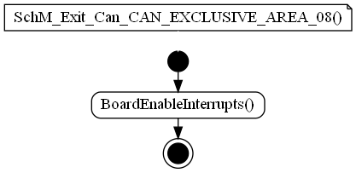

### SchM_Exit_Can_CAN_EXCLUSIVE_AREA_09

|  |  |  |  |
| --- | --- | --- | --- |
| Object | | | |
| This function is used to enable interrupts when an event ends (Can module). | | | |
| **Prototype** | | | |
| EXPORTED void SchM_Exit_Can_CAN_EXCLUSIVE_AREA_09 (void) | | | |
| **Precondition** | | | |
| None. | | | |
| **Detailed Design Requirement** | | | |
| DSG_SchM_SchM_Exit_Can_CAN_EXCLUSIVE_AREA_09 | | | |
| **Architecture Requirement** | | | |
| ARCH_SW_SchM_Exit_Can_CAN_EXCLUSIVE_AREA_09 | | | |
| **Input parameters** | | | |
| Name | Type | Description | Range |
| NA | NA | NA | NA |
| **Output parameters** | | | |
| Name | Type | Description | Range |
| NA | NA | NA | NA |
| **Return value** | | | |
| Type | Description | | |
| NA | None. | | |
| **Dynamic aspect** | | | |
| Who(callers) | Description | | |
| Can_TS_T40D2M10I2R0 module. | Called in Can_FlexCan_SellectClockSource function. | | |
| **Static aspect** | | | |
| * | | | |
| **Constrains** | | | |
| None. | | | |

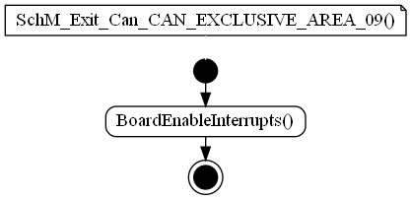

### SchM_Exit_Can_CAN_EXCLUSIVE_AREA_13

|  |  |  |  |
| --- | --- | --- | --- |
| Object | | | |
| This function is used to enable interrupts when an event ends (Can module). | | | |
| **Prototype** | | | |
| EXPORTED void SchM_Exit_Can_CAN_EXCLUSIVE_AREA_13 (void) | | | |
| **Precondition** | | | |
| None. | | | |
| **Detailed Design Requirement** | | | |
| DSG_SchM_SchM_Exit_Can_CAN_EXCLUSIVE_AREA_13 | | | |
| **Architecture Requirement** | | | |
| ARCH_SW_SchM_Exit_Can_CAN_EXCLUSIVE_AREA_13 | | | |
| **Input parameters** | | | |
| Name | Type | Description | Range |
| NA | NA | NA | NA |
| **Output parameters** | | | |
| Name | Type | Description | Range |
| NA | NA | NA | NA |
| **Return value** | | | |
| Type | Description | | |
| NA | None. | | |
| **Dynamic aspect** | | | |
| Who(callers) | Description | | |
| Can_TS_T40D2M10I2R0 module. | Called in Can_FlexCan_SetControllerToStartMode function. | | |
| **Static aspect** | | | |
| * | | | |
| **Constrains** | | | |
| None. | | | |

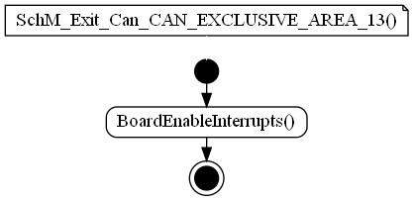

### SchM_Exit_Fee_FEE_EXCLUSIVE_AREA_00

|  |  |  |  |
| --- | --- | --- | --- |
| Object | | | |
| This function is used to enable interrupts when an event ends (Fee module). | | | |
| **Prototype** | | | |
| EXPORTED void SchM_Exit_Fee_FEE_EXCLUSIVE_AREA_00 (void) | | | |
| **Precondition** | | | |
| None. | | | |
| **Detailed Design Requirement** | | | |
| DSG_SchM_SchM_Exit_Fee_FEE_EXCLUSIVE_AREA_00 | | | |
| **Architecture Requirement** | | | |
| ARCH_SW_SchM_Exit_Fee_FEE_EXCLUSIVE_AREA_00 | | | |
| **Input parameters** | | | |
| Name | Type | Description | Range |
| NA | NA | NA | NA |
| **Output parameters** | | | |
| Name | Type | Description | Range |
| NA | NA | NA | NA |
| **Return value** | | | |
| Type | Description | | |
| NA | None. | | |
| **Dynamic aspect** | | | |
| Who(callers) | Description | | |
| Fee_TS_T40D2M10I2R0 module. | Called in Fee_Read function. | | |
| **Static aspect** | | | |
| * | | | |
| **Constrains** | | | |
| None. | | | |

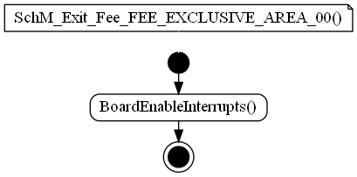

### SchM_Exit_Fee_FEE_EXCLUSIVE_AREA_01

|  |  |  |  |
| --- | --- | --- | --- |
| Object | | | |
| This function is used to enable interrupts when an event ends (Fee module). | | | |
| **Prototype** | | | |
| EXPORTED void SchM_Exit_Fee_FEE_EXCLUSIVE_AREA_01 (void) | | | |
| **Precondition** | | | |
| None. | | | |
| **Detailed Design Requirement** | | | |
| DSG_SchM_SchM_Exit_Fee_FEE_EXCLUSIVE_AREA_01 | | | |
| **Architecture Requirement** | | | |
| ARCH_SW_SchM_Exit_Fee_FEE_EXCLUSIVE_AREA_01 | | | |
| **Input parameters** | | | |
| Name | Type | Description | Range |
| NA | NA | NA | NA |
| **Output parameters** | | | |
| Name | Type | Description | Range |
| NA | NA | NA | NA |
| **Return value** | | | |
| Type | Description | | |
| NA | None. | | |
| **Dynamic aspect** | | | |
| Who(callers) | Description | | |
| Fee_TS_T40D2M10I2R0 module. | Called in Fee_Write function. | | |
| **Static aspect** | | | |
| * | | | |
| **Constrains** | | | |
| None. | | | |

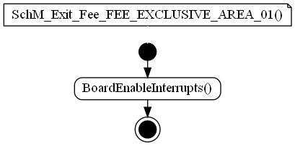

### SchM_Exit_Fls_FLS_EXCLUSIVE_AREA_00

|  |  |  |  |
| --- | --- | --- | --- |
| Object | | | |
| This function is used to enable interrupts when an event ends (Fls module). | | | |
| **Prototype** | | | |
| EXPORTED void SchM_Exit_Fls_FLS_EXCLUSIVE_AREA_00 (void) | | | |
| **Precondition** | | | |
| None. | | | |
| **Detailed Design Requirement** | | | |
| DSG_SchM_SchM_Exit_Fls_FLS_EXCLUSIVE_AREA_00 | | | |
| **Architecture Requirement** | | | |
| ARCH_SW_SchM_Exit_Fls_FLS_EXCLUSIVE_AREA_00 | | | |
| **Input parameters** | | | |
| Name | Type | Description | Range |
| NA | NA | NA | NA |
| **Output parameters** | | | |
| Name | Type | Description | Range |
| NA | NA | NA | NA |
| **Return value** | | | |
| Type | Description | | |
| NA | None. | | |
| **Dynamic aspect** | | | |
| Who(callers) | Description | | |
| Fls_TS_T40D2M10I2R0 module. | Called in Fls_Flash_SectorErase function. | | |
| **Static aspect** | | | |
| * | | | |
| **Constrains** | | | |
| None. | | | |

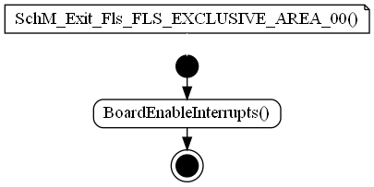

### SchM_Exit_Fls_FLS_EXCLUSIVE_AREA_10

|  |  |  |  |
| --- | --- | --- | --- |
| Object | | | |
| This function is used to enable interrupts when an event ends (Fls module). | | | |
| **Prototype** | | | |
| EXPORTED void SchM_Exit_Fls_FLS_EXCLUSIVE_AREA_10 (void) | | | |
| **Precondition** | | | |
| None. | | | |
| **Detailed Design Requirement** | | | |
| DSG_SchM_SchM_Exit_Fls_FLS_EXCLUSIVE_AREA_10 | | | |
| **Architecture Requirement** | | | |
| ARCH_SW_SchM_Exit_Fls_FLS_EXCLUSIVE_AREA_10 | | | |
| **Input parameters** | | | |
| Name | Type | Description | Range |
| NA | NA | NA | NA |
| **Output parameters** | | | |
| Name | Type | Description | Range |
| NA | NA | NA | NA |
| **Return value** | | | |
| Type | Description | | |
| NA | None. | | |
| **Dynamic aspect** | | | |
| Who(callers) | Description | | |
| Fls_TS_T40D2M10I2R0 module. | Called in Fls_Erase function. | | |
| **Static aspect** | | | |
| * | | | |
| **Constrains** | | | |
| None. | | | |

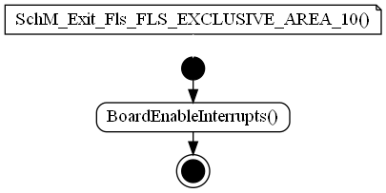

### SchM_Exit_Fls_FLS_EXCLUSIVE_AREA_11

|  |  |  |  |
| --- | --- | --- | --- |
| Object | | | |
| This function is used to enable interrupts when an event ends (Fls module). | | | |
| **Prototype** | | | |
| EXPORTED void SchM_Exit_Fls_FLS_EXCLUSIVE_AREA_11 (void) | | | |
| **Precondition** | | | |
| None. | | | |
| **Detailed Design Requirement** | | | |
| DSG_SchM_SchM_Exit_Fls_FLS_EXCLUSIVE_AREA_11 | | | |
| **Architecture Requirement** | | | |
| ARCH_SW_SchM_Exit_Fls_FLS_EXCLUSIVE_AREA_11 | | | |
| **Input parameters** | | | |
| Name | Type | Description | Range |
| NA | NA | NA | NA |
| **Output parameters** | | | |
| Name | Type | Description | Range |
| NA | NA | NA | NA |
| **Return value** | | | |
| Type | Description | | |
| NA | None. | | |
| **Dynamic aspect** | | | |
| Who(callers) | Description | | |
| Fls_TS_T40D2M10I2R0 module. | Called in Fls_Write function. | | |
| **Static aspect** | | | |
| * | | | |
| **Constrains** | | | |
| None. | | | |

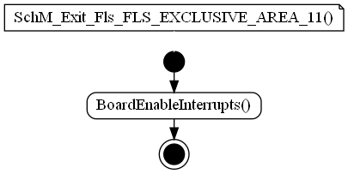

### SchM_Exit_Fls_FLS_EXCLUSIVE_AREA_12

|  |  |  |  |
| --- | --- | --- | --- |
| Object | | | |
| This function is used to enable interrupts when an event ends (Fls module). | | | |
| **Prototype** | | | |
| EXPORTED void SchM_Exit_Fls_FLS_EXCLUSIVE_AREA_12 (void) | | | |
| **Precondition** | | | |
| None. | | | |
| **Detailed Design Requirement** | | | |
| DSG_SchM_SchM_Exit_Fls_FLS_EXCLUSIVE_AREA_12 | | | |
| **Architecture Requirement** | | | |
| ARCH_SW_SchM_Exit_Fls_FLS_EXCLUSIVE_AREA_12 | | | |
| **Input parameters** | | | |
| Name | Type | Description | Range |
| NA | NA | NA | NA |
| **Output parameters** | | | |
| Name | Type | Description | Range |
| NA | NA | NA | NA |
| **Return value** | | | |
| Type | Description | | |
| NA | None. | | |
| **Dynamic aspect** | | | |
| Who(callers) | Description | | |
| Fls_TS_T40D2M10I2R0 module. | Called in Fls_Read function. | | |
| **Static aspect** | | | |
| * | | | |
| **Constrains** | | | |
| None. | | | |

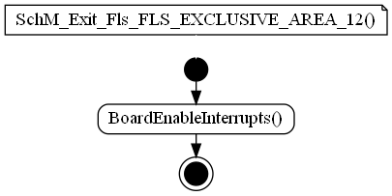

### SchM_Exit_Fls_FLS_EXCLUSIVE_AREA_13

|  |  |  |  |
| --- | --- | --- | --- |
| Object | | | |
| This function is used to enable interrupts when an event ends (Fls module). | | | |
| **Prototype** | | | |
| EXPORTED void SchM_Exit_Fls_FLS_EXCLUSIVE_AREA_13 (void) | | | |
| **Precondition** | | | |
| None. | | | |
| **Detailed Design Requirement** | | | |
| DSG_SchM_SchM_Exit_Fls_FLS_EXCLUSIVE_AREA_13 | | | |
| **Architecture Requirement** | | | |
| ARCH_SW_SchM_Exit_Fls_FLS_EXCLUSIVE_AREA_13 | | | |
| **Input parameters** | | | |
| Name | Type | Description | Range |
| NA | NA | NA | NA |
| **Output parameters** | | | |
| Name | Type | Description | Range |
| NA | NA | NA | NA |
| **Return value** | | | |
| Type | Description | | |
| NA | None. | | |
| **Dynamic aspect** | | | |
| Who(callers) | Description | | |
| Fls_TS_T40D2M10I2R0 module. | Called in Fls_Write function. | | |
| **Static aspect** | | | |
| * | | | |
| **Constrains** | | | |
| None. | | | |

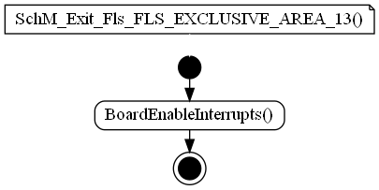

### SchM_Exit_NvM_SCHM_NVM_EXCLUSIVE_AREA_0

|  |  |  |  |
| --- | --- | --- | --- |
| Object | | | |
| This function is used to enable interrupts when an event ends (NvM module). | | | |
| **Prototype** | | | |
| EXPORTED void SchM_Exit_NvM_SCHM_NVM_EXCLUSIVE_AREA_0 (void) | | | |
| **Precondition** | | | |
| None. | | | |
| **Detailed Design Requirement** | | | |
| DSG_SchM_SchM_Exit_NvM_SCHM_NVM_EXCLUSIVE_AREA_0 | | | |
| **Architecture Requirement** | | | |
| ARCH_SW_SchM_Exit_NvM_SCHM_NVM_EXCLUSIVE_AREA_0 | | | |
| **Input parameters** | | | |
| Name | Type | Description | Range |
| NA | NA | NA | NA |
| **Output parameters** | | | |
| Name | Type | Description | Range |
| NA | NA | NA | NA |
| **Return value** | | | |
| Type | Description | | |
| NA | None. | | |
| **Dynamic aspect** | | | |
| Who(callers) | Description | | |
| NvM_TS_TxDxM6I17R0 module. | Called in many functions. | | |
| **Static aspect** | | | |
| * | | | |
| **Constrains** | | | |
| None. | | | |

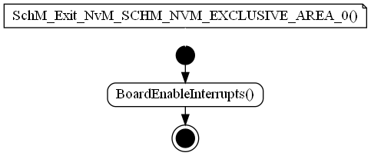

## Variabiles

## Macros

### SCHM_START_SEC_VAR_UNSPECIFIED

|  |  |
| --- | --- |
| Name | Value |
| SCHM_START_SEC_VAR_UNSPECIFIED | NA |
| **Definition** | |
| #define SCHM_START_SEC_VAR_UNSPECIFIED | |
| **Description** | |
| Constant with external linkage. | |

### SCHM_STOP_SEC_CODE

|  |  |
| --- | --- |
| Name | Value |
| SCHM_STOP_SEC_CODE | NA |
| **Definition** | |
| #define SCHM_STOP_SEC_CODE | |
| **Description** | |
| Constant with external linkage. | |

### FEE_START_SEC_CODE

|  |  |
| --- | --- |
| Name | Value |
| FEE_START_SEC_CODE | NA |
| **Definition** | |
| #define FEE_START_SEC_CODE | |
| **Description** | |
| Constant with external linkage. | |

### FEE_STOP_SEC_CODE

|  |  |
| --- | --- |
| Name | Value |
| FEE_STOP_SEC_CODE | NA |
| **Definition** | |
| #define FEE_STOP_SEC_CODE | |
| **Description** | |
| Constant with external linkage. | |

### RTE_SCHM_SWCBSW_FEE_MAINFUNCTION

|  |  |
| --- | --- |
| Name | Value |
| RTE_SCHM_SWCBSW_FEE_MAINFUNCTION | NA |
| **Definition** | |
| #define RTE_SCHM_SWCBSW_FEE_MAINFUNCTION | |
| **Description** | |
| NA | |

### FLS_START_SEC_CODE

|  |  |
| --- | --- |
| Name | Value |
| FLS_START_SEC_CODE | NA |
| **Definition** | |
| #define FLS_START_SEC_CODE | |
| **Description** | |
| Constant with external linkage. | |

### FLS_STOP_SEC_CODE

|  |  |
| --- | --- |
| Name | Value |
| FLS_STOP_SEC_CODE | NA |
| **Definition** | |
| #define FLS_STOP_SEC_CODE | |
| **Description** | |
| Constant with external linkage. | |

### NVM_START_SEC_CODE

|  |  |
| --- | --- |
| Name | Value |
| NVM_START_SEC_CODE | NA |
| **Definition** | |
| #define NVM_START_SEC_CODE | |
| **Description** | |
| Constant with external linkage. | |

### NVM_STOP_SEC_CODE

|  |  |
| --- | --- |
| Name | Value |
| NVM_STOP_SEC_CODE | NA |
| **Definition** | |
| #define NVM_STOP_SEC_CODE | |
| **Description** | |
| Constant with external linkage. | |

# EEPROM

# Configuration

# Compilation Options