|  |  |
| --- | --- |
| **FblUpdUsr SW Detailed Design** | |
| **Summary** | Software Detailed Design Document of the FblUpdUsr Component |

|  |  |  |
| --- | --- | --- |
| **Author** | **Review** | **Approval** |
| Title: Andreea Suiu | See Project Master Document for the roles and Project Members List for the name of people | See Project Master Document for the roles and Project Members List for the name of people |
|  |  |  |
| **Distribution** | | |
| See Project Master Document for the roles and Project Members List for the name of people | See Project Master Document for the roles and Project Members List for the name of people | See Project Master Document for the roles and Project Members List for the name of people |

# Table of content

1. General Information 3

1.1. Revision history * 3

1.2. Purpose and Scope 3

1.3. Referenced documents 3

1.3.1. External documents 3

1.3.2. Internal Documents 3

1.4. Terminology and definitions 3

2. SW atomic architectural unit design 4

2.1. Overview 4

2.2. Traceability 4

3. FEATURES 4

3.1. Services 4

3.1.1. Service Name 4

3.2. Types 5

3.2.1. Name Structure definition 5

3.3. Variables 5

3.4. Constants 5

4. EEPROM 5

5. Configuration 5

6. Compilation Options 5

# General Information

## Revision history *

|  |  |  |  |
| --- | --- | --- | --- |
| **Revision** | **Date** | **Author(s)** | **Description/comment** |
| 1.0. | 19.01.2022 | Andreea Suiu | First revision. |
|  |  |  |  |
|  |  |  |  |

*\* Template history is found in the CM tool used for templates*

## Purpose and Scope

The purpose of this document is to provide an overview of the FblUpdUsr SW Component operation principle, and to present the implementation choices in terms of module and function splitting.

## Referenced documents

### External documents

|  |  |  |
| --- | --- | --- |
| **Id** | **Title** | **Reference** |
|  |  |  |
|  |  |  |
|  |  |  |

### Internal Documents

|  |  |  |
| --- | --- | --- |
| **Id** | **Title** | **Reference** |
|  |  |  |
|  |  |  |
|  |  |  |
|  |  |  |

## Terminology and definitions

The generic acronyms are available in the [AEM process and method wiki](https://alvteams.alv.autoliv.int/sites/aeuaeequalityassurance/AEM%20Process%20wiki/acronyms.aspx)

|  |  |
| --- | --- |
| **Terminology** | **Meaning** |
| AAU | Atomic architectural unit |
| SW | software |
|  |  |

# SW Module Detailed Design

## Overview

The aim of the FblUpdUsr component is to configure startup conditions and to start the main execution (to start the bootloader updater activity). The startup conditions consist of initialization memory sections, configuration clocks, reset, timers and interrupts. The bootloader updater activity consists in invalidation of bootloader and flashing the updated version of bootloader.

## Traceability

# Features

## Services

### BoardDisableInterrupts

|  |  |  |  |
| --- | --- | --- | --- |
| Object | | | |
| This function is used to manage interruptions disabling by taking into consideration the interrupt nesting. | | | |
| **Prototype** | | | |
| void BoardDisableInterrupts (void) | | | |
| **Precondition** | | | |
| None. | | | |
| **Detailed Design Requirement** | | | |
| DSG_FblUpdUsr_BoardDisableInterrupts | | | |
| **Architecture Requirement** | | | |
| ARCH_SW_FblUpdUsr_BoardDisableInterrupts | | | |
| **Input parameters** | | | |
| Name | Type | Description | Range |
| NA | NA | NA | NA |
| **Output parameters** | | | |
| Name | Type | Description | Range |
| NA | NA | NA | NA |
| **Return value** | | | |
| Type | Description | | |
| NA | None. | | |
| **Dynamic aspect** | | | |
| Who(callers) | Description | | |
| SchM module. | Called when is necessary to disable interrupts. | | |
| **Static aspect** | | | |
| * | | | |
| **Constrains** | | | |
| None. | | | |

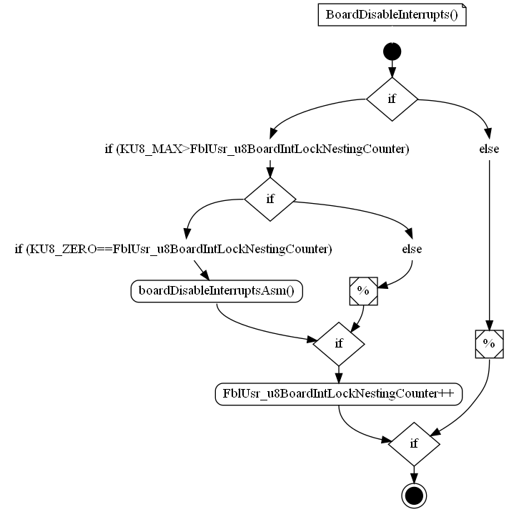

### BoardEnableInterrupts

|  |  |  |  |
| --- | --- | --- | --- |
| Object | | | |
| This function is used to manage interruptions enabling by taking into consideration the interrupt nesting. | | | |
| **Prototype** | | | |
| void BoardEnableInterrupts (void) | | | |
| **Precondition** | | | |
| None. | | | |
| **Detailed Design Requirement** | | | |
| DSG_FblUpdUsr_BoardEnableInterrupts | | | |
| **Architecture Requirement** | | | |
| ARCH_SW_FblUpdUsr_BoardEnableInterrupts | | | |
| **Input parameters** | | | |
| Name | Type | Description | Range |
| NA | NA | NA | NA |
| **Output parameters** | | | |
| Name | Type | Description | Range |
| NA | NA | NA | NA |
| **Return value** | | | |
| Type | Description | | |
| NA | None. | | |
| **Dynamic aspect** | | | |
| Who(callers) | Description | | |
| SchM module. | Called when is necessary to enable interrupts. | | |
| **Static aspect** | | | |
| * | | | |
| **Constrains** | | | |
| None. | | | |

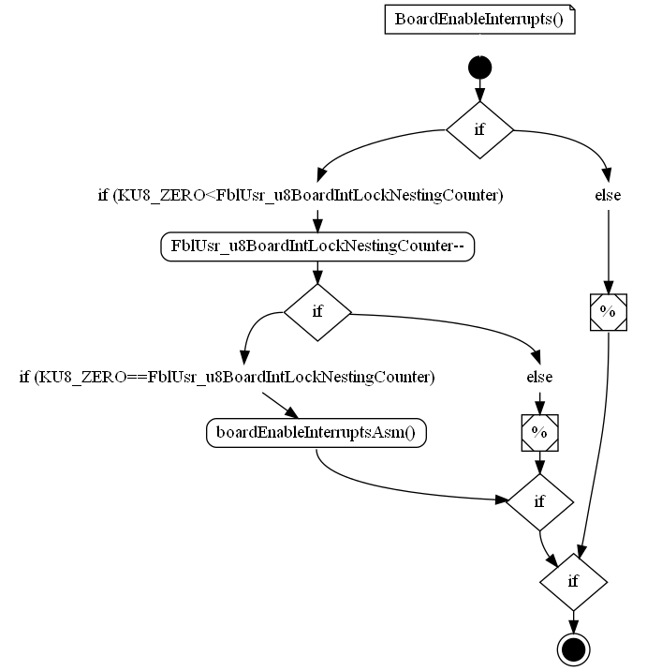

### BoardInitializationTimers

|  |  |  |  |
| --- | --- | --- | --- |
| Object | | | |
| This function is used to set to configure and start the timers. | | | |
| **Prototype** | | | |
| uint8 BoardInitializationTimers (const uint16 u16Timer) | | | |
| **Precondition** | | | |
| None. | | | |
| **Return values** | | | |
| BOARD_TRUE - Timer configuration successful  BOARD_FALSE - Timer configuration failed | | | |
| **Detailed Design Requirement** | | | |
| DSG_FblUpdUsr_BoardInitializationTimers | | | |
| **Architecture Requirement** | | | |
| None. | | | |
| **Input parameters** | | | |
| Name | Type | Description | Range |
| u16Timer | const u16 | u16Timer timer value |  |
| **Output parameters** | | | |
| Name | Type | Description | Range |
| NA | NA | NA | NA |
| **Return value** | | | |
| Type | Description | | |
| uint8 | u8RetVal. | | |
| **Dynamic aspect** | | | |
| Who(callers) | Description | | |
| Startup module. | Called by main function. | | |
| **Static aspect** | | | |
| * | | | |
| **Constrains** | | | |
| None. | | | |



### BoardInitInterrupts

|  |  |  |  |
| --- | --- | --- | --- |
| Object | | | |
| This function is used to initialize the interrupt controller and sets a default priority in all interrupt vectors, integrator shall ensure that each integrated software using interrupts shall verify the interrupt settings or set them to a correct value. | | | |
| **Prototype** | | | |
| void BoardInitInterrupts (void) | | | |
| **Precondition** | | | |
| None. | | | |
| **Detailed Design Requirement** | | | |
| DSG_FblUpdUsr_BoardInitInterrupts | | | |
| **Architecture Requirement** | | | |
| None. | | | |
| **Input parameters** | | | |
| Name | Type | Description | Range |
| NA | NA | NA | NA |
| **Output parameters** | | | |
| Name | Type | Description | Range |
| NA | NA | NA | NA |
| **Return value** | | | |
| Type | Description | | |
| NA | None. | | |
| **Dynamic aspect** | | | |
| Who(callers) | Description | | |
| FblUsr module. | Called in BoardStart function. | | |
| **Static aspect** | | | |
| * | | | |
| **Constrains** | | | |
| None. | | | |

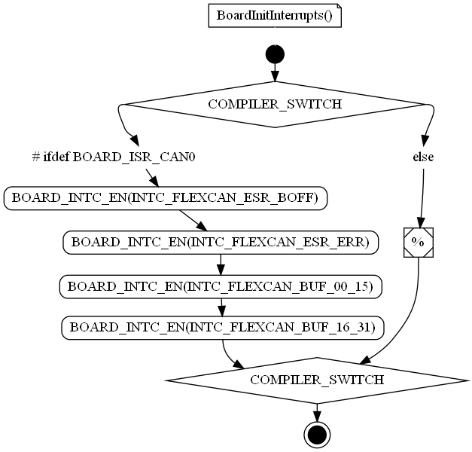

### BoardInitMemorySections

|  |  |  |  |
| --- | --- | --- | --- |
| Object | | | |
| Initialize memory sections. | | | |
| **Prototype** | | | |
| static void BoardInitMemorySections (void) [static] | | | |
| **Precondition** | | | |
| None. | | | |
| **Detailed Design Requirement** | | | |
| DSG_FblUpdUsr_BoardInitMemorySections | | | |
| **Architecture Requirement** | | | |
| None. | | | |
| **Input parameters** | | | |
| Name | Type | Description | Range |
| NA | NA | NA | NA |
| **Output parameters** | | | |
| Name | Type | Description | Range |
| NA | NA | NA | NA |
| **Return value** | | | |
| Type | Description | | |
| NA | None. | | |
| **Dynamic aspect** | | | |
| Who(callers) | Description | | |
| FblUsr module. | Called in BoardStart function. | | |
| **Static aspect** | | | |
| * | | | |
| **Constrains** | | | |
| None. | | | |

### BoardIsSwReset

|  |  |  |  |
| --- | --- | --- | --- |
| Object | | | |
| This function is used to get the reset reason. | | | |
| **Prototype** | | | |
| Platforms_ResetType BoardIsSwReset (void) | | | |
| **Precondition** | | | |
| None. | | | |
| **Return values** | | | |
| PLATFORMS_SW_RESET - software reset  PLATFORMS_POWER_ON_RESET - power on reset  PLATFORMS_WATCHDOG_RESET- watchdog reset | | | |
| **Detailed Design Requirement** | | | |
| DSG_FblUpdUsr_BoardIsSwReset | | | |
| **Architecture Requirement** | | | |
| ARCH_SW_FblUpdUsr_BoardIsSwReset | | | |
| **Input parameters** | | | |
| Name | Type | Description | Range |
| NA | NA | NA | NA |
| **Output parameters** | | | |
| Name | Type | Description | Range |
| NA | NA | NA | NA |
| **Return value** | | | |
| Type | Description | | |
| Platforms_ResetType | BoardResetReturn = reset type | | |
| **Dynamic aspect** | | | |
| Who(callers) | Description | | |
| FblUsr module. | Called in InitNoInitRam function. | | |
| **Static aspect** | | | |
| * | | | |
| **Constrains** | | | |
| None. | | | |



### BoardSchedulingTimer

|  |  |  |  |
| --- | --- | --- | --- |
| Object | | | |
| Scheduling Timer used to have a time reference (ex: flag is set every u8Timer, parameter passed to BoardInitialisationTimers(u8Timer)) | | | |
| **Prototype** | | | |
| uint8 BoardSchedulingTimer (void) | | | |
| **Precondition** | | | |
| None. | | | |
| **Detailed Design Requirement** | | | |
| DSG_FblUpdUsr_BoardSchedulingTimer | | | |
| **Architecture Requirement** | | | |
| None. | | | |
| **Input parameters** | | | |
| Name | Type | Description | Range |
| NA | NA | NA | NA |
| **Output parameters** | | | |
| Name | Type | Description | Range |
| NA | NA | NA | NA |
| **Return value** | | | |
| Type | Description | | |
| uint8 | u8Flag = flag for scheduling timer. | | |
| **Dynamic aspect** | | | |
| Who(callers) | Description | | |
| Startup module. | Called by main function. | | |
| **Static aspect** | | | |
| * | | | |
| **Constrains** | | | |
| None. | | | |

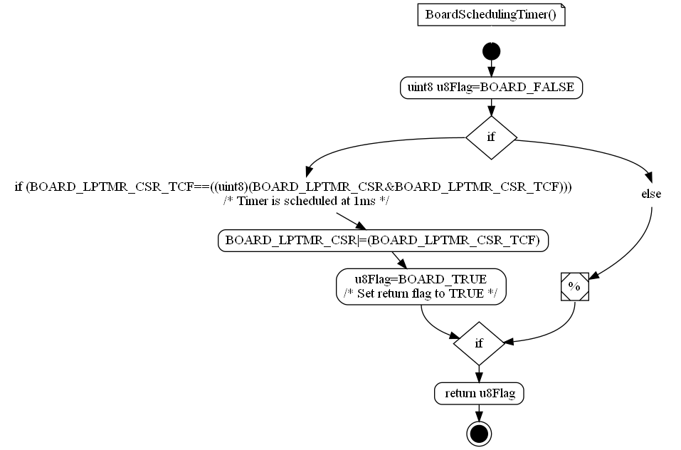

### BoardStart

|  |  |  |  |
| --- | --- | --- | --- |
| Object | | | |
| Realize board initial startup conditions for correct main execution. Function used to start the bootloader updater activity. | | | |
| **Prototype** | | | |
| void BoardStart (void) | | | |
| **Precondition** | | | |
| None. | | | |
| **Detailed Design Requirement** | | | |
| DSG_FblUpdUsr_BoardStart | | | |
| **Architecture Requirement** | | | |
| None. | | | |
| **Input parameters** | | | |
| Name | Type | Description | Range |
| NA | NA | NA | NA |
| **Output parameters** | | | |
| Name | Type | Description | Range |
| NA | NA | NA | NA |
| **Return value** | | | |
| Type | Description | | |
| NA | None. | | |
| **Dynamic aspect** | | | |
| Who(callers) | Description | | |
| None. | None. | | |
| **Static aspect** | | | |
| * | | | |
| **Constrains** | | | |
| None. | | | |

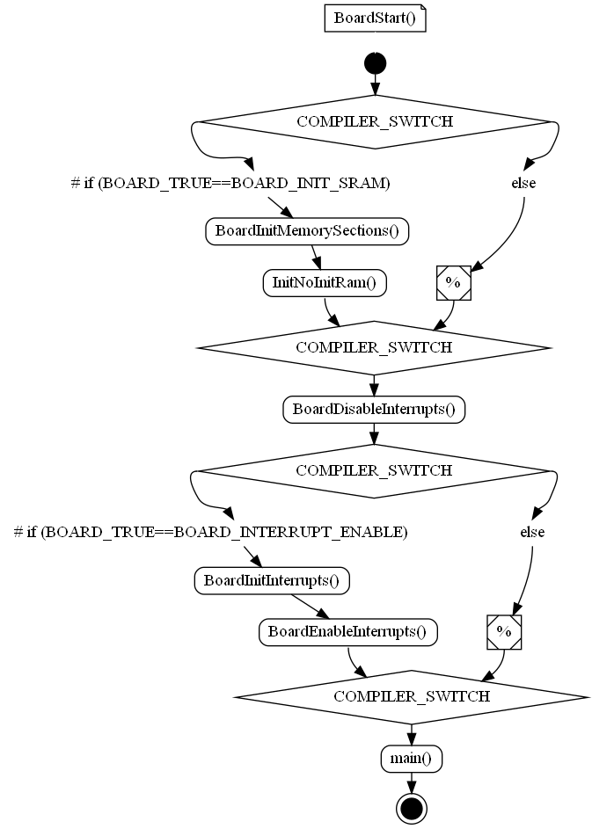

### InitNoInitRam

|  |  |  |  |
| --- | --- | --- | --- |
| Object | | | |
| Initialize RAM if reset was not a SW reset initialization. | | | |
| **Prototype** | | | |
| static void InitNoInitRam (void) [static] | | | |
| **Precondition** | | | |
| None. | | | |
| **Detailed Design Requirement** | | | |
| DSG_FblUpdUsr_InitNoInitRam | | | |
| **Architecture Requirement** | | | |
| None. | | | |
| **Input parameters** | | | |
| Name | Type | Description | Range |
| NA | NA | NA | NA |
| **Output parameters** | | | |
| Name | Type | Description | Range |
| NA | NA | NA | NA |
| **Return value** | | | |
| Type | Description | | |
| NA | None. | | |
| **Dynamic aspect** | | | |
| Who(callers) | Description | | |
| FblUsr module. | Called in BoardStart function. | | |
| **Static aspect** | | | |
| * | | | |
| **Constrains** | | | |
| None. | | | |

### boardResetStart

|  |  |  |  |
| --- | --- | --- | --- |
| Object | | | |
| The function contains the reset vector for S32K14X: reset vector is two 32-bit words, linked to a hardware-specific location, that tell the hardware: 1) Reset value of main stack pointer 2) Address of the boardResetStart function. | | | |
| **Prototype** | | | |
| void boardResetStart (void) | | | |
| **Precondition** | | | |
| None. | | | |
| **Detailed Design Requirement** | | | |
| DSG_FblUpdUsr_boardResetStart | | | |
| **Architecture Requirement** | | | |
| None. | | | |
| **Input parameters** | | | |
| Name | Type | Description | Range |
| NA | NA | NA | NA |
| **Output parameters** | | | |
| Name | Type | Description | Range |
| NA | NA | NA | NA |
| **Return value** | | | |
| Type | Description | | |
| NA | None. | | |
| **Dynamic aspect** | | | |
| Who(callers) | Description | | |
| None. | None. | | |
| **Static aspect** | | | |
| * | | | |
| **Constrains** | | | |
| None. | | | |

### FblUpdUsr_EraseMemoryFunction

|  |  |  |  |
| --- | --- | --- | --- |
| Object | | | |
| Function used to erase the flash memory. | | | |
| **Prototype** | | | |
| static __ramfunc void FblUpdUsr_EraseMemoryFunction (uint32 u32address) [static] | | | |
| **Detailed Design Requirement** | | | |
| DSG_FblUpdUsr_FblUpdUsr_EraseMemoryFunction | | | |
| **Architecture Requirement** | | | |
| None. | | | |
| **Input parameters** | | | |
| Name | Type | Description | Range |
| address | uint32 | the register address |  |
| **Output parameters** | | | |
| Name | Type | Description | Range |
| NA | NA | NA | NA |
| **Return value** | | | |
| Type | Description | | |
| NA | NA | | |
| **Dynamic aspect** | | | |
| Who(callers) | Description | | |
| FblUpdUsr module. | Called locally in main function via direct call. | | |
| **Static aspect** | | | |
| * | | | |
| **Constrains** | | | |
| None. | | | |

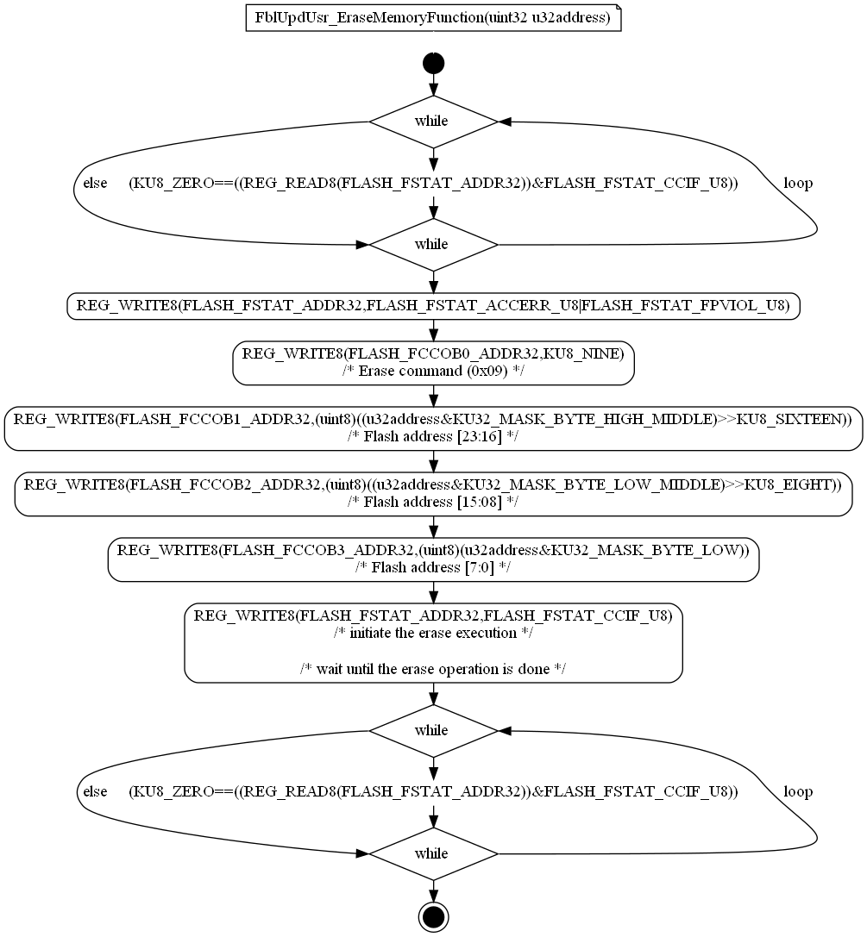

### FblUpdUsr_TriggerWD

|  |  |  |  |
| --- | --- | --- | --- |
| Object | | | |
| Function used to trigger watchdog. | | | |
| **Prototype** | | | |
| static void FblUpdUsr_TriggerWD (void) [static] | | | |
| **Detailed Design Requirement** | | | |
| DSG_FblUpdUsr_FblUpdUsr_TriggerWD | | | |
| **Architecture Requirement** | | | |
| None. | | | |
| **Input parameters** | | | |
| Name | Type | Description | Range |
| NA | NA | NA | NA |
| **Output parameters** | | | |
| Name | Type | Description | Range |
| NA | NA | NA | NA |
| **Return value** | | | |
| Type | Description | | |
| NA | NA | | |
| **Dynamic aspect** | | | |
| Who(callers) | Description | | |
| FblUpdUsr module. | Called locally in main function via direct call. | | |
| **Static aspect** | | | |
| * | | | |
| **Constrains** | | | |
| None. | | | |

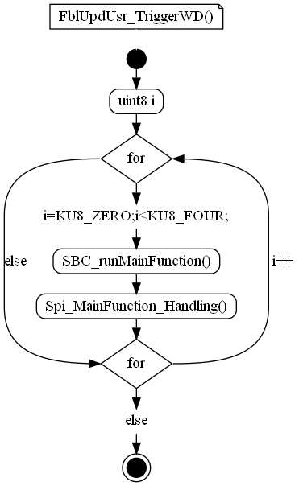

### FblUpdUsr_WriteMemoryFunction

|  |  |  |  |
| --- | --- | --- | --- |
| Object | | | |
| Function used to write the flash memory. | | | |
| **Prototype** | | | |
| static __ramfunc void FblUpdUsr_WriteMemoryFunction (void) [static] | | | |
| **Detailed Design Requirement** | | | |
| DSG_FblUpdUsr_FblUpdUsr_WriteMemoryFunction | | | |
| **Architecture Requirement** | | | |
| None. | | | |
| **Input parameters** | | | |
| Name | Type | Description | Range |
| NA | NA | NA | NA |
| **Output parameters** | | | |
| Name | Type | Description | Range |
| NA | NA | NA | NA |
| **Return value** | | | |
| Type | Description | | |
| NA | NA | | |
| **Dynamic aspect** | | | |
| Who(callers) | Description | | |
| FblUpdUsr module. | Called locally in main function via direct call. | | |
| **Static aspect** | | | |
| * | | | |
| **Constrains** | | | |
| None. | | | |



### main

|  |  |  |  |
| --- | --- | --- | --- |
| Object | | | |
| Function used to start the execution (activation of PLL clock, initialization of port, start up bootloader updater activity). | | | |
| **Prototype** | | | |
| int main (void) | | | |
| **Parameters** | | | |
| None. | | | |
| **Input parameters** | | | |
| Name | Type | Description | Range |
| NA | NA | NA | NA |
| **Output parameters** | | | |
| Name | Type | Description | Range |
| NA | NA | NA | NA |
| **Return value** | | | |
| Type | Description | | |
| int | None. | | |
| **Dynamic aspect** | | | |
| Who(callers) | Description | | |
| None. | None. | | |
| **Static aspect** | | | |
| * | | | |
| **Constrains** | | | |
| None. | | | |



## Variabiles

### FblUsr_u8BoardIntLockNestingCounter

|  |  |  |
| --- | --- | --- |
| Type | Value |  |
| uint8 | ((uint8) 0x00) | |
| **Description** | | |
| The counter for enabling/disabling interrupts. | | |
| **Definition** | | |
| uint8 FblUsr_u8BoardIntLockNestingCounter = ((uint8) 0x00) | | |

### PLATFORMS_TOOL_STARTNOINIT

|  |  |  |
| --- | --- | --- |
| Type | Value |  |
| uint32 PLATFORMS_TOOL_ENDBSS [extern] uint32 PLATFORMS_TOOL_ENDDATA [extern] uint32 PLATFORMS_TOOL_ENDDATARW [extern] uint32 PLATFORMS_TOOL_INITDATA [extern] uint32 PLATFORMS_TOOL_INITDATARW [extern] uint32 PLATFORMS_TOOL_STARTBSS [extern] uint32 PLATFORMS_TOOL_STARTDATA [extern] uint32 PLATFORMS_TOOL_STARTDATARW [extern] uint32 | (uint32 *)0x1fff91c0uL | |
| **Description** | | |
| Constant with external linkage. | | |
| **Definition** | | |
| uint32 PLATFORMS_TOOL_ENDBSS [extern] uint32 PLATFORMS_TOOL_ENDDATA [extern] uint32 PLATFORMS_TOOL_ENDDATARW [extern] uint32 PLATFORMS_TOOL_INITDATA [extern] uint32 PLATFORMS_TOOL_INITDATARW [extern] uint32 PLATFORMS_TOOL_STARTBSS [extern] uint32 PLATFORMS_TOOL_STARTDATA [extern] uint32 PLATFORMS_TOOL_STARTDATARW [extern] uint32 PLATFORMS_TOOL_STARTNOINIT [extern] uint32* u32PlatformsAddressBase = (uint32 *)0x1fff91c0uL | | |

### u32PlatformsAddressBaseInit

|  |  |  |
| --- | --- | --- |
| Type | Value |  |
| uint32 | (uint32 *)0x62060uL | |
| **Description** | | |
| Constant with external linkage. | | |
| **Definition** | | |
| uint32* u32PlatformsAddressBaseInit = (uint32 *)0x62060uL | | |

### u32PlatformsAddressBaseLimit

|  |  |  |
| --- | --- | --- |
| Type | Value |  |
| uint32 | (uint32 *)0x1fff925cuL | |
| **Description** | | |
| Constant with external linkage. | | |
| **Definition** | | |
| uint32* u32PlatformsAddressBaseLimit = (uint32 *)0x1fff925cuL | | |

### u32PlatformsAddressBSSBase

|  |  |  |
| --- | --- | --- |
| Type | Value |  |
| uint32 | (uint32 *)0x1fff8700uL | |
| **Description** | | |
| Constant with external linkage. | | |
| **Definition** | | |
| uint32* u32PlatformsAddressBSSBase = (uint32 *)0x1fff8700uL | | |

### u32PlatformsAddressBSSLimit

|  |  |  |
| --- | --- | --- |
| Type | Value |  |
| uint32 | (uint32 *)0x1fff91b4uL | |
| **Description** | | |
| Constant with external linkage. | | |
| **Definition** | | |
| uint32* u32PlatformsAddressBSSLimit = (uint32 *)0x1fff91b4uL | | |

### u32PlatformsAddressExtraBase

|  |  |  |
| --- | --- | --- |
| Type | Value |  |
| uint32 | (uint32 *)0x1fff8000uL | |
| **Description** | | |
| Constant with external linkage. | | |
| **Definition** | | |
| uint32* u32PlatformsAddressExtraBase = (uint32 *)0x1fff8000uL | | |

### u32PlatformsAddressExtraBaseInit

|  |  |  |
| --- | --- | --- |
| Type | Value |  |
| uint32 | (uint32 *)0x40000uL | |
| **Description** | | |
| Constant with external linkage. | | |
| **Definition** | | |
| uint32* u32PlatformsAddressExtraBaseInit = (uint32 *)0x40000uL | | |

### u32PlatformsAddressExtraBaseLimit

|  |  |  |
| --- | --- | --- |
| Type | Value |  |
| uint32 | (uint32 *)0x1fff8130uL | |
| **Description** | | |
| Constant with external linkage. | | |
| **Definition** | | |
| uint32* u32PlatformsAddressExtraBaseLimit = (uint32 *)0x1fff8130uL | | |

### u32PlatformsAddressNoInitBase

|  |  |  |
| --- | --- | --- |
| Type | Value |  |
| uint32 | (uint32 *) 0x20003f00uL | |
| **Description** | | |
| Constant with external linkage. | | |
| **Definition** | | |
| uint32* u32PlatformsAddressNoInitBase = (uint32 *) 0x20003f00uL | | |

### BoardStack[ISTACKLEN]

|  |  |  |
| --- | --- | --- |
| Type | Value |  |
| uint32 | NA | |
| **Description** | | |
| const uint32 reset_vector[2] | | |
| **Definition** | | |
| uint32 BoardStack[ISTACKLEN] | | |

## Macros

### FBLUSR_KU32_BYTE

|  |  |
| --- | --- |
| Name | Value |
| FBLUSR_KU32_BYTE | ((uint32) 0xFF) |
| **Definition** | |
| #define FBLUSR_KU32_BYTE ((uint32) 0xFF) | |
| **Description** | |
| NA | |

### FBLUSR_KU32_MAX_VAL

|  |  |
| --- | --- |
| Name | Value |
| FBLUSR_KU32_MAX_VAL | (0xFFFFFFFFu) |
| **Definition** | |
| #define FBLUSR_KU32_MAX_VAL (0xFFFFFFFFu) | |
| **Description** | |
| NA | |

### FBLUSR_KU32_VAL_12

|  |  |
| --- | --- |
| Name | Value |
| FBLUSR_KU32_VAL_12 | (12U) |
| **Definition** | |
| #define FBLUSR_KU32_VAL_12 (12U) | |
| **Description** | |
| NA | |

### FBLUSR_KU32_VAL_16

|  |  |
| --- | --- |
| Name | Value |
| FBLUSR_KU32_VAL_16 | (16U) |
| **Definition** | |
| #define FBLUSR_KU32_VAL_16 (16U) | |
| **Description** | |
| NA | |

### FBLUSR_KU32_VAL_4

|  |  |
| --- | --- |
| Name | Value |
| FBLUSR_KU32_VAL_4 | ((uint32) 0x4) |
| **Definition** | |
| #define FBLUSR_KU32_VAL_4 ((uint32) 0x4) | |
| **Description** | |
| This file contains board-specific startup code. | |

### BOARD_START_STACK_CODE

|  |  |
| --- | --- |
| Name | Value |
| BOARD_START_STACK_CODE | NA |
| **Definition** | |
| #define BOARD_START_STACK_CODE | |
| **Description** | |
| NA | |

### BOARD_STOP_STACK_CODE

|  |  |
| --- | --- |
| Name | Value |
| BOARD_STOP_STACK_CODE | NA |
| **Definition** | |
| #define BOARD_STOP_STACK_CODE | |
| **Description** | |
| NA | |

### B_FALSE

|  |  |
| --- | --- |
| Name | Value |
| B_FALSE | ((boolean)0x55) |
| **Definition** | |
| #define B_FALSE ((boolean)0x55) | |
| **Description** | |
| NA | |

### B_TRUE

|  |  |
| --- | --- |
| Name | Value |
| B_TRUE | ((boolean)0xAA) |
| **Definition** | |
| #define B_TRUE ((boolean)0xAA) | |
| **Description** | |
| NA | |

### EXPORTED

|  |  |
| --- | --- |
| Name | Value |
| EXPORTED | NA |
| **Definition** | |
| #define EXPORTED | |
| **Description** | |
| NA | |

### KAC_DAY_VERSION

|  |  |
| --- | --- |
| Name | Value |
| KAC_DAY_VERSION | '22' |
| **Definition** | |
| #define KAC_DAY_VERSION '22' | |
| **Description** | |
| NA | |

### KAC_MONTH_VERSION

|  |  |
| --- | --- |
| Name | Value |
| KAC_MONTH_VERSION | '1' |
| **Definition** | |
| #define KAC_MONTH_VERSION '1' | |
| **Description** | |
| NA | |

### KAC_SOFT_VERSION

|  |  |
| --- | --- |
| Name | Value |
| KAC_SOFT_VERSION | 'ER_001CO.000' |
| **Definition** | |
| #define KAC_SOFT_VERSION 'ER_001CO.000' | |
| **Description** | |
| NA | |

### KAC_YEAR_VERSION

|  |  |
| --- | --- |
| Name | Value |
| KAC_YEAR_VERSION | '14' |
| **Definition** | |
| #define KAC_YEAR_VERSION '14' | |
| **Description** | |
| NA | |

### KB_ZERO

|  |  |
| --- | --- |
| Name | Value |
| KB_ZERO | ((boolean) 0) |
| **Definition** | |
| #define KB_ZERO ((boolean) 0) | |
| **Description** | |
| NA | |

### KPF_NULL

|  |  |
| --- | --- |
| Name | Value |
| KPF_NULL | ((void *) 0) |
| **Definition** | |
| #define KPF_NULL ((void *) 0) | |
| **Description** | |
| NA | |

### KPU8_NULL

|  |  |
| --- | --- |
| Name | Value |
| KPU8_NULL | ((uint8*) 0) |
| **Definition** | |
| #define KPU8_NULL ((uint8*) 0) | |
| **Description** | |
| NA | |

### KS16_MAX

|  |  |
| --- | --- |
| Name | Value |
| KS16_MAX | ((sint16) 32767) |
| **Definition** | |
| #define KS16_MAX ((sint16) 32767) | |
| **Description** | |
| NA | |

### KS16_MAX_S8

|  |  |
| --- | --- |
| Name | Value |
| KS16_MAX_S8 | ((sint16) 127) /* 0x007F */ |
| **Definition** | |
| #define KS16_MAX_S8 ((sint16) 127) /* 0x007F */ | |
| **Description** | |
| NA | |

### KS16_MIN

|  |  |
| --- | --- |
| Name | Value |
| KS16_MIN | ((sint16) (-32767)) |
| **Definition** | |
| #define KS16_MIN ((sint16) (-32767)) | |
| **Description** | |
| NA | |

### KS16_MIN_S8

|  |  |
| --- | --- |
| Name | Value |
| KS16_MIN_S8 | ((sint16) -128) /* 0xFF80 */ |
| **Definition** | |
| #define KS16_MIN_S8 ((sint16) -128) /* 0xFF80 */ | |
| **Description** | |
| NA | |

### KS16_ZERO

|  |  |
| --- | --- |
| Name | Value |
| KS16_ZERO | ((sint16) 0) |
| **Definition** | |
| #define KS16_ZERO ((sint16) 0) | |
| **Description** | |
| NA | |

### KS32_MAX

|  |  |
| --- | --- |
| Name | Value |
| KS32_MAX | ((sint32) 2147483647) |
| **Definition** | |
| #define KS32_MAX ((sint32) 2147483647) | |
| **Description** | |
| NA | |

### KS32_MAX_S16

|  |  |
| --- | --- |
| Name | Value |
| KS32_MAX_S16 | ((sint32) 32767) |
| **Definition** | |
| #define KS32_MAX_S16 ((sint32) 32767) | |
| **Description** | |
| NA | |

### KS32_MAX_U16

|  |  |
| --- | --- |
| Name | Value |
| KS32_MAX_U16 | ((sint32) 0xFFFF) |
| **Definition** | |
| #define KS32_MAX_U16 ((sint32) 0xFFFF) | |
| **Description** | |
| NA | |

### KS32_MAX_U8

|  |  |
| --- | --- |
| Name | Value |
| KS32_MAX_U8 | ((sint32) 0xFF) |
| **Definition** | |
| #define KS32_MAX_U8 ((sint32) 0xFF) | |
| **Description** | |
| NA | |

### KS32_MIN

|  |  |
| --- | --- |
| Name | Value |
| KS32_MIN | ((sint32) (-2147483647)) |
| **Definition** | |
| #define KS32_MIN ((sint32) (-2147483647)) | |
| **Description** | |
| NA | |

### KS32_MIN_S16

|  |  |
| --- | --- |
| Name | Value |
| KS32_MIN_S16 | ((sint32) -32768) |
| **Definition** | |
| #define KS32_MIN_S16 ((sint32) -32768) | |
| **Description** | |
| NA | |

### KS32_ZERO

|  |  |
| --- | --- |
| Name | Value |
| KS32_ZERO | ((sint32) 0) |
| **Definition** | |
| #define KS32_ZERO ((sint32) 0) | |
| **Description** | |
| NA | |

### KS8_MAX

|  |  |
| --- | --- |
| Name | Value |
| KS8_MAX | ((uint8) 127) |
| **Definition** | |
| #define KS8_MAX ((uint8) 127) | |
| **Description** | |
| NA | |

### KS8_MIN

|  |  |
| --- | --- |
| Name | Value |
| KS8_MIN | ((sint8) (-127)) |
| **Definition** | |
| #define KS8_MIN ((sint8) (-127)) | |
| **Description** | |
| NA | |

### KS8_ZERO

|  |  |
| --- | --- |
| Name | Value |
| KS8_ZERO | ((sint8) 0x00) |
| **Definition** | |
| #define KS8_ZERO ((sint8) 0x00) | |
| **Description** | |
| NA | |

### KU16_MASK_BYTE_HIGH

|  |  |
| --- | --- |
| Name | Value |
| KU16_MASK_BYTE_HIGH | ((uint16) 0xFF00) |
| **Definition** | |
| #define KU16_MASK_BYTE_HIGH ((uint16) 0xFF00) | |
| **Description** | |
| NA | |

### KU16_MASK_BYTE_LOW

|  |  |
| --- | --- |
| Name | Value |
| KU16_MASK_BYTE_LOW | ((uint16) 0x00FF) |
| **Definition** | |
| #define KU16_MASK_BYTE_LOW ((uint16) 0x00FF) | |
| **Description** | |
| NA | |

### KU16_MAX

|  |  |
| --- | --- |
| Name | Value |
| KU16_MAX | ((uint16) 65535) |
| **Definition** | |
| #define KU16_MAX ((uint16) 65535) | |
| **Description** | |
| NA | |

### KU16_MAX_U8

|  |  |
| --- | --- |
| Name | Value |
| KU16_MAX_U8 | ((uint16) 0xFF) |
| **Definition** | |
| #define KU16_MAX_U8 ((uint16) 0xFF) | |
| **Description** | |
| NA | |

### KU16_MIN

|  |  |
| --- | --- |
| Name | Value |
| KU16_MIN | ((uint16) 0) |
| **Definition** | |
| #define KU16_MIN ((uint16) 0) | |
| **Description** | |
| NA | |

### KU16_ONE

|  |  |
| --- | --- |
| Name | Value |
| KU16_ONE | ((uint16) 0x0001) |
| **Definition** | |
| #define KU16_ONE ((uint16) 0x0001) | |
| **Description** | |
| NA | |

### KU16_RAM_MEMORY_END

|  |  |
| --- | --- |
| Name | Value |
| KU16_RAM_MEMORY_END | ((uint16)0x3FFF) |
| **Definition** | |
| #define KU16_RAM_MEMORY_END ((uint16)0x3FFF) | |
| **Description** | |
| NA | |

### KU16_RAM_MEMORY_START

|  |  |
| --- | --- |
| Name | Value |
| KU16_RAM_MEMORY_START | ((uint16)0x1000) |
| **Definition** | |
| #define KU16_RAM_MEMORY_START ((uint16)0x1000) | |
| **Description** | |
| NA | |

### KU16_ZERO

|  |  |
| --- | --- |
| Name | Value |
| KU16_ZERO | ((uint16) 0) |
| **Definition** | |
| #define KU16_ZERO ((uint16) 0) | |
| **Description** | |
| NA | |

### KU32_MASK_BYTE_HIGH

|  |  |
| --- | --- |
| Name | Value |
| KU32_MASK_BYTE_HIGH | ((uint32) 0xFF000000uL) |
| **Definition** | |
| #define KU32_MASK_BYTE_HIGH ((uint32) 0xFF000000uL) | |
| **Description** | |
| NA | |

### KU32_MASK_BYTE_HIGH_MIDDLE

|  |  |
| --- | --- |
| Name | Value |
| KU32_MASK_BYTE_HIGH_MIDDLE | ((uint32) 0x00FF0000uL) |
| **Definition** | |
| #define KU32_MASK_BYTE_HIGH_MIDDLE ((uint32) 0x00FF0000uL) | |
| **Description** | |
| NA | |

### KU32_MASK_BYTE_LOW

|  |  |
| --- | --- |
| Name | Value |
| KU32_MASK_BYTE_LOW | ((uint32) 0x000000FFuL) |
| **Definition** | |
| #define KU32_MASK_BYTE_LOW ((uint32) 0x000000FFuL) | |
| **Description** | |
| NA | |

### KU32_MASK_BYTE_LOW_MIDDLE

|  |  |
| --- | --- |
| Name | Value |
| KU32_MASK_BYTE_LOW_MIDDLE | ((uint32) 0x0000FF00uL) |
| **Definition** | |
| #define KU32_MASK_BYTE_LOW_MIDDLE ((uint32) 0x0000FF00uL) | |
| **Description** | |
| NA | |

### KU32_MASK_WORD_HIGH

|  |  |
| --- | --- |
| Name | Value |
| KU32_MASK_WORD_HIGH | ((uint32) 0xFFFF0000uL) |
| **Definition** | |
| #define KU32_MASK_WORD_HIGH ((uint32) 0xFFFF0000uL) | |
| **Description** | |
| NA | |

### KU32_MASK_WORD_LOW

|  |  |
| --- | --- |
| Name | Value |
| KU32_MASK_WORD_LOW | ((uint32) 0x0000FFFFuL) |
| **Definition** | |
| #define KU32_MASK_WORD_LOW ((uint32) 0x0000FFFFuL) | |
| **Description** | |
| NA | |

### KU32_MAX

|  |  |
| --- | --- |
| Name | Value |
| KU32_MAX | ((uint32) 4294967295uL) |
| **Definition** | |
| #define KU32_MAX ((uint32) 4294967295uL) | |
| **Description** | |
| NA | |

### KU32_MAX_U16

|  |  |
| --- | --- |
| Name | Value |
| KU32_MAX_U16 | ((uint32) 0xFFFFuL) |
| **Definition** | |
| #define KU32_MAX_U16 ((uint32) 0xFFFFuL) | |
| **Description** | |
| NA | |

### KU32_MAX_U8

|  |  |
| --- | --- |
| Name | Value |
| KU32_MAX_U8 | ((uint32) 0x000000FF) |
| **Definition** | |
| #define KU32_MAX_U8 ((uint32) 0x000000FF) | |
| **Description** | |
| NA | |

### KU32_MIN

|  |  |
| --- | --- |
| Name | Value |
| KU32_MIN | ((uint32) 0) |
| **Definition** | |
| #define KU32_MIN ((uint32) 0) | |
| **Description** | |
| NA | |

### KU32_ONE

|  |  |
| --- | --- |
| Name | Value |
| KU32_ONE | ((uint32) 0x00000001) |
| **Definition** | |
| #define KU32_ONE ((uint32) 0x00000001) | |
| **Description** | |
| NA | |

### KU32_ZERO

|  |  |
| --- | --- |
| Name | Value |
| KU32_ZERO | ((uint32) 0) |
| **Definition** | |
| #define KU32_ZERO ((uint32) 0) | |
| **Description** | |
| NA | |

### KU8_BIT_0

|  |  |
| --- | --- |
| Name | Value |
| KU8_BIT_0 | ((uint8) 0) |
| **Definition** | |
| #define KU8_BIT_0 ((uint8) 0) | |
| **Description** | |
| NA | |

### KU8_BIT_1

|  |  |
| --- | --- |
| Name | Value |
| KU8_BIT_1 | ((uint8) 1) |
| **Definition** | |
| #define KU8_BIT_1 ((uint8) 1) | |
| **Description** | |
| NA | |

### KU8_BIT_10

|  |  |
| --- | --- |
| Name | Value |
| KU8_BIT_10 | ((uint8) 10) |
| **Definition** | |
| #define KU8_BIT_10 ((uint8) 10) | |
| **Description** | |
| NA | |

### KU8_BIT_11

|  |  |
| --- | --- |
| Name | Value |
| KU8_BIT_11 | ((uint8) 11) |
| **Definition** | |
| #define KU8_BIT_11 ((uint8) 11) | |
| **Description** | |
| NA | |

### KU8_BIT_12

|  |  |
| --- | --- |
| Name | Value |
| KU8_BIT_12 | ((uint8) 12) |
| **Definition** | |
| #define KU8_BIT_12 ((uint8) 12) | |
| **Description** | |
| NA | |

### KU8_BIT_13

|  |  |
| --- | --- |
| Name | Value |
| KU8_BIT_13 | ((uint8) 13) |
| **Definition** | |
| #define KU8_BIT_13 ((uint8) 13) | |
| **Description** | |
| NA | |

### KU8_BIT_14

|  |  |
| --- | --- |
| Name | Value |
| KU8_BIT_14 | ((uint8) 14) |
| **Definition** | |
| #define KU8_BIT_14 ((uint8) 14) | |
| **Description** | |
| NA | |

### KU8_BIT_15

|  |  |
| --- | --- |
| Name | Value |
| KU8_BIT_15 | ((uint8) 15) |
| **Definition** | |
| #define KU8_BIT_15 ((uint8) 15) | |
| **Description** | |
| NA | |

### KU8_BIT_16

|  |  |
| --- | --- |
| Name | Value |
| KU8_BIT_16 | ((uint8) 16) |
| **Definition** | |
| #define KU8_BIT_16 ((uint8) 16) | |
| **Description** | |
| NA | |

### KU8_BIT_17

|  |  |
| --- | --- |
| Name | Value |
| KU8_BIT_17 | ((uint8) 17) |
| **Definition** | |
| #define KU8_BIT_17 ((uint8) 17) | |
| **Description** | |
| NA | |

### KU8_BIT_18

|  |  |
| --- | --- |
| Name | Value |
| KU8_BIT_18 | ((uint8) 18) |
| **Definition** | |
| #define KU8_BIT_18 ((uint8) 18) | |
| **Description** | |
| NA | |

### KU8_BIT_19

|  |  |
| --- | --- |
| Name | Value |
| KU8_BIT_19 | ((uint8) 19) |
| **Definition** | |
| #define KU8_BIT_19 ((uint8) 19) | |
| **Description** | |
| NA | |

### KU8_BIT_2

|  |  |
| --- | --- |
| Name | Value |
| KU8_BIT_2 | ((uint8) 2) |
| **Definition** | |
| #define KU8_BIT_2 ((uint8) 2) | |
| **Description** | |
| NA | |

### KU8_BIT_20

|  |  |
| --- | --- |
| Name | Value |
| KU8_BIT_20 | ((uint8) 20) |
| **Definition** | |
| #define KU8_BIT_20 ((uint8) 20) | |
| **Description** | |
| NA | |

### KU8_BIT_21

|  |  |
| --- | --- |
| Name | Value |
| KU8_BIT_21 | ((uint8) 21) |
| **Definition** | |
| #define KU8_BIT_21 ((uint8) 21) | |
| **Description** | |
| NA | |

### KU8_BIT_22

|  |  |
| --- | --- |
| Name | Value |
| KU8_BIT_22 | ((uint8) 22) |
| **Definition** | |
| #define KU8_BIT_22 ((uint8) 22) | |
| **Description** | |
| NA | |

### KU8_BIT_23

|  |  |
| --- | --- |
| Name | Value |
| KU8_BIT_23 | ((uint8) 23) |
| **Definition** | |
| #define KU8_BIT_23 ((uint8) 23) | |
| **Description** | |
| NA | |

### KU8_BIT_24

|  |  |
| --- | --- |
| Name | Value |
| KU8_BIT_24 | ((uint8) 24) |
| **Definition** | |
| #define KU8_BIT_24 ((uint8) 24) | |
| **Description** | |
| NA | |

### KU8_BIT_25

|  |  |
| --- | --- |
| Name | Value |
| KU8_BIT_25 | ((uint8) 25) |
| **Definition** | |
| #define KU8_BIT_25 ((uint8) 25) | |
| **Description** | |
| NA | |

### KU8_BIT_26

|  |  |
| --- | --- |
| Name | Value |
| KU8_BIT_26 | ((uint8) 26) |
| **Definition** | |
| #define KU8_BIT_26 ((uint8) 26) | |
| **Description** | |
| NA | |

### KU8_BIT_27

|  |  |
| --- | --- |
| Name | Value |
| KU8_BIT_27 | ((uint8) 27) |
| **Definition** | |
| #define KU8_BIT_27 ((uint8) 27) | |
| **Description** | |
| NA | |

### KU8_BIT_28

|  |  |
| --- | --- |
| Name | Value |
| KU8_BIT_28 | ((uint8) 28) |
| **Definition** | |
| #define KU8_BIT_28 ((uint8) 28) | |
| **Description** | |
| NA | |

### KU8_BIT_29

|  |  |
| --- | --- |
| Name | Value |
| KU8_BIT_29 | ((uint8) 29) |
| **Definition** | |
| #define KU8_BIT_29 ((uint8) 29) | |
| **Description** | |
| NA | |

### KU8_BIT_3

|  |  |
| --- | --- |
| Name | Value |
| KU8_BIT_3 | ((uint8) 3) |
| **Definition** | |
| #define KU8_BIT_3 ((uint8) 3) | |
| **Description** | |
| NA | |

### KU8_BIT_30

|  |  |
| --- | --- |
| Name | Value |
| KU8_BIT_30 | ((uint8) 30) |
| **Definition** | |
| #define KU8_BIT_30 ((uint8) 30) | |
| **Description** | |
| NA | |

### KU8_BIT_31

|  |  |
| --- | --- |
| Name | Value |
| KU8_BIT_31 | ((uint8) 31) |
| **Definition** | |
| #define KU8_BIT_31 ((uint8) 31) | |
| **Description** | |
| NA | |

### KU8_BIT_4

|  |  |
| --- | --- |
| Name | Value |
| KU8_BIT_4 | ((uint8) 4) |
| **Definition** | |
| #define KU8_BIT_4 ((uint8) 4) | |
| **Description** | |
| NA | |

### KU8_BIT_5

|  |  |
| --- | --- |
| Name | Value |
| KU8_BIT_5 | ((uint8) 5) |
| **Definition** | |
| #define KU8_BIT_5 ((uint8) 5) | |
| **Description** | |
| NA | |

### KU8_BIT_6

|  |  |
| --- | --- |
| Name | Value |
| KU8_BIT_6 | ((uint8) 6) |
| **Definition** | |
| #define KU8_BIT_6 ((uint8) 6) | |
| **Description** | |
| NA | |

### KU8_BIT_7

|  |  |
| --- | --- |
| Name | Value |
| KU8_BIT_7 | ((uint8) 7) |
| **Definition** | |
| #define KU8_BIT_7 ((uint8) 7) | |
| **Description** | |
| NA | |

### KU8_BIT_8

|  |  |
| --- | --- |
| Name | Value |
| KU8_BIT_8 | ((uint8) 8) |
| **Definition** | |
| #define KU8_BIT_8 ((uint8) 8) | |
| **Description** | |
| NA | |

### KU8_BIT_9

|  |  |
| --- | --- |
| Name | Value |
| KU8_BIT_9 | ((uint8) 9) |
| **Definition** | |
| #define KU8_BIT_9 ((uint8) 9) | |
| **Description** | |
| NA | |

### KU8_EIGHT

|  |  |
| --- | --- |
| Name | Value |
| KU8_EIGHT | ((uint8) 0x08) |
| **Definition** | |
| #define KU8_EIGHT ((uint8) 0x08) | |
| **Description** | |
| NA | |

### KU8_FIVE

|  |  |
| --- | --- |
| Name | Value |
| KU8_FIVE | ((uint8) 0x05) |
| **Definition** | |
| #define KU8_FIVE ((uint8) 0x05) | |
| **Description** | |
| NA | |

### KU8_FOUR

|  |  |
| --- | --- |
| Name | Value |
| KU8_FOUR | ((uint8) 0x04) |
| **Definition** | |
| #define KU8_FOUR ((uint8) 0x04) | |
| **Description** | |
| NA | |

### KU8_MASK_BIT_0

|  |  |
| --- | --- |
| Name | Value |
| KU8_MASK_BIT_0 | ((uint8) 0x01) |
| **Definition** | |
| #define KU8_MASK_BIT_0 ((uint8) 0x01) | |
| **Description** | |
| NA | |

### KU8_MASK_BIT_1

|  |  |
| --- | --- |
| Name | Value |
| KU8_MASK_BIT_1 | ((uint8) 0x02) |
| **Definition** | |
| #define KU8_MASK_BIT_1 ((uint8) 0x02) | |
| **Description** | |
| NA | |

### KU8_MASK_BIT_2

|  |  |
| --- | --- |
| Name | Value |
| KU8_MASK_BIT_2 | ((uint8) 0x04) |
| **Definition** | |
| #define KU8_MASK_BIT_2 ((uint8) 0x04) | |
| **Description** | |
| NA | |

### KU8_MASK_BIT_3

|  |  |
| --- | --- |
| Name | Value |
| KU8_MASK_BIT_3 | ((uint8) 0x08) |
| **Definition** | |
| #define KU8_MASK_BIT_3 ((uint8) 0x08) | |
| **Description** | |
| NA | |

### KU8_MASK_BIT_4

|  |  |
| --- | --- |
| Name | Value |
| KU8_MASK_BIT_4 | ((uint8) 0x10) |
| **Definition** | |
| #define KU8_MASK_BIT_4 ((uint8) 0x10) | |
| **Description** | |
| NA | |

### KU8_MASK_BIT_5

|  |  |
| --- | --- |
| Name | Value |
| KU8_MASK_BIT_5 | ((uint8) 0x20) |
| **Definition** | |
| #define KU8_MASK_BIT_5 ((uint8) 0x20) | |
| **Description** | |
| NA | |

### KU8_MASK_BIT_6

|  |  |
| --- | --- |
| Name | Value |
| KU8_MASK_BIT_6 | ((uint8) 0x40) |
| **Definition** | |
| #define KU8_MASK_BIT_6 ((uint8) 0x40) | |
| **Description** | |
| NA | |

### KU8_MASK_BIT_7

|  |  |
| --- | --- |
| Name | Value |
| KU8_MASK_BIT_7 | ((uint8) 0x80) |
| **Definition** | |
| #define KU8_MASK_BIT_7 ((uint8) 0x80) | |
| **Description** | |
| NA | |

### KU8_MASK_BITS_2_7

|  |  |
| --- | --- |
| Name | Value |
| KU8_MASK_BITS_2_7 | ((uint8) 0xFC) |
| **Definition** | |
| #define KU8_MASK_BITS_2_7 ((uint8) 0xFC) | |
| **Description** | |
| NA | |

### KU8_MASK_HALF_BYTE_HIGH

|  |  |
| --- | --- |
| Name | Value |
| KU8_MASK_HALF_BYTE_HIGH | ((uint8) 0xF0) |
| **Definition** | |
| #define KU8_MASK_HALF_BYTE_HIGH ((uint8) 0xF0) | |
| **Description** | |
| NA | |

### KU8_MASK_HALF_BYTE_LOW

|  |  |
| --- | --- |
| Name | Value |
| KU8_MASK_HALF_BYTE_LOW | ((uint8) 0x0F) |
| **Definition** | |
| #define KU8_MASK_HALF_BYTE_LOW ((uint8) 0x0F) | |
| **Description** | |
| NA | |

### KU8_MAX

|  |  |
| --- | --- |
| Name | Value |
| KU8_MAX | ((uint8) 255) |
| **Definition** | |
| #define KU8_MAX ((uint8) 255) | |
| **Description** | |
| NA | |

### KU8_MIN

|  |  |
| --- | --- |
| Name | Value |
| KU8_MIN | ((uint8) 0) |
| **Definition** | |
| #define KU8_MIN ((uint8) 0) | |
| **Description** | |
| NA | |

### KU8_NINE

|  |  |
| --- | --- |
| Name | Value |
| KU8_NINE | ((uint8) 0x09) |
| **Definition** | |
| #define KU8_NINE ((uint8) 0x09) | |
| **Description** | |
| NA | |

### KU8_ONE

|  |  |
| --- | --- |
| Name | Value |
| KU8_ONE | ((uint8) 0x01) |
| **Definition** | |
| #define KU8_ONE ((uint8) 0x01) | |
| **Description** | |
| NA | |

### KU8_ONE_HUNDRED

|  |  |
| --- | --- |
| Name | Value |
| KU8_ONE_HUNDRED | ((uint8) 100) |
| **Definition** | |
| #define KU8_ONE_HUNDRED ((uint8) 100) | |
| **Description** | |
| NA | |

### KU8_POS_HIGH_BYTE

|  |  |
| --- | --- |
| Name | Value |
| KU8_POS_HIGH_BYTE | ((uint8) 8) |
| **Definition** | |
| #define KU8_POS_HIGH_BYTE ((uint8) 8) | |
| **Description** | |
| NA | |

### KU8_POS_L_HIGH_BYTE

|  |  |
| --- | --- |
| Name | Value |
| KU8_POS_L_HIGH_BYTE | ((uint8) 24) |
| **Definition** | |
| #define KU8_POS_L_HIGH_BYTE ((uint8) 24) | |
| **Description** | |
| NA | |

### KU8_POS_L_HIGH_MIDDLE_BYTE

|  |  |
| --- | --- |
| Name | Value |
| KU8_POS_L_HIGH_MIDDLE_BYTE | ((uint8) 16) |
| **Definition** | |
| #define KU8_POS_L_HIGH_MIDDLE_BYTE ((uint8) 16) | |
| **Description** | |
| NA | |

### KU8_POS_L_LOW_BYTE

|  |  |
| --- | --- |
| Name | Value |
| KU8_POS_L_LOW_BYTE | ((uint8) 0) |
| **Definition** | |
| #define KU8_POS_L_LOW_BYTE ((uint8) 0) | |
| **Description** | |
| NA | |

### KU8_POS_L_LOW_MIDDLE_BYTE

|  |  |
| --- | --- |
| Name | Value |
| KU8_POS_L_LOW_MIDDLE_BYTE | ((uint8) 8) |
| **Definition** | |
| #define KU8_POS_L_LOW_MIDDLE_BYTE ((uint8) 8) | |
| **Description** | |
| NA | |

### KU8_POS_LOW_BYTE

|  |  |
| --- | --- |
| Name | Value |
| KU8_POS_LOW_BYTE | ((uint8) 0) |
| **Definition** | |
| #define KU8_POS_LOW_BYTE ((uint8) 0) | |
| **Description** | |
| NA | |

### KU8_SEVEN

|  |  |
| --- | --- |
| Name | Value |
| KU8_SEVEN | ((uint8) 0x07) |
| **Definition** | |
| #define KU8_SEVEN ((uint8) 0x07) | |
| **Description** | |
| NA | |

### KU8_SHIFT_HALF_BYTE

|  |  |
| --- | --- |
| Name | Value |
| KU8_SHIFT_HALF_BYTE | ((uint8) 4) |
| **Definition** | |
| #define KU8_SHIFT_HALF_BYTE ((uint8) 4) | |
| **Description** | |
| NA | |

### KU8_SIX

|  |  |
| --- | --- |
| Name | Value |
| KU8_SIX | ((uint8) 0x06) |
| **Definition** | |
| #define KU8_SIX ((uint8) 0x06) | |
| **Description** | |
| NA | |

### KU8_SIXTEEN

|  |  |
| --- | --- |
| Name | Value |
| KU8_SIXTEEN | ((uint8) 0x10) |
| **Definition** | |
| #define KU8_SIXTEEN ((uint8) 0x10) | |
| **Description** | |
| NA | |

### KU8_TEN

|  |  |
| --- | --- |
| Name | Value |
| KU8_TEN | ((uint8) 0x0A) |
| **Definition** | |
| #define KU8_TEN ((uint8) 0x0A) | |
| **Description** | |
| NA | |

### KU8_THREE

|  |  |
| --- | --- |
| Name | Value |
| KU8_THREE | ((uint8) 0x03) |
| **Definition** | |
| #define KU8_THREE ((uint8) 0x03) | |
| **Description** | |
| NA | |

### KU8_TWO

|  |  |
| --- | --- |
| Name | Value |
| KU8_TWO | ((uint8) 0x02) |
| **Definition** | |
| #define KU8_TWO ((uint8) 0x02) | |
| **Description** | |
| NA | |

### KU8_ZERO

|  |  |
| --- | --- |
| Name | Value |
| KU8_ZERO | ((uint8) 0x00) |
| **Definition** | |
| #define KU8_ZERO ((uint8) 0x00) | |
| **Description** | |
| NA | |

### KUC_SIZE_STRING_SOFT_VERSION

|  |  |
| --- | --- |
| Name | Value |
| KUC_SIZE_STRING_SOFT_VERSION | ((uint8) 12) |
| **Definition** | |
| #define KUC_SIZE_STRING_SOFT_VERSION ((uint8) 12) | |
| **Description** | |
| NA | |

### KUC_SOFT_MINOR_VERSION_NB

|  |  |
| --- | --- |
| Name | Value |
| KUC_SOFT_MINOR_VERSION_NB | ((uint8) 0) |
| **Definition** | |
| #define KUC_SOFT_MINOR_VERSION_NB ((uint8) 0) | |
| **Description** | |
| NA | |

### KUC_SOFT_VERSION_NB

|  |  |
| --- | --- |
| Name | Value |
| KUC_SOFT_VERSION_NB | ((uint8) 0) |
| **Definition** | |
| #define KUC_SOFT_VERSION_NB ((uint8) 0) | |
| **Description** | |
| NA | |

### LOCAL

|  |  |
| --- | --- |
| Name | Value |
| LOCAL | static |
| **Definition** | |
| #define LOCAL static | |
| **Description** | |
| NA | |

### ramfunc

|  |  |
| --- | --- |
| Name | Value |
| ramfunc | __ramfunc |
| **Definition** | |
| #define ramfunc __ramfunc | |
| **Description** | |
| NA | |

### U16_BIT_CLEAR(reg,

|  |  |
| --- | --- |
| Name | Value |
| U16_BIT_CLEAR(reg, | (reg, mask) ((reg) &= ((mask)^((uint16)0xFFFF))) |
| **Definition** | |
| #define U16_BIT_CLEAR(reg, mask) ((reg) &= ((mask)^((uint16)0xFFFF))) | |
| **Description** | |
| NA | |

### U16_BIT_SET(reg,

|  |  |
| --- | --- |
| Name | Value |
| U16_BIT_SET(reg, | (reg, mask) ((reg) |= (mask)) |
| **Definition** | |
| #define U16_BIT_SET(reg, mask) ((reg) |= (mask)) | |
| **Description** | |
| NA | |

### U16_COMPLEMENT(val)

|  |  |
| --- | --- |
| Name | Value |
| U16_COMPLEMENT(val) | (val) ((val) ^ ((uint16)0xFFFF)) |
| **Definition** | |
| #define U16_COMPLEMENT(val) ((val) ^ ((uint16)0xFFFF)) | |
| **Description** | |
| NA | |

### U16_GET_ABSOLUTE_VALUE_FROM_S16(value)

|  |  |
| --- | --- |
| Name | Value |
| U16_GET_ABSOLUTE_VALUE_FROM_S16(value) | (value) (((value)<((sint16)(0)))?((uint16)-(value)):((uint16)(value)) |
| **Definition** | |
| #define U16_GET_ABSOLUTE_VALUE_FROM_S16(value) (((value)<((sint16)(0)))?((uint16)-(value)):((uint16)(value)) | |
| **Description** | |
| NA | |

### U16_GET_HIGH_BYTE(_word)

|  |  |
| --- | --- |
| Name | Value |
| U16_GET_HIGH_BYTE(_word) | (_word) ((uint8)(((_word) & KU16_MASK_BYTE_HIGH) >> KU8_POS_HIGH_BYTE)) |
| **Definition** | |
| #define U16_GET_HIGH_BYTE(_word) ((uint8)(((_word) & KU16_MASK_BYTE_HIGH) >> KU8_POS_HIGH_BYTE)) | |
| **Description** | |
| NA | |

### U16_GET_LOW_BYTE(_word)

|  |  |
| --- | --- |
| Name | Value |
| U16_GET_LOW_BYTE(_word) | (_word) ((uint8)(((_word) & KU16_MASK_BYTE_LOW ) >> KU8_POS_LOW_BYTE )) |
| **Definition** | |
| #define U16_GET_LOW_BYTE(_word) ((uint8)(((_word) & KU16_MASK_BYTE_LOW ) >> KU8_POS_LOW_BYTE )) | |
| **Description** | |
| NA | |

### U16_GET_SATURATED_VALUE_FROM_U32(value)

|  |  |
| --- | --- |
| Name | Value |
| U16_GET_SATURATED_VALUE_FROM_U32(value) | (value) (((value)>((uint32)(KU16_MAX)))?((uint16)KU16_MAX):((uint16)(value)) /* PRQA S 3491 */) |
| **Definition** | |
| #define U16_GET_SATURATED_VALUE_FROM_U32(value) (((value)>((uint32)(KU16_MAX)))?((uint16)KU16_MAX):((uint16)(value)) /* PRQA S 3491 */) | |
| **Description** | |
| NA | |

### U32_BIT_CLEAR(reg,

|  |  |
| --- | --- |
| Name | Value |
| U32_BIT_CLEAR(reg, | (reg, mask) ((reg) &= ((mask)^((uint32)0xFFFFFFFFuL))) |
| **Definition** | |
| #define U32_BIT_CLEAR(reg, mask) ((reg) &= ((mask)^((uint32)0xFFFFFFFFuL))) | |
| **Description** | |
| NA | |

### U32_BIT_SET(reg,

|  |  |
| --- | --- |
| Name | Value |
| U32_BIT_SET(reg, | (reg, mask) ((reg) |= (mask)) |
| **Definition** | |
| #define U32_BIT_SET(reg, mask) ((reg) |= (mask)) | |
| **Description** | |
| NA | |

### U32_COMPLEMENT(val)

|  |  |
| --- | --- |
| Name | Value |
| U32_COMPLEMENT(val) | (val) ((val)^((uint32)0xFFFFFFFFuL)) |
| **Definition** | |
| #define U32_COMPLEMENT(val) ((val)^((uint32)0xFFFFFFFFuL)) | |
| **Description** | |
| NA | |

### U32_GET_ABSOLUTE_VALUE_FROM_S32(value)

|  |  |
| --- | --- |
| Name | Value |
| U32_GET_ABSOLUTE_VALUE_FROM_S32(value) | (value) (((value)<((sint32)(0)))?((uint32)-(value)):((uint32)(value)) |
| **Definition** | |
| #define U32_GET_ABSOLUTE_VALUE_FROM_S32(value) (((value)<((sint32)(0)))?((uint32)-(value)):((uint32)(value)) | |
| **Description** | |
| NA | |

### U32_GET_HIGH_BYTE(_long)

|  |  |
| --- | --- |
| Name | Value |
| U32_GET_HIGH_BYTE(_long) | (_long) ((uint8)(( (_long) & KU32_MASK_BYTE_HIGH) >> KU8_POS_L_HIGH_BYTE)) |
| **Definition** | |
| #define U32_GET_HIGH_BYTE(_long) ((uint8)(( (_long) & KU32_MASK_BYTE_HIGH) >> KU8_POS_L_HIGH_BYTE)) | |
| **Description** | |
| NA | |

### U32_GET_HIGH_MIDDLE_BYTE(_long)

|  |  |
| --- | --- |
| Name | Value |
| U32_GET_HIGH_MIDDLE_BYTE(_long) | (_long) ((uint8)(( (_long) & KU32_MASK_BYTE_HIGH_MIDDLE) >> KU8_POS_L_HIGH_MIDDLE_BYTE)) |
| **Definition** | |
| #define U32_GET_HIGH_MIDDLE_BYTE(_long) ((uint8)(( (_long) & KU32_MASK_BYTE_HIGH_MIDDLE) >> KU8_POS_L_HIGH_MIDDLE_BYTE)) | |
| **Description** | |
| NA | |

### U32_GET_LOW_BYTE(_long)

|  |  |
| --- | --- |
| Name | Value |
| U32_GET_LOW_BYTE(_long) | (_long) ((uint8)( (_long) & KU32_MASK_BYTE_LOW)) |
| **Definition** | |
| #define U32_GET_LOW_BYTE(_long) ((uint8)( (_long) & KU32_MASK_BYTE_LOW)) | |
| **Description** | |
| NA | |

### U32_GET_LOW_MIDDLE_BYTE(_long)

|  |  |
| --- | --- |
| Name | Value |
| U32_GET_LOW_MIDDLE_BYTE(_long) | (_long) ((uint8)(( (_long) & KU32_MASK_BYTE_LOW_MIDDLE) >> KU8_POS_L_LOW_MIDDLE_BYTE)) |
| **Definition** | |
| #define U32_GET_LOW_MIDDLE_BYTE(_long) ((uint8)(( (_long) & KU32_MASK_BYTE_LOW_MIDDLE) >> KU8_POS_L_LOW_MIDDLE_BYTE)) | |
| **Description** | |
| NA | |

### U32_SWAP_BYTE_ORDER(u32ToSwap)

|  |  |
| --- | --- |
| Name | Value |
| U32_SWAP_BYTE_ORDER(u32ToSwap) | (u32ToSwap) |
| **Definition** | |
| #define U32_SWAP_BYTE_ORDER(u32ToSwap) | |
| **Description** | |
| NA | |

### U8_BIT_CLEAR(reg,

|  |  |
| --- | --- |
| Name | Value |
| U8_BIT_CLEAR(reg, | (reg, mask) ((reg) &= ((mask)^((uint8)0xFF))) |
| **Definition** | |
| #define U8_BIT_CLEAR(reg, mask) ((reg) &= ((mask)^((uint8)0xFF))) | |
| **Description** | |
| NA | |

### U8_BIT_SET(reg,

|  |  |
| --- | --- |
| Name | Value |
| U8_BIT_SET(reg, | (reg, mask) ((reg) |= (mask)) |
| **Definition** | |
| #define U8_BIT_SET(reg, mask) ((reg) |= (mask)) | |
| **Description** | |
| NA | |

### U8_GET_ABSOLUTE_VALUE_FROM_S8(value)

|  |  |
| --- | --- |
| Name | Value |
| U8_GET_ABSOLUTE_VALUE_FROM_S8(value) | (value) (((value)<((sint8)(0)))?((uint8)-(value)):((uint8)(value)) |
| **Definition** | |
| #define U8_GET_ABSOLUTE_VALUE_FROM_S8(value) (((value)<((sint8)(0)))?((uint8)-(value)):((uint8)(value)) | |
| **Description** | |
| NA | |

### V_MEMROM0

|  |  |
| --- | --- |
| Name | Value |
| V_MEMROM0 | NA |
| **Definition** | |
| #define V_MEMROM0 | |
| **Description** | |
| NA | |

### V_MEMROM1

|  |  |
| --- | --- |
| Name | Value |
| V_MEMROM1 | const |
| **Definition** | |
| #define V_MEMROM1 const | |
| **Description** | |
| NA | |

### V_MEMROM2

|  |  |
| --- | --- |
| Name | Value |
| V_MEMROM2 | NA |
| **Definition** | |
| #define V_MEMROM2 | |
| **Description** | |
| NA | |

### FBLUSR_BTLD_UPDT_ADDR

|  |  |
| --- | --- |
| Name | Value |
| FBLUSR_BTLD_UPDT_ADDR | ((uint32) 0x7CFF0) |
| **Definition** | |
| #define FBLUSR_BTLD_UPDT_ADDR ((uint32) 0x7CFF0) | |
| **Description** | |
| NA | |

### FBLUSR_KU16_EIGHT

|  |  |
| --- | --- |
| Name | Value |
| FBLUSR_KU16_EIGHT | ((uint16) 0x8) |
| **Definition** | |
| #define FBLUSR_KU16_EIGHT ((uint16) 0x8) | |
| **Description** | |
| This file contains the implementation of main function. | |

### FBLUSR_KU8_255_VAL

|  |  |
| --- | --- |
| Name | Value |
| FBLUSR_KU8_255_VAL | ((uint8) 255) |
| **Definition** | |
| #define FBLUSR_KU8_255_VAL ((uint8) 255) | |
| **Description** | |
| NA | |

### FBLUSR_NO_INIT_START_ADDR

|  |  |
| --- | --- |
| Name | Value |
| FBLUSR_NO_INIT_START_ADDR | ((uint32)0x20003F00) |
| **Definition** | |
| #define FBLUSR_NO_INIT_START_ADDR ((uint32)0x20003F00) | |
| **Description** | |
| NA | |

# EEPROM

# Configuration

# Compilation Options