

*Fig.1 Block diagram*

CANoe tests

* 1. eCS_Status signal switches from INIT -> LOCKED
  2. Init phase is not longer than 200ms
     1. See fig.2 (e.g. 40ms)
  3. eCS_Stoerung and eCS_HW_defekt are set to NO_ERROR

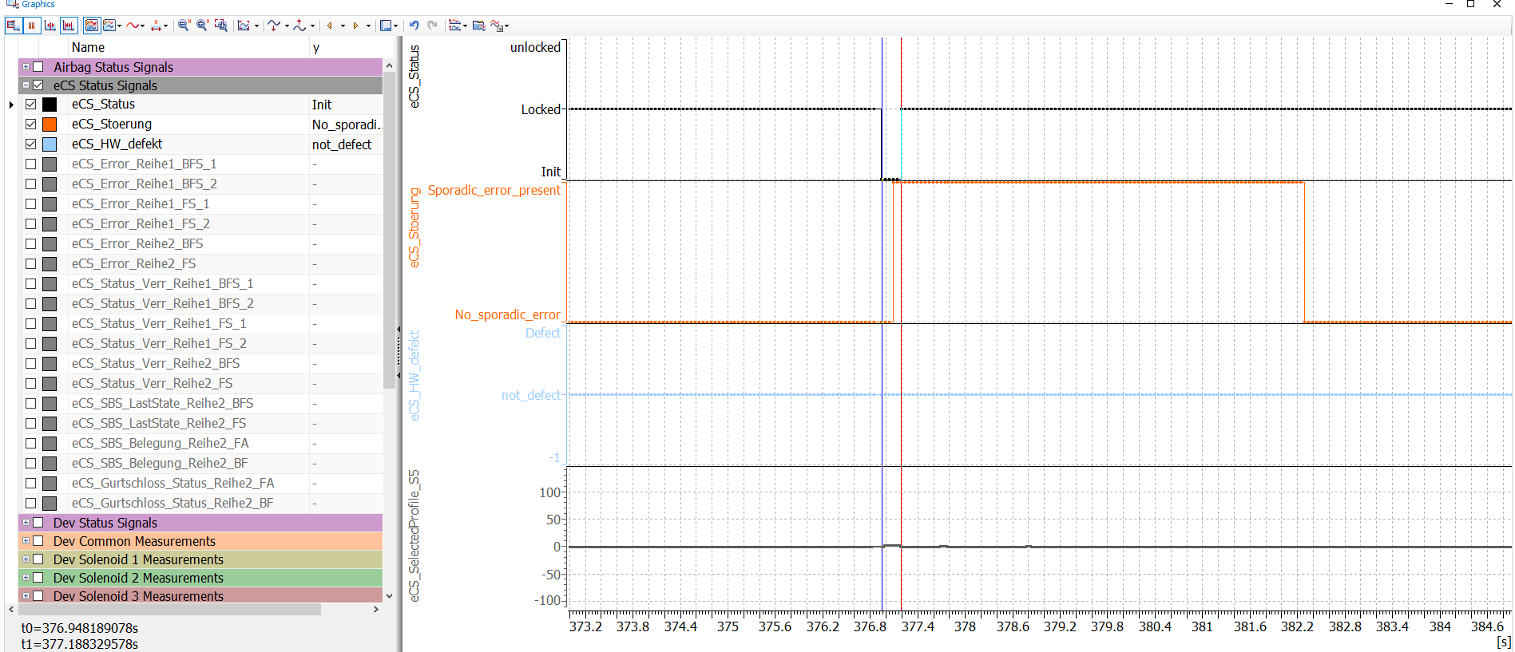

*Fig.2 CANoe Graphics View*

* 1. eCS_Status stays LOCKED for ~500ms during initialization of accelerometer and solenoid electrical auto-tests
  2. eCS_Status switches to UNLOCKED after completion of auto-tests if ECU is fault-free

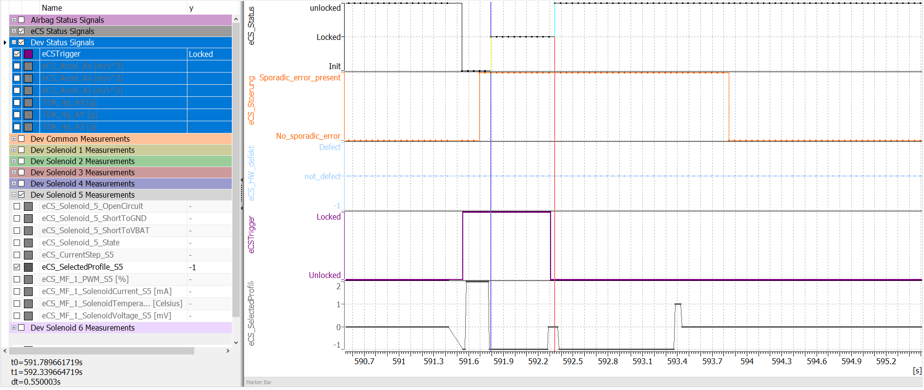

*Fig.3 CANoe Graphics View*

* 1. eCS_Solenoid_6_State switches from DIAGNOSTIC_STATE to STARTUP_STATE*** and to UNLOCK_STATE
     1. During DIAGNOSTIC_STATE the diagnostic profile is executed for 300ms to allow detection of solenoid electrical faults
     2. *** ECU will transition to STARTUP_STATE if a buckle latched condition is detected. If no wake-up circuit is physically connected, then this transition will be observed
     3. In the STARTUP_STATE the ECU will execute a LOCK profile followed by the UNLOCK profile in order to detect a mechanical block of the solenoid

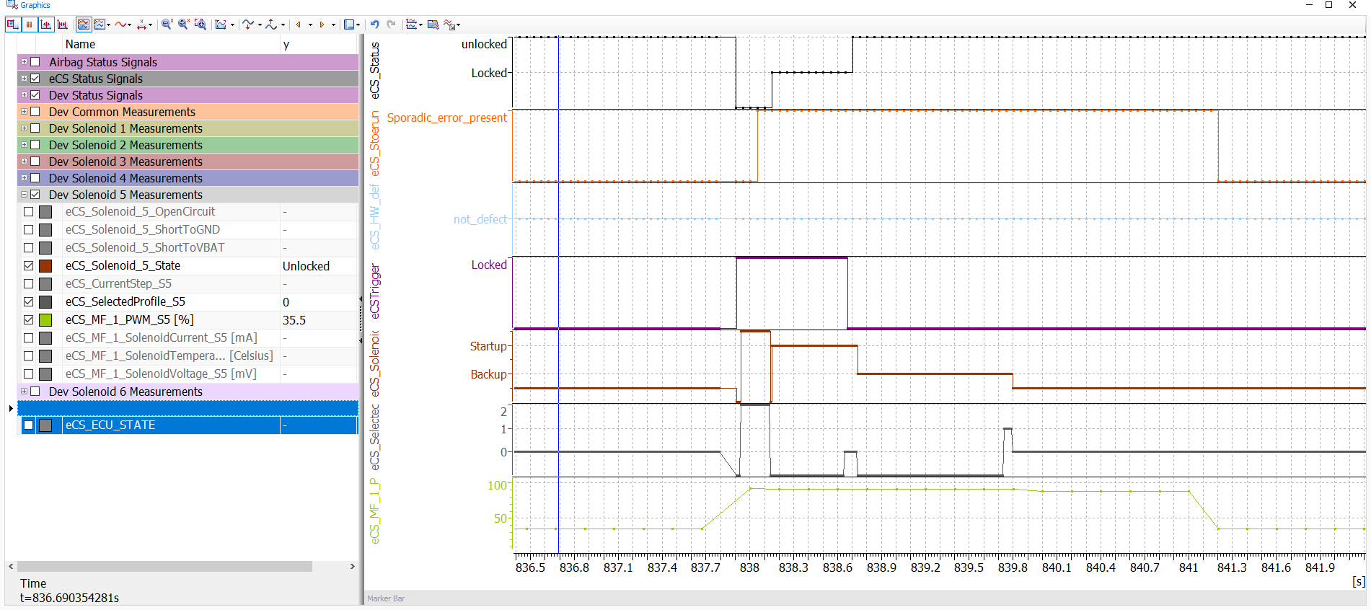

*Fig.4 CANoe Graphics View*

* 1. eCS_Solenoid_x_State switches from UNLOCK_STATE to DISABLED_STATE when the Crash signal has been received with a value different from != 0
  2. eCS_SolenoidProfile_Sx switches from UNLOCK to LOCK when the Crash signal has been received with a value different from != 0

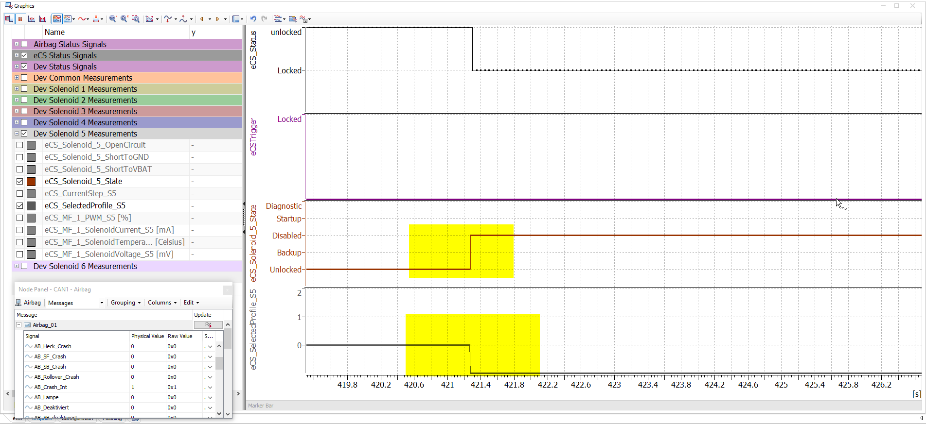

*Fig.5.1 CANoe CAN_Trace*

* 1. eCS_Solenoid_x_State switches from UNLOCK_STATE to LOCKED_STATE when the ActuatorTest signal has been received with a value of 1
  2. eCS_SolenoidProfile_Sx switches from UNLOCK to LOCK when the Crash signal has been received with a value of 1

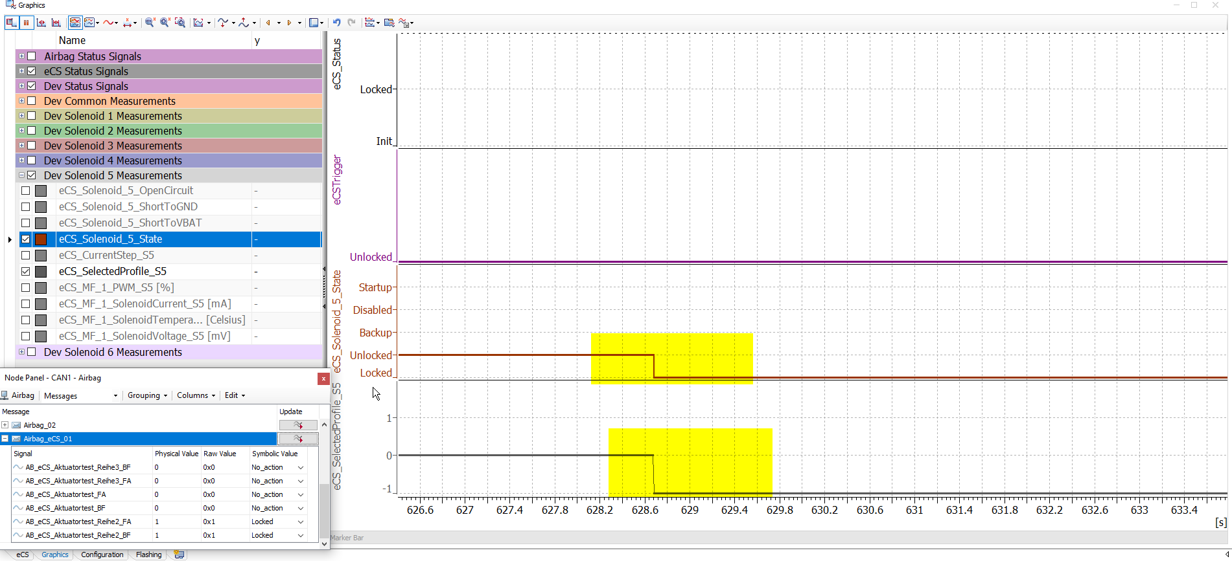

*Fig.5.2 CANoe CAN_Trace*

* 1. eCS_Solenoid_x_State switches from LOCKED_STATE to UNLOCK_STATE when the ActuatorTest signal has been received with a value of 2
  2. eCS_SolenoidProfile_Sx switches from LOCK to UNLOCK when the Crash signal has been received with a value of 2

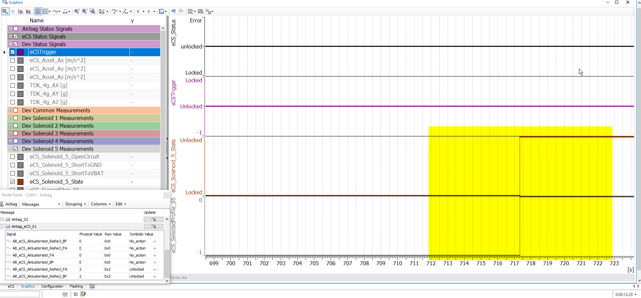

*Fig.5.3 CANoe CAN_Trace*

* 1. Verify that the after setting the buckle signal to BUCKLEDthe solenoid makes a transition to LOCK and then UNLOCK state, if no mechanical block is present, the eCS_UnlockConfirmation_Sx signals should be set to UNLOCK_CONFIRMED and the eCS_Stoerung signal should be set to NO_ERROR

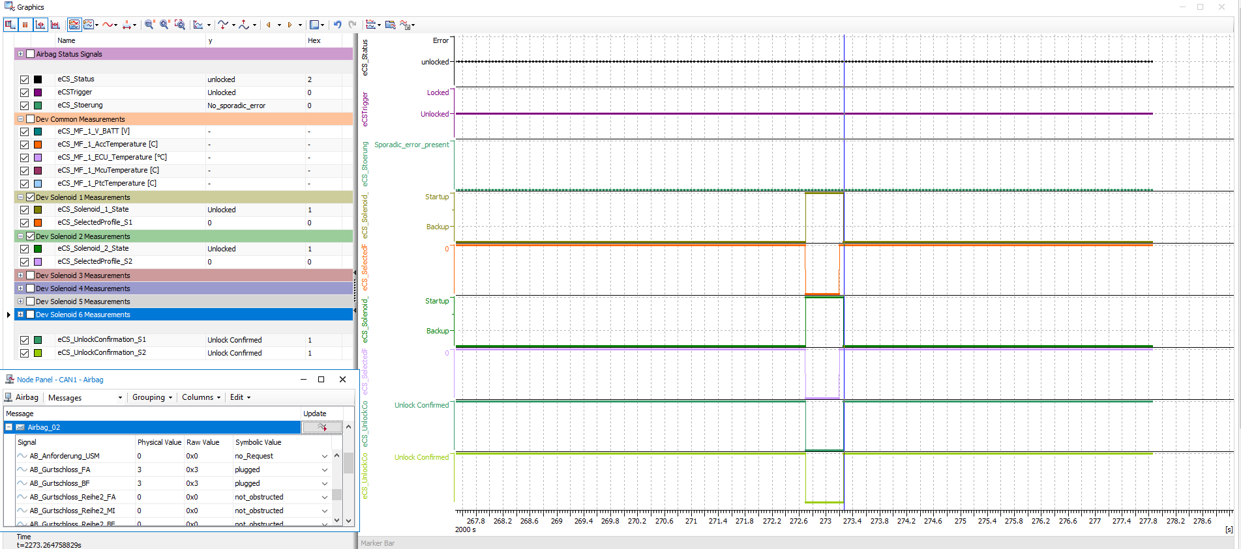

* 1. Verify that the Actuator Test signals trigger the correct reaction on the correct solenoid
  2. Verify that the Buckle signals trigger the correct reaction on the correct solenoid
     1. ActuatorTest_FA -> triggers Solenoid 1 && 2
     2. ActuatorTest_Reihe2_FA -> triggers Solenoid 5
     3. Etc.

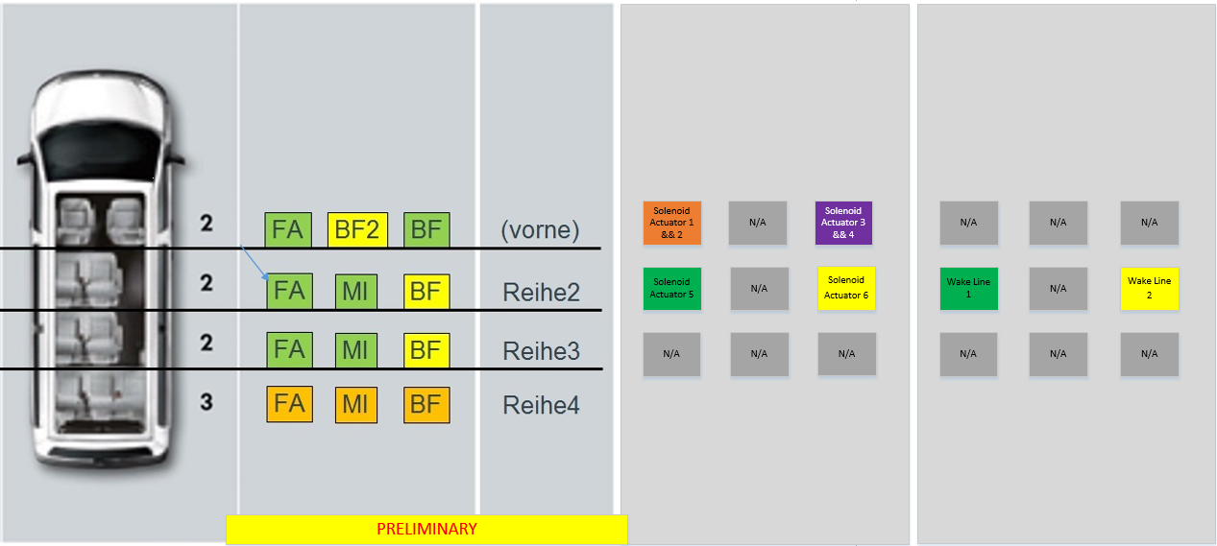

*Fig.5.4 Seat Mapping*

* 1. Periodicity of eCS_01 frame is 50ms
  2. Periodicity of DevKit_01 is 10ms
  3. Periodicity of eCS_MeasFrame is 10ms if configured as in *Fig.6*

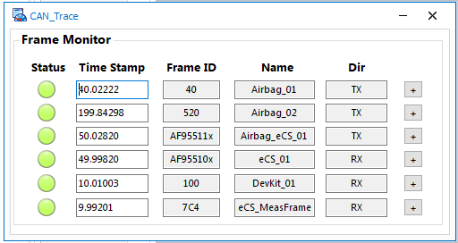

*Fig.5 CANoe CAN_Trace*

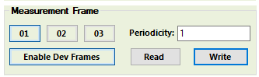

*Fig.6 CANoe MF configuration*

* 1. Activate MF block 2 and check event statuses for implausible values (outside ISO range)

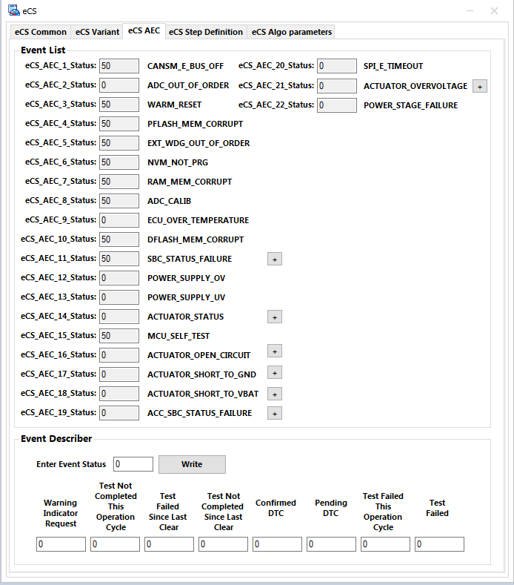

*Fig.7 CANoe Event Panel*

* 1. Read and write NVP_u32eCSVariant via UDS and check data persistency

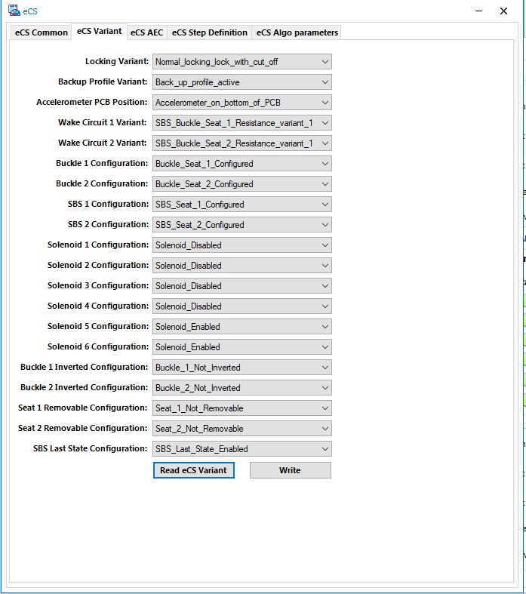

*Fig.8 CANoe Variant Panel*

* 1. ECU resumes normal CAN communication and is fault free after soft and hard resets (1103/ 1101)
  2. ECU resumes normal CAN communication and is fault free after transition through Bootloader (1003->1002->1101)
  3. ECU increments LOCK/UNLOCK/UNLOCK_CONFIRMED counters as expected
  4. Acceleration is within the following ranges if the ECU is placed flat on the desk:
     1. Z axis -> 1g
     2. X axis -> ~0g
     3. Y axis -> ~0g

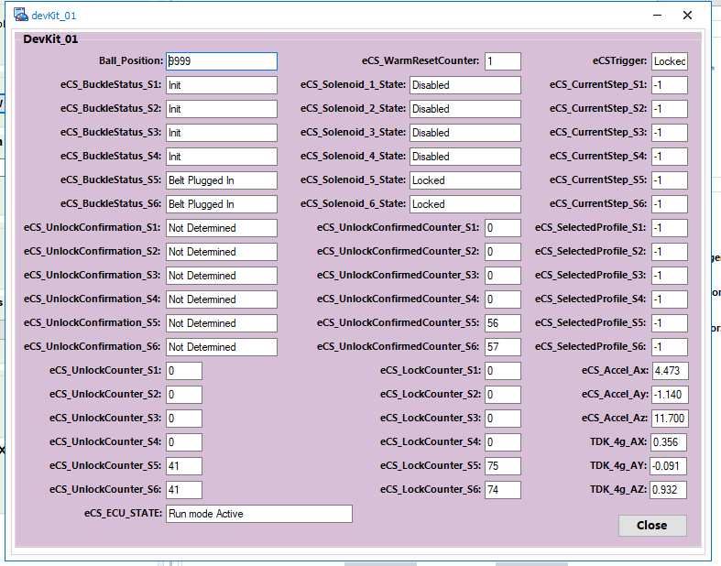

*Fig.9 CANoe Graphics Panel*

* 1. *If the eCS is UNLOCKED with the BOOST turned off the following values are to be expected:*
     1. *Solenoid Current <mA> ~90mA*
     2. *Solenoid Voltage <mV> ~4000mV*
     3. *Solenoid Current/Voltage is 0 for disabled solenoids*
     4. *PWM is 100% for disabled solenoids*
     5. *PWM is 30-60% if BOOST is turned off depending on KL30V*
     6. *KL30 is 11700mV if power supply is set at 12V*

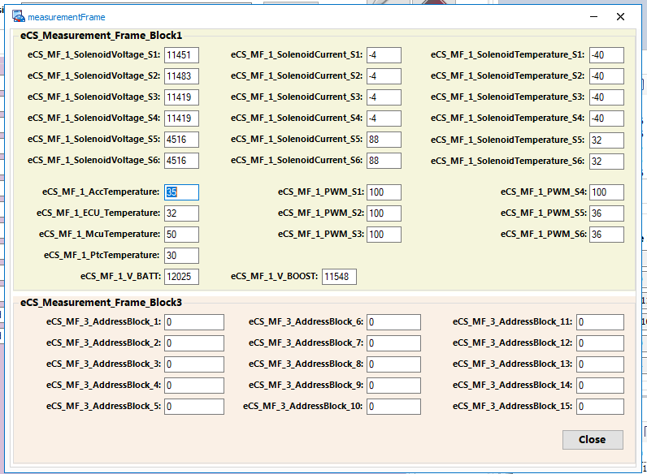

*Fig.10 CANoe MF Panel*

1. *Oscilloscope tests*
2. Expect the following waveform on the oscilloscope on the MAGV+6 / ON_OFF_POWER / EN_BOOST

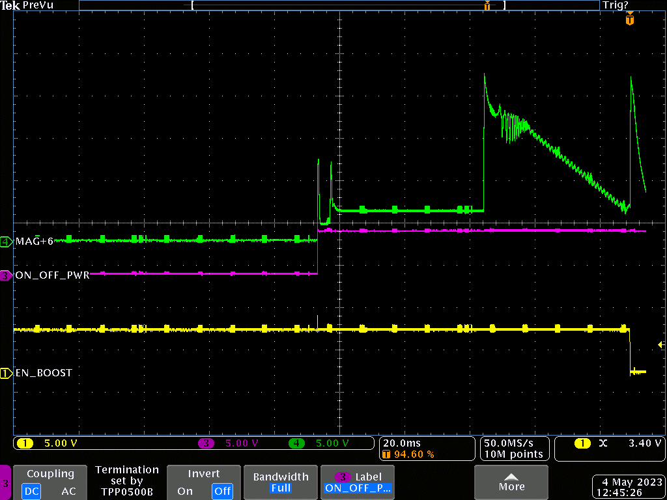

1. Check duration of step 5 (due to faulty HW). 50ms to be expected

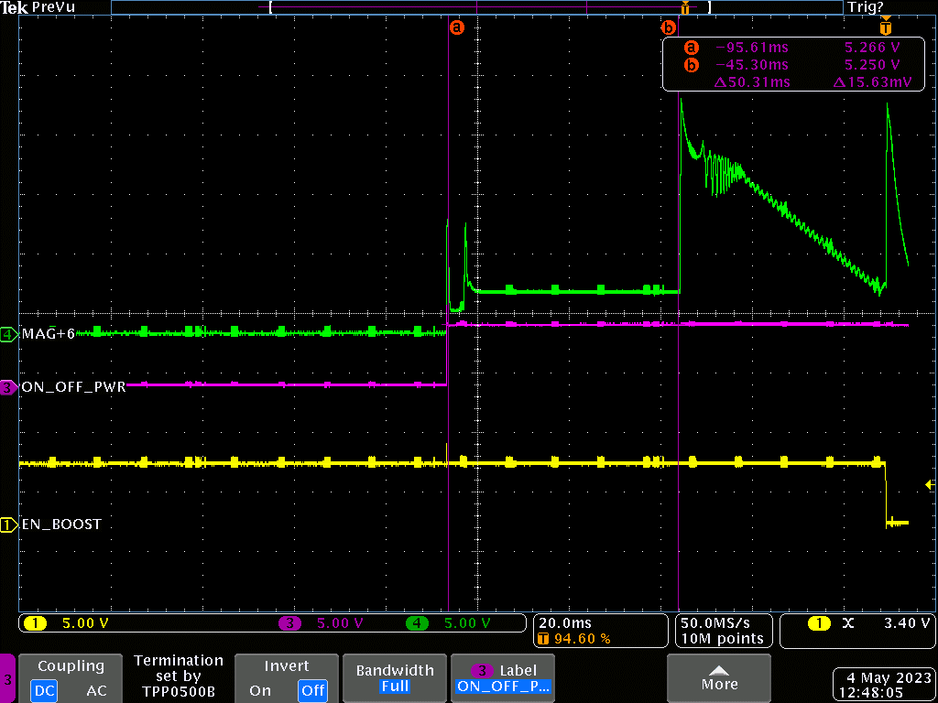

1. Check duration and voltage values of peaks (first one is due to profile ramp, 2nd peak is for unlock confirmation)

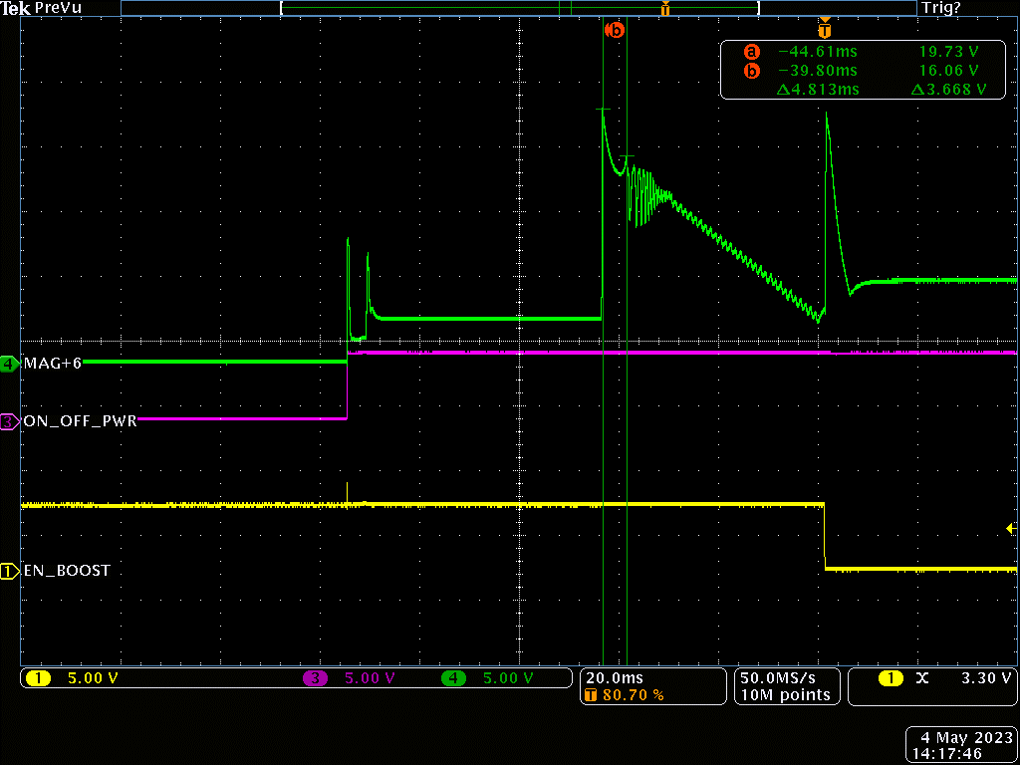

1. Check that if the solenoid is blocked mechanically the 2nd peak is not present.

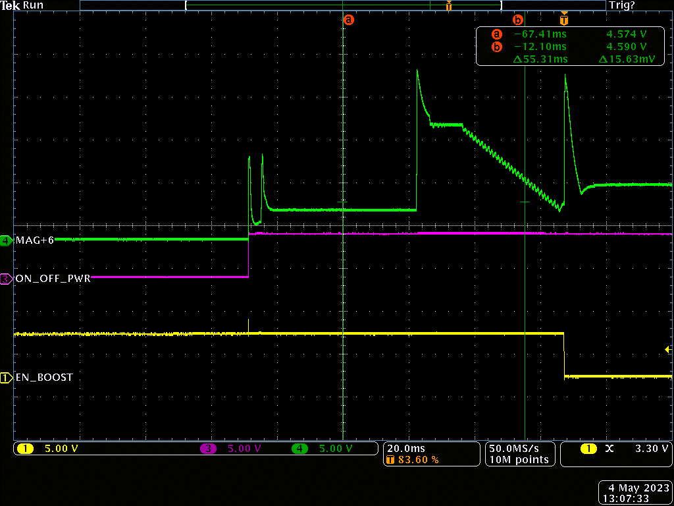

* 1. Check duration between 2nd peak and BOOST off
  2. Check that ON_OFF_PWR is set from STD_LOW to STD_HIGH on UNLOCK decision
  3. Check that EN_BOOST is set from STD_HIGH to STD_LOW after UNLOCK was confirmed on all solenoids

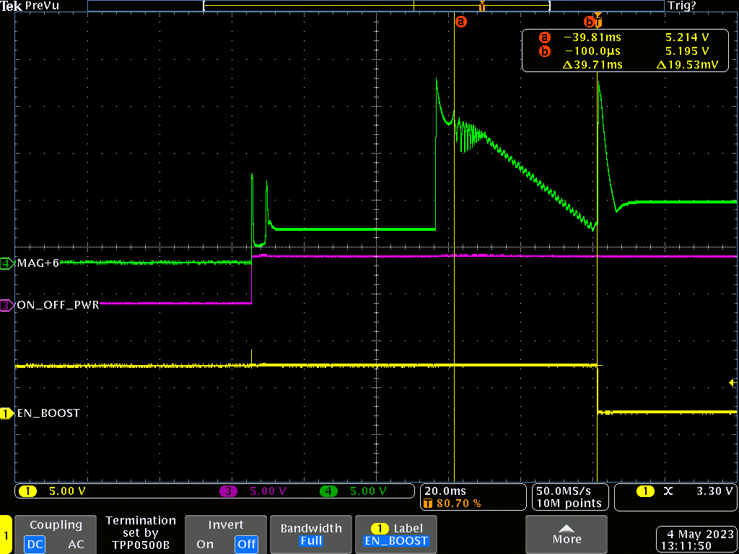

* 1. On the holding step when the EN_BOOST is set to STD_LOW the voltage should be ~4.6V and ~94mA

|  |  |
| --- | --- |
| Readings | |
| Voltage [V] | Current [mA] |
| 4.4 | 90 |

e. On the holding step, when the EN_BOOST is set to STD_LOW, modify supply voltage between 10V and 16V and check the current value to be ~94mA.

|  |  |
| --- | --- |
| Readings | |
| Voltage Supply [V] | Current [mA] |
| 10 | 91 |
| 10.5 | 91 |
| 11 | 91 |
| 11.5 | 91 |
| 12 | 91 |
| 12.5 | 91 |
| 13 | 91 |
| 13.5 | 91 |
| 14 | 91 |
| 14.5 | 91 |
| 15 | 90 |
| 15.5 | 90 |
| 16 | 90 |

* 1. Check that ON_OFF_PWR is set from STD_HIGH to STD_LOW on LOCK decision after 1ms after EN_BOOST is set to STD_HIGH

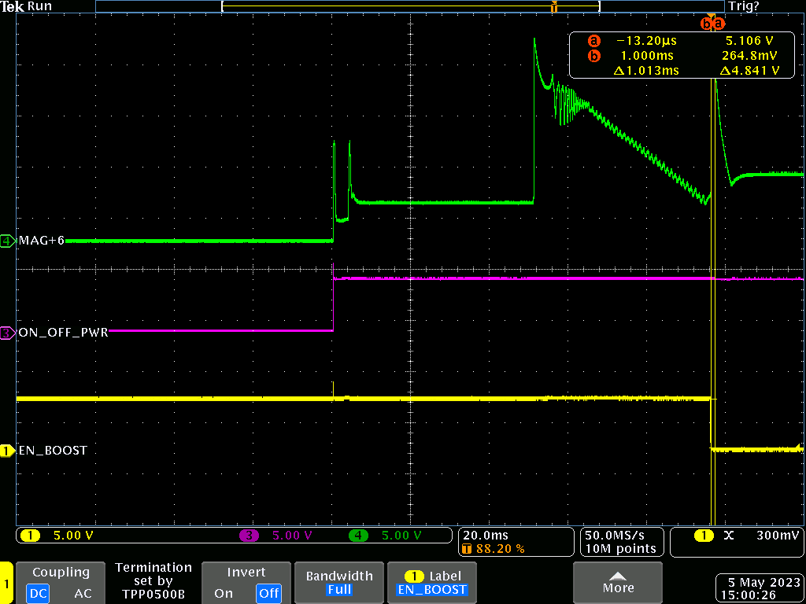

Seat Configuration Setup and tests:

**VARIANT 1 CONFIGURATION**

1. Open file in location: eCS_Project\Tools\OEM_Specific\Workspace\ reihenschaltung_gurt_sbr_100_400 en-US.pdf
2. Make sure to have this configuration in order to test correct seat variants:

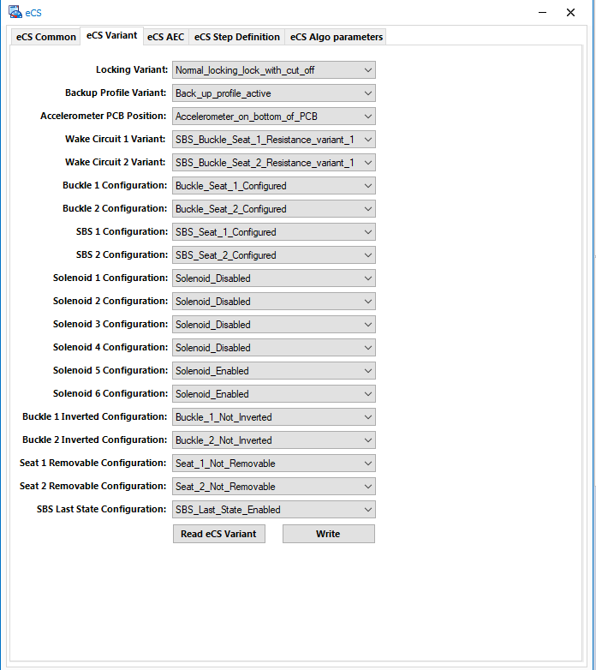

1. According to pdf requirements, we must test the following resistance ranges:

**\*. Case distinction R <= 60 Ohm:**

**1. non-removable seats: short circuit to ground**

**2. removable seats: seat removed**

*. Tolerance range: 60 Ohm < R <80 Ohm

**\*. Seat occupied, belt not plugged: 80 Ohm <= R <=120 Ohm**

*. Tolerance range: 120 Ohm < R <160 Ohm

**\*. Implausible: 160 Ohm <= R <= 240 Ohm**

*. Tolerance range: 240 Ohm < R < 320 Ohm

**\*. Seat not occupied, belt not plugged: 320 Ohm <= R <= 480 Ohm**

*. Tolerance range: 480 Ohm < R < 620 Ohm

**\*. Belt plugged: R >= 620 Ohm**

According to upper-specified requirements, we must obtain the following tests:

1. **R <= 60 Ohm: non-removable seats: short circuit to ground and removable seats: seat removed**

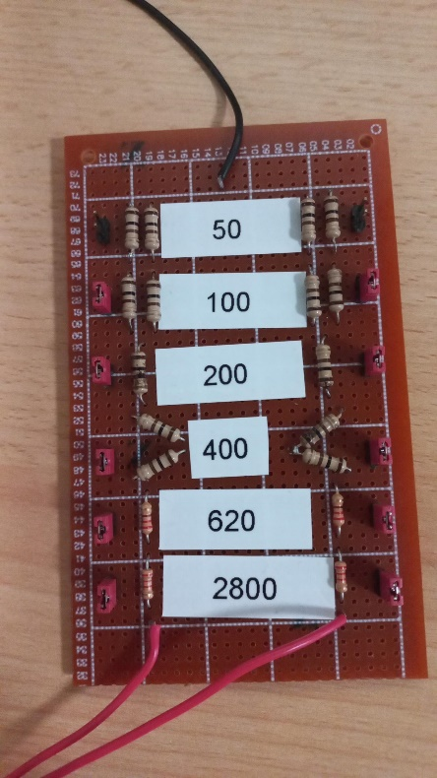 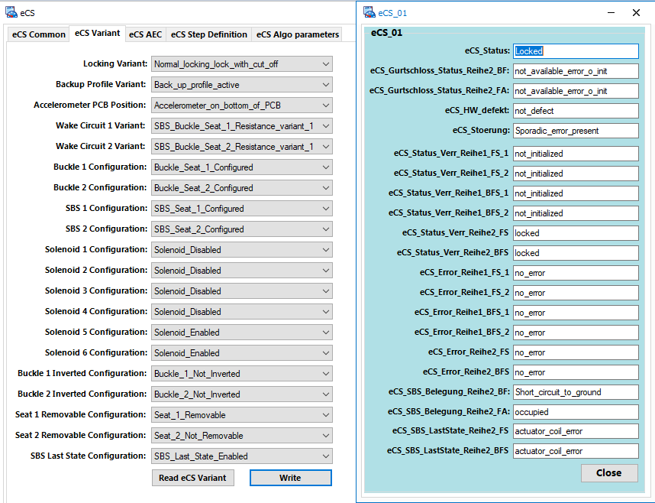

1. **Seat occupied, belt not plugged: 80 Ohm <= R <=120 Ohm**

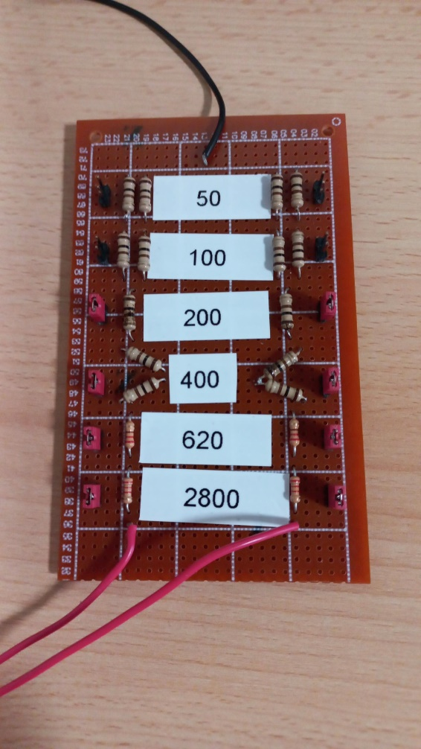 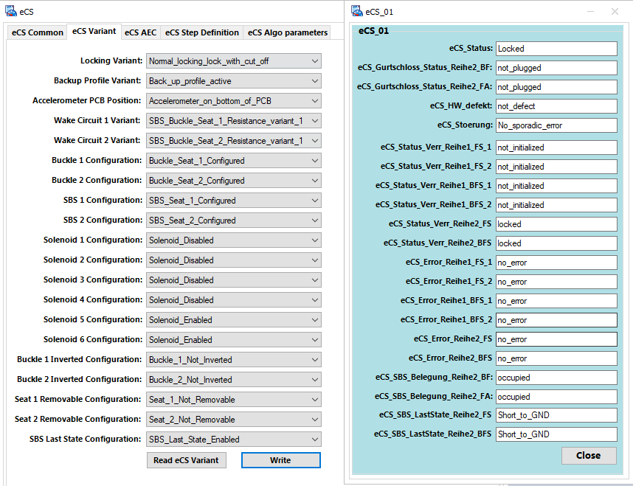

1. **Implausible: 160 Ohm <= R <= 240 Ohm**

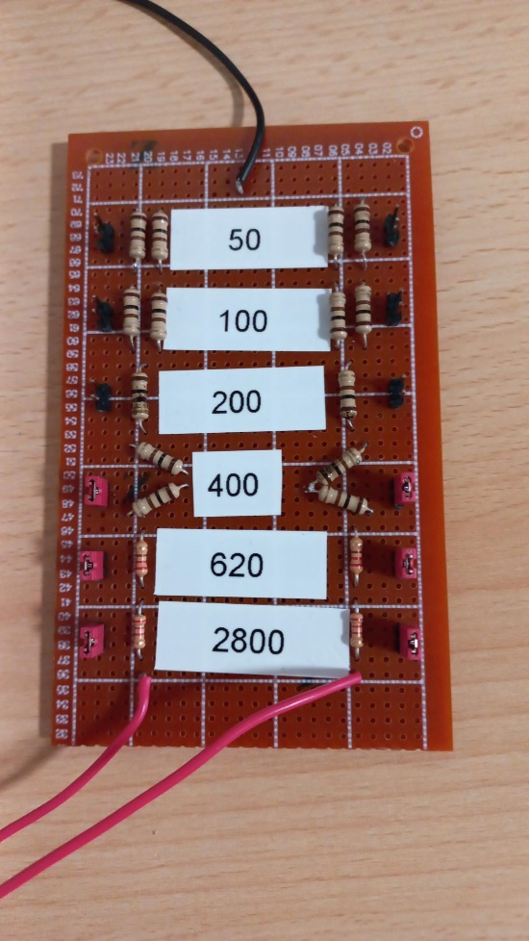 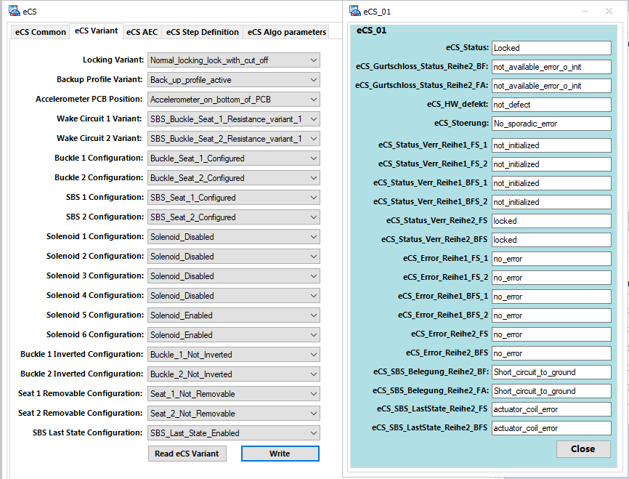

1. **Seat not occupied, belt not plugged: 320 Ohm <= R <= 480 Ohm**

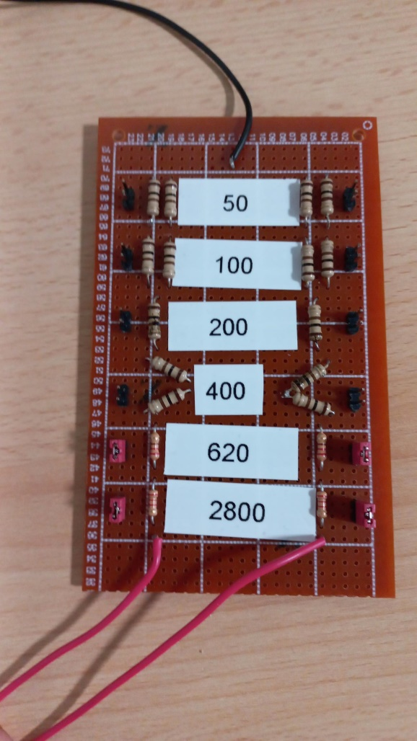 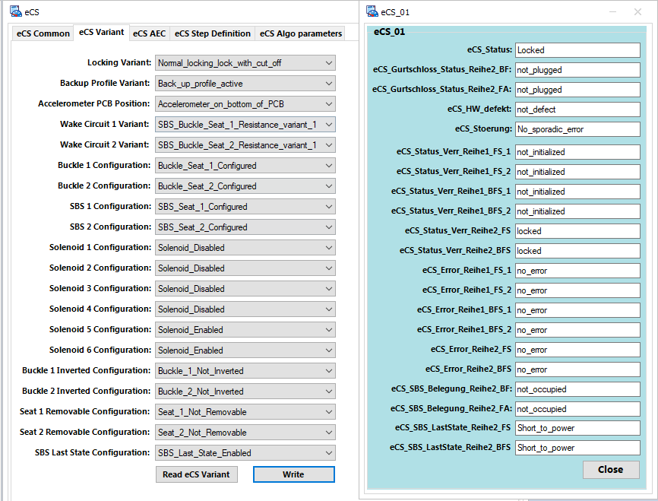

1. **Belt plugged: R >= 620 Ohm**

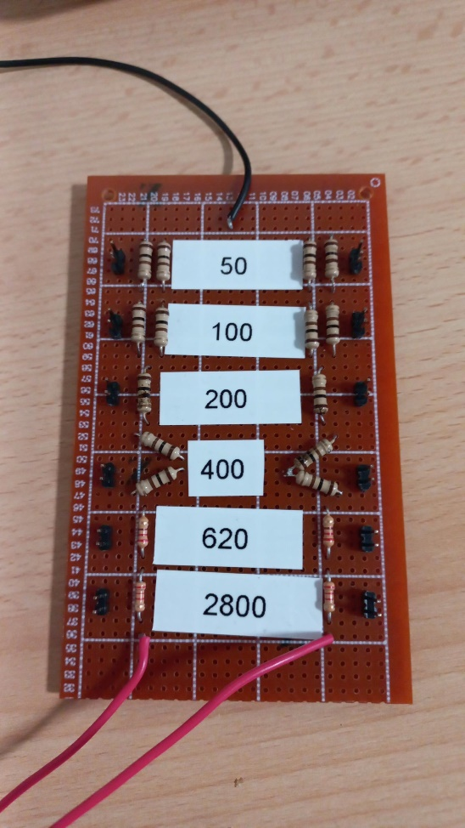 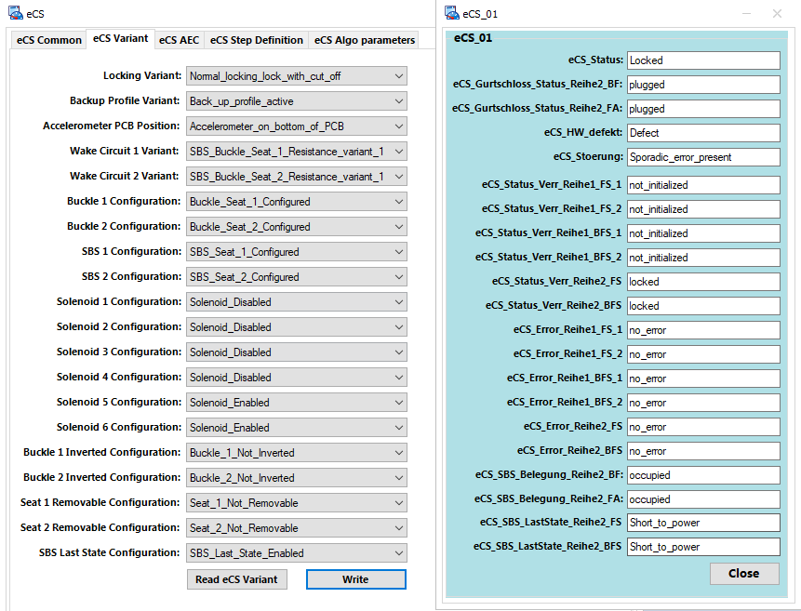

**VARIANT 2 CONFIGURATION**

1. Open file in location: eCS_Project\Tools\OEM_Specific\Workspace\ reihenschaltung_gurt_sbr_0_470 en-US.pdf
2. Make sure to have the following configured signals:

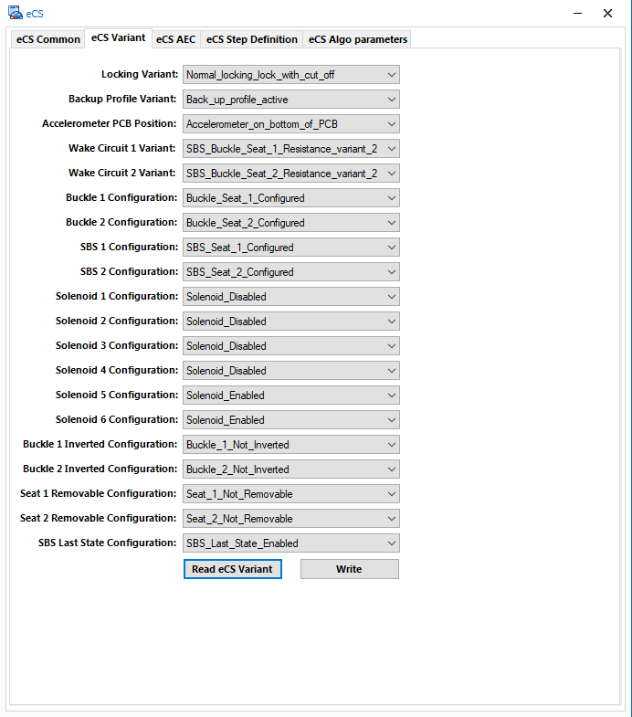

According to pdf requirements, we must test the following resistance ranges:

**\*. Seat occupied, belt not plugged: R <=120 Ohm**

*. Tolerance range: 120 Ohm < R < 420 Ohm

**\*. Seat not occupied, belt not plugged: 420 Ohm <= R <= 490 Ohm**

*. Tolerance range: 490 Ohm < R < 2400 Ohm

**\*. Belt plugged: R >= 2400 Ohm**

1. **Seat occupied, belt not plugged: R <=120 Ohm**

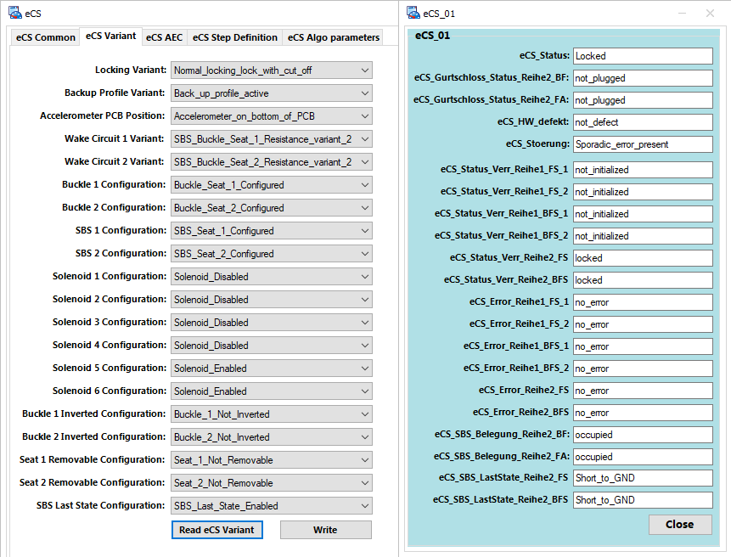

1. **Seat not occupied, belt not plugged: 420 Ohm <= R <= 490 Ohm**

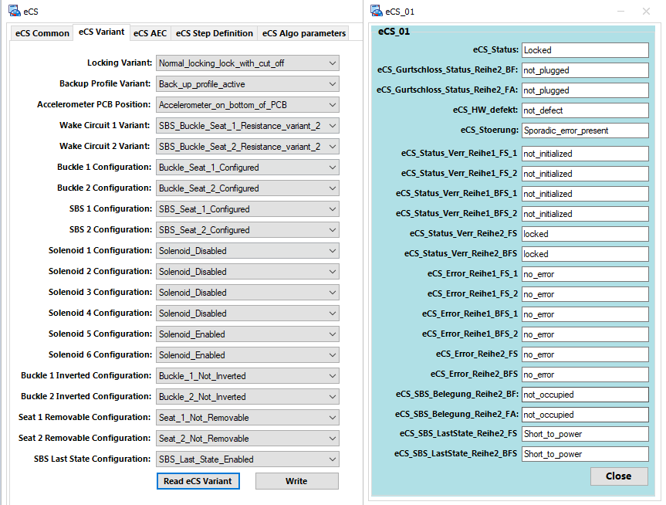

1. **Belt plugged: R >= 2400 Ohm**

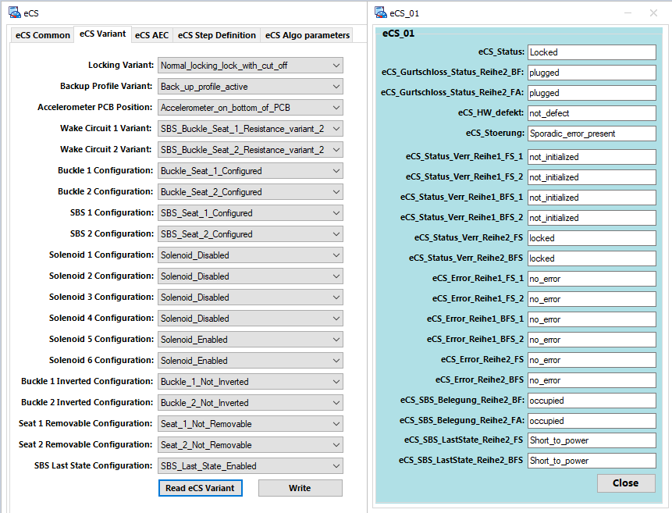

1. *Bootloader tests*

In order to flash the new software version, there are required some preconditions:

1. The software must be compiled with “all-release” option
2. The folders needed to perform the flashing sequence must be copied to the CANoe configuration folder

The flashing files (app and fbl_u) are found at: **C:\Projects\ECS\Phase_01\View_Development\Release\CanFlash**

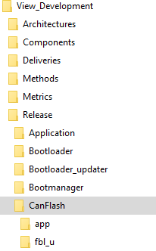

The folders in the CanFlash must be copied to the CANoe configuration folder (**C:\Projects\ECS\Phase_01\View_Development\Tools\CANoe\Config\SWDL_Binaries\ES01404H.R11**)

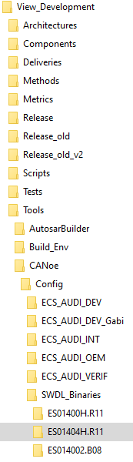

1. Disconnect the debugger and remove the jumper

The required steps to test the flashing process are:

1. Read the Software Version

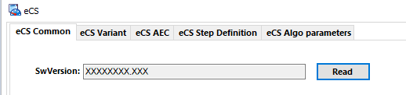

1. Move to the Flashing tab in CANoe

In the flashing window, there are three panels: the flash_panel which contains the configuration options and the status of flashing process, the DiagOnCAN panel in which you can see all the activity on the CAN and the Test Setup panel which contains the testcase written for the flashing sequence. The most important panel is the Flash_panel which contains all the buttons needed for the configuring and checking the status of flashing sequence.

1. Choose software version that will be flashed on the ECU using the dropdown button

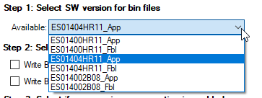

The name of the software versions consists of: the name of the CANoe configuration folder + _ + the software you want to flash (application or bootloader updater).

The configuration options for the flashing sequence are automatically selected when the software version is chosen from the dropdown button. If you want to choose a different configuration for the flashing process, you must uncheck the buttons for the unwanted options.

For the other configurations, you must:

1. Choose which logical block to download

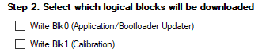

1. Choose if you want compression or encryption or both to be enabled



1. Enable the tool



1. Press the “Start Flashing” button to start the flashing sequence



The flashing sequence progress will be displayed in real time in the Progress window, in the console window and in the CAN Trace window.

1. When the flashing sequence is done, the windows should look like below:

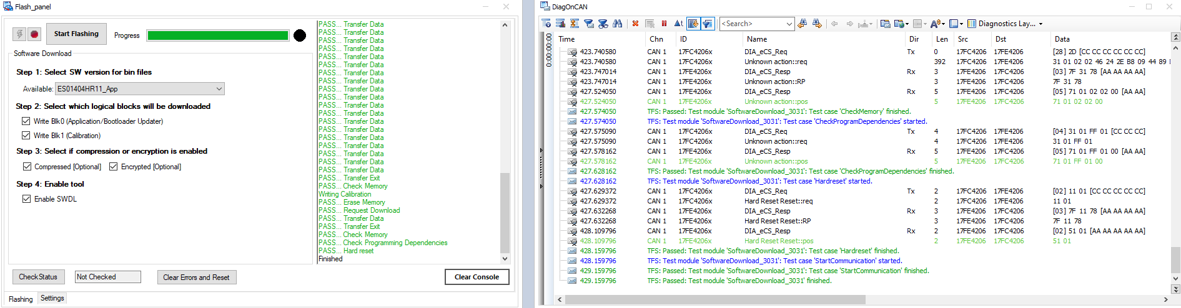

1. Move to the eCS tab
2. Check the CAN Trace to be sure there is communication

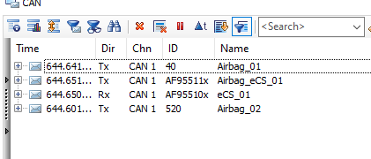

1. Read the Software Version to be sure it is the version from the flashed software

