|  |  |  |  |
| --- | --- | --- | --- |
| **Author** | | **Review** | **Approval** |
| Title: Muret Guillaume | | Title1: Name1  Title2: Name2 | Title1: Name1  Title2: Name2 |
|  | |  |  |
| **Distribution** | | | |
| Title1: Name1  Title4: Name4 | | Title2: Name2  Title5: Name5 | Title3: Name3  Title6: Name6 |
|  | |  |  |
| **Executive**  **Summary** | This document provides how to use the AEC Configurator software with the screen description, button description and the key shortcut description. | | |

**AEC Configurator user manual**

# Table of content

1. General Information 4

1.1. Revision history \* 4

1.2. Purpose and Scope 4

1.3. Glossary and Definition 5

2. Overview 6

3. Practical guide 7

3.1. Launch the AECconfigurator.jar 7

3.2. Screen presentation 7

3.2.1. Screen “Edit AEC values” 7

3.2.2. Screen “Edit AEC component” 8

3.2.3. Screen “Generation setting” 9

3.2.4. Screen “AEC value board” 10

3.2.5. Screen “Show differences” 11

3.3. Functionality 12

3.3.1. Edit the AEC 12

3.3.2. Create a new AEC 13

3.3.3. Delete an AEC 14

3.3.4. Create a new AEC’s attribute 15

3.3.5. Delete an AEC’s attribute 17

3.3.6. Change the AEC’s component order 17

3.3.7. Change the AEC’s attribute order 17

3.3.8. Change the AEC’s attribute size 18

3.3.9. Change the generation settings 19

3.3.10. Generate the files 20

3.4. Key shortcut 23

# Table of figure

[Figure 1: Screen “Edit AEC values” 7](#_Toc457397517)

[Figure 2: Button display "Edit AEC component” screen 8](#_Toc457397518)

[Figure 3: Screen "Edit AEC component" 8](#_Toc457397519)

[Figure 4: Button display "Generation setting” screen 9](#_Toc457397520)

[Figure 5: Screen "Generation setting" 9](#_Toc457397521)

[Figure 6: Button display "AEC board value" screen 10](#_Toc457397522)

[Figure 7: Screen "AEC value board" 10](#_Toc457397523)

[Figure 8: Dialog box generation success 11](#_Toc457397524)

[Figure 9: Screen “Show differences” 11](#_Toc457397525)

[Figure 10: Edit AEC value with errors 12](#_Toc457397526)

[Figure 11: Button add a new AEC 13](#_Toc457397527)

[Figure 12: Dialog success AEC creation 13](#_Toc457397528)

[Figure 13: Dialog error AEC creation 14](#_Toc457397529)

[Figure 14: Button delete an AEC 14](#_Toc457397530)

[Figure 15: Button add new attribute 15](#_Toc457397531)

[Figure 16: Dialog add a new attribute (structure) 15](#_Toc457397532)

[Figure 17: Dialog add a new attribute (value) 16](#_Toc457397533)

[Figure 18: Button delete AEC's attribute 17](#_Toc457397534)

[Figure 19: Buttons change AEC's order 17](#_Toc457397535)

[Figure 20: Buttons change AEC's attribute order (1) 18](#_Toc457397536)

[Figure 21: Buttons change AEC's attribute order (2) 18](#_Toc457397537)

[Figure 22: Dialog calibration memory full 19](#_Toc457397538)

[Figure 23: Dialog select the generation path 20](#_Toc457397539)

[Figure 24: Dialog generation success 21](#_Toc457397540)

[Figure 25: Dialog reserved AEC not at the end 21](#_Toc457397541)

[Figure 26: Dialog reserved byte not at the end 22](#_Toc457397542)

[Figure 27: Dialog same AEC name 22](#_Toc457397543)

[Figure 28: The different key shortcut 24](#_Toc457397544)

# General Information

## Revision history \*

|  |  |  |  |
| --- | --- | --- | --- |
| **Revision** | **Date** | **Author(s)** | **Description/comment** |
| 0 | 2016/07/26 | Muret Guillaume | First revision |
|  |  |  |  |
|  |  |  |  |

*\* Template history is found in the CM tool used for templates*

## Purpose and Scope

The review of this document is done thanks to …

This document provides how to use the AEC Configurator software with the screen description, button description and the key shortcut description.

## Glossary and Definition

This section presents all the definitions and/or abbreviations used in this document.

*List of terms in alphabetical order:*

|  |  |
| --- | --- |
| ***Term*** | ***Meaning*** |
| ADC | Analog Digital Converter |
| AEC | Autoliv Error Code |
| API | Application Programming Interface |
| ASDM | Active Safety Domain Master |
| ASIC | Application Specific Integrated Circuit |
| ASY | Active SafetY |
| BSW | Basic SW modules |
| CAN | Controller Area Network |
| C/S | Chip Select |
| COP | Computer Operating Properly |
| eCPL | Electronic Crash Pole Locking |
| DART | Ditch - Airborne - Rough Terrain |
| DFLASH | Data FLASH |
| ECC | Error Code Correction |
| ECU | Electronic Control Unit |
| EOL | End Of Life |
| HFPP | High Force Pre-Pre-Tensioning belt function |
| HF-PRE | High Force PRE pre-tensioning |
| HR | Hard Releasing |
| I/O | Input/Output |
| IMU | Inartial Measurements Unit |
| ISS | Integrated Safing System |
| LFPP | Low Force Pre-Pre-Tensioning belt function |
| MSA | Motor Start/Stop Automatic |
| MCAL | Micro-Controller Abstraction Layer |
| MCU | Micro-controller Unit |
| NMG | Mode ManaGement |
| NVM | Non Volatile Memory |
| OS | Operating System |
| PCM | Pre-Crash Master |
| PFLASH | Program FLASH |
| PIT | Periodic Interrupt Timer |
| PLL | Phase-locked loop |
| RAM | Random Access Memory |
| RCWM | Rear Collision Warning and Mitigation |
| RML | Left PP ECU |
| RMR | Right PP ECU |
| RMx | Both PP ECU |
| ROM | Read Only Memory |
| RSU | Remote Sensor Unit |
| RTE | Real Time Environment |
| RTOS | Real Time Operating System |
| SFR | Standard Function Recovery |
| SODL | Side Obstacle Detection Left |
| SPI | Serial Peripheral Interface |
| SRS | Supplementary Restraint System |
| TBC | To be confirmed |
| TBD | To be defined |
| TF | Technical Function |
| TFLASH | Test FLASH of the Pictus MCU (“one time programmable” memory) |
| W/D | Watchdog |

# Overview

This document describes how to use the “AECconfigurator.jar”. This software is attach to the PP4G project in the ERH module. It is used to set the NVP calibration of the AEC. After the calibration, the user can generate the different files:

* Source file “ERH\_AEC\_cfg\_generated.c” in the folder:   
   *🡪 <PTC> \ Project\_Information \ Development\_View \ Source \ Application \ \_ERH \ src*
* Header files “ERH\_private.h” , “ERH\_cfg\_private.h” , “ERH\_public.h” , “ERH\_cfg\_public.h” , “ERH\_AEC\_cfg\_generated.h” in the folder:  
   *🡪 <PTC> \ Project\_Information \ Development\_View \ Source \ Application \ \_ERH \ inc*
* Motorola file “AEC\_calibration.S00” in the folder:  
   *🡪 <PTC> \ Project\_Information \ Development\_View \ Source \ Application \ OPT\_GENERIC \ out*
* Autosar xml file “ERHdataDictionnary.arxml” in the folder   
   *🡪 <PTC> \ ETAS \ SystemAuthoring \ Repository \ DataDictionary \ Common*

After the generation, a new application build should be done.

# Practical guide

## Launch the AECconfigurator.jar

The “AECconfigurator.jar” file can be found on PTC:

* *<PTC> \ ETAS \ Configuration\_Item\_View \ Application \ \_ERH\_ErrorHandler \ Config*

You just need to double click on the “AECconfigurator.jar” file to launch the software.

## Screen presentation

This section describes the different screen of the application:

### Screen “Edit AEC values”

The first screen of the application will display the AEC list and the first AEC can be edited.

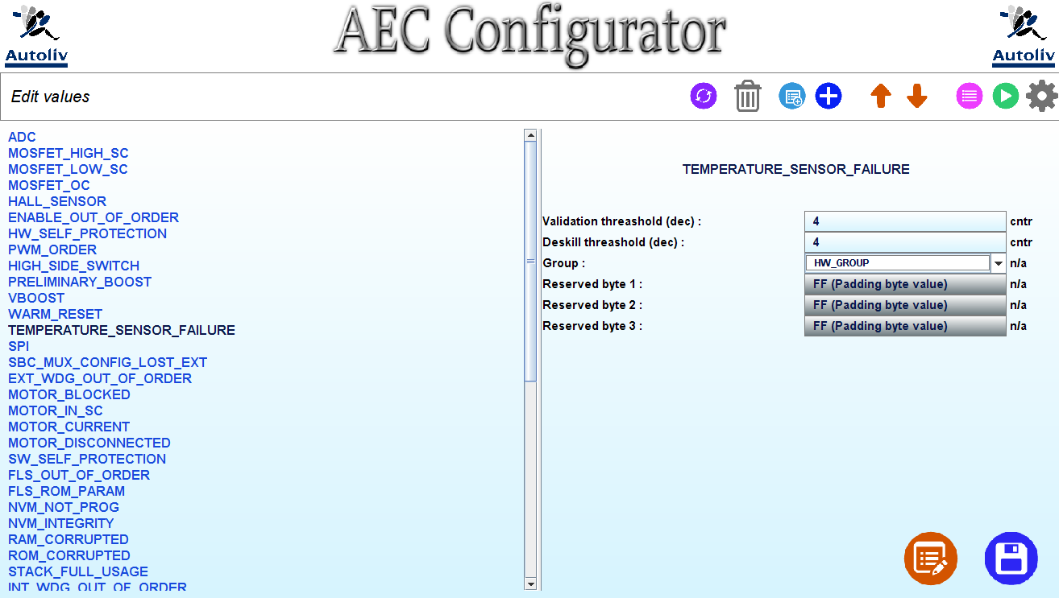

Figure 1: Screen “Edit AEC values”

Another AEC can be select if the user’s mouse enter in another AEC name zone.

To edit a value, the user need to click in the text zone provided for. The darker input zone cannot be editable like “FF (Padding byte value)”.

The different key shortcut are represented on the below board (Figure 28)

### Screen “Edit AEC component”

This screen will be displayed if the user is on the “Edit values” screen and tap on the following button or if the user tap on the key shortcut “CTRL + E”.

This screen display the selected AEC in the previous screen with more information to edit.



Figure 2: Button display "Edit AEC component” screen

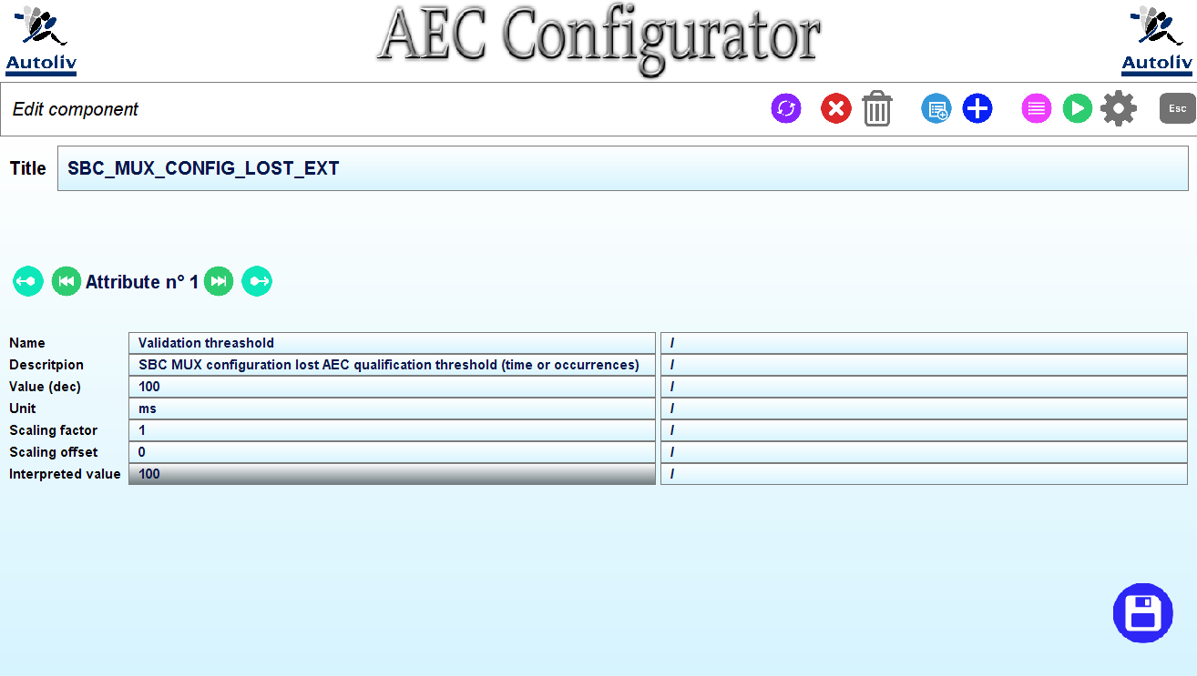

Figure 3: Screen "Edit AEC component"

The different key shortcut are explained on the following figure (Figure 28)

### Screen “Generation setting”

This screen can be displayed from every other screen. The user just need to tap on the following button or to use the key shortcut “CTRL + P”.



Figure 4: Button display "Generation setting” screen

The generation folders path and the memory settings and the structure configuration can be set from this screen.

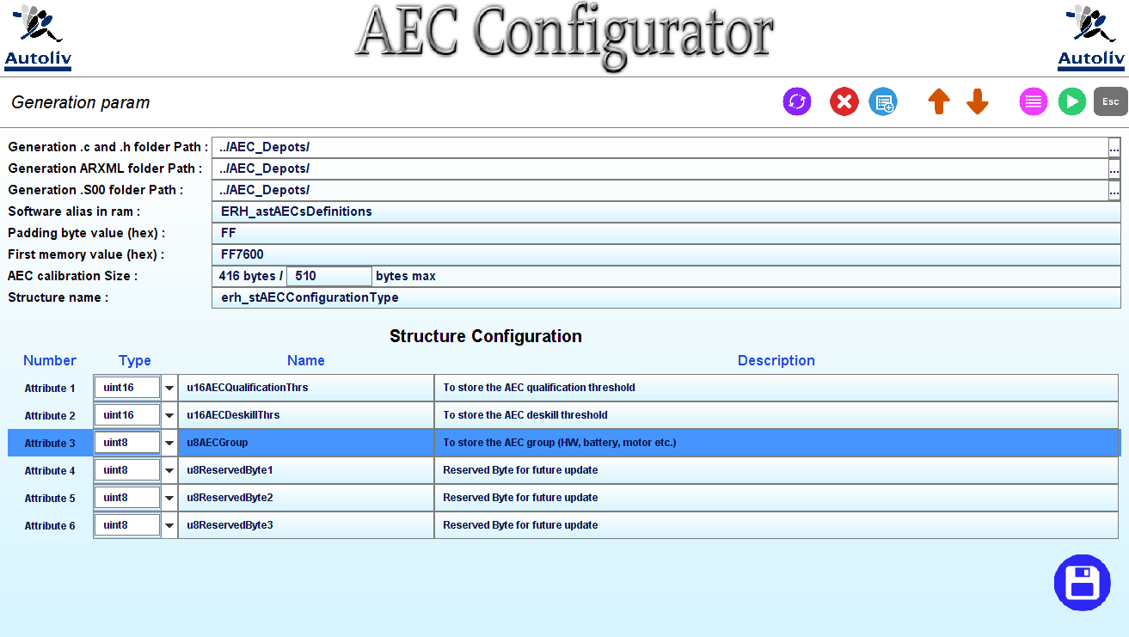

Figure 5: Screen "Generation setting"

The different key shortcut are explained on the following figure (Figure 28)

### Screen “AEC value board”

This screen can be displayed from every other screen. The user just need to tap on the following button or to use the key shortcut “CTRL + L”.



Figure 6: Button display "AEC board value" screen

The attribute value of every AEC can be set from this screen.

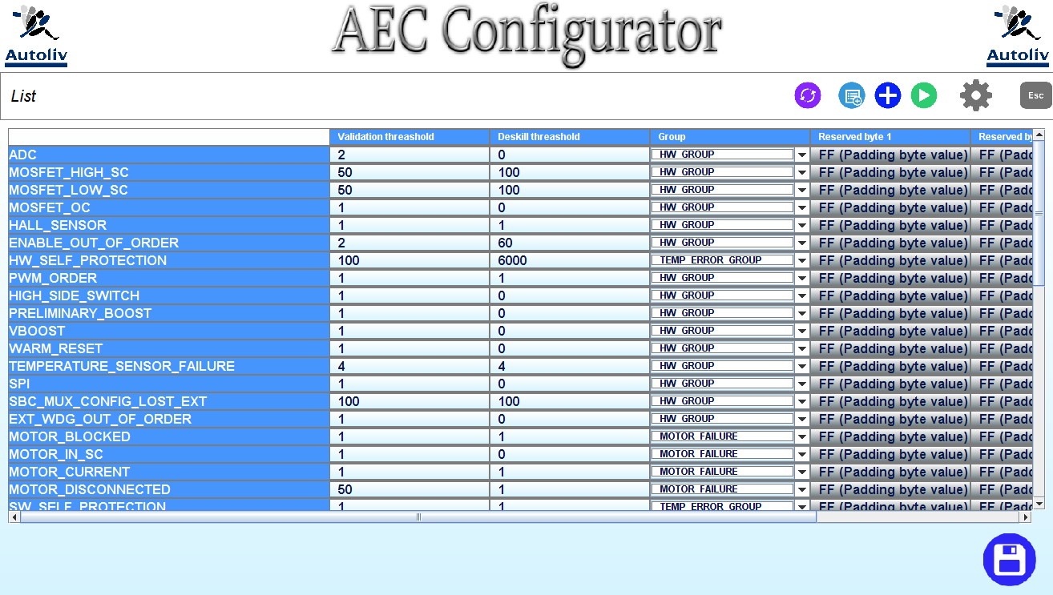

Figure 7: Screen "AEC value board"

The different key shortcut are explained on the following figure (Figure 28)

### Screen “Show differences”

This screen can be displayed after the generation of the different files. The user just need to tap on the button “Show differences” of this dialog:

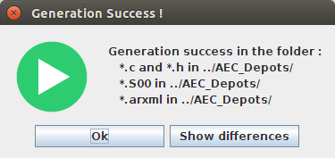

Figure 8: Dialog box generation success

This screen displays the different between the old file and the new generated file. The different line in the new file are red highlighted. The new line in the new file are blue highlighted.

On this figure (Figure 9) there are lot of different lines.

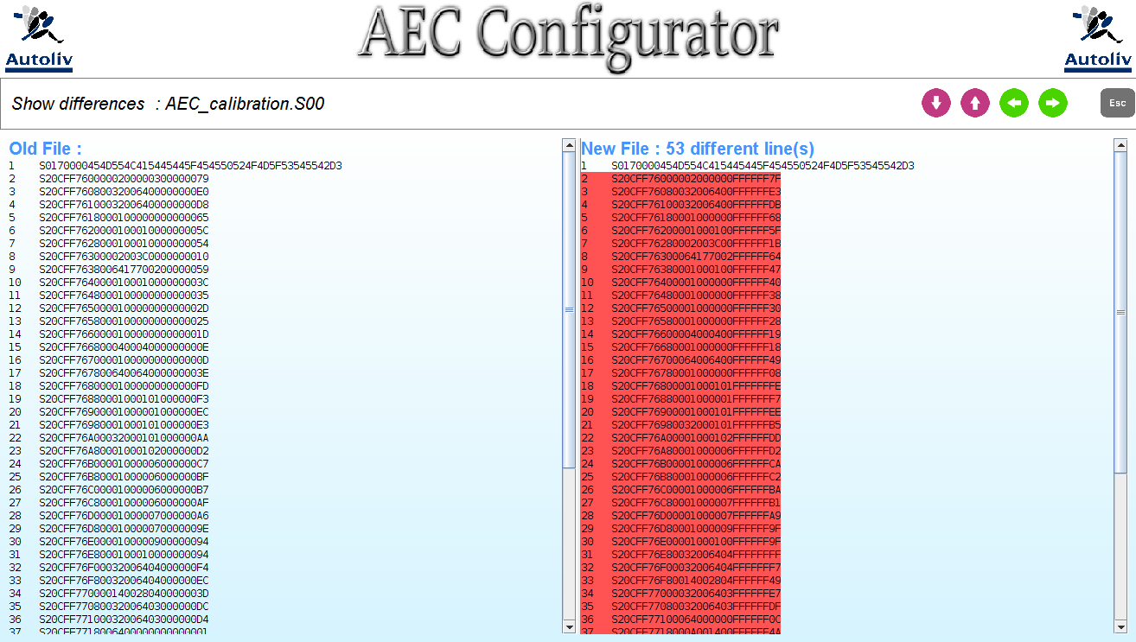

Figure 9: Screen “Show differences”

## Functionality

This section describes the different functionality of the “AEC Configurator”.

### Edit the AEC

From the three screens “Edit AEC values”, “AEC value board” and “Edit AEC component” respectively Figure 1, Figure 3 and Figure 7, the user can edit the AEC value.

The user can:

#### From the screen “Edit AEC values” (Figure 1)

Edit the selected AEC value, select another AEC with the mouse.

#### From the screen “Edit AEC component” (Figure 3)

Edit the selected AEC’s name, description value, unit, scaling factor and offset. The user can add a little description ont the right’s text field. If the description zone is empty, this character ‘/’ is displayed.

#### From the screen “AEC value board” (Figure 7)

Edit all the AEC’s values.

The application have to manage the different error that the user can do like:

* Memory size error : a value too high
* Number format error : a string instead of integer for instance
* Empty text field
* First character error

If one of these error is detected: the text error zone will be displayed red and this dialog will be displayed on the screen:

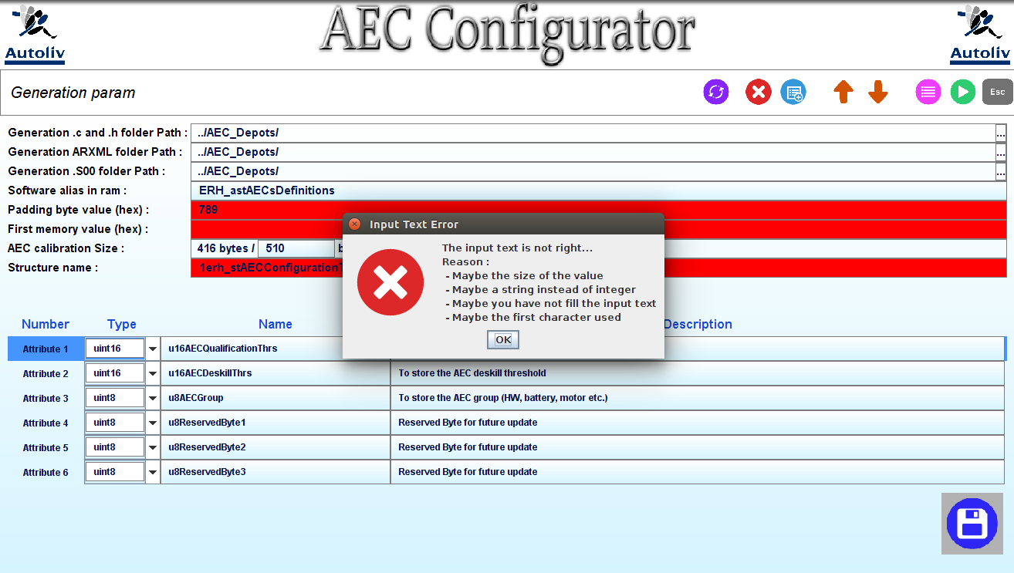

Figure 10: Edit AEC value with errors

### Create a new AEC

From the three screens “Edit AEC values”, “AEC value board” and “Edit AEC component” respectively Figure 1, Figure 3 and Figure 7, the user can add a new AEC. The button to add a new component is the following button and the key shortcut is “CTRL + N”.



Figure 11: Button add a new AEC

The action of this button will copy and add the selected AEC before it.

If the AEC has been successfully created, you will see this dialog on the screen:

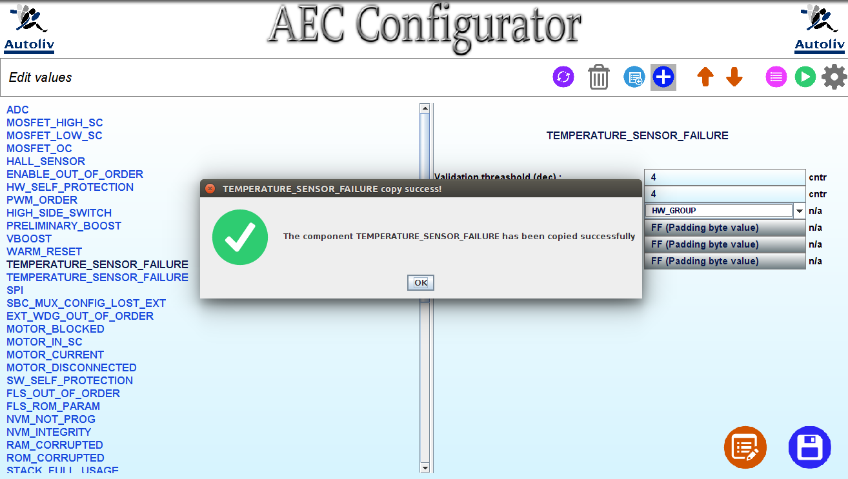

Figure 12: Dialog success AEC creation

If the memory allowed for the AEC configuration is over, the selected AEC will not be copied and the following dialog will appear (Figure 13). The user can change the allocated memory from the screen “Generation setting” (Figure 5).

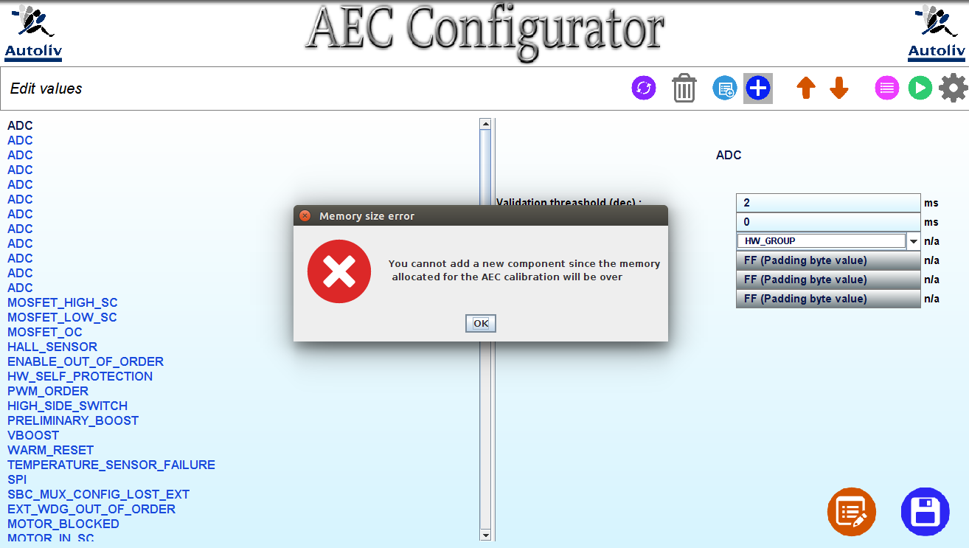

Figure 13: Dialog error AEC creation

After the creation of the AEC, the screen “Edit AEC component” (Figure 3) will be displayed.

### Delete an AEC

From the two screens “Edit AEC values”, and “Edit AEC component” respectively Figure 1 and Figure 7, the user can delete an AEC. The button to delete an AEC is the following button and the key shortcut is “CTRL + SUPPR”.



Figure 14: Button delete an AEC

The action of this button will delete the selected AEC.

A dialog will be displayed to ask the user if he is sure to delete it.

### Create a new AEC’s attribute

From the four screens “Edit AEC values”, “AEC value board”, “Generation settings” and “Edit AEC component” respectively Figure 1, Figure 3, Figure 5 and Figure 7, the user can create a new AEC attribute. The button to add a new attribute is the following button and the key shortcut is “CTRL + SPACE”.



Figure 15: Button add new attribute

The action of this button will display the following dialog:

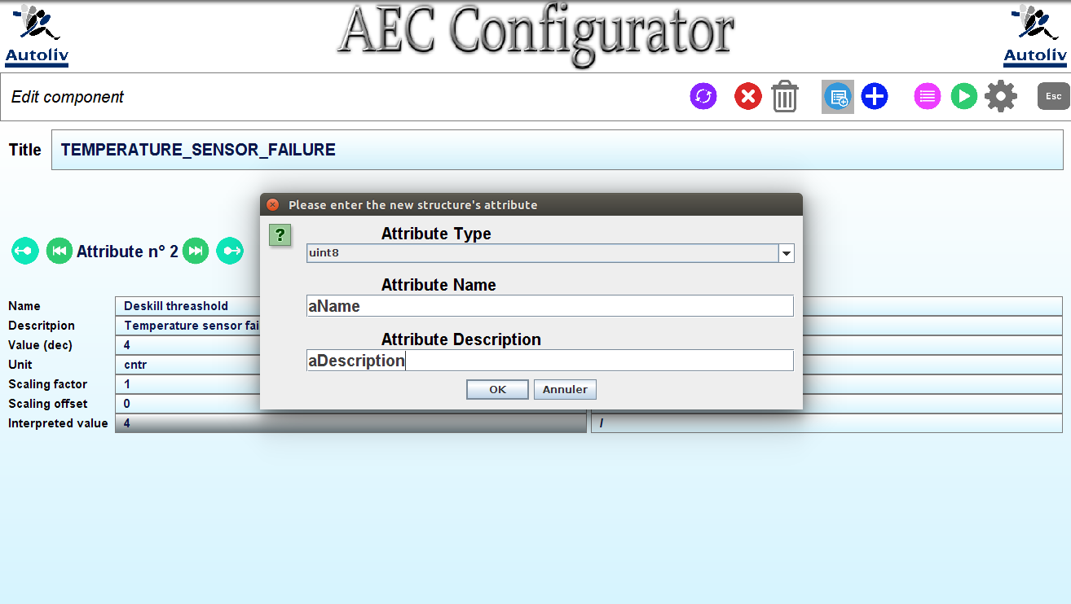

Figure 16: Dialog add a new attribute (structure)

On this dialog, the user have to set the attribute type, name and description. Those attributes are the structure’s attributes that will be wrote in the “ERH\_cfg\_public.h” file.

After a click on “OK”, a second dialog will be displayed on the screen. Since the AEC’s structure is the same for every AEC, this dialog ask the user to enter the new attribute default value for all the AEC’s attribute:

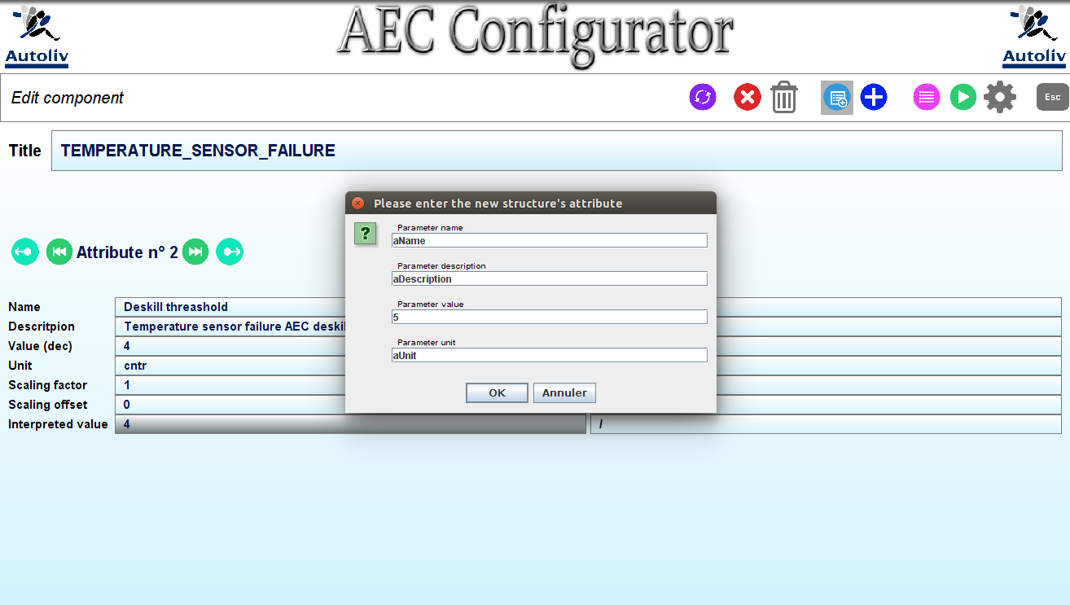

Figure 17: Dialog add a new attribute (value)

If the fields are correctly wrote and the user click on “OK”, a confirm dialog will be displayed.

When the user click on “OK”, the software will check if the memory is over:

* If the memory size is not full, the screen “AEC value board” (Figure 7) will be displayed. It will facilitate the AEC’s value edition.
* If the memory size is full, the screen “AEC value board” will be displayed with an error dialog. This dialog inform the user that the memory allocated for the AEC calibration is full. When the user click on “OK”, the screen “Generation setting” will be displayed.

### Delete an AEC’s attribute

From the two screens “Generation settings” and “Edit AEC component” respectively Figure 5 and Figure 7, the user can delete an AEC attribute. The button to delete an attribute is the following button and the key shortcut is “CTRL + D”.



Figure 18: Button delete AEC's attribute

The action of this button will display a confirmation dialog. If the user confirm his intention, the AEC’s attribute will be deleted.

### Change the AEC’s component order

From the screen “Edit AEC values” (Figure 1), the user can change the AEC’s order. The two button used to change the AEC’s order are the following button and the key shortcut are “CTRL + F” (take an AEC down in the list) and “CTRL + R” (take an AEC down in the list)

 

Figure 19: Buttons change AEC's order

### Change the AEC’s attribute order

From the two screens “Edit AEC component” (Figure 3) and “Generation setting” (Figure 5), the user can change the AEC’s attribute order. However! The attributes must be arrange from the largest to the smallest.

From the “Edit AEC component” screen, the two buttons used to switch the attribute position are the following buttons and the key shortcut are “CTRL + O” (switch with the next attribute) and “CTRL + I” (switch with the previous attribute).



Figure 20: Buttons change AEC's attribute order (1)

From the “Generation setting” screen, the two buttons used to switch the attribute position are the following button and the key shortcut are “CTRL + F” (switch with the next attribute) and “CTRL + R” (switch with the previous attribute).

 

Figure 21: Buttons change AEC's attribute order (2)

### Change the AEC’s attribute size

From the screen “Generation setting” (Figure 5), the user can set the attribute size by clicking on the combo box where the type is written and change the AEC’s attribute size. If the user change the size, the AEC’s attributes order and name will be modified. If the memory is allocated for the calibration is full, the following dialog will be displayed:

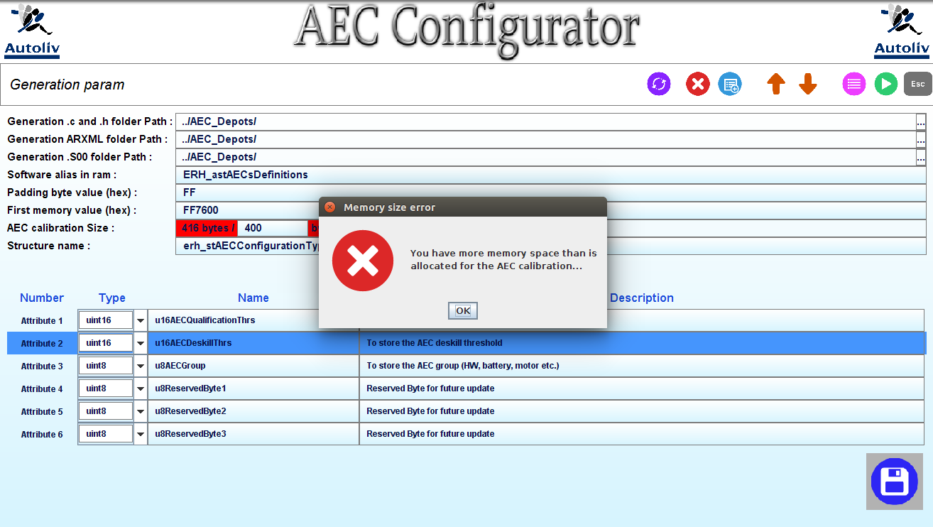

Figure 22: Dialog calibration memory full

### Change the generation settings

From the screen “Generation setting” (Figure 5) the user can edit the generation settings. He can

* Set the generation folder path for the different generated files by clicking directly on the folder path displayed on the screen. The path displayed on the screen is the path relative to the “AECconfigurator.jar” folder.

If the user click on the folder path, this type of dialog will be displayed:

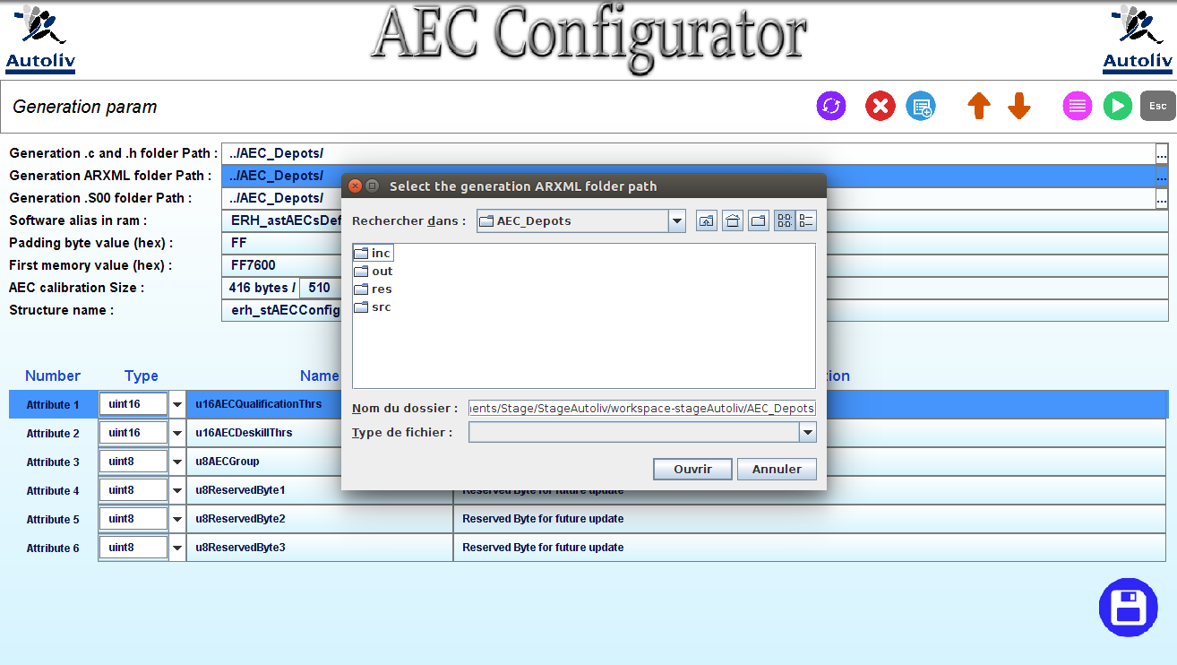

Figure 23: Dialog select the generation path

* Set the software alias in RAM by clicking on the text zone reserved for this value. The software alias in RAM is the Tab where all the AEC are stored.
* Set the padding byte value by clicking on the text zone reserved for this value. The padding byte value is the value that will be set for the reserved byte.
* Set the First memory value by clicking on the text zone reserved for this value.
* Set the AEC calibration size.
* Set the AEC structure name.
* Set the AEC structure’s attribute.

### Generate the files

From every screen, the user can generate the files. The user just need to tap on this button to generate the files (\*.c, \*.h, \*.S00 and \*.arxml)

If the generation finished without problem, this dialog box will be displayed on the screen:

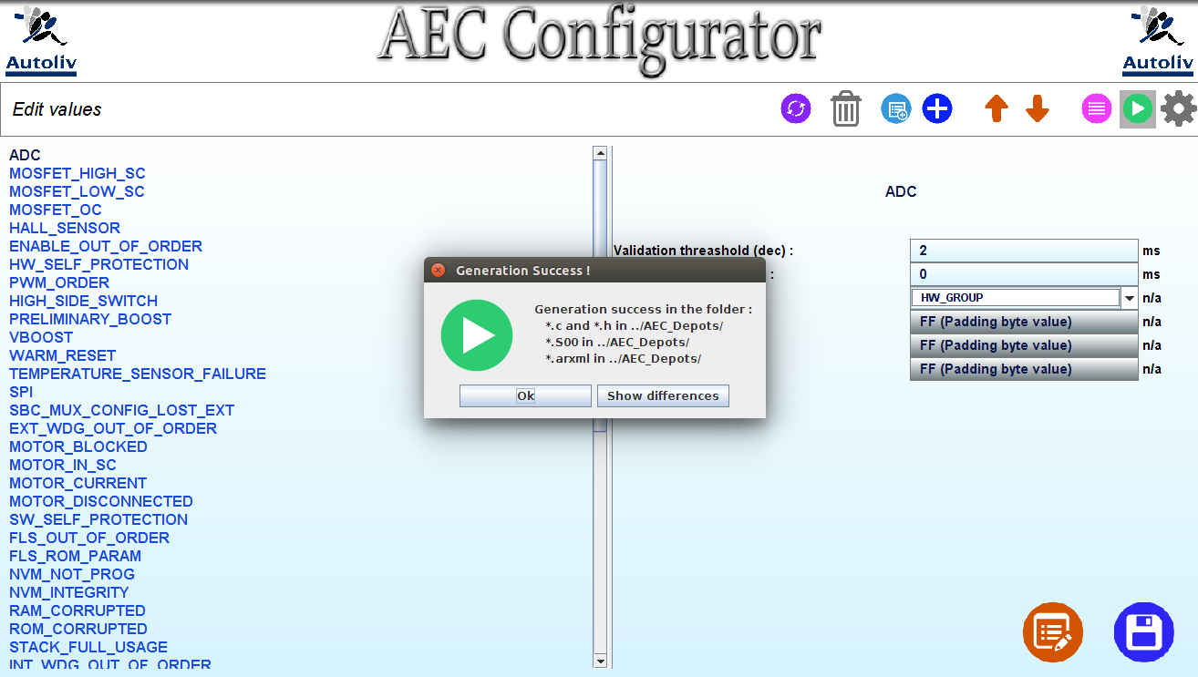

Figure 24: Dialog generation success

If the reserved AEC are not placed at the end of the AEC list, the following dialog will be displayed:

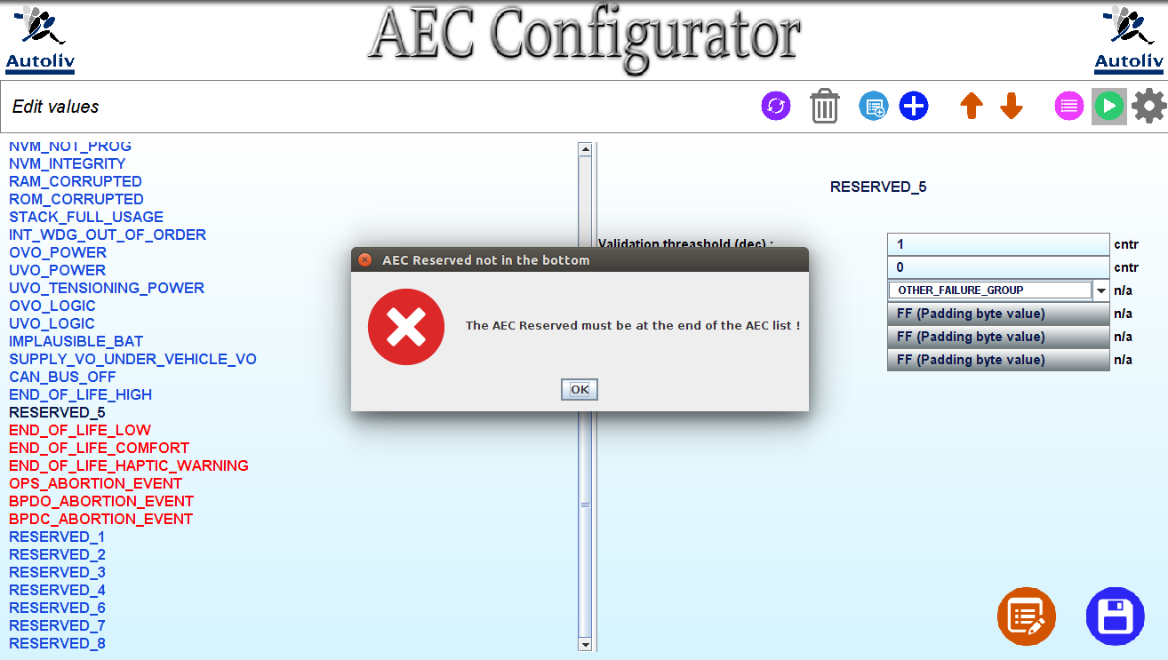

Figure 25: Dialog reserved AEC not at the end

Moreover, if the AEC’s attribute reserved byte are not at the end of the AEC’s attribute list, the following dialog will be displayed:

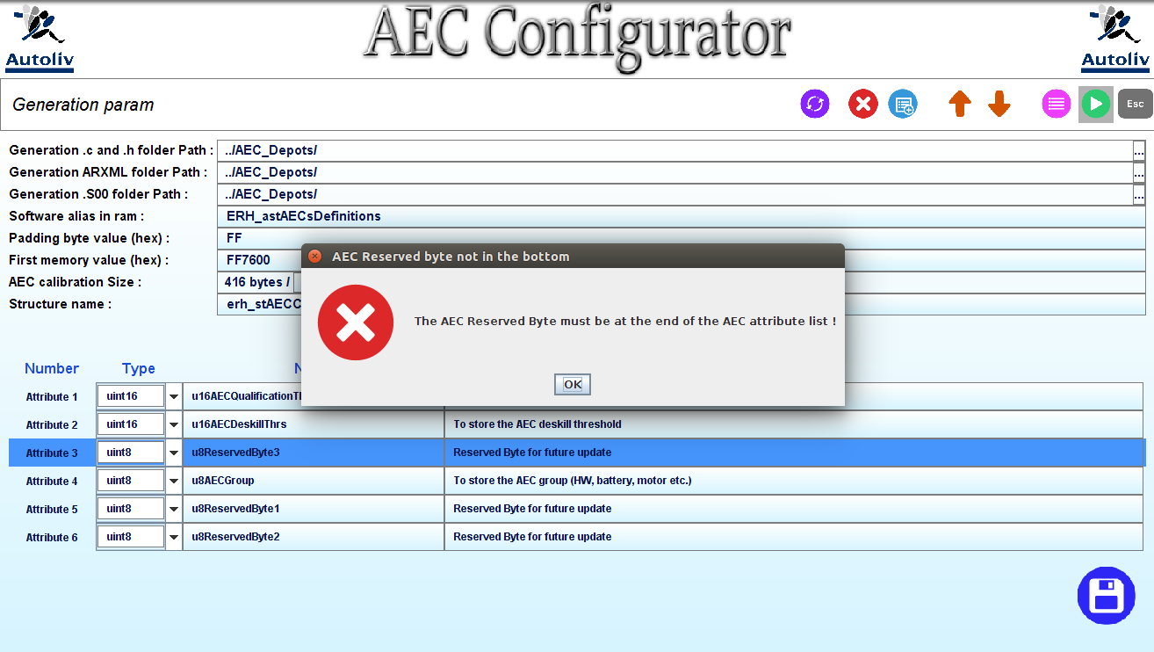

Figure 26: Dialog reserved byte not at the end

Finally if two AEC has the same name (or two AEC attribute has the same name), the following dialog will be displayed:

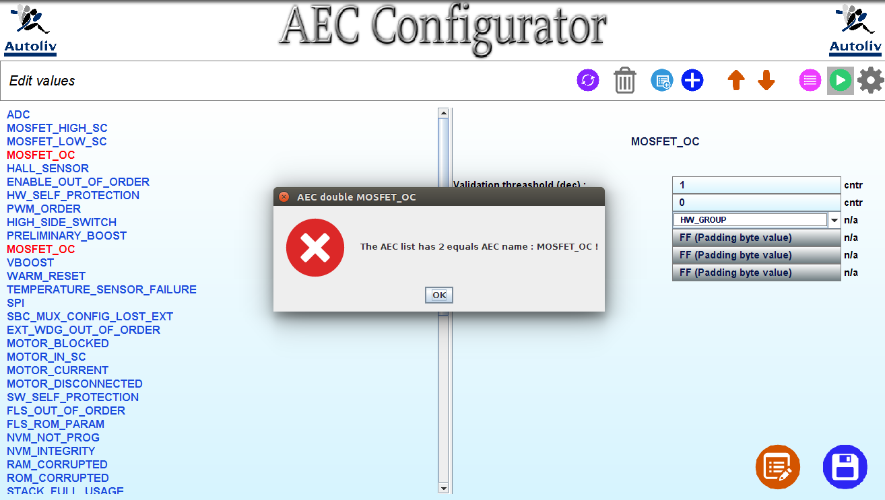

Figure 27: Dialog same AEC name

## Key shortcut

This section list the different key shortcut that the user can use:

|  |  |  |
| --- | --- | --- |
| Button | Intention / Action | Key shortcut |
| **ADC** | Next or previous AEC | CTRL + UP or CTRL + DOWN |
| **…** | Set the generation folder path | No key |
| E:\specification\util\resources\ic_deleteComponent.png | Delete the selected AEC | CTRL + DEL |
| E:\specification\util\resources\ic_deleteAttribute.png | Delete the selected AEC’s attribute | CTRL + D |
| E:\specification\util\resources\ic_arrowDown.png | Switch the selected component with the next component | CTRL + F |
| E:\specification\util\resources\ic_arrowUp.png | Switch the selected component with the previous component | CTRL + R |
| E:\specification\util\resources\ic_next.png | Display the next attribute | CTRL + RIGHT |
| E:\specification\util\resources\ic_precedent.png | Display the previous attribute | CTRL + LEFT |
| E:\specification\util\resources\ic_swipeRight.png | Switch the selected attribute with the next | CTRL + O |
| E:\specification\util\resources\ic_swipeLeft.png | Switch the selected attribute with the previous | CTRL + I |
| E:\specification\util\resources\ic_generate.png | Generate the files | CTRL + G |
| E:\specification\util\resources\ic_addAttribute.png | Add a new attribute | CTRL + SPACE |
| E:\specification\util\resources\ic_addAEC.png | Add a copy of the selected AEC before it | CTRL + N |
| E:\specification\util\resources\ic_list.png | Display the detailed list | CTRL + L |
| E:\specification\util\resources\ic_settings.png | Edit the generation setting | CTRL + P |
| E:\specification\util\resources\ic_edit.png | Edit the AEC component | CTRL + E |
| E:\specification\util\resources\ic_save.png | Save the AEC calibration | CTRL + S |
| E:\specification\util\resources\ic_escape.png | Escape : return to the “Edit Values” screen | Escape |
| E:\specification\util\resources\ic_refresh.png | Refresh the screen : display the screen with the saved values | CTRL + Z or CTRL + W or F5 |
| E:\specification\util\resources\ic_nextPage.png | Display the next page | CTRL + RIGHT |
| E:\specification\util\resources\ic_previousPage.png | Display the previous page | CTRL + LEFT |
| E:\specification\util\resources\ic_scrollDown.png | Scroll the old and the new panel down | CTRL + DOWN |
| E:\specification\util\resources\ic_scrollUp.png | Scroll the old and the new panel up | CTRL + UP |

Figure 28: The different key shortcut