|  |  |  |  |  |  |  |
| --- | --- | --- | --- | --- | --- | --- |
| DISTRIBUTION : | Firm | To | Ref | Copies | 1st page | e-mail |
|  |  |  |  |  |  |  |
|  |  |  |  |  |  |  |
|  |  |  |  |  |  |  |
|  |  |  |  |  |  |  |
|  |  |  |  |  |  |  |

**How delivery test summary report generation works**

OBJECT

This document describes how to configure Delivery test summary report generator.

SUMMARY

/

CONCLUSION

/

|  |  |  |
| --- | --- | --- |
| STATUS: | For comments | ✓ |
|  | For application |  |

|  |  |  |
| --- | --- | --- |
| Established by | Reviewed by | Approved by |
| Name: Puscasu David  Date: 03.11.2021  Visa: | Name:  Date:  Visa: | Name:  Date:  Visa: |

The present document contains **6 pages**, including the flyleaf and the appendices.

# EVOLUTION OF THE DOCUMENT

|  |  |  |  |  |
| --- | --- | --- | --- | --- |
| **Issue** | **Date** | **Author** | **Rev.** | **Motive and nature of the modifications** |
| ?????? | 03.11.2021 | Puscasu David | 1.1 | First Edition |
|  |  |  |  |  |
|  |  |  |  |  |
|  |  |  |  |  |
|  |  |  |  |  |

**CONTENTS**

EVOLUTION OF THE DOCUMENT 2

1. RELEVANT DOCUMENTS 4

2. GLOSSARY OF TERMS / EXPRESSIONS 4

3. PREREQUISITES 4

4. HOW REPORTS ARE GENERATED 4

4.1. How the Delivery test summary report script works 5

# RELEVANT DOCUMENTS

|  |  |  |
| --- | --- | --- |
| **N°** | **Title** | **Reference** |
|  |  |  |

# GLOSSARY OF TERMS / EXPRESSIONS

|  |  |
| --- | --- |
| ***Term*** | ***Definition*** |
| ***BAT*** | *Batch File ( Windows batch file extension )* |
|  |  |
|  |  |

# PREREQUISITES

In order for this tool to work, it is absolutely necessary to map the S: drive.

The delivery test summary report generation tool does not need any other prerequisites.

# HOW REPORTS ARE GENERATED

The tool needed to generate reports is called **Delivery_test_summary_report.exe**. In the same folder with this tool you must also have the **Delivery_test_summary_report.bat** file which contains all the arguments needed to run.

The arguments used are the following:

-i - will be the path to the file SW Delivery Tests follow-up.xls.

(eg -i=" s:\Tests\Tests_Deliveries\Automatic_Tests\SW Delivery Tests follow-up.xls ")

-l - will be the path to the Delivery test summary report template file, along with its name and extension.

(eg -l=" %parent_folder%\Templates\Delivery_Tests_Summary_Report_template.docx")

-o - will be the path to the Delivery test summary report generated file, along with its name and extension.

(eg -o=" %parent_folder%\Outputs\Delivery_Tests_Summary_Report.docx")

To run this tool, first make sure that the **Delivery_test_summary_report.bat** file is written correctly, then run this file by double clicking on it.

## How the Delivery test summary report script works

To generate the file Delivery_Tests_Summary_Report.docx this tool performs the following steps:

* read the result of required tests from SW Delivery Tests follow-up.xls file;

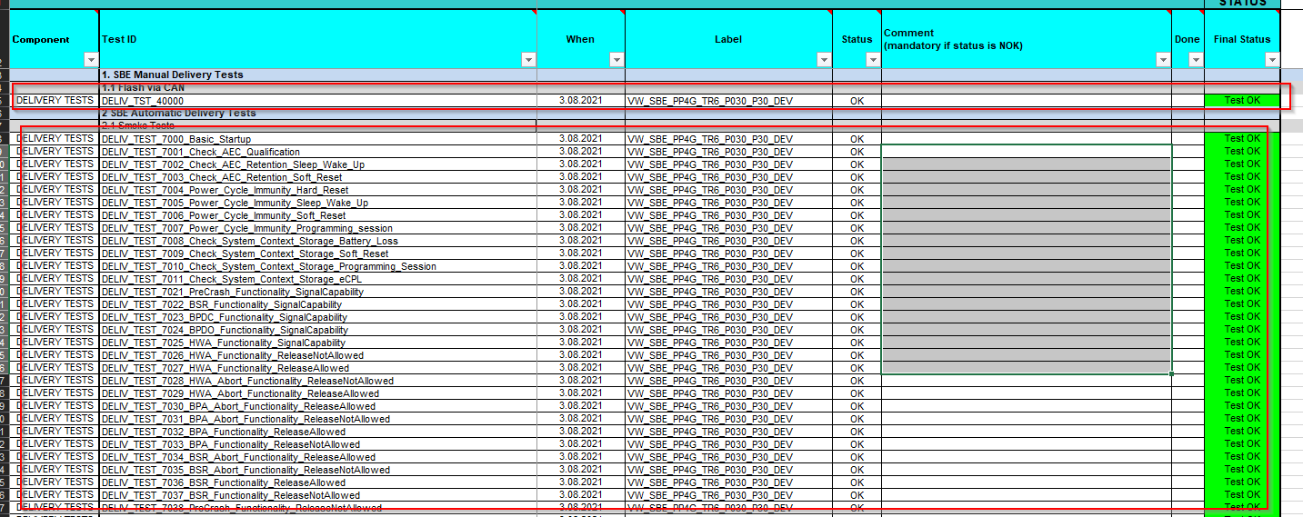

* based on a template it generates a Word document in which the result of each test.

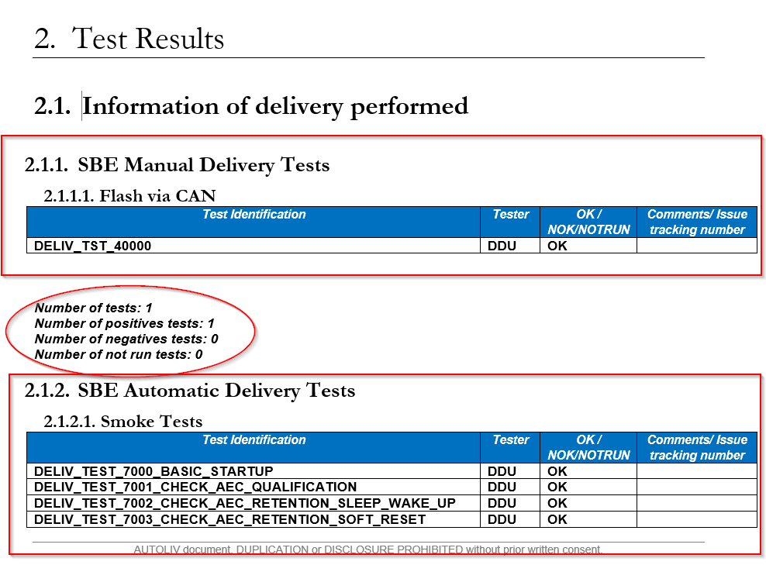

For each type of tests, manual and automatic, this tool creates a subsection in subchapter 2.1, Information of delivery performed. These subsections contain a table with the tests performed and their results, and the synthesis report data is added below the table.

In subchapter 2.2, Global Summary, summary report data are added for all tests in the document.

