**Autoliv Confidential**

|  |
| --- |
| **Distribution** |
| see [E3920297 - Project Configuration Item Management (PCIM)](https://plm.autoliv.int/linkto/latestreleased/alvProjectManagement/E3920297/*) |

**Software DELIVERY TEST Summary Report**

**Project:** **223748 VW AUI AU 416 EL SB ECU**

**SW Version: P25**

**HW Version :** C1

1. Introduction 3

1.1. Definitions and Abbreviations 3

1.2. Strategy 3

1.3. Test scope 3

1.4. Product Identification 4

1.5. Test environment 4

1.6. Document References 5

1.6.1. Input Documents (Customer Specifications, Autoliv Specifications) 5

1.6.2. Output Documents (Test Specifications) 5

2. Test Results 5

2.1. Information of integration performed 5

2.1.1. Tests Performed – 5

2.2. Global Summary 5

3. Issues Verified 5

3.1. Software Release Issue(s) Noted 6

3.2. Other Issue(s) Noted 6

3.3. Issue(s) closed 6

**EVOLUTION OF THE DOCUMENT**

| Version | Date | Author | Motive and nature of the modifications |
| --- | --- | --- | --- |
| 1.1 | 14-10-2021 | David  Puscasu | Initial version |
|  |  |  |  |

# 1. Introduction

This document provides managers, the Lead Software Verification Engineer, Design Leader, the software group and all affiliated technical support staff with the delivery summary information for **223748 VW AUI AU 416 EL SB ECU** P25 SW release.

## Definitions and Abbreviations

SCH Scheduler

SW Software

SBE Seat Belt Electronic

SWPF Software Product Follow-Up

SwArchM Software Architecture Matrix

ATM Auto Test Manager

BPA Belt Parking Algorithm

DIA Diagnostic

HWA Haptic Warning

MMG Mode Management

OS Operating System

PAL Power Abstraction Layer

PMP Physical Measure Provider

RTE Real Time Environment

SFR Standard Function Recovery

## Strategy

Delivery tests are be performed with the scope ensuring software robustness for the software release.

Priority #1 modules tested:

## Test scope

The purpose of the software delivery tests is to verify, through testing, the main software features.

Test scope is defined in SDP (E3920154).

## Product Identification

**Project Name:**  223748 VW AUI AU 416 EL SB ECU

**Software Version:** P2

**Hardware Version:** C1

## Test environment

AUDI_TR6 Test Environment will have the following equipment’s:

* Mock-Up / Proto
* Belt Retractor
* PC with Neeva
* CAN Case XL

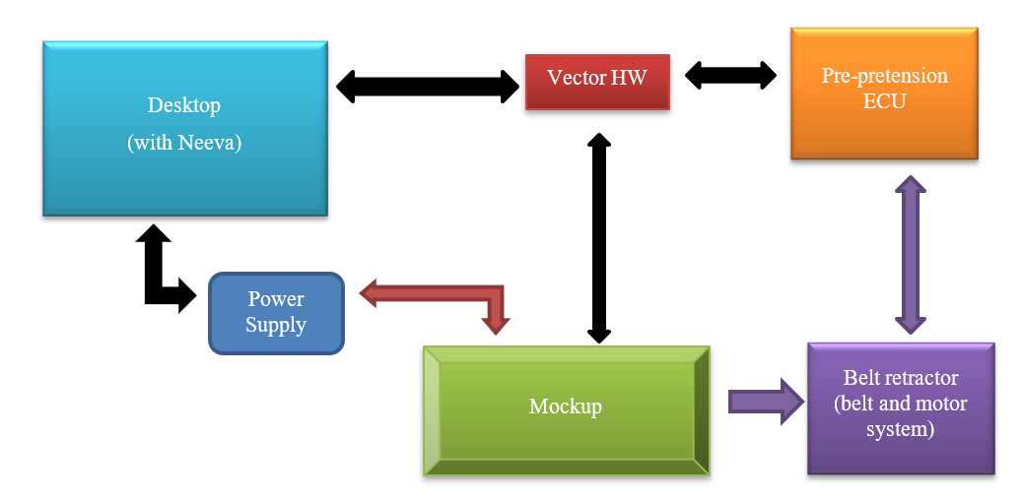

## Document References

### Input Documents (Customer Specifications, Autoliv Specifications)

|  |  |  |
| --- | --- | --- |
| **Ref.** | **Document** | **Version** |
| 1 | E3920154 Audi Tranche 6 Software Development Plan.docx | E3920154 |

Notes:

### Output Documents (Test Specifications)

|  |  |  |
| --- | --- | --- |
| **Ref.** | **Document** | **Version** |
| Tests | e:/MKSProjects/SEB/PP/AUDI_TR6/  Phase_01/View_Development/Tests/Tests_Integration/Automatic_Tests/Test_Scenarios/ | 1.10 |
| Results | e:/MKSProjects/SEB/PP/AUDI_TR6/  Phase_01/View_Development/Tests/Tests_Integration/Automatic_Tests/Test_Reports/ | 1.10 |

# Test Results

## Information of integration performed

### SBE Manual Delivery Tests

#### Flash via CAN

|  |  |  |  |
| --- | --- | --- | --- |
| ***Test Identification*** | ***Tester*** | ***OK / NOK/NOTRUN*** | ***Comments/ Issue tracking number*** |
| **DELIV_TST_40000** | **DDU** | **OK** |  |

***Number of tests: 1***  
***Number of positives tests: 1***  
***Number of negatives tests: 0***  
***Number of not run tests: 0***

### SBE Automatic Delivery Tests

#### Smoke Tests

|  |  |  |  |
| --- | --- | --- | --- |
| ***Test Identification*** | ***Tester*** | ***OK / NOK/NOTRUN*** | ***Comments/ Issue tracking number*** |
| **DELIV_TEST_7000_BASIC_STARTUP** | **DDU** | **OK** |  |
| **DELIV_TEST_7001_CHECK_AEC_QUALIFICATION** | **DDU** | **OK** |  |
| **DELIV_TEST_7002_CHECK_AEC_RETENTION_SLEEP_WAKE_UP** | **DDU** | **OK** |  |
| **DELIV_TEST_7003_CHECK_AEC_RETENTION_SOFT_RESET** | **DDU** | **OK** |  |
| **DELIV_TEST_7004_POWER_CYCLE_IMMUNITY_HARD_RESET** | **DDU** | **OK** |  |
| **DELIV_TEST_7005_POWER_CYCLE_IMMUNITY_SLEEP_WAKE_UP** | **DDU** | **OK** |  |
| **DELIV_TEST_7006_POWER_CYCLE_IMMUNITY_SOFT_RESET** | **DDU** | **OK** |  |
| **DELIV_TEST_7007_POWER_CYCLE_IMMUNITY_PROGRAMMING_SESSION** | **DDU** | **OK** |  |
| **DELIV_TEST_7008_CHECK_SYSTEM_CONTEXT_STORAGE_BATTERY_LOSS** | **DDU** | **OK** |  |
| **DELIV_TEST_7009_CHECK_SYSTEM_CONTEXT_STORAGE_SOFT_RESET** | **DDU** | **OK** |  |
| **DELIV_TEST_7010_CHECK_SYSTEM_CONTEXT_STORAGE_PROGRAMMING_SESSION** | **DDU** | **OK** |  |
| **DELIV_TEST_7011_CHECK_SYSTEM_CONTEXT_STORAGE_ECPL** | **DDU** | **OK** |  |
| **DELIV_TEST_7021_PRECRASH_FUNCTIONALITY_SIGNALCAPABILITY** | **DDU** | **OK** |  |
| **DELIV_TEST_7022_BSR_FUNCTIONALITY_SIGNALCAPABILITY** | **DDU** | **OK** |  |
| **DELIV_TEST_7023_BPDC_FUNCTIONALITY_SIGNALCAPABILITY** | **DDU** | **OK** |  |
| **DELIV_TEST_7024_BPDO_FUNCTIONALITY_SIGNALCAPABILITY** | **DDU** | **OK** |  |
| **DELIV_TEST_7025_HWA_FUNCTIONALITY_SIGNALCAPABILITY** | **DDU** | **OK** |  |
| **DELIV_TEST_7026_HWA_FUNCTIONALITY_RELEASENOTALLOWED** | **DDU** | **OK** |  |
| **DELIV_TEST_7027_HWA_FUNCTIONALITY_RELEASEALLOWED** | **DDU** | **OK** |  |
| **DELIV_TEST_7028_HWA_ABORT_FUNCTIONALITY_RELEASENOTALLOWED** | **DDU** | **OK** |  |
| **DELIV_TEST_7029_HWA_ABORT_FUNCTIONALITY_RELEASEALLOWED** | **DDU** | **OK** |  |
| **DELIV_TEST_7030_BPA_ABORT_FUNCTIONALITY_RELEASEALLOWED** | **DDU** | **OK** |  |
| **DELIV_TEST_7031_BPA_ABORT_FUNCTIONALITY_RELEASENOTALLOWED** | **DDU** | **OK** |  |
| **DELIV_TEST_7032_BPA_FUNCTIONALITY_RELEASEALLOWED** | **DDU** | **OK** |  |
| **DELIV_TEST_7033_BPA_FUNCTIONALITY_RELEASENOTALLOWED** | **DDU** | **OK** |  |
| **DELIV_TEST_7034_BSR_ABORT_FUNCTIONALITY_RELEASEALLOWED** | **DDU** | **OK** |  |
| **DELIV_TEST_7035_BSR_ABORT_FUNCTIONALITY_RELEASENOTALLOWED** | **DDU** | **OK** |  |
| **DELIV_TEST_7036_BSR_FUNCTIONALITY_RELEASEALLOWED** | **DDU** | **OK** |  |
| **DELIV_TEST_7037_BSR_FUNCTIONALITY_RELEASENOTALLOWED** | **DDU** | **OK** |  |
| **DELIV_TEST_7038_PRECRASH_FUNCTIONALITY_RELEASENOTALLOWED** | **DDU** | **OK** |  |
| **DELIV_TEST_7039_PRECRASH_FUNCTIONALITY_RELEASEALLOWED** | **DDU** | **OK** |  |
| **DELIV_TEST_7040_PRECRASH_ABORT_FUNCTIONALITY_RELEASENOTALLOWED** | **DDU** | **OK** |  |
| **DELIV_TEST_7041_PRECRASH_ABORT_FUNCTIONALITY_RELEASEALLOWED** | **DDU** | **OK** |  |
| **DELIV_TEST_7042_PRECRASH_FUNCTIONALITY_CONSECUTIVEREQUESTS_RELEASENOTALLOWED** | **DDU** | **OK** |  |
| **DELIV_TEST_7043_BSR_FUNCTIONALITY_RELEASEALLOWED_RELEASEALLOWED_VARIANT** | **DDU** | **OK** |  |
| **DELIV_TEST_7044_HWA_ABORT_FUNCTIONALITY_RELEASENOTALLOWED_REQUEST_VARIANT** | **DDU** | **OK** |  |
| **DELIV_TEST_7045_HWA_ABORT_FUNCTIONALITY_RELEASEALLOWED_REQUEST_VARIANT** | **DDU** | **OK** |  |
| **DELIV_TEST_7046_BPA_ABORT_FUNCTIONALITY_RELEASEALLOWED_REQUEST_VARIANT** | **DDU** | **OK** |  |
| **DELIV_TEST_7047_BPA_ABORT_FUNCTIONALITY_RELEASENOTALLOWED_REQUEST_VARIANT** | **DDU** | **OK** |  |
| **DELIV_TEST_7048_BSR_ABORT_FUNCTIONALITY_RELEASEALLOWED_REQUEST_VARIANT** | **DDU** | **OK** |  |
| **DELIV_TEST_7049_BSR_ABORT_FUNCTIONALITY_RELEASENOTALLOWED_REQUEST_VARIANT** | **DDU** | **OK** |  |
| **DELIV_TEST_7050_PRECRASH_FUNCTIONALITY_CONSECUTIVEREQUESTS_RELEASENOTALLOWED_VARIANT** | **DDU** | **OK** |  |
| **DELIV_TEST_7051_PRECRASH_CYCLE_PRIORITY_OVER_HWA** | **DDU** | **OK** |  |
| **DELIV_TEST_7052_PRECRASH_CYCLE_PRIORITY_OVER_BPA** | **DDU** | **OK** |  |
| **DELIV_TEST_7053_HWA_CYCLE_PRIORITY_OVER_PRECRASH** | **DDU** | **OK** |  |
| **DELIV_TEST_7054_SW_INIT_PHASE** | **DDU** | **OK** |  |
| **DELIV_TEST_7055_REQUEST_ALL_TENSIONING_PROFILES_VL** | **DDU** | **OK** |  |
| **DELIV_TEST_7056_REQUEST_ALL_TENSIONING_PROFILES_VR** | **DDU** | **OK** |  |
| **DELIV_TEST_7057_SOFTWARE_IDENTIFICATION_NUMBERS_VR** | **DDU** | **OK** |  |
| **DELIV_TEST_7058_SOFTWARE_IDENTIFICATION_NUMBERS_VL** | **DDU** | **OK** |  |

***Number of tests: 50***  
***Number of positives tests: 50***  
***Number of negatives tests: 0***  
***Number of not run tests: 0***

## Global Summary

***Total number of tests: 51***

***Total number of positives tests: 51***

***Total number of negatives tests: 0***

***Total number of not run tests: 0***

# Issues Verified

## Software Release Issue(s) Noted

| Tracking Number | Description | Note |
| --- | --- | --- |
|  |  |  |

## Other Issue(s) Noted

| Tracking Number | Description | Note |
| --- | --- | --- |
|  |  |  |

## Issue(s) closed

| Tracking Number | Description | Note |
| --- | --- | --- |
|  |  |  |