|  |  |
| --- | --- |
| **AEM TEMPLATE**  **SW Detailed Design (DD)**  **EXXXXXX** | |
| **Summary** | This is the Software Detailed Design Document |

|  |  |  |
| --- | --- | --- |
| **Author** | **Review** | **Approval** |
| Title: Name | See Project Master Document for the roles and Project Members List for the name of people | See Project Master Document for the roles and Project Members List for the name of people |
|  |  |  |
| **Distribution** | | |
| See Project Master Document for the roles and Project Members List for the name of people | See Project Master Document for the roles and Project Members List for the name of people | See Project Master Document for the roles and Project Members List for the name of people |

# Table of content

1. General Information 3

1.1. Revision history * 3

1.2. Purpose and Scope 3

1.3. Referenced documents 3

1.3.1. External documents 3

1.3.2. Internal Documents 3

1.4. Terminology and definitions 3

2. SW atomic architectural unit design 4

2.1. Overview 4

2.2. Traceability 4

3. FEATURES 4

3.1. Services 4

3.1.1. Service Name 4

3.2. Types 5

3.2.1. Name Structure definition 5

3.3. Variables 5

3.4. Constants 5

4. EEPROM 5

5. Configuration 5

6. Compilation Options 5

# General Information

## Revision history *

|  |  |  |  |
| --- | --- | --- | --- |
| **Revision** | **Date** | **Author(s)** | **Description/comment** |
|  |  |  |  |
|  |  |  |  |
|  |  |  |  |

*\* Template history is found in the CM tool used for templates*

## Purpose and Scope

The review of this document is done thanks to …

The purpose of this document is…

## Referenced documents

### External documents

|  |  |  |
| --- | --- | --- |
| **Id** | **Title** | **Reference** |
|  |  |  |
|  |  |  |
|  |  |  |

### Internal Documents

|  |  |  |
| --- | --- | --- |
| **Id** | **Title** | **Reference** |
|  |  |  |
|  |  |  |
|  |  |  |
|  |  |  |

## Terminology and definitions

The generic acronyms are available in the [AEM process and method wiki](https://alvteams.alv.autoliv.int/sites/aeuaeequalityassurance/AEM%20Process%20wiki/acronyms.aspx)

|  |  |
| --- | --- |
| **Terminology** | **Meaning** |
| AAU | Atomic architectural unit |
| SW | software |
|  |  |

# SW Module Detailed Design

## Overview

## Traceability

## Groups

|  |
| --- |
| Group Name |
| First_Example_Module_Group_Example |
| **Description** |
| This is a new created group, this will create a new man3 file with group members described in that file. Members description of a group will contain only description from brief section in their original file. |
| **Functions** |
| First_Example_Module_another_service_c_template |
| **Variables** |
| u8AnotherVariableExample |
| u8AnotherVariableExample2 |
| u8AnotherVariableExample3 |
| **Macros** |
| DATATYPE_ANOTHER_MACRO_DEFINED_FROM_C_FILE |

# Features

## Services

### First_Example_Module_service_c_template

|  |  |  |  |
| --- | --- | --- | --- |
| Object | | | |
| An example of description for local function. Belongs to First_Example_Module. | | | |
| **Prototype** | | | |
| void First_Example_Module_service_c_template (uint8 variable1, uint16 variable2, uint8 ouput_param) | | | |
| **Exceptions** | | | |
| This function has no exceptions. | | | |
| **Precondition** | | | |
| This function has no preconditions. | | | |
| **Postcondition** | | | |
| This function has no postconditions. | | | |
| **Detailed Design Requirement** | | | |
| DSG_First_Example_Module_service_c_template | | | |
| **Architecture Requirement** | | | |
| ARCH_TEST_REQ | | | |
| **Input parameters** | | | |
| Name | Type | Description | Range |
| variable1 | uint8 | This is a description for variable1 | 0..255 |
| variable2 | uint16 | This is a description for variable 2 | 0, 1, 2 |
| **Output parameters** | | | |
| Name | Type | Description | Range |
| ouput_param | uint8 | This is an ouput parameter. | OK, NOK, other_values |
| **Return value** | | | |
| Type | Description | | |
| NA | This function has no return. | | |
| **Dynamic aspect** | | | |
| Who(callers) | Description | | |
| Write here who calls this function. | Write here a description caller of this function. | | |
| **Static aspect** | | | |
| * | | | |
| **Constrains** | | | |
| Write here if you have any constraints. | | | |

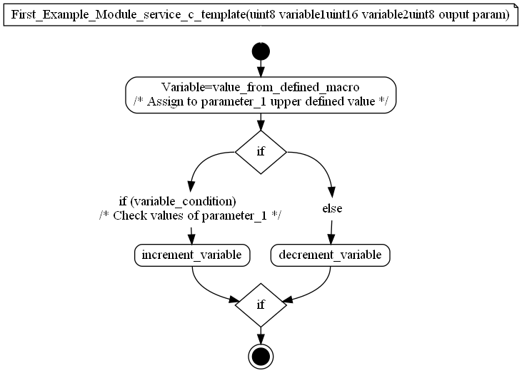

### First_Example_Module_another_service_c_template

|  |  |  |  |
| --- | --- | --- | --- |
| Object | | | |
| An example of description for local function. Belongs to First_Example_Module. | | | |
| **Prototype** | | | |
| LOCAL void First_Example_Module_another_service_c_template (uint8 another_variable_example) | | | |
| **Exceptions** | | | |
| This function has no exceptions. | | | |
| **Precondition** | | | |
| This function has no preconditions. | | | |
| **Postcondition** | | | |
| This function has no postconditions. | | | |
| **Detailed Design Requirement** | | | |
| DSG_First_Example_Module_another_service_c_template | | | |
| **Architecture Requirement** | | | |
| ARCH_TEST_REQ | | | |
| **Input parameters** | | | |
| Name | Type | Description | Range |
| another_variable_example | uint8 | This is a description for another_variable_example | 0..255 |
| **Output parameters** | | | |
| Name | Type | Description | Range |
| NA | NA | NA | NA |
| **Return value** | | | |
| Type | Description | | |
| NA | This function has no return. | | |
| **Dynamic aspect** | | | |
| Who(callers) | Description | | |
| Write here who calls this function. | Write here a description caller of this function. | | |
| **Static aspect** | | | |
| * | | | |
| **Constrains** | | | |
| Write here if you have any constraints. | | | |

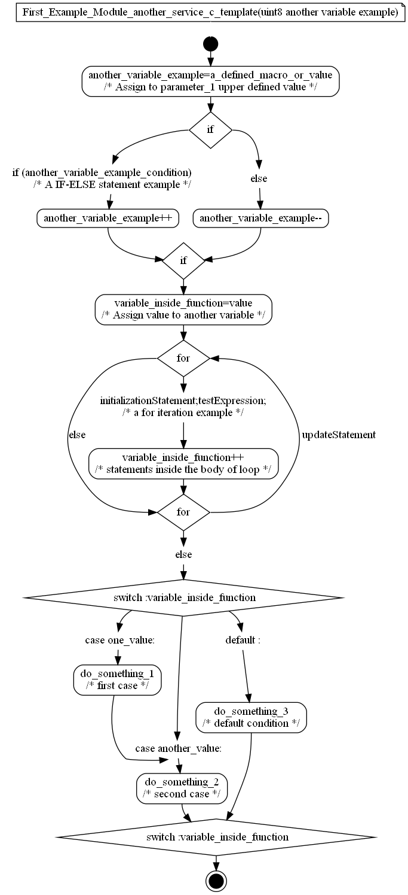

## Variabiles

### u8VariableExample

|  |  |  |
| --- | --- | --- |
| Type | Value |  |
| uint8 | ZERO | |
| **Description** | | |
| This variable is used to give an example descripton of a variable. | | |
| **Definition** | | |
| uint8 u8VariableExample = ZERO | | |
| **Initialization** | | |
| ZERO. | | |
| **Range** | | |
| 0..255 or anything. | | |

### u8AnotherVariableExample

|  |  |  |
| --- | --- | --- |
| Type | Value |  |
| uint8 | NA | |
| **Description** | | |
| A local variable description example that will also appear in group. | | |
| **Definition** | | |
| LOCAL uint8 u8AnotherVariableExample | | |
| **Initialization** | | |
| Not Initialised. | | |
| **Range** | | |
| A range example. | | |

### u8AnotherVariableExample2

|  |  |  |
| --- | --- | --- |
| Type | Value |  |
| uint8 | NA | |
| **Description** | | |
| A local variable description example that will also appear in group. | | |
| **Definition** | | |
| LOCAL uint8 u8AnotherVariableExample2 | | |
| **Initialization** | | |
| Not Initialised. | | |
| **Range** | | |
| A range example. | | |

### u8AnotherVariableExample3

|  |  |  |
| --- | --- | --- |
| Type | Value |  |
| uint8 | NA | |
| **Description** | | |
| A local variable description example that will also appear in group. | | |
| **Definition** | | |
| LOCAL uint8 u8AnotherVariableExample3 | | |
| **Initialization** | | |
| Not Initialised. | | |
| **Range** | | |
| OK, NOK. | | |

## Macros

### DATATYPE_MACRO_DEFINED_FROM_C_FILE

|  |  |
| --- | --- |
| Name | Value |
| DATATYPE_MACRO_DEFINED_FROM_C_FILE | ((uint8) 0x10) |
| **Definition** | |
| #define DATATYPE_MACRO_DEFINED_FROM_C_FILE ((uint8) 0x10) | |
| **Description** | |
| Defined macro from C file. | |

### DATATYPE_MACRO_DEFINED_FROM_H_FILE

|  |  |
| --- | --- |
| Name | Value |
| DATATYPE_MACRO_DEFINED_FROM_H_FILE | ((uint8) 0x01) |
| **Definition** | |
| #define DATATYPE_MACRO_DEFINED_FROM_H_FILE ((uint8) 0x01) | |
| **Description** | |
| Defined macro from H file. | |

### DATATYPE_ANOTHER_MACRO_DEFINED_FROM_C_FILE

|  |  |
| --- | --- |
| Name | Value |
| DATATYPE_ANOTHER_MACRO_DEFINED_FROM_C_FILE | ((uint8) 0x01) |
| **Definition** | |
| #define DATATYPE_ANOTHER_MACRO_DEFINED_FROM_C_FILE ((uint8) 0x01) | |
| **Description** | |
| Defined macro from C file that will appear in GROUP. | |

## Structures

### First_Example_Module_Struct_Define

|  |  |
| --- | --- |
| Definition | |
| First_Example_Module_Struct_Define | |
| **Description** | |
| This is a Struct description. | |
| **Fields** | |
| Name | Description |
| uint8 SomeMemberOfStructure | Definition of a member of structure. |

### First_Example_Module_Union_Define

|  |  |
| --- | --- |
| Definition | |
| First_Example_Module_Union_Define | |
| **Description** | |
| This is a union description. | |
| **Fields** | |
| Name | Description |
| uint8 FirstMemberOfUnion | Definition of a first member of union. |
| uint8 SecondtMemberOfUnion | Definition of a second member of union. |

# EEPROM

# Configuration

# Compilation Options