|  |  |  |  |  |  |  |
| --- | --- | --- | --- | --- | --- | --- |
| DISTRIBUTION : | Firm | To | Ref | Copies | 1st page | e-mail |
|  |  |  |  |  |  |  |
|  |  |  |  |  |  |  |
|  |  |  |  |  |  |  |
|  |  |  |  |  |  |  |
|  |  |  |  |  |  |  |

**How integration test summary report generation works**

OBJECT

This document describes how to configure Integration test summary report generator.

SUMMARY

/

CONCLUSION

/

|  |  |  |
| --- | --- | --- |
| STATUS: | For comments | ✓ |
|  | For application |  |

|  |  |  |
| --- | --- | --- |
| Established by | Reviewed by | Approved by |
| Name: Puscasu David  Date: 03.11.2021  Visa: | Name:  Date:  Visa: | Name:  Date:  Visa: |

The present document contains **7 pages**, including the flyleaf and the appendices.

# EVOLUTION OF THE DOCUMENT

|  |  |  |  |  |
| --- | --- | --- | --- | --- |
| **Issue** | **Date** | **Author** | **Rev.** | **Motive and nature of the modifications** |
| ?????? | 03.11.2021 | Puscasu David | 1.1 | First Edition |
|  |  |  |  |  |
|  |  |  |  |  |
|  |  |  |  |  |
|  |  |  |  |  |

**CONTENTS**

EVOLUTION OF THE DOCUMENT 2

1. RELEVANT DOCUMENTS 4

2. GLOSSARY OF TERMS / EXPRESSIONS 4

3. PREREQUISITES 4

4. HOW REPORTS ARE GENERATED 4

4.1. How the Integration test summary report script works 5

# RELEVANT DOCUMENTS

|  |  |  |
| --- | --- | --- |
| **N°** | **Title** | **Reference** |
|  |  |  |

# GLOSSARY OF TERMS / EXPRESSIONS

|  |  |
| --- | --- |
| ***Term*** | ***Definition*** |
| ***BAT*** | *Batch File ( Windows batch file extension )* |
|  |  |
|  |  |

# PREREQUISITES

In order for this tool to work, it is absolutely necessary to map the S: drive.

The integration test summary report generation tool does not need any other prerequisites.

# HOW REPORTS ARE GENERATED

The tool needed to generate reports is called **Integration_test_summary_report.exe**. In the same folder with this tool you must also have the **Integration_test_summary_report.bat** file which contains all the arguments needed to run.

The arguments used are the following:

-i - will be the path to the test results folder (.xml files and RA files).

(eg -i=" S:\Tests\Tests_Integration\Automatic_Tests\Test_Reports ")

-l - will be the path to the Integration test summary report template file, along with its name and extension.

(eg -l=" %parent_folder%\Templates\Integration_Tests_Summary_Report_template.docx")

-o - will be the path to the Integration test summary report generated file, along with its name and extension.

(eg -o=" %parent_folder%\Outputs\Integration_Tests_Summary_Report.docx")

To run this tool first make sure that the **Integration_test_summary_report.bat** file is written correctly, then run this file by double clicking on it.

## How the Integration test summary report script works

To generate the file Integration_Tests_Summary_Report.docx this tool performs the following steps:

* read the list of required tests from RA file (Excel file) for each module;

For example at the BFD module:

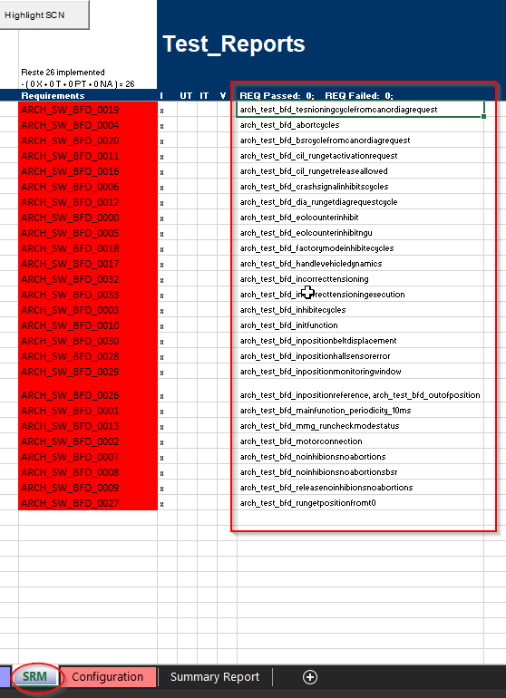

This tool enters the SRM sheet of the Excel file and reads the list of tests required for the BFD module.

* check if each test read from RA file has been executed and read the result of each test from the corresponding .xml files for each test;

For example at the ARCH_TEST_BFD_TesnioningCycleFromCANorDiagRequest.xml test report:

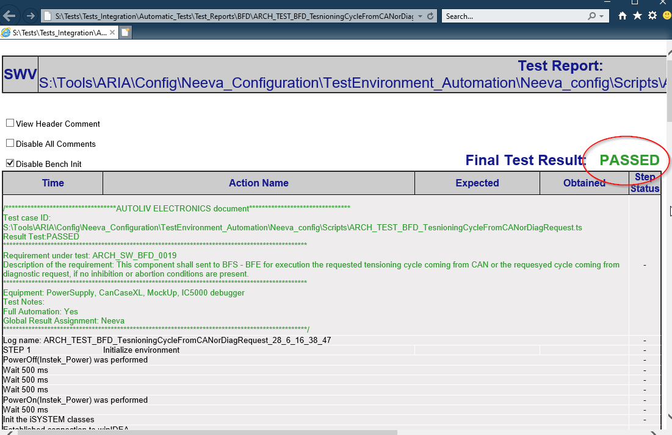

This tool parses the .xml file and reads its result, in this case "PASSED".

* based on the template, it generates a Word document in which the result of each test for each module is written.

For example at the BFD module:

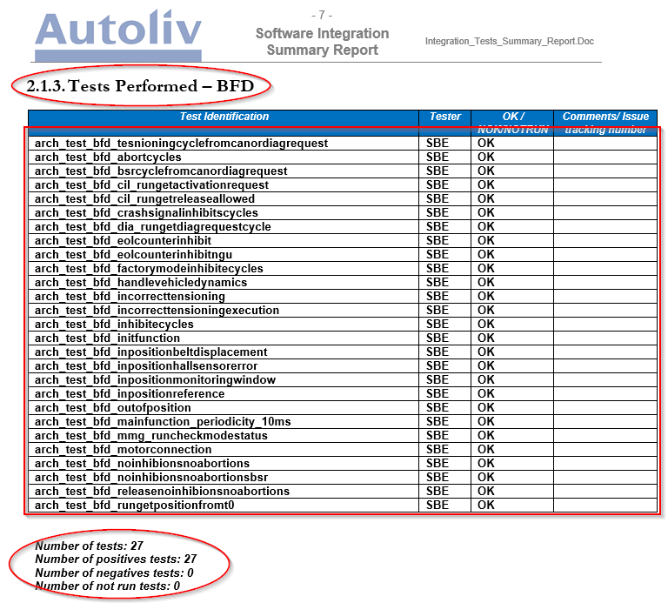

In Chapter 2, Test Results, sub-chapter 2.1., Information of integration performed, this tool creates a new sub-sequence for each module.

This sub-sequence contains a table with each test and its result, and the synthesis report data is added below the table.

In subchapter 2.2, Global Summary, summary report data are added for all tests in the document.

