**Autoliv Confidential**

|  |
| --- |
| **Distribution** |
| see [E3920297 - Project Configuration Item Management (PCIM)](https://plm.autoliv.int/linkto/latestreleased/alvProjectManagement/E3920297/*) |

**Software INTEGRATION Summary Report**

**Project:** **223748 VW AUI AU 416 EL SB ECU**

**SW Version: P25**

**HW Version :** C1

1. Introduction 3

1.1. Definitions and Abbreviations 3

1.2. Strategy 3

1.3. Test scope 4

1.4. Product Identification 4

1.5. Test environment 5

1.6. Document References 5

1.6.1. Input Documents (Customer Specifications, Autoliv Specifications) 5

1.6.2. Output Documents (Test Specifications) 5

2. Test Results 6

2.1. Information of integration performed 6

2.1.1. Tests Performed – ATM module 6

2.1.2. Tests Performed – BFD module 8

2.1.3. Tests Performed – BFE module 9

2.1.4. Tests Performed – BFS module 10

2.1.5. Tests Performed – BMM module 10

2.1.6. Tests Performed – BPA module 11

2.1.7. Tests Performed – BSW module 11

2.1.8. Tests Performed – CIL module 11

2.1.9. Tests Performed – DIA module 13

2.1.10. Tests Performed – ECUM module 15

2.1.11. Tests Performed – EOL module 15

2.1.12. Tests Performed – ERH module 16

2.1.13. Tests Performed – HWA module 17

2.1.14. Tests Performed – MIC module 17

2.1.15. Tests Performed – MMG module 17

2.1.16. Tests Performed – OS module 18

2.1.17. Tests Performed – PAL module 19

2.1.18. Tests Performed – PMP module 21

2.1.19. Tests Performed – PRO module 21

2.1.20. Tests Performed – RCM module 21

2.1.21. Tests Performed – RTE module 22

2.1.22. Tests Performed – SCH module 22

2.1.23. Tests Performed – SCM module 23

2.1.24. Tests Performed – SFR module 23

2.2. Global Summary 24

3. Issues Verified 24

3.1. Software Release Issue(s) Noted 24

3.2. Other Issue(s) Noted 25

3.3. Issue(s) closed 25

**EVOLUTION OF THE DOCUMENT**

| Version | Date | Author | Motive and nature of the modifications |
| --- | --- | --- | --- |
| 1.1 | 09-12-2019 | Aymeric Diankouika | Creation of the document for R1.1 SW release |
| 1.2 | 10-12-2019 | Aymeric Diankouika | Add history in document |
| 1.3 | 28-01-2020 | Aymeric Diankouika | Update list of tests in DIA |
| 1.4 | 12-08-2020 | Andrei Anca | Update document for project 223748 VW AUI AU 416 EL SB ECU |
| 1.5 | 17-12-2020 | Andrei Anca | Update document for project 223748 VW AUI AU 416 EL SB ECU |
| 1.6 | 03-02-2021 | Andrei Anca | Update document for project 223748 VW AUI AU 416 EL SB ECU |
| 1.7 | 03-08-2021 | Andrei Anca | Update document for project 223748 VW AUI AU 416 EL SB ECU |
|  |  |  |  |
|  |  |  |  |
|  |  |  |  |

# 1. Introduction

This document provides managers, the Lead Software Verification Engineer, Design Leader, the software group and all affiliated technical support staff with the integration summary information for **223748 VW AUI AU 416 EL SB ECU** P25 SW release.

## Definitions and Abbreviations

SCH Scheduler

SW Software

SBE Seat Belt Electronic

SWPF Software Product Follow-Up

SwArchM Software Architecture Matrix

ATM Auto Test Manager

BPA Belt Parking Algorithm

DIA Diagnostic

HWA Haptic Warning

MMG Mode Management

OS Operating System

PAL Power Abstraction Layer

PMP Physical Measure Provider

RTE Real Time Environment

SFR Standard Function Recovery

## Strategy

Integration tests are be performed having the SW Architectural requirements as inputs. Tests will mainly check the behaviour of the software, both dynamic and static aspects of a function and metrics of a module.

Priority #1 modules tested:

## Test scope

The purpose of the software integration tests is to verify, through testing, the software architecture requirements.

Test scope is defined in SDP (E3920154).

**CONCLUSION**

P30 SW Integration tests:

* Integration tests phase 1 (Platform to project integration) finished at 80% regarding the scope defined in SDP
* Integration tests phase 2 and 3 (minor and major project changes) finished at 60% regarding the scope defined in SDP

Results can be retrieved from SwArchM matrix.

## Product Identification

**Project Name:**  223748 VW AUI AU 416 EL SB ECU

**Software Version:** P2

**Hardware Version:** C1

## Test environment

PP4G Test Environment will have the following equipment’s:

* Mock-Up / Proto
* Belt Retractor
* PC with Neeva
* CAN Case XL

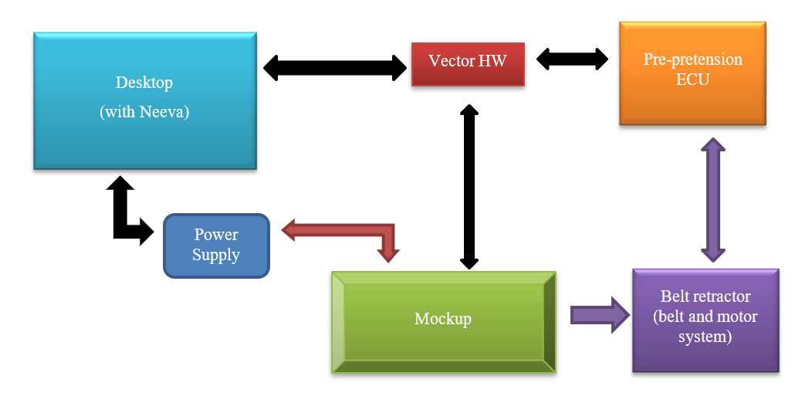

## Document References

### Input Documents (Customer Specifications, Autoliv Specifications)

|  |  |  |
| --- | --- | --- |
| **Ref.** | **Document** | **Version** |
| 1 | E3920154 Audi Tranche 6 Software Development Plan.docx | E3920154 |

Notes:

### Output Documents (Test Specifications)

|  |  |  |
| --- | --- | --- |
| **Ref.** | **Document** | **Version** |
| Tests | e:/MKSProjects/SEB/PP/AUDI_TR6/  Phase_01/View_Development/Tests/Tests_Integration/Automatic_Tests/Test_Scenarios/ | 1.10 |
| Results | e:/MKSProjects/SEB/PP/AUDI_TR6/  Phase_01/View_Development/Tests/Tests_Integration/Automatic_Tests/Test_Reports/ | 1.10 |

# Test Results

## Information of integration performed

### Tests Performed –

|  |  |  |  |
| --- | --- | --- | --- |
| ***Test Identification*** | ***Tester*** | ***OK / NOK/NOTRUN*** | ***Comments/ Issue tracking number*** |
|  |  |  |  |

## Global Summary

***Total number of tests:***

***Total number of positives tests:***

***Total number of negatives tests:***

***Total number of not run tests:***

# Issues Verified

## Software Release Issue(s) Noted

| Tracking Number | Description | Note |
| --- | --- | --- |
| **807538** | |  |  | | --- | --- | | |  | | --- | | [AUDI_TR6][P25][INT] Periodicity Mismatch for Run Autotests | | |  |
| **807568** | |  |  | | --- | --- | | |  | | --- | | AUDI_TR6][P25][INT] Inputs mismatch for BFE_runExecuteStandardSteps | | |  |
| **807569** | |  |  | | --- | --- | | |  | | --- | | [AUDI_TR6][P25][INT] The Motor stage internal status Not provided | | |  |
| **807570** | |  |  | | --- | --- | | |  | | --- | | [AUDI_TR6][P25][INT] Motor stage internal status Startup | | |  |
| **807571** | |  |  | | --- | --- | | |  | | --- | | [AUDI_TR6][P25][INT] BFE Get Power order not called | | |  |
| **807567** | |  |  | | --- | --- | | |  | | --- | | [AUDI_TR6][P25][INT] BFE_runScheduleSteps  NVP Paramaters | | |  |
| **807554** | |  |  | | --- | --- | | |  | | --- | | [AUDI_TR6][P25][INT] Enable/DisableHBSMonitoring | | |  |
| **807613** | |  |  | | --- | --- | | |  | | --- | | [AUDI_TR6][P25][INT]  Function BMM_runGetPositionFromMinPos_deg is never called | | |  |
| **807584** | |  |  | | --- | --- | | |  | | --- | | [AUDI_TR6][P25][INT] BMM_runGetSpeed_deg_s is Not Reachable | | |  |
| **807582** | |  |  | | --- | --- | | |  | | --- | | [AUDI_TR6][P25][INT] Status of the detection of the pyro device firing | | |  |
| **807598** | |  |  | | --- | --- | | |  | | --- | | AUDI_TR6][P25][INT] RAM ECC Event staus is not read in CIL_runAppliToCAN | | |  |
| **807566** | |  |  | | --- | --- | | |  | | --- | | [AUDI_TR6][P25][INT] DIA_WriteDataByIdentifier_SessionChangeInit not reached | | |  |
| **807585** | |  |  | | --- | --- | | |  | | --- | | [AUDI_TR6][P25][INT] Generation of clock signal from a MCU externa | | |  |
| **807586** | |  |  | | --- | --- | | |  | | --- | | [AUDI_TR6][P25][INT] DIA_runRidF780_EnableDisableECLKStop shall stop the generation of clock signal | | |  |
| **807587** | |  |  | | --- | --- | | |  | | --- | | [AUDI_TR6][P25][INT] EnableDisableECLKRes shall provide urrent status of the external clock | | |  |
| **807588** | |  |  | | --- | --- | | |  | | --- | | [AUDI_TR6][P25][INT] DIA_WriteDataByIdentifier_Init not reached | | |  |
| **807589** | |  |  | | --- | --- | | |  | | --- | | [AUDI_TR6][P25][INT] The function Dcm_Confirmation do not exist | | |  |
| **807590** | |  |  | | --- | --- | | |  | | --- | | [AUDI_TR6][P25][INT] CallBackDCMRequestServices_CBReqServInd_1_StopProtocol was not developed | | |  |
| **807609** | |  |  | | --- | --- | | |  | | --- | | [AUDI_TR6][P25][INT] ECC Not Implemented | | |  |
| **807610** | |  |  | | --- | --- | | |  | | --- | | [AUDI_TR6][P25][INT] SCH Periodicity is not called corectly | | |  |
| **807592** | |  |  | | --- | --- | | |  | | --- | | [AUDI_TR6][P25][INT] DIA_runClearDiagRequestCycle shall be called to acknowledge the releasing cycle | | |  |
| **807591** | |  |  | | --- | --- | | |  | | --- | | [AUDI_TR6][P25][INT] The car cranking status signal from CIL shall be an input. | | |  |

## Other Issue(s) Noted

| Tracking Number | Description | Note |
| --- | --- | --- |
| **803992** | [AUDI_TR6][P20][INT] Function BMM_runGetPositionFromMinPos_deg is never called | Issue Rejected |

## Issue(s) closed

| Tracking Number | Description | Note |
| --- | --- | --- |
| **803790** | [AUDI_TR6][P20][INT] Functions wrong periodic call | Issue Closed |
| **803836** | [AUDI_TR6][P20][INT] System Context is not saved when transitioning to Bootloader | Issue Closed |
| **803991** | [AUDI_TR6][P20][INT] Startup functions wrong periodic call | Issue Closed |