|  |  |  |  |  |  |  |
| --- | --- | --- | --- | --- | --- | --- |
| DISTRIBUTION : | Firm | To | Ref | Copies | 1st page | e-mail |
|  |  |  |  |  |  |  |
|  |  |  |  |  |  |  |
|  |  |  |  |  |  |  |
|  |  |  |  |  |  |  |
|  |  |  |  |  |  |  |

**How qualification test summary report generation works**

OBJECT

This document describes how to configure Qualification test summary report generator.

SUMMARY

/

CONCLUSION

/

|  |  |  |
| --- | --- | --- |
| STATUS: | For comments | ✓ |
|  | For application |  |

|  |  |  |
| --- | --- | --- |
| Established by | Reviewed by | Approved by |
| Name: Puscasu David  Date: 03.11.2021  Visa: | Name:  Date:  Visa: | Name:  Date:  Visa: |

The present document contains **8 pages**, including the flyleaf and the appendices.

# EVOLUTION OF THE DOCUMENT

|  |  |  |  |  |
| --- | --- | --- | --- | --- |
| **Issue** | **Date** | **Author** | **Rev.** | **Motive and nature of the modifications** |
| ?????? | 03.11.2021 | Puscasu David | 1.1 | First Edition |
|  |  |  |  |  |
|  |  |  |  |  |
|  |  |  |  |  |
|  |  |  |  |  |

**CONTENTS**

EVOLUTION OF THE DOCUMENT 2

1. RELEVANT DOCUMENTS 4

2. GLOSSARY OF TERMS / EXPRESSIONS 4

3. PREREQUISITES 4

4. HOW REPORTS ARE GENERATED 4

4.1. How the Qualification test summary report script works 5

# RELEVANT DOCUMENTS

|  |  |  |
| --- | --- | --- |
| **N°** | **Title** | **Reference** |
|  |  |  |

# GLOSSARY OF TERMS / EXPRESSIONS

|  |  |
| --- | --- |
| ***Term*** | ***Definition*** |
| ***BAT*** | *Batch File ( Windows batch file extension )* |
|  |  |
|  |  |

# PREREQUISITES

In order for this tool to work, it is absolutely necessary to map the S: drive.

The qualification test summary report generation tool does not need any other prerequisites.

# HOW REPORTS ARE GENERATED

The tool needed to generate reports is called **Qualification_test_summary_report.exe**. In the same folder with this tool you must also have the **Qualification_test_summary_report.bat** file which contains all the arguments needed to run.

The arguments used are the following:

-i - will be the path to RA files of reports on the Verification Storage folder.

(eg -i="%parent_folder%\Inputs\04_Verification_Storage")

-x - will be the path to the Qualification automatic tests reports folder.

(eg -x="S:\Tests\Tests_Qualification\Automatic_Tests\Test_Reports")

-m - will be the path to the .xlsm files from Peer_Review folder.

(eg -m="S:\Tests\Tests_Qualification\Peer_Review")

-l - will be the path to the Qualification test summary report template file, along with its name and extension.

(eg -l="%parent_folder%\Templates\Qualificarion_Tests_Summary_Report_template.docx")

-o - will be the path to the Qualification test summary report generated file, along with its name and extension.

(eg -o="%parent_folder%\Outputs\Delivery_Tests_Summary_Report.docx")

To run this tool, first make sure that the **Qualification_test_summary_report.bat** file is written correctly, then run this file by double clicking on it.

## How the Qualification test summary report script works

To generate the file Qualification_Tests_Summary_Report.docx this tool performs the following steps:

* read the list of modules from the RA files;

For example at the TF_B:

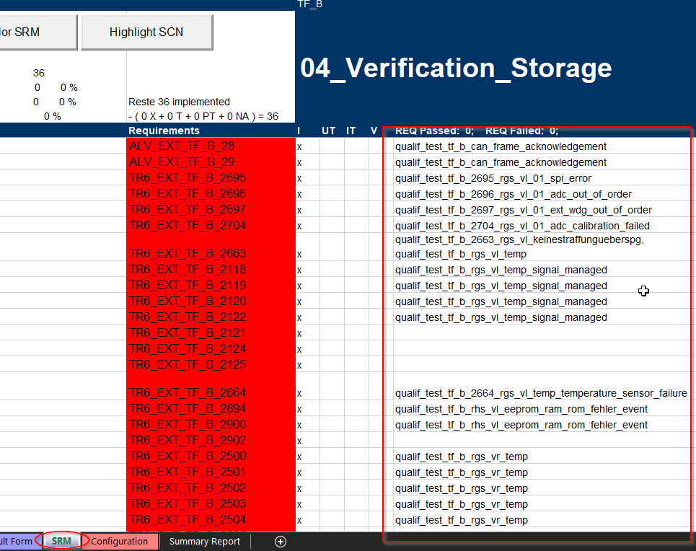

This tool enters the SRM sheet of the Excel file and reads the list of tests required for TF_B.

* read the list of tests performed for each module as well as the status of the test results in the .xlsm files in the Peer Review folder;

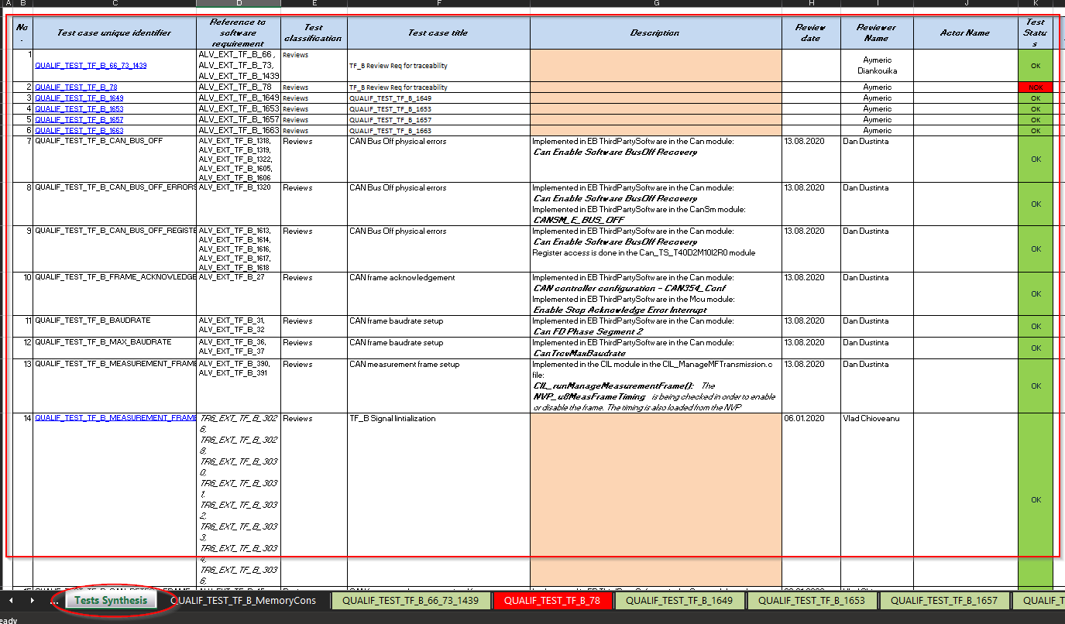

This tool enters the Tests Synthesis sheet of the Excel file and reads the list of tests and reads its result.

* read the result of test from the corresponding .xml files for each test;

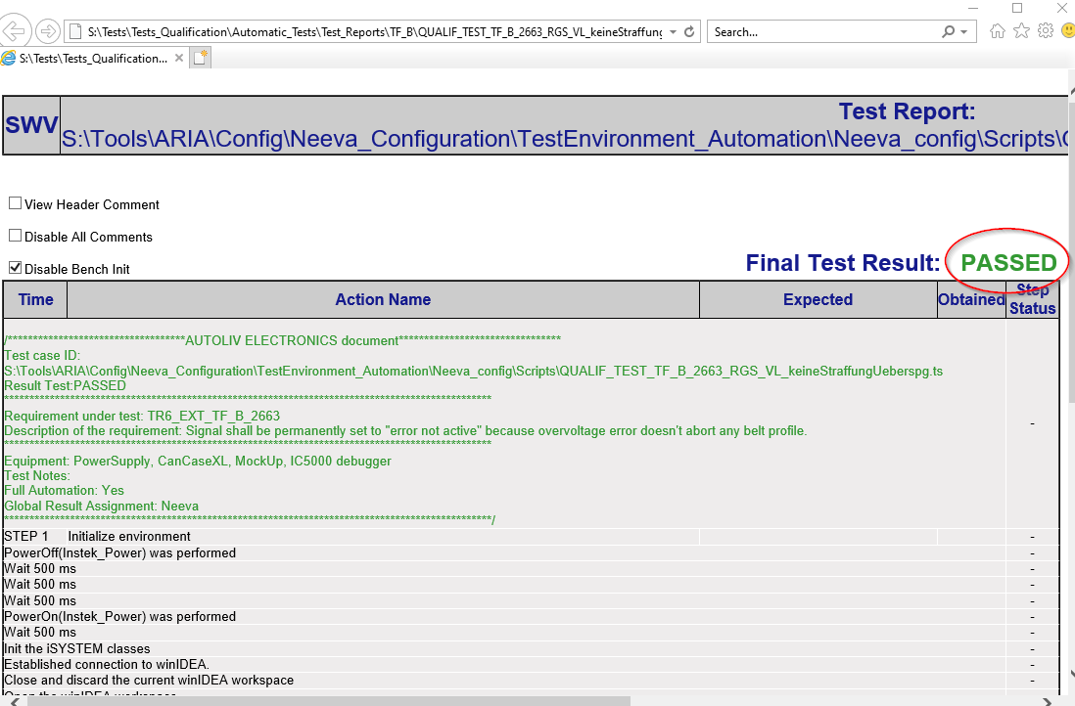

This tool parses the .xml file and reads its result, in this case "PASSED".

* based on template it generates a Word document in which the result of each test for each module is written.

In sub-chapter 2.1., Testing Information for the White Box, this tool creates a new subsection in which it adds the data read from the .xlsm files in the Peer Review folder.

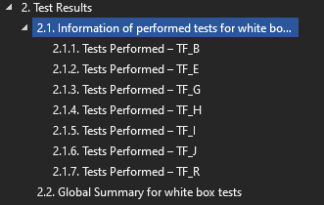

This sub-sequence contains a table with each test and its result, and the synthesis report data is added below the table.

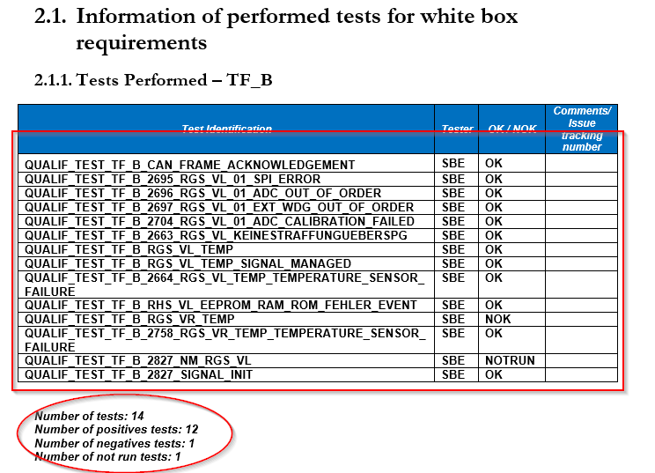

In subchapter 2.2, Global Summary for white box tests, summary report data are added for all white box tests.

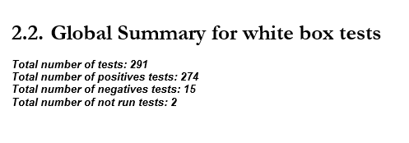

In sub-chapter 2.3., Testing Information for the White Box, this tool creates a new subsection in which it adds the data read from the .xml with tests results.

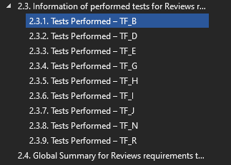

This sub-sequence contains a table with each test and its result, and the Summary Report data is added below the table.

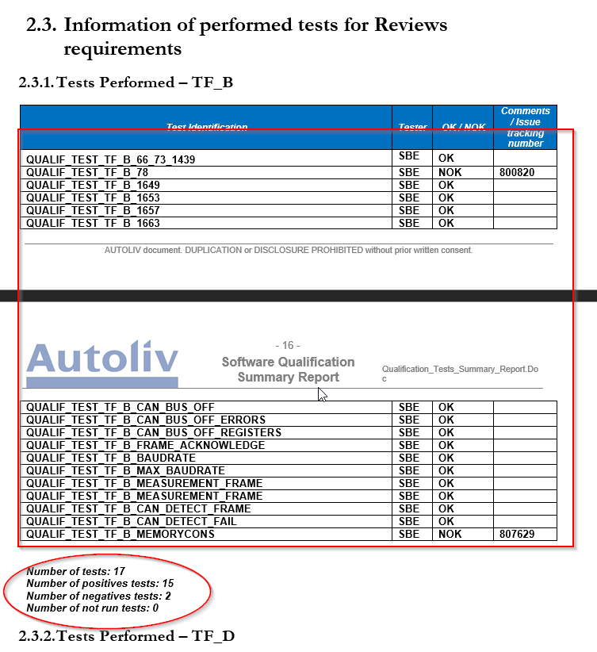

In subchapter 2.4, Global Summary for Reviews requirements tests, summary report data are added for this tests.

