**Autoliv Confidential**

|  |
| --- |
| **Distribution** |
| see [E3920297 - Project Configuration Item Management (PCIM)](https://plm.autoliv.int/linkto/latestreleased/alvProjectManagement/E3920297/*) |

**Software QUALIFICATION Summary Report**

**Project:** **223748 VW AUI AU 416 EL SB ECU**

**SW Version: P25**

**HW Version : B1**

1. Introduction 3

1.1. Definitions and Abbreviations 3

1.2. Strategy 4

1.3. Test scope 4

1.4. Product Identification 4

1.5. Test environment 5

1.6. Document References 5

1.6.1. Input Documents (Customer Specifications, Autoliv Specifications) 5

1.6.2. Output Documents (Test Specifications) 5

2. Test Results 6

2.1. Information of performed tests for white box requirements 6

2.1.1. Tests Performed – TF_B 6

2.1.2. Tests Performed – TF_E 7

2.1.3. Tests Performed – TF_G 11

2.1.4. Tests Performed – TF_H 12

2.1.5. Tests Performed – TF_I 14

2.1.6. Tests Performed – TF_J 15

2.1.7. Tests Performed – TF_R 15

2.2. Information of performed tests for Reviews requirements 17

2.2.1. Tests Performed – TF_B 17

2.2.2. Tests Performed – TF_E 17

2.2.3. Tests Performed – TF_G 18

2.2.4. Tests Performed – TF_H 18

2.2.5. Tests Performed – TF_I 20

2.2.6. Tests Performed – TF_J 21

2.2.7. Tests Performed – TF_N 21

2.2.8. Tests Performed – TF_R 22

3. Issues Verified 29

3.1. Software Release Issue(s) Verifed 29

3.2. Other Issue(s) Noted 29

3.3. Issue(s) closed 29

**EVOLUTION OF THE DOCUMENT**

| Version | Date | Author | Motive and nature of the modifications |
| --- | --- | --- | --- |
| 1.1 | 09-01-2020 | Aymeric Diankouika | Creation of the document for R1.1 SW release |
| 1.2 | 09-01-2020 | Aymeric Diankouika | Update TF-H tests list |
| 1.3 | 28-01-2020 | Aymeric Diankouika | Update TF-H tests list |
| 1.4 | 29-01-2020 | Aymeric Diankouika | Change a TF-H test name |
| 1.5 | 14-08-2020 | Dan Dustinta | Update summary report for AUDI_TR6 |
| 1.6 | 03-02-2021 | Andreea Negrea | Update summary report for P25 |
|  |  |  |  |
|  |  |  |  |
|  |  |  |  |
|  |  |  |  |

# 1. Introduction

This document provides managers, the Lead Software Verification Engineer, Design Leader, the software group and all affiliated technical support staff with the integration summary information for **223748 VW AUI AU 416 EL SB ECU** P20 SW release.

## Definitions and Abbreviations

SCH Scheduler

SW Software

SBE Seat Belt Electronic

SWPF Software Product Follow-Up

SwArchM Software Architecture Matrix

ATM Auto Test Manager

BPA Belt Parking Algorithm

DIA Diagnostic

HWA Haptic Warning

MMG Mode Management

OS Operating System

PAL Power Abstraction Layer

PMP Physical Measure Provider

RTE Real Time Environment

SFR Standard Function Recovery

## Strategy

Software White-box tests are performed having the Software requirements as inputs. Tests will mainly check the behaviour of the software, inputs values.

Priority #1 requirement tested:

## Test scope

The purpose of the software qualification tests is to verify, through testing, the software requirements.

Test scope is defined in Software Qualification Plan ([E4069699](https://plm.autoliv.int/linkto/latestreleased/ElectronicsDesignManagement/E4069699/*)).

**CONCLUSION**

P025 SW White-box Qualification Tests:

* White box qualification tests phase finished at 74% regarding the scope defined in the Software Qualification Plan
* 6 PTC issue were created

Results can be retrieved from SRM ([E4275524](http://plm.autoliv.int/linkto/latest/ElectronicsDesignManagement/E4275524/*)).

## Product Identification

**Project Name:**  223748 VW AUI AU 416 EL SB ECU

**Software Version:** P25

**Hardware Version:** B1

## Test environment

AUDI_TR6 Test Environment will have the following equipment:

* Mock-Up / Proto
* Belt Retractor
* PC with Neeva
* CAN Case XL

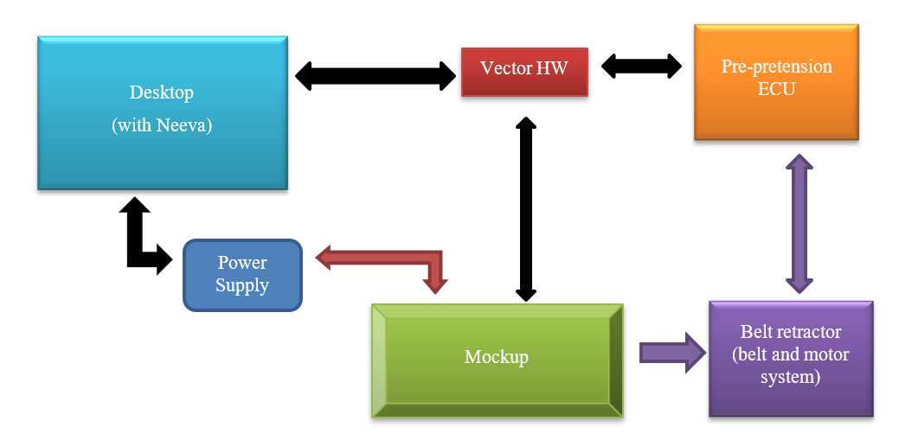

## Document References

### Input Documents (Customer Specifications, Autoliv Specifications)

|  |  |  |
| --- | --- | --- |
| **Ref.** | **Document** | **Version** |
| 1 | **E4069699** - Increment SW Verification Plan | Rev006 |

Notes:

### Output Documents (Test Specifications)

|  |  |  |
| --- | --- | --- |
| **Ref.** | **Document** | **Version** |
| Tests | e:/MKSProjects/SBE/PP/AUDI_TR6/Phase_01/View_Development/  Tests/Tests_Qualification /Automatic_Tests/Test_Scenarios/ | VW_SBE_PP4G_TR6_P025_P25_01_DEV |
| Results | e:/MKSProjects/SBE/PP/AUDI_TR6/Phase_01/View_Development/  Tests/Tests_Qualification /Automatic_Tests/Test_Reports/ | VW_SBE_PP4G_TR6_P025_P25_01_DEV |

# Test Results

## Information of manual performed tests for white box requirements

### Tests Performed –

|  |  |  |  |
| --- | --- | --- | --- |
| ***Test Identification*** | ***Tester*** | ***OK / NOK*** | ***Comments/ Issue tracking number*** |
|  |  |  |  |

## Global Summary for manual tests

***Total number of tests:***

***Total number of positives tests:***

***Total number of negatives tests:***

***Total number of not run tests:***

## Information of automatic performed tests for white box requirements

### Tests Performed –

|  |  |  |  |
| --- | --- | --- | --- |
| ***Test Identification*** | ***Tester*** | ***OK / NOK*** | ***Comments/ Issue tracking number*** |
|  |  |  |  |

## Global Summary for automatic tests

***Total number of tests:***

***Total number of positives tests:***

***Total number of negatives tests:***

***Total number of not run tests:***

## Information of performed tests for Reviews requirements

### Tests Performed –

|  |  |  |  |
| --- | --- | --- | --- |
| ***Test Identification*** | ***Tester*** | ***OK / NOK*** | ***Comments/ Issue tracking number*** |
|  |  |  |  |

## Global Summary for Reviews requirements tests

***Total number of tests:***

***Total number of positives tests:***

***Total number of negatives tests:***

***Total number of not run tests:***

# Issues Verified

## Software Release Issue(s) Verifed

| Tracking Number | Description | Status |
| --- | --- | --- |
| - | |  |  | | --- | --- | | |  | | --- | | - | | | - |

## Other Issue(s) Noted

| Tracking Number | Description | Status |
| --- | --- | --- |
| - | |  |  | | --- | --- | | |  | | --- | | - | | | - |

## Issue(s) closed

| Tracking Number | Description | Note |
| --- | --- | --- |
| - | |  |  | | --- | --- | | |  | | --- | | - | | | - |