|  |  |  |  |  |  |  |
| --- | --- | --- | --- | --- | --- | --- |
| DISTRIBUTION : | Firm | To | Ref | Copies | 1st page | e-mail |
|  |  |  |  |  |  |  |
|  |  |  |  |  |  |  |
|  |  |  |  |  |  |  |
|  |  |  |  |  |  |  |
|  |  |  |  |  |  |  |

**How SysSwPF generator tool works**

OBJECT

This document describes how to configure SysSwPF generator Tool.

SUMMARY

/

CONCLUSION

/

|  |  |  |
| --- | --- | --- |
| STATUS: | For comments | ✓ |
|  | For application |  |

|  |  |  |
| --- | --- | --- |
| Established by | Reviewed by | Approved by |
| Name: Gustescu Emilian  Date: 18.08.2022  Visa: | Name:  Date:  Visa: | Name:  Date:  Visa: |

The present document contains **5 pages**, including the flyleaf and the appendices.

# EVOLUTION OF THE DOCUMENT

|  |  |  |  |  |
| --- | --- | --- | --- | --- |
| **Issue** | **Date** | **Author** | **Rev.** | **Motive and nature of the modifications** |
| ?????? | 18.08.2022 | Gustescu Emilian | 1.1 | First Edition |
|  |  |  |  |  |
|  |  |  |  |  |
|  |  |  |  |  |
|  |  |  |  |  |

**CONTENTS**

EVOLUTION OF THE DOCUMENT 2

1. RELEVANT DOCUMENTS 4

2. GLOSSARY OF TERMS / EXPRESSIONS 4

3. PREREQUISITES 4

4. HOW sanity check for integration tests tool works 4

4.1. What exactly this tool does 5

# RELEVANT DOCUMENTS

|  |  |  |
| --- | --- | --- |
| **N°** | **Title** | **Reference** |
|  |  |  |

# GLOSSARY OF TERMS / EXPRESSIONS

|  |  |
| --- | --- |
| ***Term*** | ***Definition*** |
| ***BAT*** | *Batch File ( Windows batch file extension )* |
|  |  |
|  |  |

# PREREQUISITES

In order for this tool to work, it is absolutely necessary to provide the path to the following files: path to the input PTC.csv file (E.G. PTC.csv), path to the input PLM.csv file (E.G. PLM.csv), path to the input template excel file (E.G. Template_file.xlsx), path to the output excel to fill in (E.G. SW Work-Product Follow-up.xlsx).

The SysSwPF generator tool does not need any other prerequisites.

# HOW Sysswpf generator tool works

The tool is called **SysSwPF_generator.exe**. In the same folder with this tool you must also have the **SysSwPF_generator.bat** file which contains all the arguments needed to run.

The arguments used are the following:

-i - will be the path to the PTC.csv file.

(E.G. -i = "s:\Scripts\Configuration_Management\ptc_tracker\Executables\Exxxxxxx DAIMLER MMA CM Items Status PTC.csv")

-l - will be the path to the PLM.csv file.

(E.G. -l = "s:\Scripts\Configuration_Management\plm_tracker\Sources\Exxxxxxx DAIMLER MMA CM Items Status PLM.csv")

-t - will be the path to the input template excel file.

(E.G. -t = "%parent_folder%\Inputs\Exxxxxxx DAIMLER MMA - SW Work-Product Follow-up.xlsx")

-o - will be the path to the excel file that was modified.

(E.G. -o = “%parent_folder%\Outputs\Exxxxxxx DAIMLER MMA - SW Work-Product Follow-up.xlsx")

To run this tool, first make sure that the **SysSwPF_generator.bat** file is written correctly, then run this file by double clicking on it.

After running the batch file, check the Outputs folder to see if the Excel file has been modified correctly.

## What exactly does this tool do

* update the excel file with data from the ptc file, if the number of rows to identify in the excel is four;

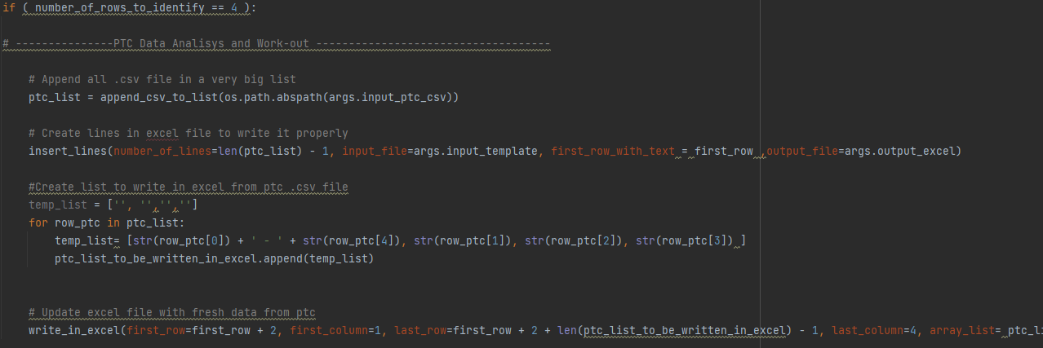

* modify the excel file if the number of rows to be identified is not four, and update the excel file with data from the ptc file;

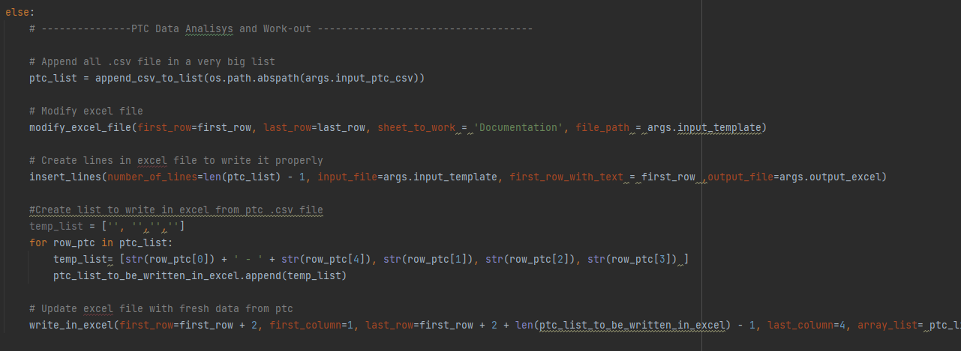

* append all .csv files and .xlsx files in two different lists; update excel list with new data from .csv list; write the new excel list back in excel

