Git Mastery: Complete 30-Day Learning Path
Beginner to Advanced • DevOps / SRE / EDA Infrastructure Focus
Daily practice: 1–2 hours

Day 1 — Introduction and Installation
What is Git?
Ans: Git is a distributed version control system used to track changes in files and source code over time.
In simple words:
Git helps you save the history of your work, compare changes, go back to previous versions, and work safely with other developers.

Main benefits of Git
- Tracks every change
- Maintains version history
- Lets you create branches for new features
- Allows multiple people to work on the same project
- Helps resolve and merge changes
- Lets you recover previous versions
- Supports professional workflows such as Pull Requests and Code Reviews
Your Files
↓
git add
↓
Staging Area
↓
git commit
↓
Local Git Repository
↓
git push
↓
GitHub / GitLab / Remote Repository
Git ≠ GitHub
- Git → Version control system installed on your computer.
- GitHub/GitLab → Platforms that host Git repositories remotely.
For your learning path, the next important topic is:
Working Directory → Staging Area → Local Repository → Remote Repository

Git vs GitHub/GitLab
Ans:

Git vs GitHub vs GitLab
These three are related, but they are not the same thing.
Git | GitHub | GitLab
Version control system | Online platform for Git repositories | Online platform for Git repositories
Runs on your computer | Hosts repositories remotely | Hosts repositories remotely
Tracks file changes | Collaboration and code hosting | Collaboration, code hosting and DevOps
Created/used through Git commands | Provides web UI | Provides web UI and CI/CD
Can work without internet | Usually uses internet/remote access | Usually uses internet/remote access
Simple architecture
Git
(on your computer)
|
| git push
↓
┌─────────────────────────┐
│ │
↓ ↓
GitHub GitLab
Remote Git hosting Remote Git hosting

1. Git
Git is the actual version control tool.
You work locally using commands such as:
git init
git add .
git commit -m "Added backup script"
git branch
git merge
Git tracks the history of your files.

2. GitHub
GitHub is a platform where you can store Git repositories online and collaborate with others.
Typical workflow:
Your Laptop
│
│ Git
↓
Local Repository
│
│ git push
↓
GitHub Repository
│
├── Pull Request
├── Code Review
├── Actions / CI/CD
└── Issues

3. GitLab
GitLab provides similar Git repository hosting and collaboration, with strong built-in DevOps and CI/CD capabilities.
Developer
↓
Git
↓
GitLab
↓
GitLab CI/CD Pipeline
↓
Build → Test → Deploy

A typical DevOps workflow might be:

Developer changes code
↓
git add
↓
git commit
↓
git push
↓
GitHub / GitLab
↓
Pull Request / Merge Request
↓
Code Review
↓
Merge
↓
CI/CD Pipeline
↓
Deployment

Easy way to remember
Git = the engine
GitHub/GitLab = online platforms built around Git

Example
You create a Bash script:
license_check.sh
git add license_check.sh
git commit -m "Added license check script"
Then upload the repository:
git push

The remote destination could be GitHub or GitLab.
For your 30-day Git learning, remember:
First learn Git commands and concepts → then GitHub/GitLab collaboration → then CI/CD integration.

Repository, working directory, staging area, commit
Ans:
These are the four most important Git concepts. Understand this flow clearly:
Working Directory
│
│ git add
▼
Staging Area
│
│ git commit
▼
Local Repository

1. Repository
A repository (repo) is a project folder that Git tracks.
Example:
my-project/
│
├── backup.sh
├── README.md
└── config.txt

When you run:
git init

Git creates a hidden .git directory:

- my-project/
- │
- ├── .git/ ← Git stores history here
- ├── backup.sh
- ├── README.md
└── config.txt
Now my-project is a Git repository.

Simple meaning
Repository = Your project + its complete version history

2. Working Directory
The working directory is where you actually create and edit files.
Example:
my-project/
│
├── backup.sh
└── README.md

Suppose backup.sh contains:

echo "Backup started"

You modify it:

echo "Backup started"
echo "Backup completed"

This change exists in your Working Directory.
Git can show that the file changed:
git status

Example:

modified: backup.sh

At this point, Git knows the file changed, but the change is not yet prepared for a commit.

3. Staging Area
The staging area is like a preparation area before creating a commit.
Suppose you changed three files:
backup.sh ← changed
healthcheck.sh ← changed
README.md ← changed

But you only want to commit backup.sh.
Run:
git add backup.sh
Now:
Working Directory

healthcheck.sh ← modified but NOT staged
README.md ← modified but NOT staged

git add backup.sh
↓

Staging Area

backup.sh ← ready for commit

Simple meaning
Staging Area = Select exactly which changes you want to save in the next commit.
You can stage everything:
git add .
Or only one file:
git add backup.sh

4. Commit
A commit is a saved snapshot of your staged changes in Git history.
After staging:
git add backup.sh
Create a commit:
git commit -m "Added backup completion message"
Now Git permanently records that version:
Commit History

Commit 1
Initial backup script
↓
Commit 2
Added error handling
↓
Commit 3
Added backup completion message

Each commit has a unique ID, for example:
a7b3c92
You can view history using:
git log

Complete example
Let's see the complete process.

Step 1: Create a project

mkdir git-demo
cd git-demo

git init

Now you have a repository.
Step 2: Create a file
echo "Hello Git" > file.txt
The file is in the Working Directory.
Check:
git status
You may see:
Untracked files:
file.txt

Step 3: Add to staging area
git add file.txt
Now:
Working Directory
│
│ git add
▼
Staging Area
file.txt is ready

Check:
git status
You may see:
Changes to be committed:
new file: file.txt

Step 4: Create a commit
git commit -m "Added file.txt"
Now:
Working Directory
│
│ git add
▼
Staging Area
│
│ git commit
▼
Local Repository

Your change is now saved in Git history.

Easy real-life example
Think of writing an exam:
Git Concept | Real-life Example
Working Directory | You are writing answers
Staging Area | You select the final answers you want to submit
Commit | You submit the answers
Repository | Stores all submitted versions/history

One-line memory trick
Repository = Project history
Working Directory = Where you work
Staging Area = What you select to save
Commit = Saved version/snapshot

Local vs remote repository
Ans:

Local Repository vs Remote Repository
The main difference is where your Git project is stored.
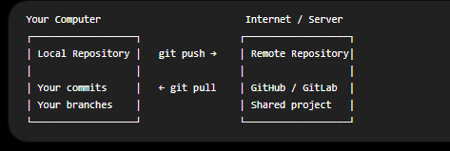

1. Local Repository
A local repository exists on your own computer.
Example:
mkdir git-demo
cd git-demo
git init
After git init, Git creates a repository locally:
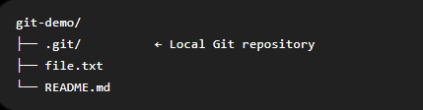
You can work without the internet:
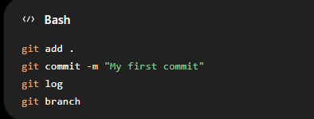
Everything is stored on your computer.
Local repository = Your personal copy of the project and its Git history.

2. Remote Repository
A remote repository is a copy of your Git repository stored on a remote server.
Examples:
- GitHub
- GitLab
- Bitbucket
- Company Git server
Example:
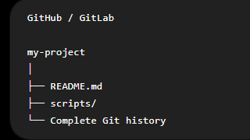
A remote repository allows:
- Backup of your code
- Team collaboration
- Sharing code
- Pull requests / merge requests
- CI/CD integration

Complete Workflow
Suppose you create a project on your laptop.

Step 1: Local repository
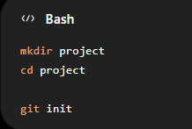
Create and commit a file:
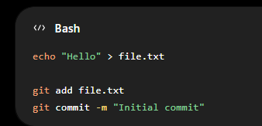
Now the commit exists only in your local repository.
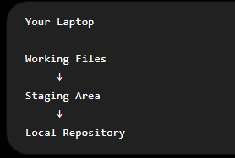

Step 2: Connect to a remote repository
For example, after creating an empty repository on GitHub or GitLab:
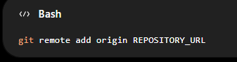
Check it:
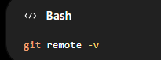
Here, origin is simply a common name given to your remote repository.

Step 3: Push local commits to remote
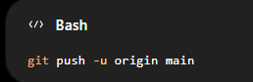
Now:
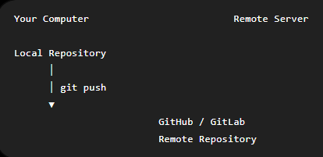

When another developer makes changes
Suppose your teammate updates the remote repository.
You can download and integrate those changes:
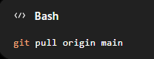
Flow:
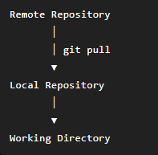

Important Commands
Command | Purpose
git init | Create a local repository
git clone URL | Copy a remote repository to your computer
git remote -v | View remote repositories
git remote add origin URL | Connect local repo to remote
git push | Send local commits to remote
git pull | Get and integrate remote changes
git fetch | Download remote changes without automatically merging

Easy way to remember
Local Repository = Your computer
Remote Repository = Shared/server copy
The next important concept is git clone vs git init, because these are two common ways to start working with a Git repository.

Commands / Practice:
git --version
git config --global user.name "Your Name"
git config --global user.email "your@email.com"
git config --list

Day 2 — Create Your First Repository
- Learn git init, status, add, commit and log
Commands / Practice:
mkdir git-lab
cd git-lab
git init
echo "Hello Git" > file.txt
git add file.txt
git commit -m "Initial commit"
git log

Day 3 — Working Directory and Staging Area
- Understand unstaged and staged changes
- Practice git diff and git diff --staged
Commands / Practice:
echo "Line 2" >> file.txt
git status
git diff
git add file.txt
git diff --staged
git commit -m "Add second line"

Day 4 — Add, Remove and Rename Files
- Practice adding, deleting and renaming tracked files
Commands / Practice:
touch app.py
git add app.py
git commit -m "Add application file"
git mv app.py main.py
git commit -am "Rename app file"
git rm main.py

Day 5 — Commit History
- Understand HEAD, commit IDs, parent commits and history
Commands / Practice:
git log
git log --oneline
git log --graph
git show HEAD

Day 6 — Undo Changes
- Understand git restore, git reset and git revert
- Know working directory vs staging vs commit history
Commands / Practice:
git restore file.txt
git reset HEAD file.txt

Day 7 — Week 1 Challenge
- Create README.md, scripts/backup.sh, scripts/healthcheck.sh and config/app.conf
- Make 5 commits, modify files, view diffs and undo an uncommitted change

Day 8 — Branch Basics
- Create, list and switch branches
Commands / Practice:
git branch
git branch branch-name
git switch branch-name
git switch -c feature/login

Day 9 — Merge Branches
- Understand fast-forward and three-way merge
Commands / Practice:
git switch main
git merge feature/login

Day 10 — Merge Conflicts
- Intentionally modify the same line on two branches
- Resolve conflict markers and commit
- Practice at least 5 conflicts
Commands / Practice:
git merge branch-name
git add file.txt
git commit

Day 11 — Delete and Manage Branches
- Manage local and remote branches
Commands / Practice:
git branch -d branch-name
git branch -D branch-name
git branch -a
git branch -r

Day 12 — Git Stash
- Save work in progress and restore it later
Commands / Practice:
git stash
git stash push -m "WIP changes"
git stash list
git stash apply
git stash pop
git stash drop

Day 13 — Remote Repositories
- Connect local repository to remote
- Understand push, pull and fetch
Commands / Practice:
git remote -v
git remote add origin REPOSITORY_URL
git push
git pull
git fetch

Day 14 — Week 2 Project
- Create main plus feature/monitoring, feature/backup and feature/terraform
- Merge, create conflicts, resolve, delete merged branches and push

Day 15 — Git Reset
- Master --soft, --mixed and --hard
- Practice only in a test repository
Commands / Practice:
git reset --soft COMMIT
git reset --mixed COMMIT
git reset --hard COMMIT

Day 16 — Git Revert
- Safely reverse a committed change by creating a new commit
Commands / Practice:
git revert COMMIT_ID

Day 17 — Git Rebase
- Rebase feature onto main
- Resolve conflicts and use continue, abort and skip
Commands / Practice:
git switch feature
git rebase main
git add .
git rebase --continue
git rebase --abort
git rebase --skip

Day 18 — Interactive Rebase
- Practice pick, reword, edit, squash, fixup and drop
- Turn 5 messy commits into 1 clean commit
Commands / Practice:
git rebase -i HEAD~5

Day 19 — Cherry-Pick
- Move a useful commit between branches
- Practice conflict resolution
Commands / Practice:
git log --oneline
git cherry-pick COMMIT_ID
git cherry-pick --continue

Day 20 — Tags and Releases
- Create lightweight and annotated tags
- Mark releases
Commands / Practice:
git tag
git tag v1.0
git tag -a v1.0 -m "Release version 1.0"
git push origin v1.0

Day 21 — Week 3 Challenge
- Create feature/terraform, feature/monitoring and hotfix/license
- Rebase, squash, cherry-pick, revert and create v1.0

Day 22 — .gitignore
- Ignore logs, temporary files, .env, Terraform-generated files
- Never commit secrets
Commands / Practice:
git status
git check-ignore filename

Day 23 — Git Hooks
- Learn pre-commit, pre-push and commit-msg hooks
- Practice validation and tests
Commands / Practice:
.git/hooks/pre-commit

Day 24 — Professional Git Workflows
- Feature Branch Workflow
- GitFlow: main, develop, feature/*, release/*, hotfix/*
- Trunk-Based Development

Day 25 — Pull Requests and Code Review
- Branch → change → commit → push → PR → review → merge
- Learn merge commit, squash merge and rebase merge

Day 26 — Git Troubleshooting
- Recover files
- Amend commit messages
- Move wrong-branch commits
- Recover lost commits
Commands / Practice:
git restore file.txt
git commit --amend -m "Correct message"
git cherry-pick COMMIT_ID
git reflog
git switch -c recovery COMMIT_ID

Day 27 — Git Internals
- Understand Blob, Tree, Commit, HEAD, Refs and Objects
- Explore .git
Commands / Practice:
git cat-file -p HEAD
git ls-tree HEAD
git rev-parse HEAD

Day 28 — Git Security
- Do not commit secrets
- Understand protected branches, SSH and personal access tokens
Commands / Practice:
ssh-keygen
ssh -T git@github.com

Day 29 — Final DevOps / EDA Infrastructure Project
- Build a realistic repository with scripts, Ansible, Terraform and monitoring
- Use branches, rebase, stash, cherry-pick, tags, .gitignore and hooks

Day 30 — Git Master Challenge
- Create feature/license-monitoring, feature/hpc-monitoring, feature/log-parser and hotfix/license-server
- Resolve conflicts, rebase, squash, cherry-pick, recover with reflog, revert and tag v1.0
Commands / Practice:
git reflog
git tag -a v1.0 -m "EDA Infrastructure v1.0"

Final Project — EDA Infrastructure Git Portfolio

Project Structure
eda-infrastructure/
├── README.md
├── .gitignore
├── scripts/
│ ├── healthcheck.sh
│ ├── license_check.sh
│ └── log_parser.py
├── ansible/
│ └── playbook.yml
├── terraform/
│ └── main.tf
└── monitoring/
└── prometheus.yml

Objective
Create a realistic infrastructure repository demonstrating professional Git usage together with automation relevant to DevOps/SRE and EDA infrastructure.

Required Branches
- main
- feature/license-monitoring
- feature/hpc-monitoring
- feature/log-parser
- hotfix/license-server

Final Project Tasks
- Initialize repository and create README.md.
- Create .gitignore for logs, temporary files, environment files and Terraform-generated files.
- Add a license check script on feature/license-monitoring.
- Add HPC monitoring content on feature/hpc-monitoring.
- Add a Python log parser on feature/log-parser.
- Make multiple small commits on each branch.
- Create and resolve at least one merge conflict.
- Rebase one feature branch onto latest main.
- Use interactive rebase to squash several commits.
- Use git stash and restore unfinished work.
- Create hotfix/license-server and cherry-pick the hotfix.
- Revert one intentionally bad commit.
- Use git reflog to recover a commit in a practice scenario.
- Create annotated tag v1.0.
- Push to remote and simulate pull-request/code-review workflow.

Final Validation Checklist
☐ Clean readable history
☐ Feature branches merged or documented
☐ Merge conflict resolved
☐ Rebase and interactive rebase completed
☐ Cherry-pick, stash, revert and reflog demonstrated
☐ No secrets committed
☐ Annotated v1.0 tag exists
☐ README explains the project

30-Day Completion Outcome
You should be comfortable with repositories, commits, branches, merges, conflicts, remotes, stash, reset, revert, rebase, interactive rebase, cherry-pick, tags, pull-request workflows, hooks, troubleshooting, Git internals and security basics.

