**Assignment on Agile Principles**

**Question 1: Agile Principles**

**Git link: https://github.com/anarayana04/git_assignment_HeroVired/tree/main/Agile-Assignement**

1.1 Explain the core principles of agile methodology. How do these principles emphasize adaptability and customer collaboration?

Agile methodology is a set of principles and practices for software development that prioritize flexibility, collaboration, and customer satisfaction. The core principles of Agile are outlined in the Agile Manifesto, which was developed by a group of software developers in 2001. The Agile Manifesto consists of four key values and 12 principles that guide agile development. Here are the core principles that emphasize adaptability and customer collaboration:

1. **Individuals and interactions over processes and tools:**

Agile places a strong emphasis on the importance of people working together effectively. It values communication and collaboration among team members and recognizes that human interactions are often more valuable than relying solely on processes and tools.

1. **Working software over comprehensive documentation:**

Agile values delivering a functional product over extensive documentation. While documentation is important, the primary focus is on creating software that works and meets customer needs. This principle encourages teams to prioritize coding and testing over exhaustive documentation.

1. **Customer collaboration over contract negotiation:**

Agile recognizes the importance of involving customers throughout the development process. It prioritizes collaboration with customers to understand their needs, gather feedback, and make adjustments accordingly. This helps ensure that the delivered product aligns closely with customer expectations.

1. **Responding to change over following a plan:**

One of the key principles of Agile is adaptability. Agile teams are encouraged to respond to changing requirements and priorities, even late in the development process. This flexibility allows teams to adjust their approach based on feedback and evolving customer needs.

1. **Welcome changing requirements, even late in development:**

This principle emphasizes the Agile mindset of embracing change. Rather than resisting changes to requirements, Agile teams are open to adapting their plans to accommodate evolving customer needs. This flexibility is critical in environments where requirements may not be fully known or may change over time.

1. **Deliver working software frequently, with a preference for shorter timescales:**

Agile promotes the idea of delivering small, incremental improvements to the software regularly. This iterative approach allows teams to receive feedback more frequently, respond to changes faster, and deliver value to the customer in shorter cycles.

1. **Continuous attention to technical excellence and good design:**

Agile encourages a focus on maintaining high standards of technical excellence and good design practices. This ensures that the software remains maintainable, scalable, and adaptable to changing requirements over time.

By adhering to these principles, agile methodologies create an environment where teams can quickly respond to changes, collaborate closely with customers, and deliver software that better meets customer expectations. The iterative and flexible nature of agile methodologies enables continuous improvement and optimization throughout the development process.

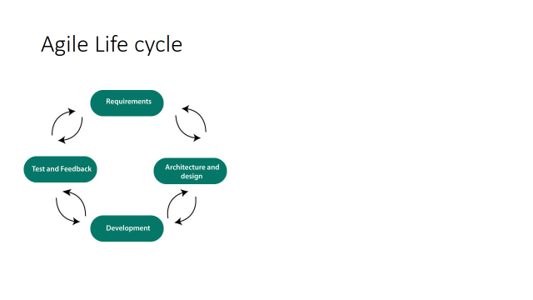

* 1. Describe how Agile principles align with the DevOps philosophy. Provide specific examples of how Agile principles can contribute to faster delivery cycles and improved software quality in a DevOps environment. Agile principles and DevOps philosophy share common goals of accelerating software delivery, enhancing collaboration, and improving overall product quality. Here are some key ways in which Agile principles align with the DevOps philosophy?

Agile principles and DevOps philosophy share common goals of accelerating software delivery, enhancing collaboration, and improving overall product quality. Here are some key ways in which Agile principles align with the DevOps philosophy:

1. **Iterative Development:**

Agile: Agile promotes iterative development with short, time-boxed cycles known as sprints. This allows for frequent releases of usable software increments.

DevOps: DevOps emphasizes continuous integration and continuous delivery (CI/CD). This aligns with Agile's iterative approach, enabling the delivery of small, incremental changes to production frequently.

1. **Cross-Functional Teams:**

Agile: Agile teams are cross-functional, consisting of members with different skills necessary to deliver a complete product.

DevOps: DevOps encourages collaboration between development and operations teams, breaking down silos. This aligns with Agile's emphasis on cross-functional teams, ensuring that the entire delivery process is streamlined and efficient.

1. **Customer Feedback:**

**Agile:** Agile values customer feedback and incorporates it through regular reviews and adjustments during development cycles.

**DevOps:** DevOps integrates feedback loops throughout the entire development and deployment pipeline. This ensures that any issues identified in production can be fed back into development for quick resolution.

1. **Adaptability and Flexibility:**

**Agile:** Agile principles emphasize adapting to change and responding to customer needs quickly.

**DevOps:** DevOps is built on the idea of adapting to changes efficiently, ensuring that the software delivery pipeline can adjust to evolving requirements without causing delays.

1. **Automation:**

Agile: Agile teams often use automated testing and build processes to ensure the quality of each iteration.

**DevOps:** DevOps promotes extensive automation, especially in the areas of testing, deployment, and infrastructure provisioning. This automation aligns with Agile's goal of maintaining a consistent and reliable development and delivery process.

1. **Continuous Improvement:**

**Agile:** Agile incorporates regular retrospectives to identify areas for improvement in the development process.

**DevOps:** DevOps promotes a culture of continuous improvement, where teams analyze metrics and feedback to enhance processes over time. This aligns with Agile's focus on inspecting and adapting processes for better outcomes.

1. **Collaborative Culture:**

**Agile:** Agile fosters a collaborative culture with open communication and shared responsibility.

**DevOps:** DevOps emphasizes collaboration between development, operations, and other stakeholders. This shared responsibility ensures that everyone works towards a common goal of delivering high-quality software efficiently.

By incorporating agile principles into a DevOps environment, teams can experience faster delivery cycles, increased collaboration, and improved software quality. The iterative nature of Agile aligns well with the continuous delivery aspect of DevOps, resulting in a more streamlined and efficient software development lifecycle.

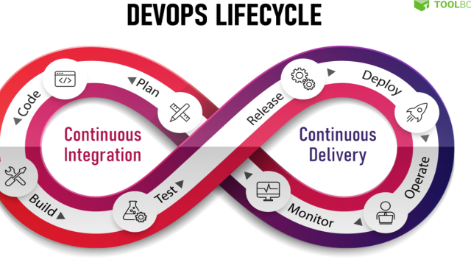

**Question 2: Agile Practices in DevOps**

2.1 Explore the concept of "Scrum" as an Agile framework. Highlight the roles, ceremonies, and artifacts involved in Scrum. Explain how Scrum can synergize with DevOps practices to facilitate continuous integration and continuous delivery (CI/CD)?

**Scrum as an Agile Framework:**

Scrum is a popular Agile framework designed to facilitate the iterative and incremental development of complex projects. It emphasizes flexibility, adaptability, and collaboration among team members to deliver high-quality products. Scrum is widely used in software development but can be applied to various domains.

**Key Components of Scrum:**

1. **Roles:**

Product Owner: Represents the stakeholders and ensures that the team delivers value to the business. They prioritize the product backlog and make decisions on what features to include.

**Scrum Master:** Facilitates the Scrum process, removes impediments, and ensures the team adheres to Scrum practices. They act as a servant-leader to support the team.

**Development Team:** A cross-functional, self-organizing group responsible for delivering the potentially shippable product increment at the end of each sprint.

2. **Ceremonies:**

**Sprint Planning:** The team plans the work for the upcoming sprint, deciding which items from the product backlog to include and how to achieve them.

**Daily Standup (Daily Scrum):** A short daily meeting where team members share progress, discuss obstacles, and plan for the next 24 hours.

**Sprint Review:** At the end of each sprint, the team demonstrates the completed work to stakeholders and receives feedback.

**Sprint Retrospective:** A reflective meeting for the team to discuss what went well, what didn't, and how to improve in the next sprint.

3. **Artifacts:**

**Product Backlog:** A prioritized list of features, enhancements, and bug fixes. Managed by the Product Owner.

**Sprint Backlog:** The subset of the product backlog that the team commits to completing during a specific sprint.

**Increment:** The sum of all completed product backlog items at the end of a sprint. It should be potentially shippable.

**Synergy with DevOps Practices:**

Scrum and DevOps are complementary and can work together to enhance the development and delivery process:

1. **Continuous Integration (CI):**

Scrum promotes frequent, small releases at the end of each sprint, aligning with the CI principle of integrating code changes regularly.

Automated testing, a common DevOps practice, ensures that each increment is of high quality and ready for release.

2. **Continuous Delivery (CD):**

Scrum's focus on delivering a potentially shippable product increment at the end of each sprint aligns with the CD principle of having a product always in a deployable state.

The sprint review provides an opportunity for stakeholders to evaluate the product increment, contributing to the continuous feedback loop.

3. **Collaboration:**

DevOps emphasizes collaboration between development and operations teams. Scrum's cross-functional teams, including members from both domains, naturally support this collaboration.

4. **Automation:**

DevOps encourages the automation of repetitive tasks. Scrum teams can leverage automation for testing, deployment, and other processes to enhance efficiency and reliability.

In summary, Scrum and DevOps share common principles of collaboration, continuous improvement, and delivering value to the customer. Integrating Scrum with DevOps practices can lead to a more streamlined and efficient development process, facilitating faster and more reliable delivery of high-quality products.

2.2 Kanban is another Agile approach that is often integrated into DevOps workflows. Define Kanban and discuss how its visual management principles can enhance collaboration between development and operations teams. Provide a step-by-step scenario of how Kanban can be used to streamline the release process in a DevOps context?

**Kanban Overview:**

Kanban is an Agile framework that originated from manufacturing practices in Japan and was later applied to software development. It focuses on visualizing work, limiting work in progress, and maximizing flow to improve efficiency and reduce bottlenecks. In a Kanban system, work items are represented as cards on a visual board, typically divided into columns representing different stages of the workflow.

**Visual Management Principles in Kanban:**

The visual management principles of Kanban provide a clear and transparent way to understand the status of work at any given time. This is crucial for enhancing collaboration between development and operations teams by creating a shared understanding of the workflow, priorities, and potential issues.

1. **Visualization:**

Create a Kanban board with columns representing different stages of your development and operations process.

Use cards to represent work items (features, tasks, user stories) and place them in the appropriate columns.

1. **Work in Progress (WIP) Limits:**

Set WIP limits for each column to prevent overloading teams and to ensure a steady flow of work.

Define WIP limits collaboratively to balance the workload and avoid bottlenecks.

1. **Flow:**

Monitor the flow of work across the board.

Identify and address any slowdowns or impediments to maintain a smooth workflow.

**Scenario: Streamlining the Release Process in a DevOps Context:**

Let's consider a scenario where Kanban is used to streamline the release process in a DevOps environment.

1. **Backlog:**

Start with a backlog column that includes all the features, tasks, and user stories that need to be addressed in the release.

Collaboratively prioritize the backlog items.

1. **To-Do:**

Move prioritized items to the "To-Do" column.

Development and operations teams collaborate on defining and estimating the tasks.

1. **In Progress:**

When a team member starts working on a task, move the corresponding card to the "In Progress" column.

WIP limits ensure that the team doesn't take on too much work at once.

1. **Testing:**

Once development is complete, move the card to the "Testing" column.

Operations and development teams collaborate to ensure that the release meets quality standards.

1. **Deployment:**

After successful testing, move the card to the "Deployment" column.

Collaborate on the deployment process, ensuring smooth transitions between development and operations.

1. **Done:**

When the release is successfully deployed and validated in the production environment, move the card to the "Done" column.

Conduct a retrospective to identify areas for improvement in the next release.

**Benefits:**

Transparency: All teams have a clear view of the status of each work item.

Collaboration: Teams collaborate at each stage, addressing issues and ensuring a shared understanding of the process.

Continuous Improvement: Regular retrospectives enable teams to reflect on their performance and make improvements.

By implementing Kanban in this way, the release process becomes more predictable, collaborative, and adaptable, ultimately contributing to the success of a DevOps culture.

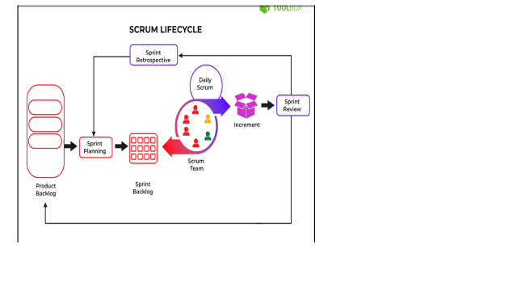

**Question 3: User Stories and Backlog Refinement**

3.1 Elaborate on the concept of "user stories" in Agile. How do user stories help bridge communication gaps between developers and stakeholders? How can user stories be utilized to prioritize tasks in a DevOps pipeline?

User stories are a fundamental concept in Agile software development, serving as a lightweight, user-centric method for expressing requirements. They are typically short, simple descriptions of a feature told from the perspective of the end user. The format of a user story is often:

"As a [type of user], I want [an action] so that [benefit/value]."

Let's break down how user stories contribute to bridging communication gaps between developers and stakeholders and how they can be utilized in prioritizing tasks in a DevOps pipeline:

1. **User-Centric Focus:**

User stories place emphasis on the end user's needs and expectations. This helps align development efforts with the overall goal of delivering value to users.

By framing requirements in terms of user needs, developers gain a better understanding of the context and purpose of the features they are building.

1. **Facilitating Communication:**

User stories facilitate communication between stakeholders and development teams. They provide a common language for discussing features and functionalities.

Stakeholders, including non-technical individuals, can easily comprehend and contribute to the development process by expressing their requirements in the form of user stories.

1. **Collaboration and Engagement:**

Writing and discussing user stories often involves collaboration between developers, product owners, and other stakeholders. This collaborative process fosters shared understanding and alignment on project goals.

The iterative nature of Agile development allows for continuous feedback and refinement of user stories, ensuring that the product evolves to meet changing needs.

1. **Prioritization:**

User stories are typically maintained in a product backlog, a dynamic list of features and enhancements. The prioritization of user stories is often based on business value, risk, or other relevant factors.

In a DevOps pipeline, user stories can be utilized to prioritize tasks by assigning higher priority to stories that deliver significant business value or address critical needs.

1. **Integration with DevOps:**

User stories are essential in the planning phase of a DevOps pipeline. They help determine which features or changes should be prioritized for development and deployment.

Prioritized user stories guide the creation of tasks and user acceptance criteria, ensuring that the development and deployment process aligns with the most critical business objectives.

1. **Traceability:**

User stories create traceability between end-user requirements and the delivered product. This traceability helps in tracking progress and ensuring that each developed feature contributes to the overall project goals.

In summary, user stories serve as a powerful tool in Agile development by focusing on user needs, fostering communication, promoting collaboration, aiding in prioritization, and facilitating the integration of development and operations activities in a DevOps pipeline. They are a key element in creating a shared understanding and a streamlined development process.

3.2 Explain the importance of backlog refinement in Agile methodology. Detail the activities involved in backlog refinement and how it contributes to effective sprint planning and execution in a DevOps environment?

Backlog refinement, also known as backlog grooming or backlog prioritization, is a crucial aspect of Agile methodology, particularly in the context of DevOps. It involves regularly reviewing and updating the product backlog to ensure that it is well-defined, prioritized, and ready for implementation. The primary goal is to improve the overall efficiency and effectiveness of the development process. Here's an explanation of the importance of backlog refinement and the activities involved:

**Importance of Backlog Refinement:**

1. **Enhances Clarity and Understanding:**

Refinement helps in breaking down user stories into smaller, more manageable tasks, making it easier for the development team to understand and estimate the work involved.

1. **Prioritization and Optimization:**

The backlog is prioritized based on business value, dependencies, and urgency. This ensures that the most valuable and critical features are addressed first, maximizing the return on investment.

1. **Adaptability to Change:**

Backlog refinement allows teams to adapt to changing requirements and priorities, ensuring that the backlog remains flexible and aligned with the evolving needs of the project.

1. **Efficient Sprint Planning:**

A well-refined backlog provides a solid foundation for sprint planning. It enables the team to select the most valuable items for the upcoming sprint, considering their dependencies, complexity, and business impact.

1. **Reduced Uncertainty:**

By breaking down user stories and defining acceptance criteria during backlog refinement, uncertainties are minimized, leading to more accurate estimation and planning.

1. **Continuous Improvement:**

Regularly revisiting and refining the backlog promotes a culture of continuous improvement. The team can learn from previous sprints and adjust the backlog based on retrospective insights.

**Activities Involved in Backlog Refinement:**

1. **Story Detailing:**

Elaborating user stories with detailed acceptance criteria, mockups, or wireframes to provide a clear understanding of what needs to be implemented.

1. **Estimation:**

Estimating the effort required for each backlog item using techniques like story points or time estimation. This helps in planning and prioritization.

1. **Prioritization:**

Reviewing and adjusting the priority of backlog items based on business value, dependencies, and stakeholder feedback.

1. **Dependency Management:**

Identifying and managing dependencies between backlog items to ensure that the team can work on them in a logical and efficient sequence.

1. **Refinement Meetings:**

Regular meetings, such as backlog refinement sessions, where the team collaboratively discusses and refines backlog items with the product owner and stakeholders.

**Contribution to Effective Sprint Planning and Execution in DevOps:**

1. **Streamlined Sprint Planning:**

A well-refined backlog allows for efficient sprint planning meetings, as the team can quickly select items that are well-defined and ready for implementation.

1. **Predictable Delivery:**

With a clear and prioritized backlog, the team can make more accurate commitments during sprint planning, leading to a more predictable and consistent delivery.

1. **Efficient DevOps Integration:**

DevOps practices emphasize collaboration and communication between development and operations teams. A well-refined backlog ensures that both teams have a clear understanding of upcoming features and can plan their work accordingly.

1. **Continuous Feedback Loop:**

Backlog refinement is an ongoing process that facilitates continuous feedback and collaboration between development, operations, and other stakeholders, fostering a DevOps culture of collaboration and transparency.

In summary, backlog refinement is an essential practice in Agile and DevOps environments that contributes to improved planning, adaptability, and overall efficiency in software development. It ensures that the team is working on the most valuable and well-defined tasks, leading to successful sprint planning and execution.

**Section 2:**

Question: Take any topic from Agile or a Topic that has been taught so far. Do a digging around the topic to find out something that is not taught in the class and make a video on that topic. The video needs to be uploaded to YouTube (either make it public or unlisted). The length of the video should be between 1 min to 5 min.

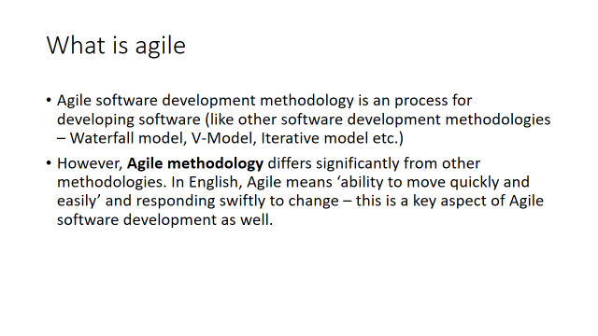







Video:

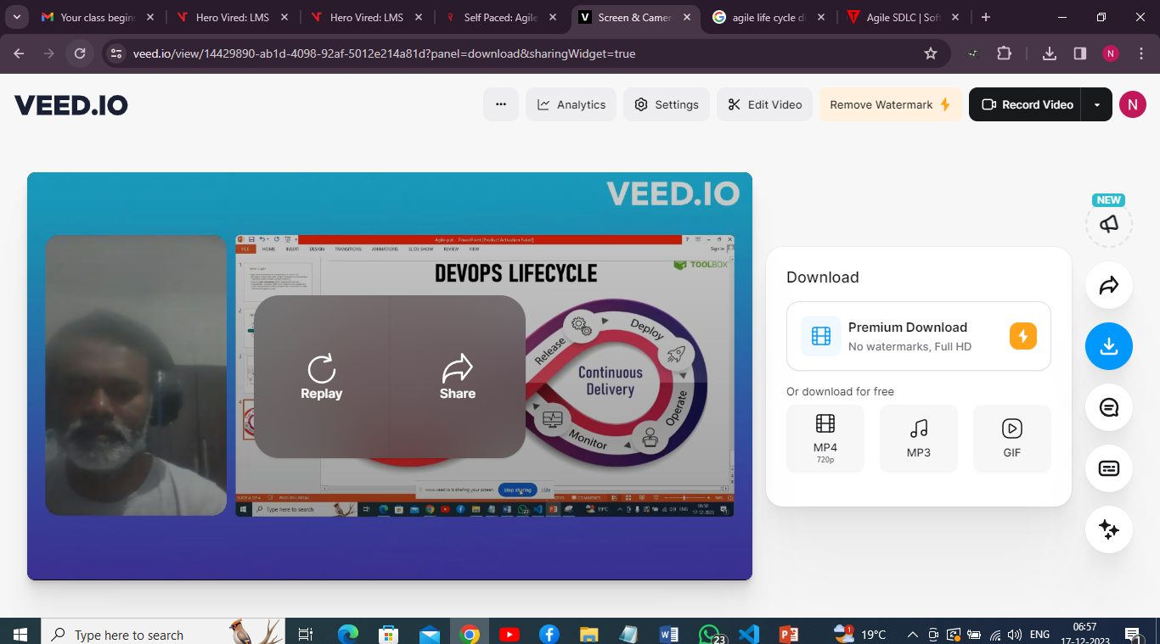

You tube link:

https://youtu.be/QYjmXJ-f8J8