Challenges assignment:

For user profile git link: <https://hvdevops.prashantdey.in/users/18>

Challenge1: Read File:

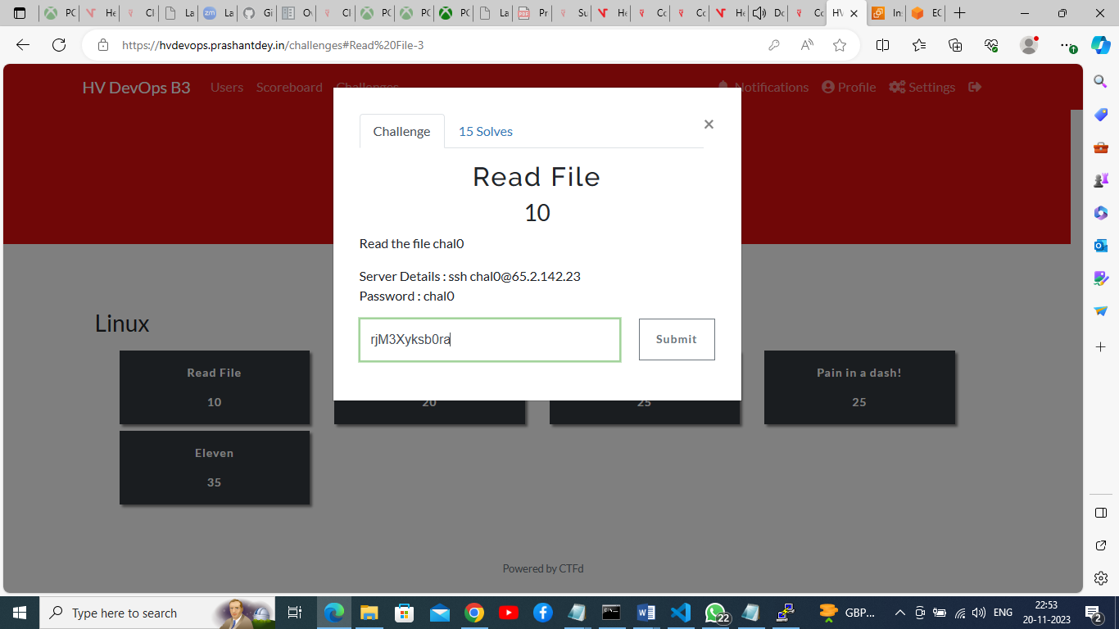

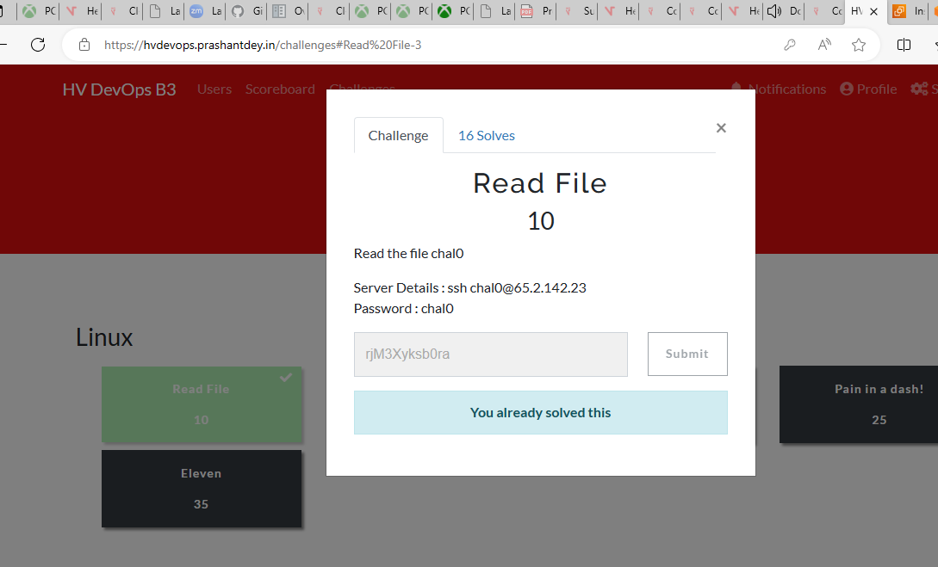

Challenge 1 completed.

## Challenge2: Hidden Files

ubuntu@ip-172-31-17-225:~$ ssh chal1@65.2.142.23

chal1@65.2.142.23's password:

Welcome to Ubuntu 22.04.1 LTS (GNU/Linux 5.15.0-1030-aws x86_64)

* Documentation: https://help.ubuntu.com

* Management: https://landscape.canonical.com

* Support: https://ubuntu.com/advantage

System information as of Mon Nov 20 17:34:03 UTC 2023

System load: 0.0 Processes: 107

Usage of /: 34.4% of 13.39GB Users logged in: 0

Memory usage: 37% IPv4 address for eth0: 172.31.2.227

Swap usage: 0%

88 updates can be applied immediately.

To see these additional updates run: apt list --upgradable

The list of available updates is more than a week old.

To check for new updates run: sudo apt update

Failed to connect to https://changelogs.ubuntu.com/meta-release-lts. Check your Internet connection or proxy settings

*** System restart required ***

Last login: Sun Nov 19 13:16:46 2023 from 167.103.2.89

$

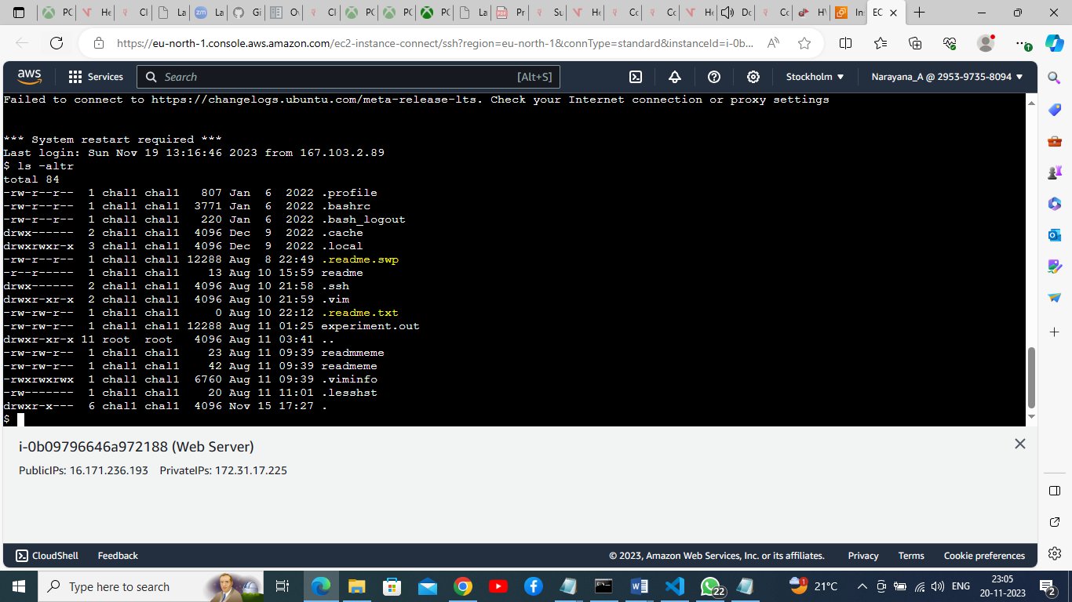

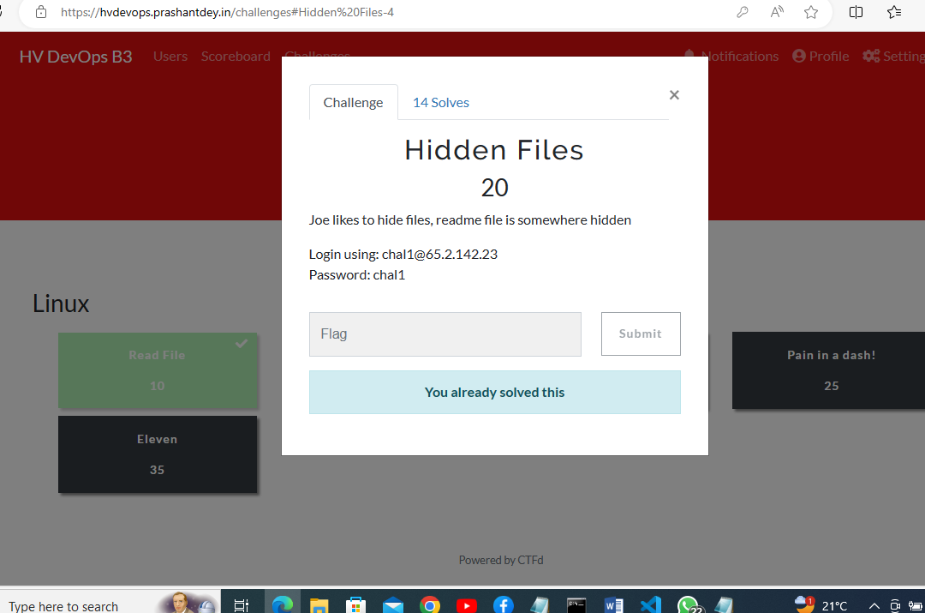

Challenge2 completed.

## Challenge3: Unique Flag

ubuntu@ip-172-31-17-225:~$ ssh chal2@65.2.142.23

chal2@65.2.142.23's password:

Welcome to Ubuntu 22.04.1 LTS (GNU/Linux 5.15.0-1030-aws x86_64)

* Documentation: https://help.ubuntu.com

* Management: https://landscape.canonical.com

* Support: https://ubuntu.com/advantage

System information as of Mon Nov 20 17:46:44 UTC 2023

System load: 0.0 Processes: 108

Usage of /: 34.4% of 13.39GB Users logged in: 0

Memory usage: 37% IPv4 address for eth0: 172.31.2.227

Swap usage: 0%

88 updates can be applied immediately.

To see these additional updates run: apt list --upgradable

The list of available updates is more than a week old.

To check for new updates run: sudo apt update

Failed to connect to https://changelogs.ubuntu.com/meta-release-lts. Check your Internet connection or proxy settings

*** System restart required ***

Last login: Sun Nov 19 16:01:07 2023 from 167.103.2.89

$

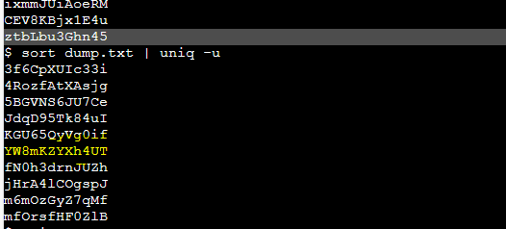

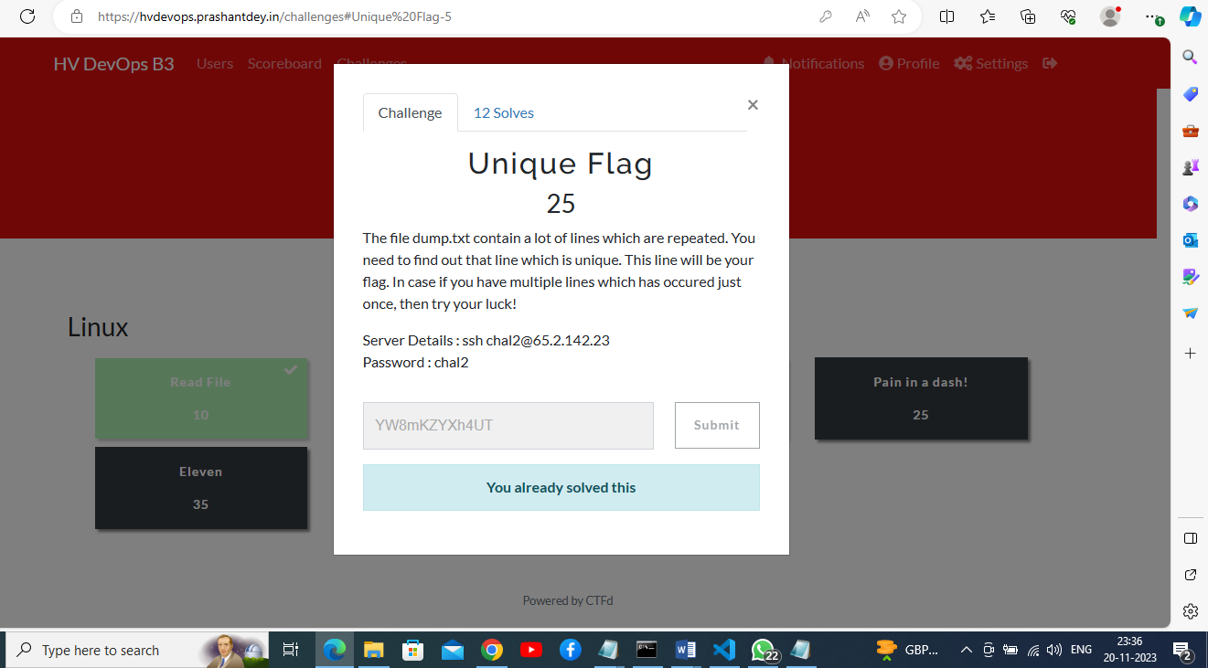

Challemge3 completed.

## Challenge4: Pain in a dash!

ubuntu@ip-172-31-17-225:~$ ssh chal4@65.2.142.23

chal4@65.2.142.23's password:

Welcome to Ubuntu 22.04.1 LTS (GNU/Linux 5.15.0-1030-aws x86_64)

* Documentation: https://help.ubuntu.com

* Management: https://landscape.canonical.com

* Support: https://ubuntu.com/advantage

System information as of Mon Nov 20 18:08:38 UTC 2023

System load: 0.0 Processes: 108

Usage of /: 34.4% of 13.39GB Users logged in: 0

Memory usage: 39% IPv4 address for eth0: 172.31.2.227

Swap usage: 0%

88 updates can be applied immediately.

To see these additional updates run: apt list --upgradable

The list of available updates is more than a week old.

To check for new updates run: sudo apt update

Failed to connect to https://changelogs.ubuntu.com/meta-release-lts. Check your Internet connection or proxy settings

*** System restart required ***

Last login: Mon Nov 20 17:56:29 2023 from 163.53.201.107

$

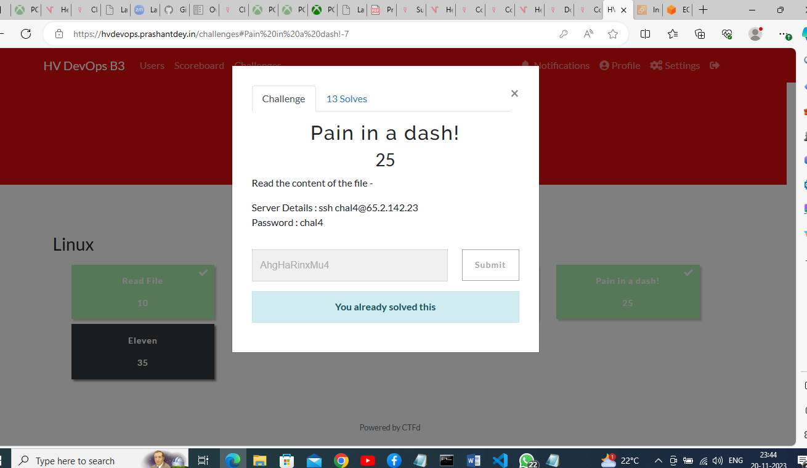

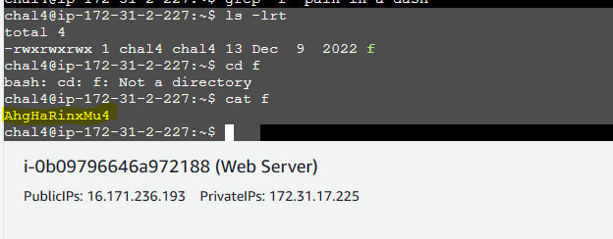

Challenge4 completed.

## Challenge5: Eleven

## 

ubuntu@ip-172-31-17-225:~$ ssh chal3@65.2.142.23

chal3@65.2.142.23's password:

Welcome to Ubuntu 22.04.1 LTS (GNU/Linux 5.15.0-1030-aws x86_64)

* Documentation: https://help.ubuntu.com

* Management: https://landscape.canonical.com

* Support: https://ubuntu.com/advantage

System information as of Mon Nov 20 18:17:31 UTC 2023

System load: 0.08447265625 Processes: 109

Usage of /: 34.4% of 13.39GB Users logged in: 0

Memory usage: 39% IPv4 address for eth0: 172.31.2.227

Swap usage: 0%

88 updates can be applied immediately.

To see these additional updates run: apt list --upgradable

The list of available updates is more than a week old.

To check for new updates run: sudo apt update

Failed to connect to https://changelogs.ubuntu.com/meta-release-lts. Check your Internet connection or proxy settings

*** System restart required ***

Last login: Mon Nov 20 17:57:43 2023 from 163.53.201.107

$

chal3@ip-172-31-2-227:~$ sort "masterdump.txt" | uniq -c | awk '$1 == 11 { print $2 }'

BuuHJWGCJNI3

chal3@ip-172-31-2-227:~$

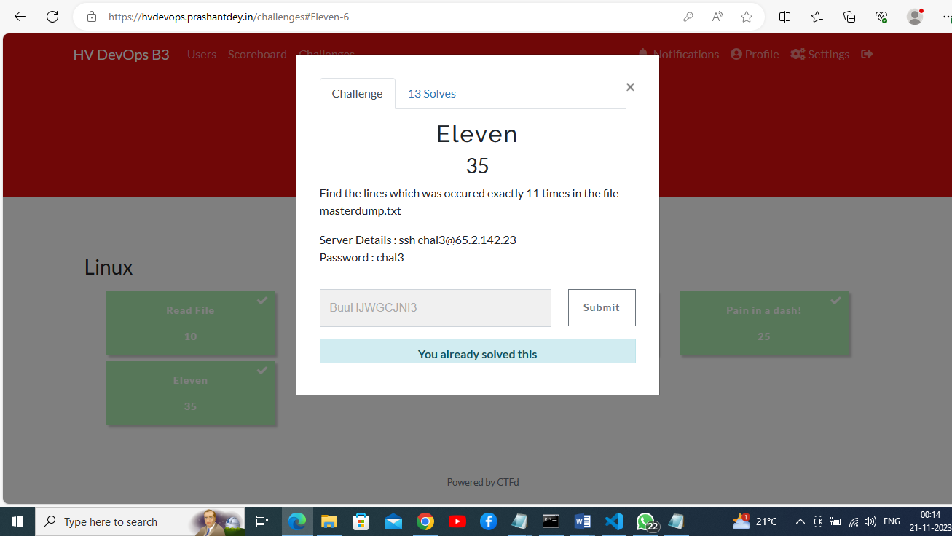

Challenge 5 completed.

All challengers are completed.

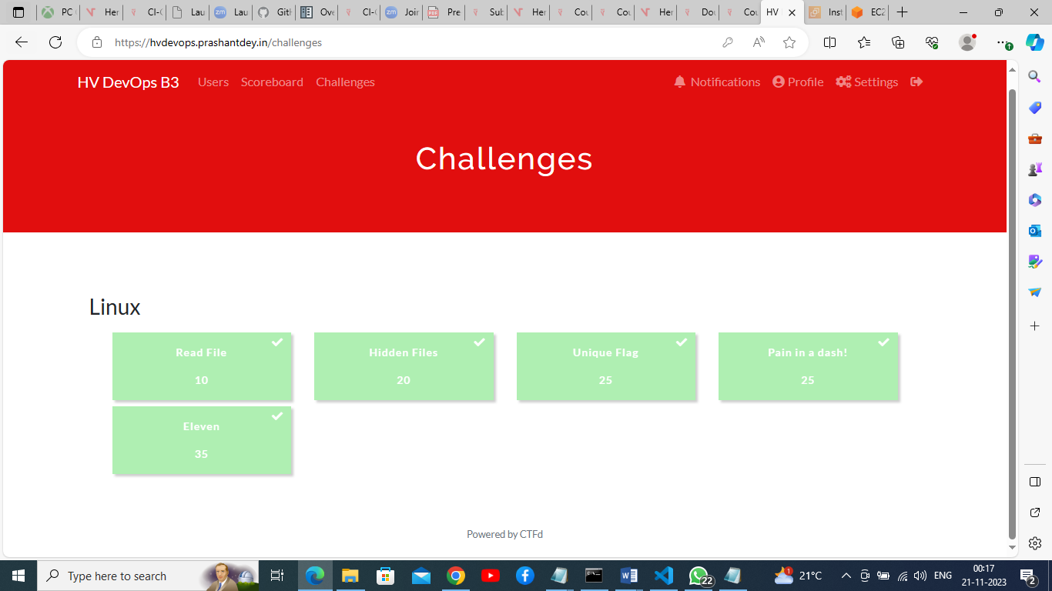

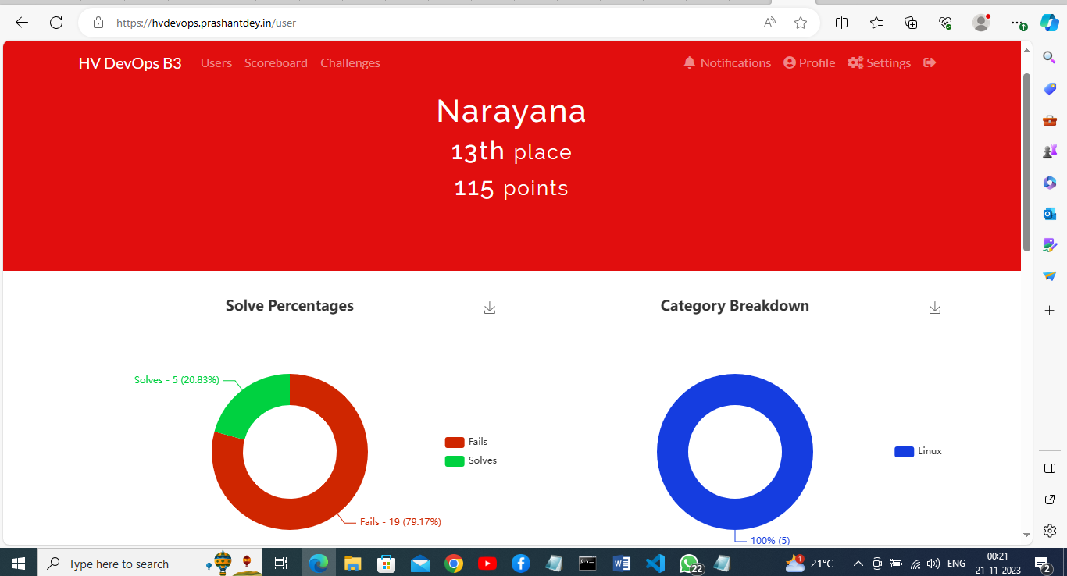

[HV DevOps B3 (prashantdey.in)](https://hvdevops.prashantdey.in/users/18)