Git Link:

In AWS frontend and backend instances created using EC2 instances.

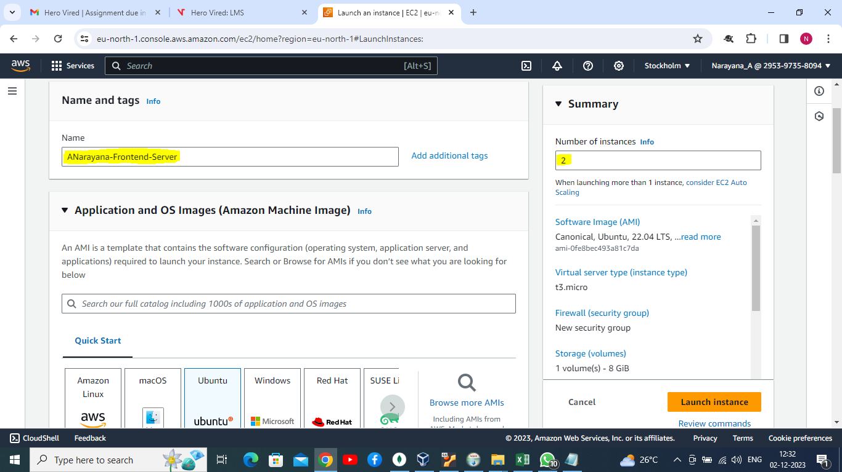

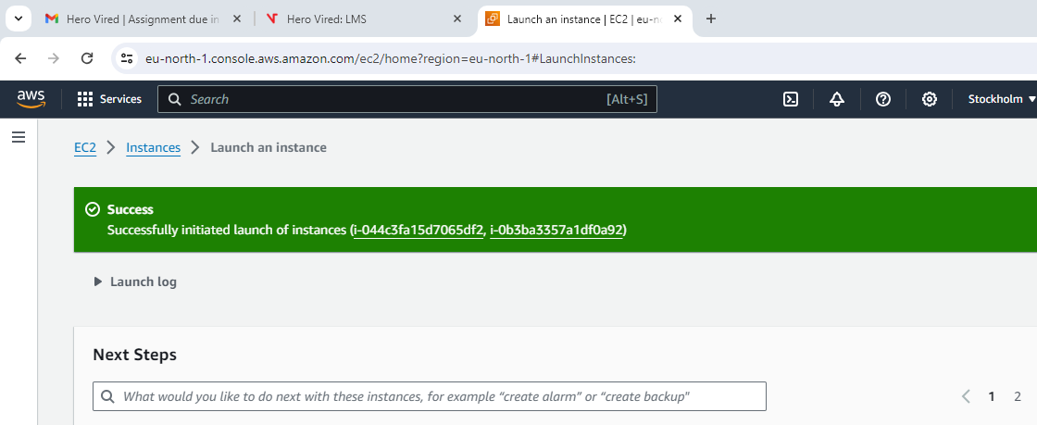

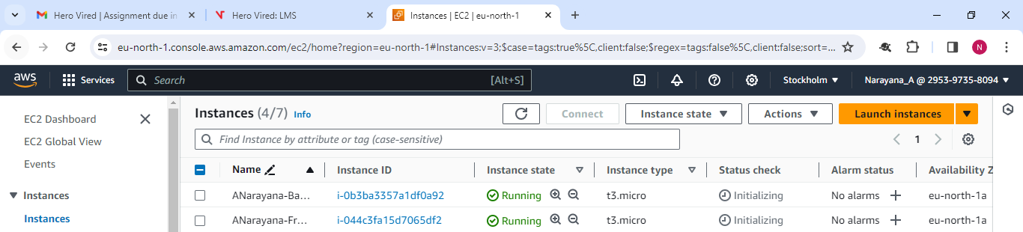

Going to install nodejs packages in both severs.

sudo apt-get update

sudo apt-get install -y ca-certificates curl gnupg

sudo mkdir -p /etc/apt/keyrings

curl -fsSL <https://deb.nodesource.com/gpgkey/nodesource-repo.gpg.key> | sudo gpg --dearmor -o /etc/apt/keyrings/nodesource.gpg

NODE_MAJOR=18

echo "deb [signed-by=/etc/apt/keyrings/nodesource.gpg] <https://deb.nodesource.com/node_$NODE_MAJOR.x> nodistro main" | sudo tee /etc/apt/sources.list.d/nodesource.list

sudo apt-get update

sudo apt-get install nodejs -y

In frentend server:

ubuntu@ip-172-31-26-184:~$ sudo apt-get update

Hit:1 http://eu-north-1.ec2.archive.ubuntu.com/ubuntu jammy InRelease

Get:2 http://eu-north-1.ec2.archive.ubuntu.com/ubuntu jammy-updates InRelease [119 kB]

Get:3 http://eu-north-1.ec2.archive.ubuntu.com/ubuntu jammy-backports InRelease [109 kB]

Get:4 http://eu-north-1.ec2.archive.ubuntu.com/ubuntu jammy/universe amd64 Packages [14.1 MB]

Get:5 http://security.ubuntu.com/ubuntu jammy-security InRelease [110 kB]

Get:6 http://eu-north-1.ec2.archive.ubuntu.com/ubuntu jammy/universe Translation-en [5652 kB]

Get:7 http://eu-north-1.ec2.archive.ubuntu.com/ubuntu jammy/universe amd64 c-n-f Metadata [286 kB]

Get:8 http://eu-north-1.ec2.archive.ubuntu.com/ubuntu jammy/multiverse amd64 Packages [217 kB]

Get:9 http://eu-north-1.ec2.archive.ubuntu.com/ubuntu jammy/multiverse Translation-en [112 kB]

Get:10 http://eu-north-1.ec2.archive.ubuntu.com/ubuntu jammy/multiverse amd64 c-n-f Metadata [8372 B]

Get:11 http://eu-north-1.ec2.archive.ubuntu.com/ubuntu jammy-updates/main amd64 Packages [1212 kB]

Get:12 http://eu-north-1.ec2.archive.ubuntu.com/ubuntu jammy-updates/main Translation-en [253 kB]

Get:13 http://eu-north-1.ec2.archive.ubuntu.com/ubuntu jammy-updates/main amd64 c-n-f Metadata [16.1 kB]

Get:14 http://eu-north-1.ec2.archive.ubuntu.com/ubuntu jammy-updates/restricted amd64 Packages [1185 kB]

Get:15 http://eu-north-1.ec2.archive.ubuntu.com/ubuntu jammy-updates/restricted Translation-en [192 kB]

Get:16 http://eu-north-1.ec2.archive.ubuntu.com/ubuntu jammy-updates/restricted amd64 c-n-f Metadata [520 B]

Get:17 http://eu-north-1.ec2.archive.ubuntu.com/ubuntu jammy-updates/universe amd64 Packages [1010 kB]

Get:18 http://eu-north-1.ec2.archive.ubuntu.com/ubuntu jammy-updates/universe Translation-en [224 kB]

Get:19 http://eu-north-1.ec2.archive.ubuntu.com/ubuntu jammy-updates/universe amd64 c-n-f Metadata [22.1 kB]

Get:20 http://eu-north-1.ec2.archive.ubuntu.com/ubuntu jammy-updates/multiverse amd64 Packages [41.6 kB]

Get:21 http://eu-north-1.ec2.archive.ubuntu.com/ubuntu jammy-updates/multiverse Translation-en [9768 B]

Get:22 http://eu-north-1.ec2.archive.ubuntu.com/ubuntu jammy-updates/multiverse amd64 c-n-f Metadata [472 B]

Get:23 http://eu-north-1.ec2.archive.ubuntu.com/ubuntu jammy-backports/main amd64 Packages [64.2 kB]

Get:24 http://eu-north-1.ec2.archive.ubuntu.com/ubuntu jammy-backports/main Translation-en [10.5 kB]

Get:25 http://eu-north-1.ec2.archive.ubuntu.com/ubuntu jammy-backports/main amd64 c-n-f Metadata [388 B]

Get:26 http://eu-north-1.ec2.archive.ubuntu.com/ubuntu jammy-backports/restricted amd64 c-n-f Metadata [116 B]

Get:27 http://eu-north-1.ec2.archive.ubuntu.com/ubuntu jammy-backports/universe amd64 Packages [27.8 kB]

Get:28 http://eu-north-1.ec2.archive.ubuntu.com/ubuntu jammy-backports/universe Translation-en [16.5 kB]

Get:29 http://eu-north-1.ec2.archive.ubuntu.com/ubuntu jammy-backports/universe amd64 c-n-f Metadata [644 B]

Get:30 http://eu-north-1.ec2.archive.ubuntu.com/ubuntu jammy-backports/multiverse amd64 c-n-f Metadata [116 B]

Get:31 http://security.ubuntu.com/ubuntu jammy-security/main amd64 Packages [1002 kB]

Get:32 http://security.ubuntu.com/ubuntu jammy-security/main Translation-en [193 kB]

Get:33 http://security.ubuntu.com/ubuntu jammy-security/main amd64 c-n-f Metadata [11.4 kB]

Get:34 http://security.ubuntu.com/ubuntu jammy-security/restricted amd64 Packages [1164 kB]

Get:35 http://security.ubuntu.com/ubuntu jammy-security/restricted Translation-en [189 kB]

Get:36 http://security.ubuntu.com/ubuntu jammy-security/restricted amd64 c-n-f Metadata [520 B]

Get:37 http://security.ubuntu.com/ubuntu jammy-security/universe amd64 Packages [807 kB]

Get:38 http://security.ubuntu.com/ubuntu jammy-security/universe Translation-en [150 kB]

Get:39 http://security.ubuntu.com/ubuntu jammy-security/universe amd64 c-n-f Metadata [16.8 kB]

Get:40 http://security.ubuntu.com/ubuntu jammy-security/multiverse amd64 Packages [36.5 kB]

Get:41 http://security.ubuntu.com/ubuntu jammy-security/multiverse Translation-en [7060 B]

Get:42 http://security.ubuntu.com/ubuntu jammy-security/multiverse amd64 c-n-f Metadata [260 B]

Fetched 28.6 MB in 5s (6282 kB/s)

Reading package lists... Done

ubuntu@ip-172-31-26-184:~$ sudo apt-get install -y ca-certificates curl gnupg

Reading package lists... Done

Building dependency tree... Done

Reading state information... Done

ca-certificates is already the newest version (20230311ubuntu0.22.04.1).

ca-certificates set to manually installed.

gnupg is already the newest version (2.2.27-3ubuntu2.1).

gnupg set to manually installed.

The following additional packages will be installed:

libcurl4

The following packages will be upgraded:

curl libcurl4

2 upgraded, 0 newly installed, 0 to remove and 69 not upgraded.

Need to get 484 kB of archives.

After this operation, 0 B of additional disk space will be used.

Get:1 http://eu-north-1.ec2.archive.ubuntu.com/ubuntu jammy-updates/main amd64 curl amd64 7.81.0-1ubuntu1.14 [194 kB]

Get:2 http://eu-north-1.ec2.archive.ubuntu.com/ubuntu jammy-updates/main amd64 libcurl4 amd64 7.81.0-1ubuntu1.14 [290 kB]

Fetched 484 kB in 0s (16.9 MB/s)

(Reading database ... 64726 files and directories currently installed.)

Preparing to unpack .../curl_7.81.0-1ubuntu1.14_amd64.deb ...

Unpacking curl (7.81.0-1ubuntu1.14) over (7.81.0-1ubuntu1.13) ...

Preparing to unpack .../libcurl4_7.81.0-1ubuntu1.14_amd64.deb ...

Unpacking libcurl4:amd64 (7.81.0-1ubuntu1.14) over (7.81.0-1ubuntu1.13) ...

Setting up libcurl4:amd64 (7.81.0-1ubuntu1.14) ...

Setting up curl (7.81.0-1ubuntu1.14) ...

Processing triggers for man-db (2.10.2-1) ...

Processing triggers for libc-bin (2.35-0ubuntu3.3) ...

Scanning processes...

Scanning linux images...

Running kernel seems to be up-to-date.

No services need to be restarted.

No containers need to be restarted.

No user sessions are running outdated binaries.

No VM guests are running outdated hypervisor (qemu) binaries on this host.

ubuntu@ip-172-31-26-184:~$ sudo mkdir -p /etc/apt/keyrings

ubuntu@ip-172-31-26-184:~$ curl -fsSL https://deb.nodesource.com/gpgkey/nodesource-repo.gpg.key | sudo gpg --dearmor -o /etc/apt/keyrings/nodesource.gpg

ubuntu@ip-172-31-26-184:~$ NODE_MAJOR=18

ubuntu@ip-172-31-26-184:~$ echo "deb [signed-by=/etc/apt/keyrings/nodesource.gpg] https://deb.nodesource.com/node_$NODE_MAJOR.x nodistro main" | sudo tee /etc/apt/sources.list.d/nodesource.list

deb [signed-by=/etc/apt/keyrings/nodesource.gpg] https://deb.nodesource.com/node_18.x nodistro main

ubuntu@ip-172-31-26-184:~$ sudo apt-get update

Hit:1 http://eu-north-1.ec2.archive.ubuntu.com/ubuntu jammy InRelease

Hit:2 http://eu-north-1.ec2.archive.ubuntu.com/ubuntu jammy-updates InRelease

Hit:3 http://eu-north-1.ec2.archive.ubuntu.com/ubuntu jammy-backports InRelease

Hit:4 http://security.ubuntu.com/ubuntu jammy-security InRelease

Get:5 https://deb.nodesource.com/node_18.x nodistro InRelease [12.1 kB]

Get:6 https://deb.nodesource.com/node_18.x nodistro/main amd64 Packages [6262 B]

Fetched 18.4 kB in 1s (27.1 kB/s)

Reading package lists... Done

ubuntu@ip-172-31-26-184:~$ sudo apt-get install nodejs -y

E: Invalid operation install nodejs -y

ubuntu@ip-172-31-26-184:~$ sudo apt-get install nodejs

E: Invalid operation install nodejs

ubuntu@ip-172-31-26-184:~$ sudo apt-get install -y nodejs

E: Invalid operation install -y

ubuntu@ip-172-31-26-184:~$ sudo apt install nodejs

Reading package lists... Done

Building dependency tree... Done

Reading state information... Done

The following NEW packages will be installed:

nodejs

0 upgraded, 1 newly installed, 0 to remove and 69 not upgraded.

Need to get 29.8 MB of archives.

After this operation, 189 MB of additional disk space will be used.

Get:1 https://deb.nodesource.com/node_18.x nodistro/main amd64 nodejs amd64 18.19.0-1nodesource1 [29.8 MB]

Fetched 29.8 MB in 1s (54.4 MB/s)

Selecting previously unselected package nodejs.

(Reading database ... 64726 files and directories currently installed.)

Preparing to unpack .../nodejs_18.19.0-1nodesource1_amd64.deb ...

Unpacking nodejs (18.19.0-1nodesource1) ...

Setting up nodejs (18.19.0-1nodesource1) ...

Processing triggers for man-db (2.10.2-1) ...

Scanning processes...

Scanning linux images...

Running kernel seems to be up-to-date.

No services need to be restarted.

No containers need to be restarted.

No user sessions are running outdated binaries.

No VM guests are running outdated hypervisor (qemu) binaries on this host.

ubuntu@ip-172-31-26-184:~$

In frontend server npm and node versions:

ubuntu@ip-172-31-26-184:~$ npm --version

10.2.3

ubuntu@ip-172-31-26-184:~$ node --version

v18.19.0

ubuntu@ip-172-31-26-184:~$

In Backend server:

ubuntu@ip-172-31-19-123:~$ sudo apt-get update

Hit:1 http://eu-north-1.ec2.archive.ubuntu.com/ubuntu jammy InRelease

Get:2 http://eu-north-1.ec2.archive.ubuntu.com/ubuntu jammy-updates InRelease [119 kB]

Get:3 http://eu-north-1.ec2.archive.ubuntu.com/ubuntu jammy-backports InRelease [109 kB]

Get:4 http://security.ubuntu.com/ubuntu jammy-security InRelease [110 kB]

Get:5 http://eu-north-1.ec2.archive.ubuntu.com/ubuntu jammy/universe amd64 Packages [14.1 MB]

Get:6 http://eu-north-1.ec2.archive.ubuntu.com/ubuntu jammy/universe Translation-en [5652 kB]

Get:7 http://eu-north-1.ec2.archive.ubuntu.com/ubuntu jammy/universe amd64 c-n-f Metadata [286 kB]

Get:8 http://eu-north-1.ec2.archive.ubuntu.com/ubuntu jammy/multiverse amd64 Packages [217 kB]

Get:9 http://eu-north-1.ec2.archive.ubuntu.com/ubuntu jammy/multiverse Translation-en [112 kB]

Get:10 http://eu-north-1.ec2.archive.ubuntu.com/ubuntu jammy/multiverse amd64 c-n-f Metadata [8372 B]

Get:11 http://eu-north-1.ec2.archive.ubuntu.com/ubuntu jammy-updates/main amd64 Packages [1212 kB]

Get:12 http://eu-north-1.ec2.archive.ubuntu.com/ubuntu jammy-updates/main Translation-en [253 kB]

Get:13 http://eu-north-1.ec2.archive.ubuntu.com/ubuntu jammy-updates/main amd64 c-n-f Metadata [16.1 kB]

Get:14 http://eu-north-1.ec2.archive.ubuntu.com/ubuntu jammy-updates/restricted amd64 Packages [1185 kB]

Get:15 http://eu-north-1.ec2.archive.ubuntu.com/ubuntu jammy-updates/restricted Translation-en [192 kB]

Get:16 http://eu-north-1.ec2.archive.ubuntu.com/ubuntu jammy-updates/restricted amd64 c-n-f Metadata [520 B]

Get:17 http://eu-north-1.ec2.archive.ubuntu.com/ubuntu jammy-updates/universe amd64 Packages [1010 kB]

Get:18 http://eu-north-1.ec2.archive.ubuntu.com/ubuntu jammy-updates/universe Translation-en [224 kB]

Get:19 http://eu-north-1.ec2.archive.ubuntu.com/ubuntu jammy-updates/universe amd64 c-n-f Metadata [22.1 kB]

Get:20 http://eu-north-1.ec2.archive.ubuntu.com/ubuntu jammy-updates/multiverse amd64 Packages [41.6 kB]

Get:21 http://eu-north-1.ec2.archive.ubuntu.com/ubuntu jammy-updates/multiverse Translation-en [9768 B]

Get:22 http://eu-north-1.ec2.archive.ubuntu.com/ubuntu jammy-updates/multiverse amd64 c-n-f Metadata [472 B]

Get:23 http://eu-north-1.ec2.archive.ubuntu.com/ubuntu jammy-backports/main amd64 Packages [64.2 kB]

Get:24 http://eu-north-1.ec2.archive.ubuntu.com/ubuntu jammy-backports/main Translation-en [10.5 kB]

Get:25 http://eu-north-1.ec2.archive.ubuntu.com/ubuntu jammy-backports/main amd64 c-n-f Metadata [388 B]

Get:26 http://eu-north-1.ec2.archive.ubuntu.com/ubuntu jammy-backports/restricted amd64 c-n-f Metadata [116 B]

Get:27 http://eu-north-1.ec2.archive.ubuntu.com/ubuntu jammy-backports/universe amd64 Packages [27.8 kB]

Get:28 http://eu-north-1.ec2.archive.ubuntu.com/ubuntu jammy-backports/universe Translation-en [16.5 kB]

Get:29 http://eu-north-1.ec2.archive.ubuntu.com/ubuntu jammy-backports/universe amd64 c-n-f Metadata [644 B]

Get:30 http://eu-north-1.ec2.archive.ubuntu.com/ubuntu jammy-backports/multiverse amd64 c-n-f Metadata [116 B]

Get:31 http://security.ubuntu.com/ubuntu jammy-security/main amd64 Packages [1002 kB]

Get:32 http://security.ubuntu.com/ubuntu jammy-security/main Translation-en [193 kB]

Get:33 http://security.ubuntu.com/ubuntu jammy-security/main amd64 c-n-f Metadata [11.4 kB]

Get:34 http://security.ubuntu.com/ubuntu jammy-security/restricted amd64 Packages [1164 kB]

Get:35 http://security.ubuntu.com/ubuntu jammy-security/restricted Translation-en [189 kB]

Get:36 http://security.ubuntu.com/ubuntu jammy-security/restricted amd64 c-n-f Metadata [520 B]

Get:37 http://security.ubuntu.com/ubuntu jammy-security/universe amd64 Packages [807 kB]

Get:38 http://security.ubuntu.com/ubuntu jammy-security/universe Translation-en [150 kB]

Get:39 http://security.ubuntu.com/ubuntu jammy-security/universe amd64 c-n-f Metadata [16.8 kB]

Get:40 http://security.ubuntu.com/ubuntu jammy-security/multiverse amd64 Packages [36.5 kB]

Get:41 http://security.ubuntu.com/ubuntu jammy-security/multiverse Translation-en [7060 B]

Get:42 http://security.ubuntu.com/ubuntu jammy-security/multiverse amd64 c-n-f Metadata [260 B]

Fetched 28.6 MB in 5s (5654 kB/s)

Reading package lists... Done

ubuntu@ip-172-31-19-123:~$ sudo apt-get install -y ca-certificates curl gnupg

Reading package lists... Done

Building dependency tree... Done

Reading state information... Done

ca-certificates is already the newest version (20230311ubuntu0.22.04.1).

ca-certificates set to manually installed.

gnupg is already the newest version (2.2.27-3ubuntu2.1).

gnupg set to manually installed.

The following additional packages will be installed:

libcurl4

The following packages will be upgraded:

curl libcurl4

2 upgraded, 0 newly installed, 0 to remove and 69 not upgraded.

Need to get 484 kB of archives.

After this operation, 0 B of additional disk space will be used.

Get:1 http://eu-north-1.ec2.archive.ubuntu.com/ubuntu jammy-updates/main amd64 curl amd64 7.81.0-1ubuntu1.14 [194 kB]

Get:2 http://eu-north-1.ec2.archive.ubuntu.com/ubuntu jammy-updates/main amd64 libcurl4 amd64 7.81.0-1ubuntu1.14 [290 kB]

Fetched 484 kB in 0s (18.0 MB/s)

(Reading database ... 64726 files and directories currently installed.)

Preparing to unpack .../curl_7.81.0-1ubuntu1.14_amd64.deb ...

Unpacking curl (7.81.0-1ubuntu1.14) over (7.81.0-1ubuntu1.13) ...

Preparing to unpack .../libcurl4_7.81.0-1ubuntu1.14_amd64.deb ...

Unpacking libcurl4:amd64 (7.81.0-1ubuntu1.14) over (7.81.0-1ubuntu1.13) ...

Setting up libcurl4:amd64 (7.81.0-1ubuntu1.14) ...

Setting up curl (7.81.0-1ubuntu1.14) ...

Processing triggers for man-db (2.10.2-1) ...

Processing triggers for libc-bin (2.35-0ubuntu3.3) ...

Scanning processes...

Scanning linux images...

Running kernel seems to be up-to-date.

No services need to be restarted.

No containers need to be restarted.

No user sessions are running outdated binaries.

No VM guests are running outdated hypervisor (qemu) binaries on this host.

ubuntu@ip-172-31-19-123:~$ sudo mkdir -p /etc/apt/keyrings

ubuntu@ip-172-31-19-123:~$ curl -fsSL https://deb.nodesource.com/gpgkey/nodesource-repo.gpg.key | sudo gpg --dearmor -o /etc/apt/keyrings/nodesource.gpg

ubuntu@ip-172-31-19-123:~$ NODE_MAJOR=18

ubuntu@ip-172-31-19-123:~$ echo "deb [signed-by=/etc/apt/keyrings/nodesource.gpg] https://deb.nodesource.com/node_$NODE_MAJOR.x nodistro main" | sudo tee /etc/apt/sources.list.d/nodesource.list

deb [signed-by=/etc/apt/keyrings/nodesource.gpg] https://deb.nodesource.com/node_18.x nodistro main

ubuntu@ip-172-31-19-123:~$ sudo apt-get update

Hit:1 http://eu-north-1.ec2.archive.ubuntu.com/ubuntu jammy InRelease

Hit:2 http://eu-north-1.ec2.archive.ubuntu.com/ubuntu jammy-updates InRelease

Hit:3 http://eu-north-1.ec2.archive.ubuntu.com/ubuntu jammy-backports InRelease

Get:4 https://deb.nodesource.com/node_18.x nodistro InRelease [12.1 kB]

Hit:5 http://security.ubuntu.com/ubuntu jammy-security InRelease

Get:6 https://deb.nodesource.com/node_18.x nodistro/main amd64 Packages [6262 B]

Fetched 18.4 kB in 1s (22.3 kB/s)

Reading package lists... Done

ubuntu@ip-172-31-19-123:~$ sudo apt install nodejs

Reading package lists... Done

Building dependency tree... Done

Reading state information... Done

The following NEW packages will be installed:

nodejs

0 upgraded, 1 newly installed, 0 to remove and 69 not upgraded.

Need to get 29.8 MB of archives.

After this operation, 189 MB of additional disk space will be used.

Get:1 https://deb.nodesource.com/node_18.x nodistro/main amd64 nodejs amd64 18.19.0-1nodesource1 [29.8 MB]

Fetched 29.8 MB in 1s (45.0 MB/s)

Selecting previously unselected package nodejs.

(Reading database ... 64726 files and directories currently installed.)

Preparing to unpack .../nodejs_18.19.0-1nodesource1_amd64.deb ...

Unpacking nodejs (18.19.0-1nodesource1) ...

Setting up nodejs (18.19.0-1nodesource1) ...

Processing triggers for man-db (2.10.2-1) ...

Scanning processes...

Scanning linux images...

Running kernel seems to be up-to-date.

No services need to be restarted.

No containers need to be restarted.

No user sessions are running outdated binaries.

No VM guests are running outdated hypervisor (qemu) binaries on this host.

ubuntu@ip-172-31-19-123:~$

Installation completed.

Npm and node versions:

ubuntu@ip-172-31-19-123:~$ npm --version

10.2.3

ubuntu@ip-172-31-19-123:~$ node --version

v18.19.0

ubuntu@ip-172-31-19-123:~$

Custom port opened for backend server to access DB port

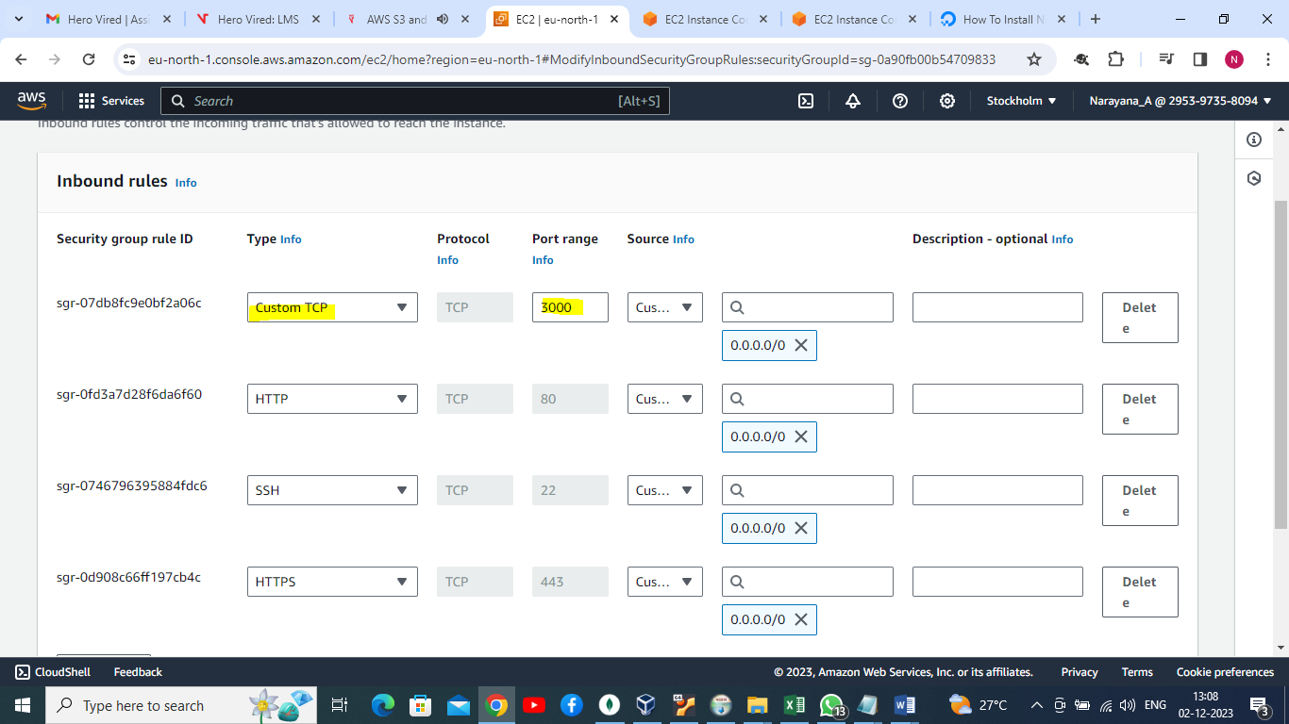

Environment file update with DB details

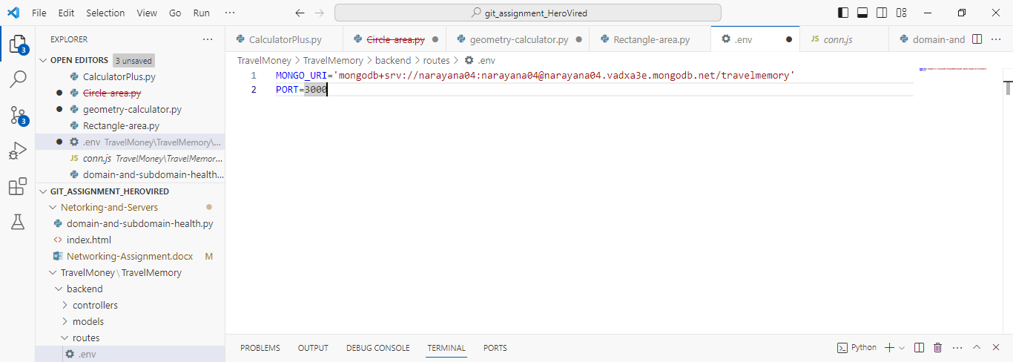

Travel memory DB created:

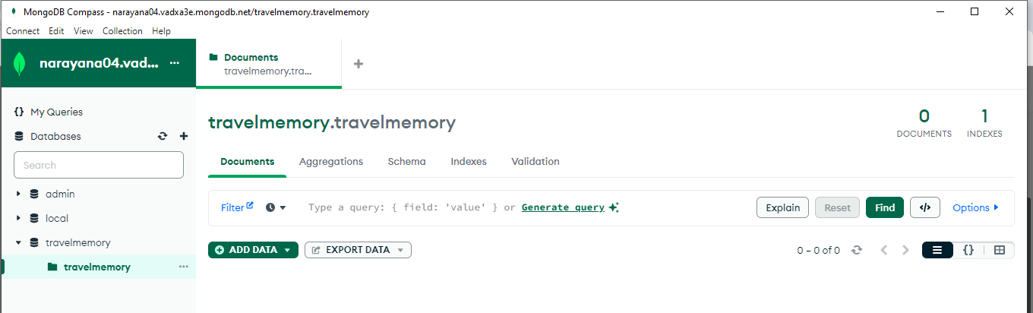

Git cloned in backend servers and created .env file nd updated mango db connection server details:

ubuntu@ip-172-31-26-184:~/TravelMemory/backend$ vi .env

ubuntu@ip-172-31-26-184:~/TravelMemory/backend$ npm install

added 117 packages, and audited 118 packages in 4s

13 packages are looking for funding

run `npm fund` for details

5 vulnerabilities (4 moderate, 1 critical)

To address issues that do not require attention, run:

npm audit fix

To address all issues (including breaking changes), run:

npm audit fix --force

Run `npm audit` for details.

npm notice

npm notice New patch version of npm available! 10.2.3 -> 10.2.4

npm notice Changelog: https://github.com/npm/cli/releases/tag/v10.2.4

npm notice Run npm install -g npm@10.2.4 to update!

npm notice

ubuntu@ip-172-31-26-184:~/TravelMemory/backend$ ls -lrt

total 72

drwxrwxr-x 2 ubuntu ubuntu 4096 Dec 3 06:56 models

-rw-rw-r-- 1 ubuntu ubuntu 496 Dec 3 06:56 index.js

drwxrwxr-x 2 ubuntu ubuntu 4096 Dec 3 06:56 controllers

-rw-rw-r-- 1 ubuntu ubuntu 250 Dec 3 06:56 conn.js

drwxrwxr-x 2 ubuntu ubuntu 4096 Dec 3 06:56 routes

-rw-rw-r-- 1 ubuntu ubuntu 372 Dec 3 06:56 package.json

-rw-rw-r-- 1 ubuntu ubuntu 44874 Dec 3 06:57 package-lock.json

drwxrwxr-x 111 ubuntu ubuntu 4096 Dec 3 06:57 node_modules

ubuntu@ip-172-31-26-184:~/TravelMemory/backend$

IP address enables in mongDB whitelist

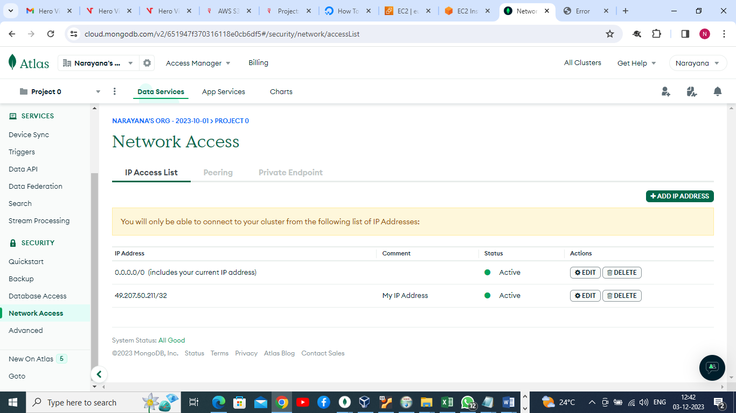

Started nodejs service in backend server.

ubuntu@ip-172-31-26-184:~/TravelMemory/backend$ node index.js

Server started at <http://localhost:3000>

Now able to connect fom browser.

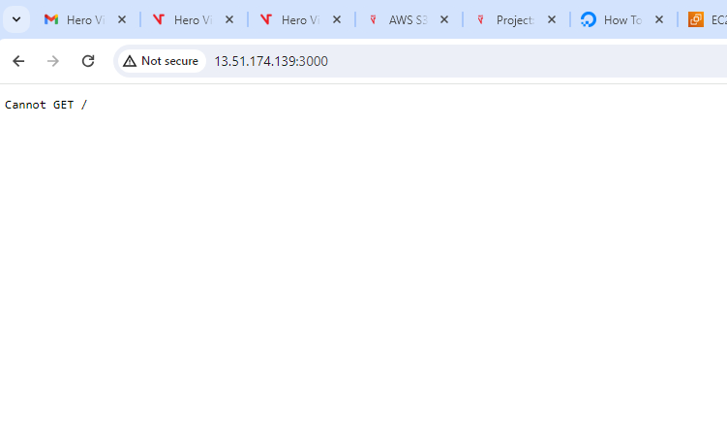

Now going to clone git repo to frontend server and install NPM packages in frontend server.